Design Note CC1

- Please use the original PLATFORM 7 sign logo:
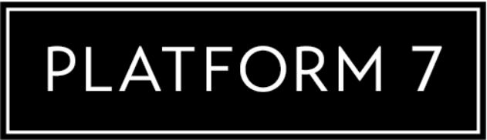
Under the shield like this:

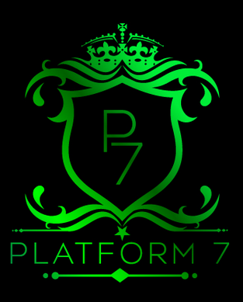

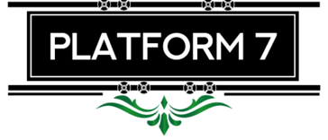

- Remove the “star” from the bottom of shield.
- Change the P7 orientation from:
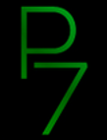
to:

- Colour:
Need Green, Black & White version.
- GREEN:
- Inside of shield to be green (I give you a very bad cut & paste example here – but it will give you an idea of what I want)

- Filigree
- BLACK:
- Crown
- Thin black line outlining the shield.
- PLATFORM 7 sign and 1 horizontal rod above PLATFORM 7 and 2 horizontal rods below PLATFORM to be black
- WHITE:
- P7 letters
- PLATFORM 7 letters
- Thin border line around PLATFORM 7


