Design Note CC

- Please use the original PLATFORM 7 sign logo under shield:
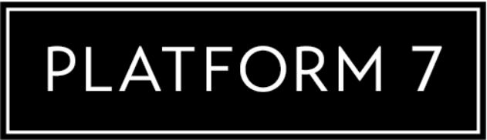
- Please use the same font in the above PLATFORM 7 for the P7 in the shield.
- Make shield bigger and the PLATFORM 7 smaller to have a more over-all square shape.
- Use this crown design:

- Curve bottom of crown to fit with top of your shield.
- OR – modify this crown design to fit your logo design style.
- I want to use a multi-green gradient in the shield. To look aged or vintage:
