P7
PLATFORM 7
Logo Design Notes

Notes:

The inspiration is of British heritage, with shield or crest heraldry, filigree, crown and the PLATFORM 7 full logo underneath.
Further inspiration comes from British Royalty crest designs, Harry Potter, deep, rich, elegant, etc…
The NEW P7 PLATFORM 7 logo has 2 parts or sections:
TOP PART: P7 Shield
BOTTOM PART: The current PLATFORM 7 train station sign logo.
The current PLATFORM 7 logo:
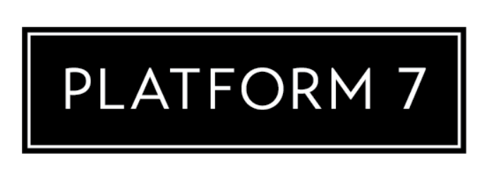
The overall design needs to have P7 on a shield, crown on top, filigree down the sides and the PLATFORM 7 logo sign underneath with single horizontal bar on top and double horizontal bars at the bottom. 4 “florets” are on the top and bottom bar.

- I’ve included images at the bottom of this Word Doc that are the source of this design.
- Also – there are some colour ideas at the very bottom of this Word Doc.

P7 LOGO DRAFT

This sketch is the draft design.

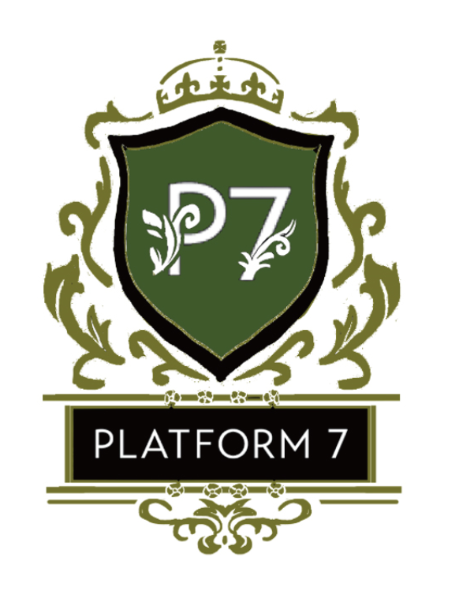
REQUESTS FOR DRAFT:
- Please thin white border around the black PLATFORM 7 sign.
- Please make the crown BLACK
- Please make the base under the PLATFORM 7 sign - BLACK
- Please make the horizontal rods on top & bottom of PLATFORM 7 sign – BLACK, but leave all florets light green.

Note:
The overall shape is square, like image #1. Not rectangle like image #4. These images are just for the filigree detail, crown design and shield designs.

#1
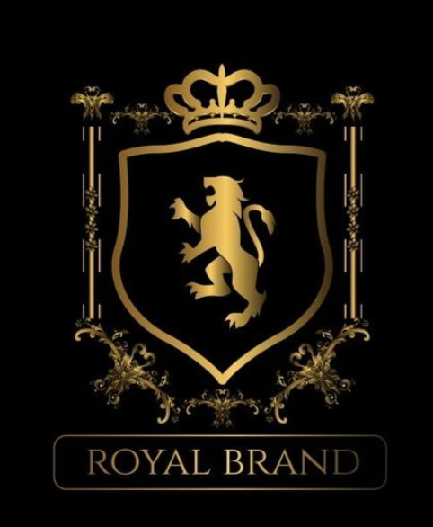

#2
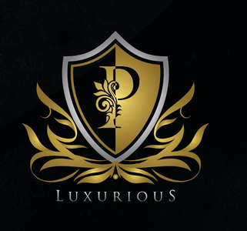

#3
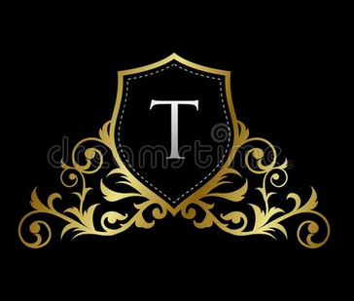

#4
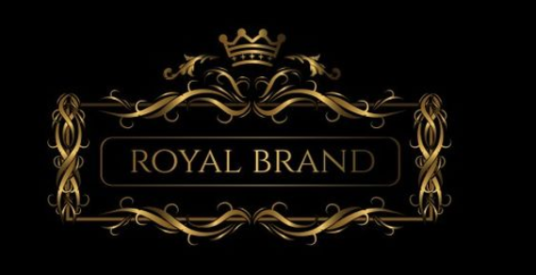

COLOUR

The only colour other than BLACK & WHITE…is GREEN.
The green needs to be VERY vibrant, electric. Could be multi-shaded.

