Design Note BB2

Revisions:

We are very close!
- I would like to add 1 more feature to the shield.
- I’m sending you an image of a train:
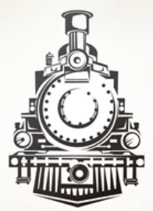
https://www.shutterstock.com/image-vector/retro-train-vintage-vector-symbol-emblem-335919971
- I’d like to have it blacked out – so it is completely black. Here is a mock-up example:
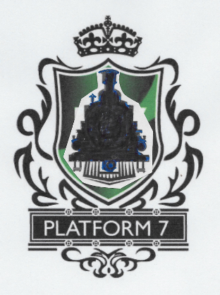

- Then can you insert this black train on the shield.
- Your green design all around (no white)
- White P7 letters on top of black train shape.
- The front of the train (at the bottom, with all the vertical lines) – please elongate or extend to a point that matches the bottom point of your shield.
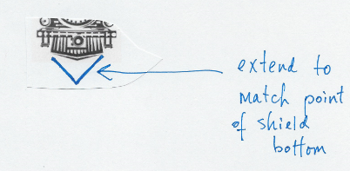
**this bottom triangle – I did not make black – but if you can please make it black also, I think it will look better and consistent with the rest of the black train shape.

