Design Note BB

Revisions:
- The horizontal rods above and below the PLATFORM 7 sign, please make them a little bolder or fatter.
- The 3 “florets” along these horizontal rods – please add 1 more so that there are 4 in total on top and 4 on bottom.
- Please use same font used in PLATFORM 7,
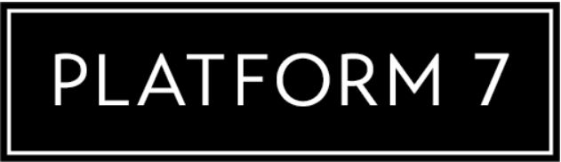
for the P7 on the shield. The P7 could be bold to have a more dramatic look.
- Use this crown design:


- Curve bottom of crown to fit with top of shield.
- Please use a multi-gradient green on the shield. Similar to yours – but if you can make it look aged or vintage:
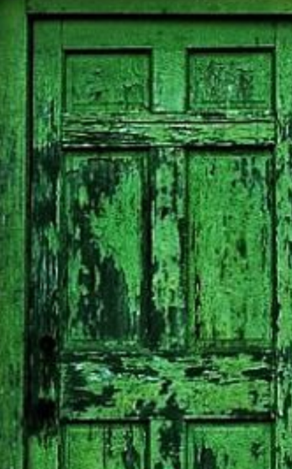
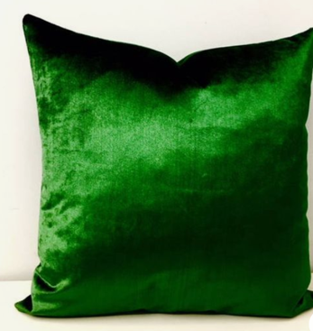

- Need to have 3 colour versions:
- Black only design – to go on white shirts
- White only design – to go on black shirts
- Green, Black & White

