Design Note BB4

Very Nice. Just a few more changes. I will be selecting winner tomorrow evening.
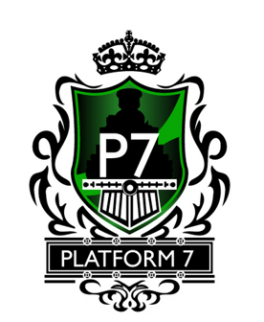
- Like the P7 font size
- Remove white border around bottom of train – keep green


- Remove “white&black-train-line” under P7 -- and -- replace with original white lines under P7

- The round circle is interesting.
Looks like a train light. Insert this round circle in the middle of the 2 horizontal lines above

- Try removing the lime green “swipe” effect from “7 o’clock-to-2 o’clock” and replace with the same gradient light green to dark green around the train steam stack at top of shield. This will show off the ENTIRE train outline.
- Try removing the 2 inner florets – and using only the 2 outer top & bottom florets

I’ve added some drawing notes:

