Design Note BB3

Very Nice. Just a few little things.

Revisions:

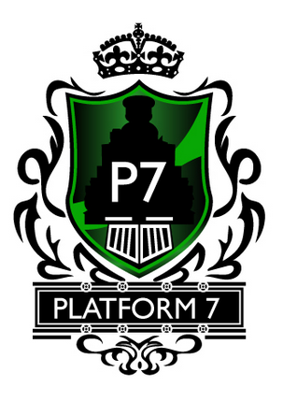
- The white bottom of the train is very dramatic.


Please reverse the white and make black…and reverse the black and make white.

- Please do 2 enlargements to the P7:
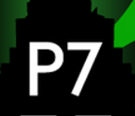

- Enlarge the P7 to come nearly to the inside edge of the black train outline. The top left & right square corners.
- Enlarge the P7 to your original size in your 1st design. This will mean that the P7 goes outside of the train outline – but I just want to see what it looks like.

Can you please design the bottom point of the train (the black & white parts) to match the green border point of the shield.



