Design Note AA

Revisions:
- Like the train imagery in the P7 shield
- Please use the original PLATFORM 7 sign logo under shield
- Please use the same font in the PLATFORM 7 sign logo:
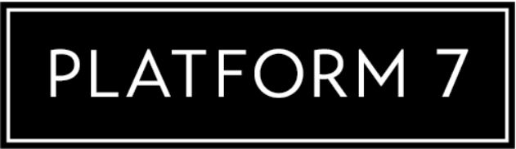
For the P7 on the shield. The P7 could be bold to have a more dramatic look.
- Make shield bigger and the PLATFORM 7 smaller to have a more over-all square shape.
- Use this crown design:

- Curve bottom of crown to fit with top of your shield.
- OR – modify this crown design to fit your logo design style.
- COLOUR – I want to use a multi-green gradient on the shield. To look aged or vintage:
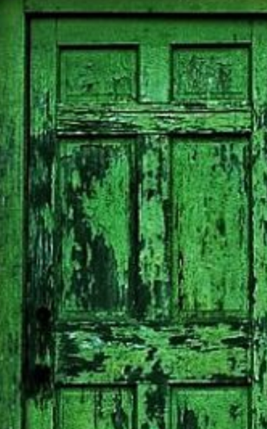
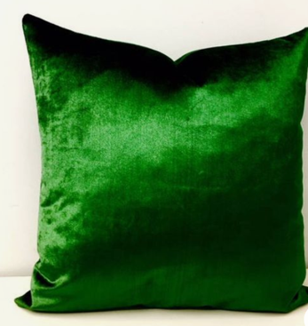

- Need to have 3 colour versions:
- Black only design – to go on white shirts
- White only design – to go on black shirts
- Green, Black & White

