Design Notes AA1
Revisions:

- Please use the original PLATFORM 7 sign logo under shield like this:
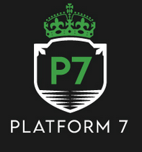

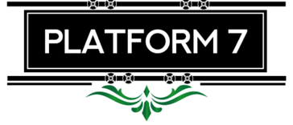

- You can add a different filigree design under PLATFORM 7
- Make crown a little smaller
- I prefer inside of shield to be green – but I understand that the black makes the train shape look better. Do you have any ideas how to use green inside shield?

