Draft of DropCite Logo Description

DropCite’s mission is to reinvent scientific research communication. We are a web-based platform that will provide a forum for researchers to comment on and discuss the latest research using the research paper as their point of contact. Conventional scientific publishing is a dinosaur built on the hard work of researchers. We are the asteroid that will put the researcher back in control.

Some Key Words to think about-

- Science
- Research Papers
- Connection
- Speed
- Community
- Openness
- Quality
- Cutting edge

Note that part of what will do involves connecting with existing social networks such as FaceBook, Twitter, ResearchGate.

The logo should be simple, clean and modern. It should be able to function both with and without the company name. Here is one we created on our own. Do not feel you have to emulate it.

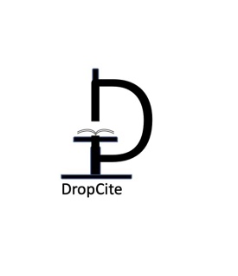

Competitor’s Logos

These are ones that we liked. Note that many of these designs rely on multiple colors and that may limit our flexibility in using this. The simplicity and single color of the FB and Twitter logos has advantages. Not categorically opposed to multiple colors, but something to consider.

Altmetrics:



https://www.altmetric.com/about-our-data/the-donut-and-score/

Crossref:
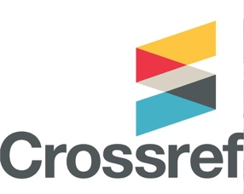

Research Gate: 

eLife:


