Menu Sponsorship Packages
Cover (add images from board packet)
South Puget Sound Habitat for Humanity (logo)

Building a Better Thurston County Together since 1989
2021-2022 Partnership Opportunities

Board Roster
Jason McLauchlin – President
Bob Bredensteiner- Treasurer
Melanie Kincaid – Board Member
Kevin Hochalter – Board Member
Bruce Wells – Board Member
Monica Beckley -Board Member
Janine Ezzell -Board Member
John Hutchings -Board Member
Jennifer Arnold- Board Member

Who We Are
South Puget Sound Habitat for Humanity provides affordable home ownership opportunities and critical home repairs to the low and very low-income families in our area. We empower homeowners and bring people together to build and repair homes, communities and hope. Since 1989, SPS Habitat for Humanity has built 75 new construction homes in the Thurston County community- helping provide safe and decent housing to over 246 local individuals whose lives and futures have been forever changed through the Habitat for Humanity program. As a locally supported nonprofit, the work we do is only made possible through support from our community.

Sections
Special Events

Women Build - Spring 2021
Presenting title sponsor - $10,000
Sponsor benefits include:
- 5 volunteer spots during Women Build
- Name and logo on build site and digital event marketing materials
- Logo on Women Build T-shirt
- Access to event photos
- Social Media promotion before, during and after event
- Option to add promo item to volunteer swag bag

Gold Sponsor- $7,500
Sponsor benefits include:
- Name and logo on event marketing materials
- Logo on Women Build T-shirt
- Access to event photos
- Social Media promotion before, during and after event
- Option to add promo item to volunteer swag bag

Silver Sponsor- $5,000
Sponsor benefits include:
- Name and logo on event marketing materials
- Logo on Women Build T-shirt Access to event photos
- Social Media promotion before, during and after event
- Option to add promo item to volunteer swag bag
Bronze Sponsor- $2,500
Sponsor benefits include:
- Logo on Women Build T-shirt
- Access to event photos
- Social Media promotion before, during and after event
$1,000 Sponsor - recognition as an event sponsor, 2 Social Media posts
$500 Sponsor - recognition as an event sponsor, 1 Social Media post
$250 Sponsor - recognition as an event sponsor, 1 Social Media post

RePurpose for a Reason Auction - Summer 2021
Presenting title sponsor -$5,000 -REPURPOSER
- Name and logo on all event materials and online pages
- Opportunity to pre-record a sponsor video to be played for auction attendee’s at live preview event * in person event depends on COVID restrictions in place*
- 5 social media shout outs on Facebook and Instagram
- Name and logo on event auction website sponsor page with hyperlink
RENOVATOR Sponsor $3,000
- Name and logo on South Puget Sound Habitat site and Auction site
- 3 Social media shout outs on Facebook and Instagram
- Name and logo on event auction website sponsor page with hyperlink
REFURBISHER Sponsor $2,000
- Name and logo on South Puget Sound Habitat and Auction site
- 2 Social media shout outs on Facebook and Instagram
- Name and logo on event auction website sponsor page with hyperlink
REFINISHER Sponsor $1,000
- Name and logo on South Puget Sound Habitat and Auction site
- 1 Social media shout out on Facebook and Instagram
RECYCLER Sponsor $500
- Social media shout out on Facebook
- Name and logo on Auction site with hyperlink

Raise the Roof Breakfast - Fall 2021
Presenting title sponsor -$4,000
Sponsor benefits include:
- Your logo on all printed materials and giveaways
- Access to online event photos to be used for marketing purposes
- Dedicated table at the event with space for up to 10 guests and your logo prominently displayed
- Recognition from the podium with an invitation to stand and be recognized at the opening of the event
- Logo posted on event webpage and breakfast program given to all guests
- Meet and Greet with Keynote speaker TBD
Platinum Sponsor – $2,000
Sponsor benefits include:
- Dedicated table at the event with space for up to 10 guests and your logo prominently displayed
- Logo posted on event webpage and breakfast program given to all guests
- Name mentioned from podium at sponsorship level
- Logo in event program and promotional materials
Gold Sponsor- $1,000
Sponsor benefits include:
- Logo posted on event webpage and breakfast program given to all guests
- Recognition on SPS Habitat’s website and social media channels
- Sponsor name on a table top
Silver Sponsor - $500
Sponsor benefits include:
- Logo posted on event webpage and breakfast program given to all guests
- Sponsor name displayed on a table top·
Bronze -$200
Sponsor benefits include:
- Logo posted on event webpage and breakfast program given to all guests

Home and Neighborhood Sponsorships
Neighborhood Builder -$100,000
Name the Neighborhood -Contact us about the opportunity for your organization to have exclusive naming rights to the next SPS Habitat for Humanity development in Thurston County. Leave a lasting legacy for your organization or for a loved one with a once in a lifetime gift, naming our next development. Limited opportunities available in Tumwater or Yelm.
Full Home Sponsor - $50,000
Sponsor benefits include:
- Speaker at home dedication ceremony
- Named as the sole sponsor in jointly-issued press releases at the beginning and end of construction.
- Up to eight team build days with preferred scheduling. *Covid restrictions may apply
- Optional on-site event to celebrate sponsorship, separate from dedication.
- Prominent recognition through signage for the duration of the build at build site
- Prominent recognition on our website including logo, short article, and link to sponsor website for one year.
- Feature article in our annual report
Why Sponsor a home?
Our past home sponsors have raved about their sponsorship experience! Having the ability to watch a family change their future one 2” x 4” at a time is a unique experience. Past sponsors have boasted that their employees not only learn new skills on our jobsite but they also see a measurable improvement in employee productivity, engagement and internal communications. The highlight for most, is being able to offer a hands on, face to face, experience of helping a local family change their lives for the better. All sponsorships can be customized to fit your budget and your organizations philanthropic goals.
Quote from Past Home Sponsor - American Forest Resource Council
“This project embodies what the forest products industry is all about… Our members – the family business owners, engineers, loggers, foresters, and millworkers – are passionate about the health and vitality of the communities in which they live, work, and play” said Travis Joseph, president of AFRC. “This collaboration with Habitat is another example of that commitment. It’s a perfect fit. We are ecstatic to be using our members’ local products and expertise – and tapping into their passion for and commitment to rural communities – to build a home for Sharaf, Kayleigh, and their three kids, including a newborn!”
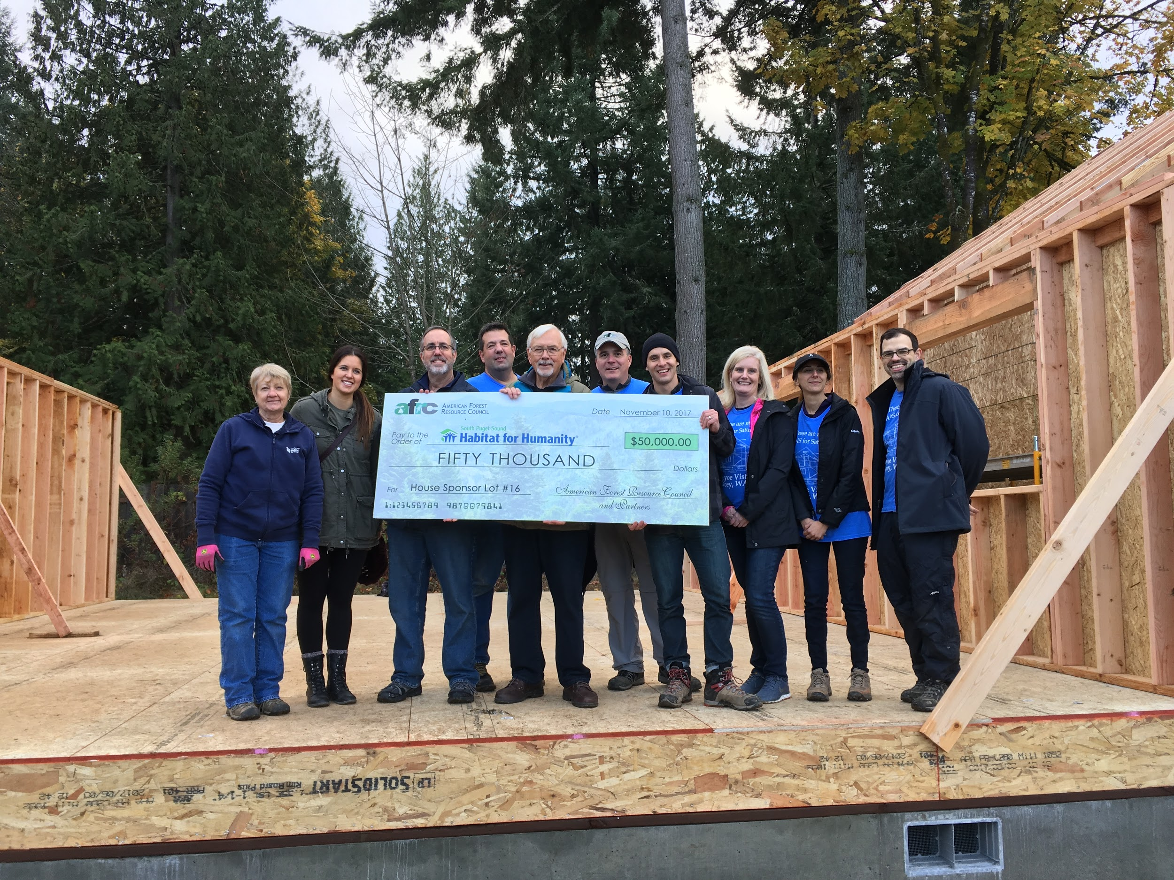

Framing Sponsor - $20,000
Sponsor benefits include:
- Speaker at groundbreaking and home dedication ceremonies.
- Named as a Frame Sponsor in SPS Habitat for Humanity - issued press releases at the beginning and end of construction.
- Up to two team build days with preferred scheduling. *COVID restrictions may apply
- Prominent recognition at build site.
- Prominent recognition in our annual report
Critical Home Repairs
“A small repair can make a MAJOR difference for local low-income homeowners”
Sponsor a Repair -$5,000
Our Critical Home Repair (CHR) Program is targeted to low income local families living in unsafe, unhealthy, and/or unaffordable conditions. Through CHR, homeowners are able to work side-by-side with SPS Habitat for Humanity to restore their home with pride and dignity. The program brings together volunteers who put their values to work helping homeowners in need. The end result is homes that are safe and maintained, homeowners who are able to continue to occupy their homes, and renewed neighborhoods.
Sponsorships include the opportunity to bring up to 5 volunteers* on at least one build day to assist with completing the repair and seeing the real impact of your gift.

Planned Giving
Bequests, charitable gift annuities, and charitable remainder trusts are just a few of the ways you can help SPS Habitat for Humanity while solidifying your own financial future.
If you have any questions about planned giving, please contact us. We would be happy to assist you and answer any questions you might have.
Other Ways to Give
Workplace Giving Campaigns
- Volunteer hours matched with employer donation
- Employee jeans/casual days or similar events
- Payroll deductions
- Employer matching funds
Donations of Stock, Land or Homes - Donation of Goods or Services
SPS Habitat for Humanity can always benefit from donations of land, vehicles, building materials, skilled labor, or event-related donations.
Gifts of Land- You can donate appreciated real estate, such as a home, vacation property, undeveloped land, farmland, ranch or commercial property. This is an effective way to fund a legacy gift that will assist families with building sustainable, affordable homes.
You can make this generous gift while still using the property throughout your lifetime, and you may even receive a tax deduction for your gift.
Gifts of Stock -Stocks, bonds and mutual funds that have appreciated in value are among the most financially advantageous to ensure all people can partner with SPS Habitat for Humanity to have affordable, safe housing.
Gifts of Cash- A donation of cash is a simple and effective way to create your legacy with SPS Habitat for Humanity. You could benefit from a charitable tax deduction while you have an immediate impact on families in need of safe, affordable housing.

Everyone deserves a decent place to live, and everyone can do something to make that possible for another family
For more information or to secure your partnership today please contact
Shawna Dutton, Development Director, Email: shawna@spshabitat.org | Phone: 360-859-4842

In order to protect our communities from COVID-19, SPS Habitat for Humanity build sites and Habitat Stores are currently closed to volunteers. This policy will be reviewed on an ongoing basis. This may affect your ability to volunteer as stated in some of the sponsor benefits. We are committed to ensuring that as soon as it is safe to do so all volunteer commitments will be honored. Some events may also be held virtually due to COVID restrictions.

