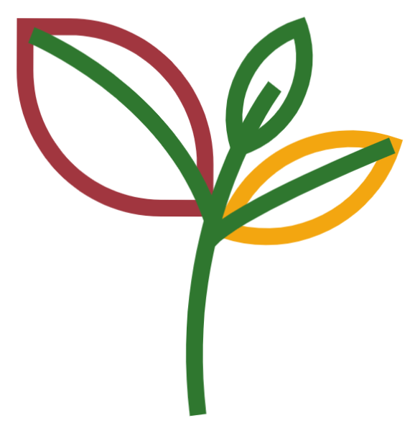

Green = 2f772f
Mustard = f3a610
Brown = a1363f



Green (Dark) = 2f772f
Green (Light) = 2c9745
Mustard = f3a610
Brown = a1363f

