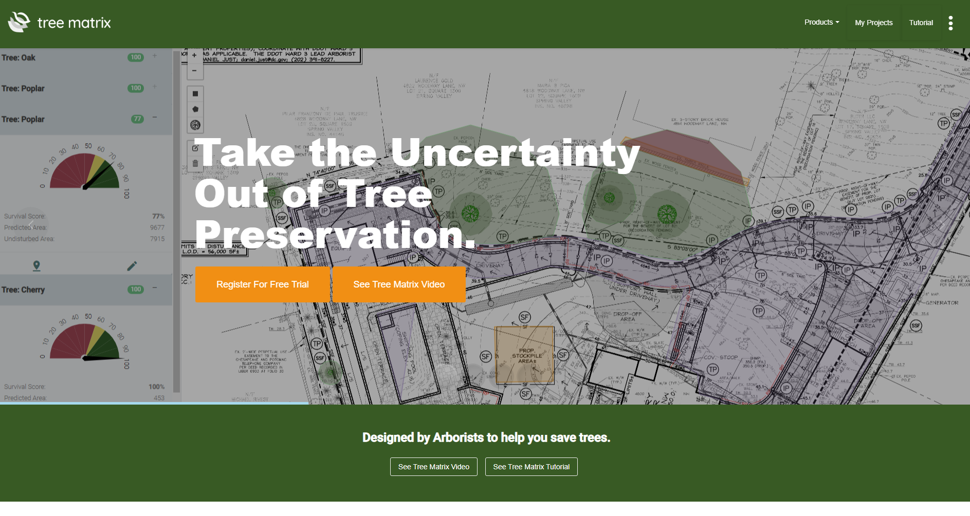

Please go to https://www.treematrix.com to see the current site.
Pages to model:

Home Page

How Tree Matrix Works
https://www.treematrix.com/how-tree-saver-works
How Plant Wizard works
https://www.treematrix.com/how-plant-wizard-works
Tree Matrix Algorithm
https://www.treematrix.com/tree-matrix-algorithm

