Project Brief:

Taco Aficionado Logo & Visual Identity

Brief Overview
Situation
- Launching a new t-shirt company and brand named Taco Aficionado
- Looking for a simple logo to act as the umbrella brand for taco themed t-shirts, hats, pillow covers, sheets, and more.
- Hoping logo will be a simple mark that includes the company name and not distract from designs and slogans

Company Description

What products/services do you offer?
- T-Shirts, hats, hoodies, tanks, posters, etc.

What’s your brand’s history?
- Previously rated Mexican Restaurants in NYC

What’s the overall message you want to convey with your business?
- Since most designs and slogans will be playful, thought the logo would be better to contrast those ideas a little. Open to alternative ideas though.

What’s your slogan?
- None currently

Project Description

Why do you need a new logo?
- Would like to print on tags, labels, t-shirts and hats

Are there are restrictions to this project?
- Not really but looking for simple one color logo preferably

What specific pieces do you need?
- Design files of logo for immediate use

In which dates do you need to receive each piece?
- When completed; Ideally in a week

Goals

What do you want to achieve with this project?
- Launch a brand and starting designing t-shirts

When do you want to achieve those results?
- Would like to ask designers for t-shirt designs in February 2021

How will you measure the results?
- Submitting more crowdsourced design projects

Audience

Who’s the target you want to reach with this project?
- Taco lovers between the ages of 8 - 90
- Likely buyers are young people

What are their demographic characteristics (gender, age, location, lifestyle, etc)?
- Male & female
- Primarily in the United States

What are your target’s needs?
- Looking to irreverent humor and passion for tacos or Mexican food

Competitors:

Who are your main competitors?
- Example: Taco Gear

How are their logos?
- Business is owned by a designer who creates all his own designs
- Logo is script and does not detract from the designs

In the past I used a logo like this:

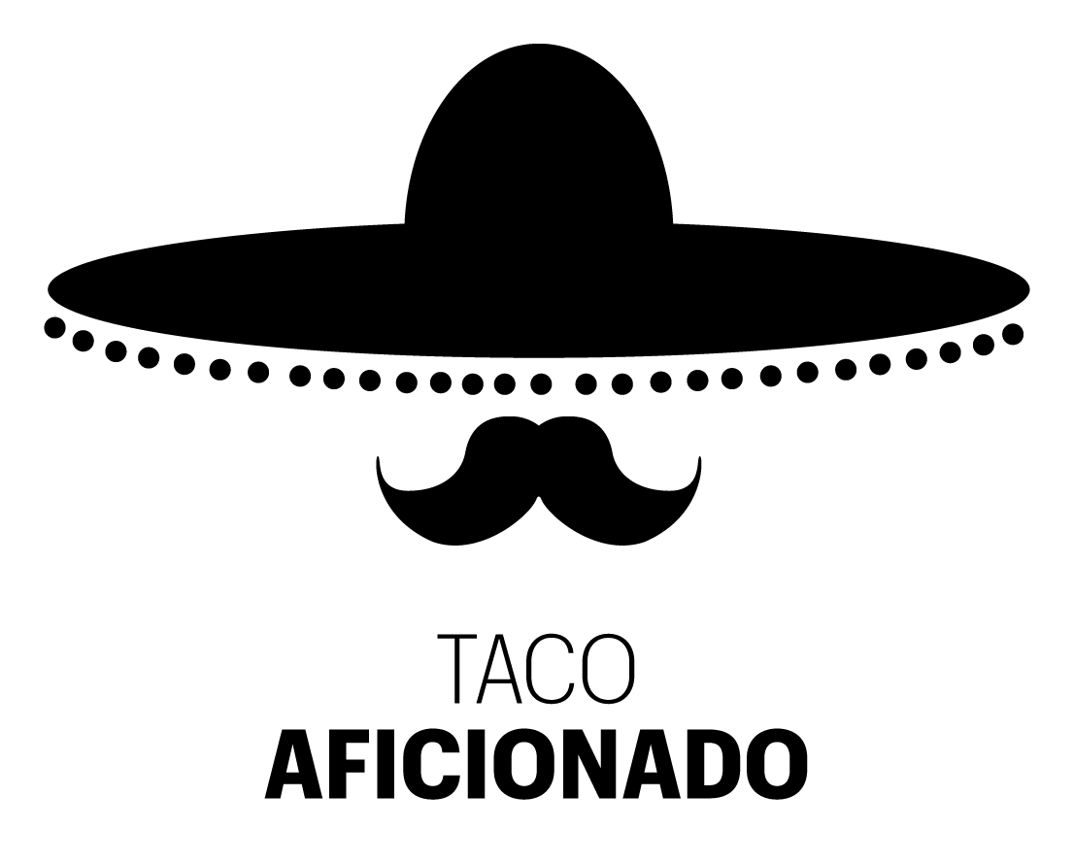

Currently using this image I found for an avatar in social media

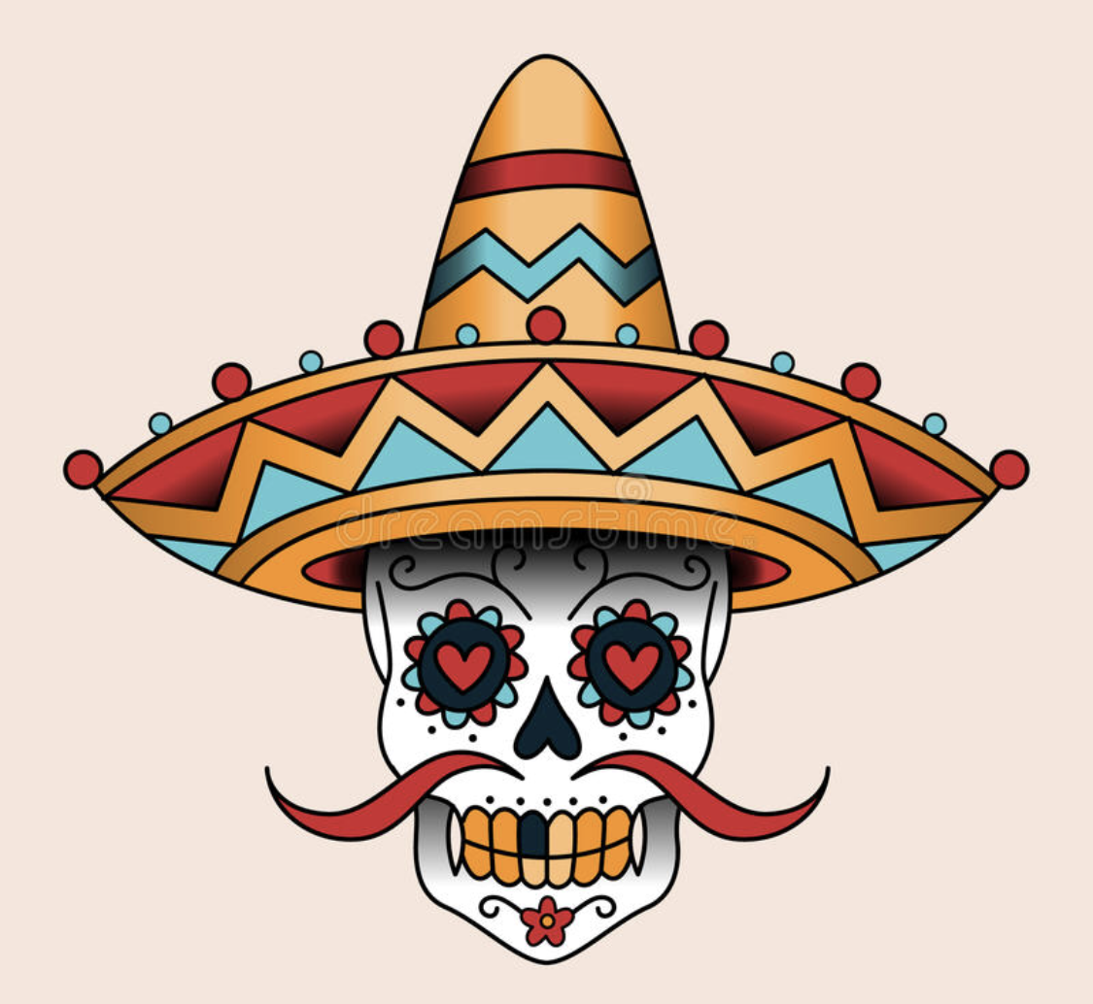
Project Details

Style
- Looking for something that looks hispanic, Mexican or latino themed
- Would like to eventually just use the mark without the name so prefer a simple logo and/or mark that can be added to the side of hats, or sleeves to promote the brand without saying the name

Color Preferences
- Looking for black and white logo
- Will need a color palette once logo is completed and open to ideas

Font Preferences
- No specific font requirements
- I think font variations of the name and mark could be fun. Thus, not locked into a single font.

Visual Examples
Sample T-Shirt (Yes, that’s me.)

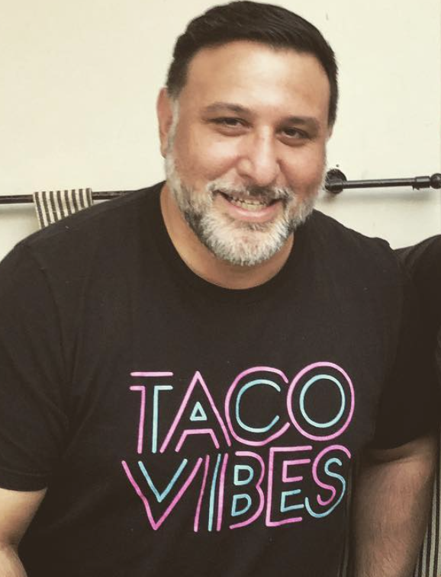

Sample Hat
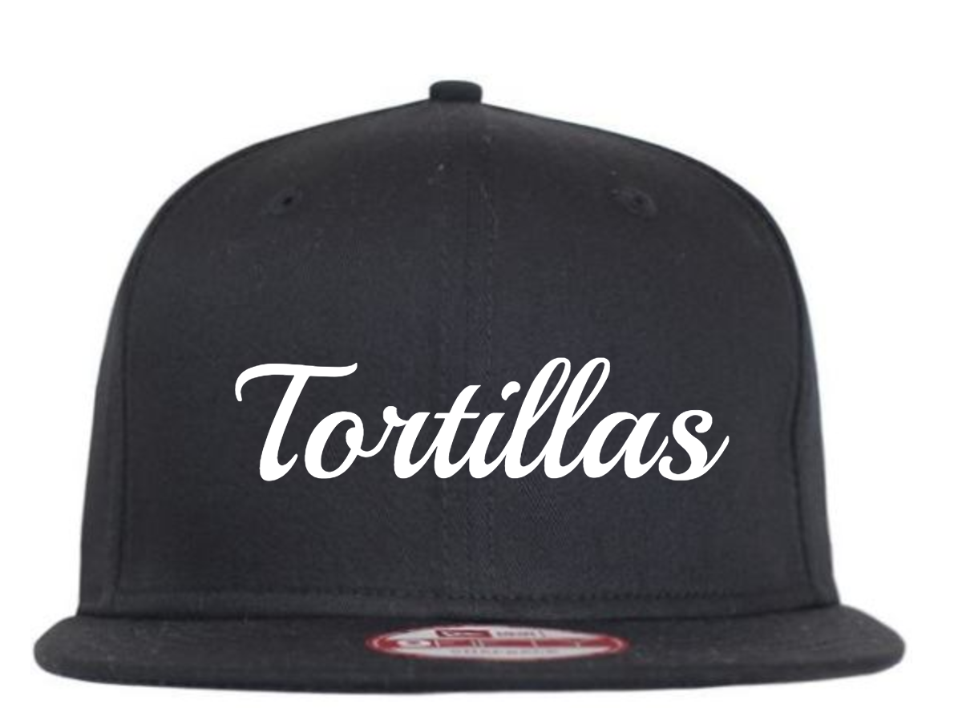

More visual inspiration

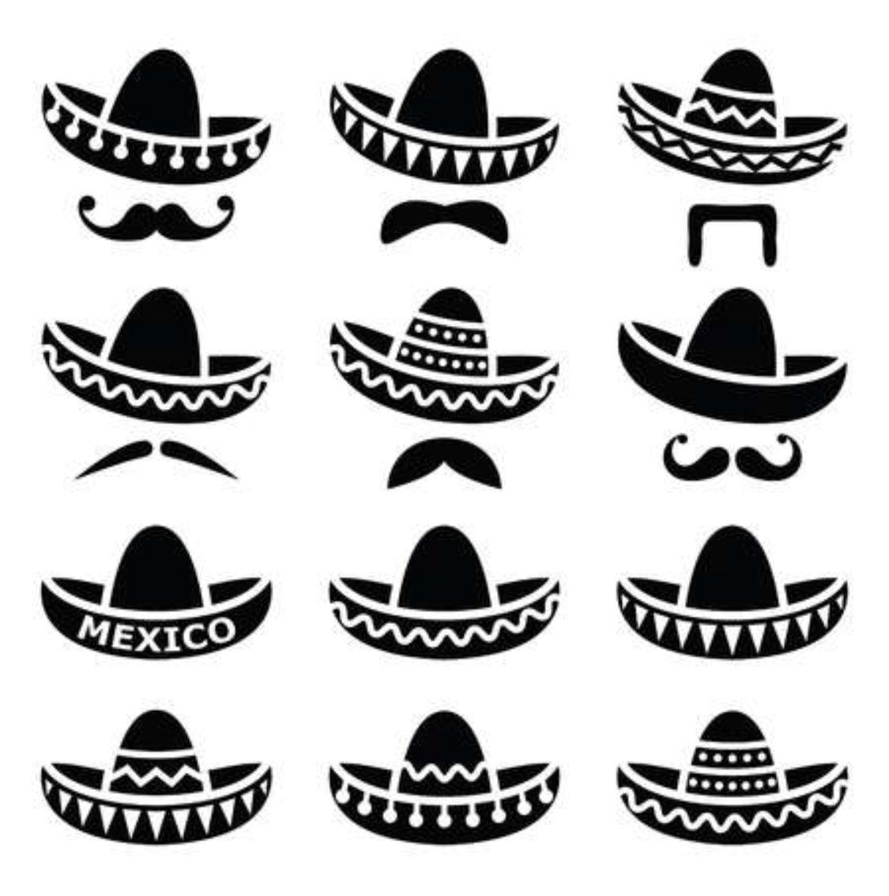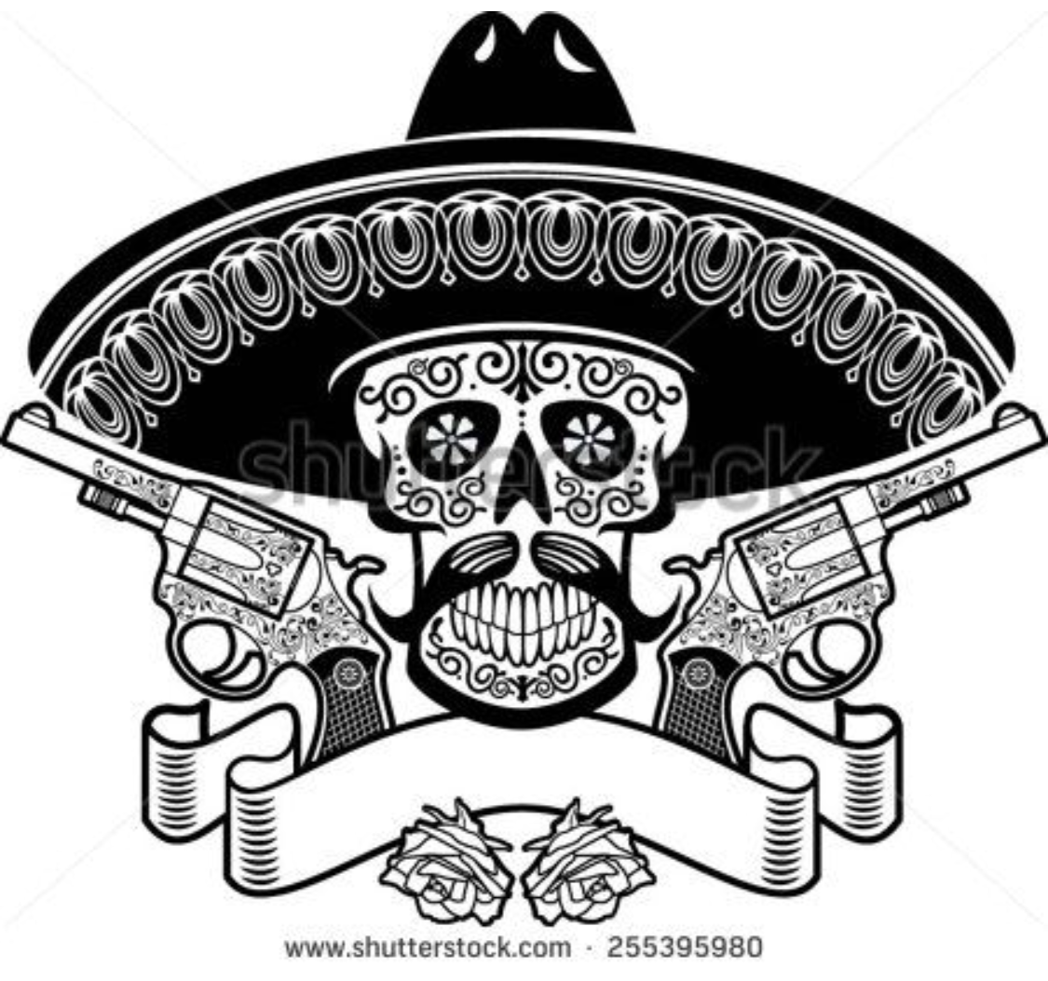

- You might be interested in these too (Muertos Tacos)
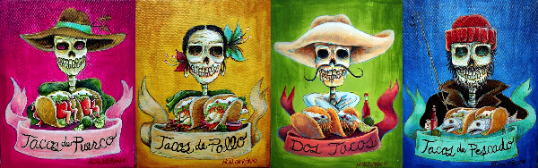

Type of (eventual) t-shirt designs

- Likely copping memes, jokes, and creating original designs
