23 November 2020

Dear,

RE:

Kindest Regards
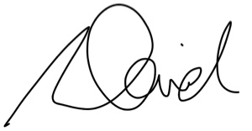
Eclipse Advisory Pty Limited
Chartered Accountants

David Robson
CEO and Founder

