Monks Bay Design Briefing

Monks Bay Consulting (MBC), is a consulting company to help organisations through business transformation, and adopt large change programmes (i.e. implementing SAP). It’s all about making sure people are onboard and will adopt the technical solution when it’s delivered. It covers areas such as Training, Communication, Stakeholder Management, Business Readiness, and understanding the business impact. Monks Bay Consulting works with large players across the global (FTSE 100, Fortune 100 etc).
I have a template of a website set up, and I like the fonts, and clean cut approach. But this is still very much in development.
https://www.monksbayconsulting.com/
The Logo and Materials is planed to be used on all my materials, website, invoices etc. And needs to portray professionalism, specialism, and reliability.
Monks Bay Consulting is named after a favourite family location on the Isle of Wight in the UK. There is a picture below of this.

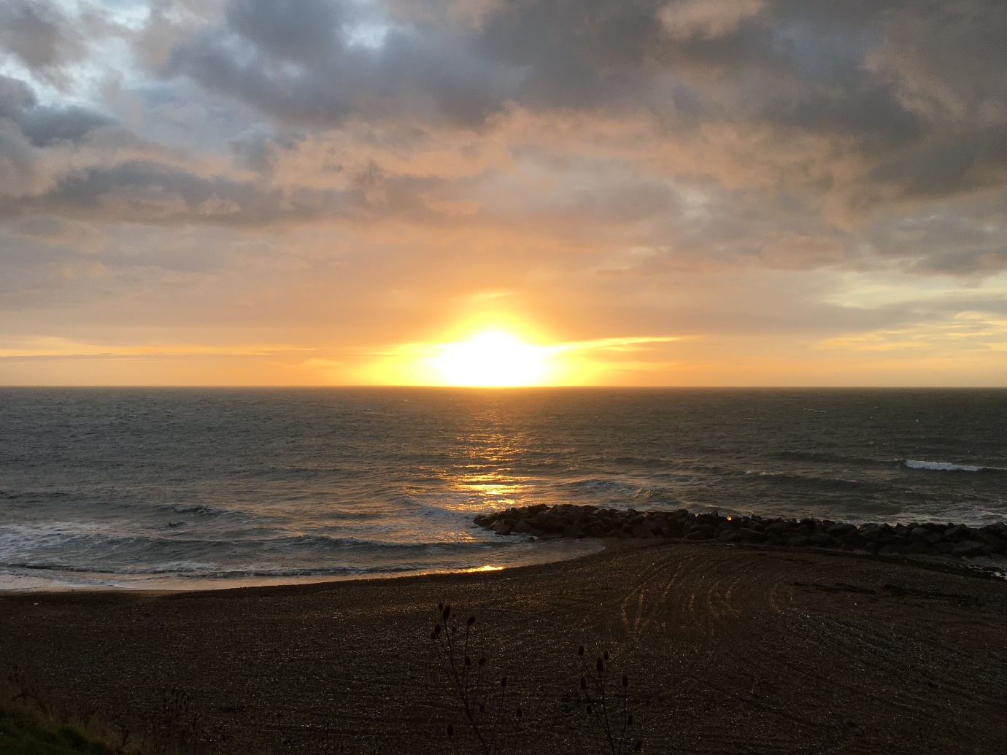

The logo and design, I would like to have professional, but if there was a way to incorporate the sea line, sun beech in the design it would be great (i.e. capture the contour lines), but also looking professional, I had tried to come up with a logo, but was unsuccessful. Examples below :



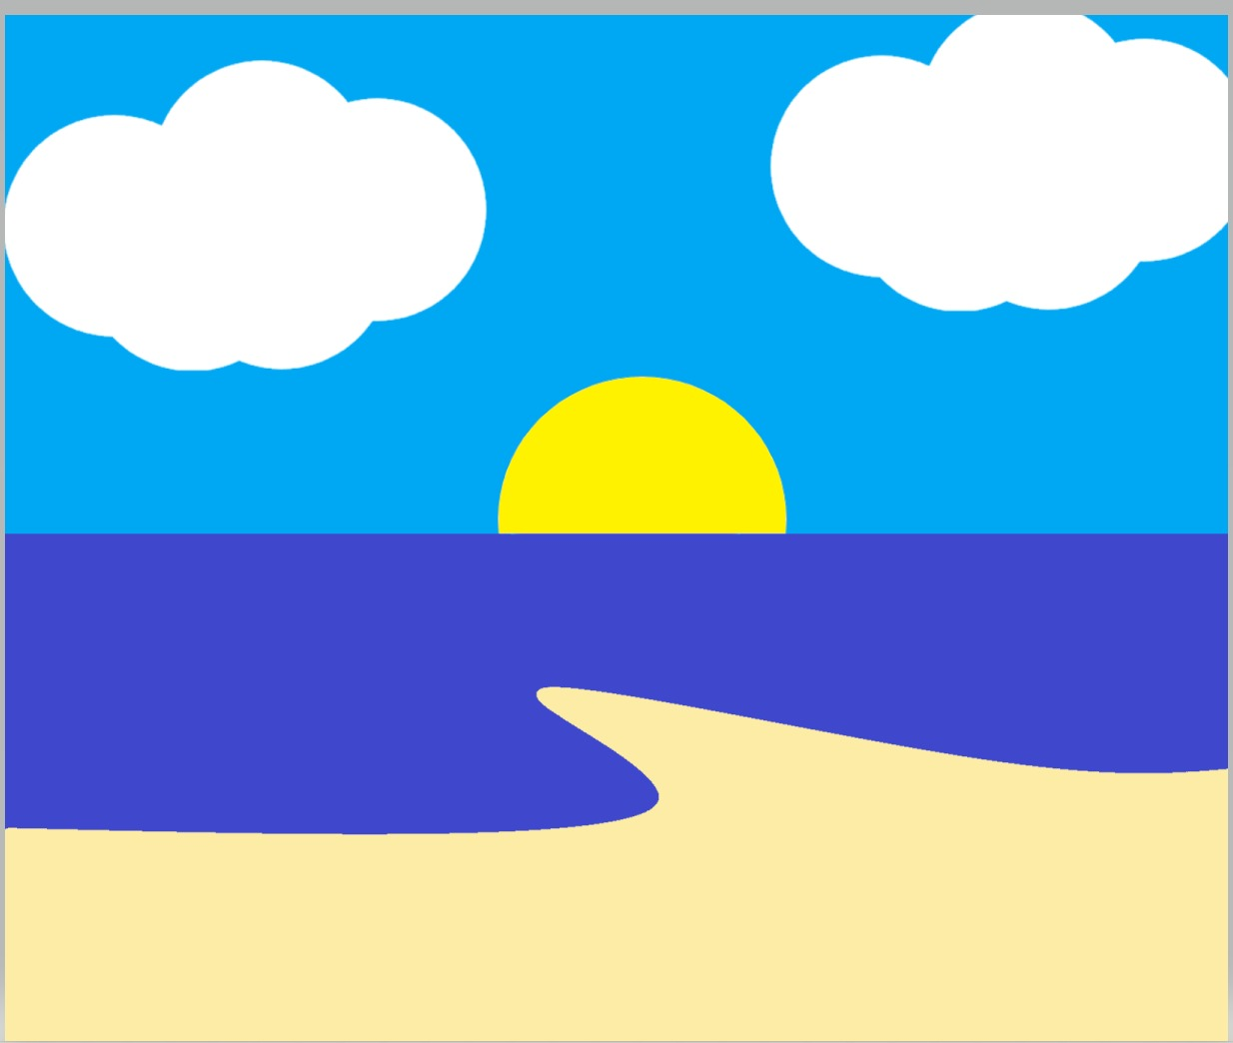

I’m basically looking for a Company Logo for Monks Bay Consulting, and also a Power Template Kit for doing standard presentations.
Also, whilst the Monks Bay is a local small area, I need the feel of the logo to reflect the tailored specialised approach we provide, yet still being able to operate a global level.

Thanks,

Damian.

