Design Brief: LC Network Logo

Project Name | Logo for International Development Org on Social Norms and Collaboration
Background | The Learning Collaborative to Advance Normative Change, (or the Learning Collaborative (LC) for short), is a network of experts working on social norms change interventions. Our members span many sectors of international development, such as health, social justice, women’s empowerment, family planning, nutrition. The uniting aspect of our work is that we address social norms (or personal or societal beliefs or attitudes about what is typical and appropriate behavior) preventing healthy behaviors.  Together, our members collaborate between organizations and individuals to develop tools, build capacity and skills, and synthesize and share knowledge. This work aims to advance understanding of social norms, and improve implementation, evaluation, and scale-up of these programs. By sharing our insights and learnings in real time we can advance global efforts to address the powerful influence of social norms.  Design Ideas:  - Materials/events produced by the LC have shared ownership by members involved, but it’s very important that the materials aren’t seen to be owned by one organization more than another. The LC logo should emphasize this collaborative process and shared ownership.  - The LC encompasses a global network, as well as regional-specific networks, such as Francophone Africa or South Asia. As such, we’d like a logo that can be customized from the global version, to be adapted to each region.  - We also use the acronym “LC”, which could be incorporated into the logo along with the full name, “Learning Collaborative to Advance Normative Change”  - We work together in a collaborative process of learning bidirectionally (meaning we all learn from each other, rather than only top-down).  - Our work is also focused on norms change (i.e. changing someone’s actions to a healthy behavior) so we also thought of the ideas of disruption or change that demonstrates this process.
Objectives | - A logo that can be customized from the global version, to be adapted to each region.  - A logo that is a combination mark (an image/icon and text)
Logo Text | The Learning Collaborative to Advance Normative Change
Target  Audience | Individuals working on research, implementation, funding and public policy around social norms interventions (globally and regionally)
Key Messages | Our core values are collaboration, connection (networking), shared decision-making and continuous learning.
Look and Feel | Modern and Classic. Youthful but Mature. Simple, clean, practical. Functional. Active, Engaging. Human. Group dynamics. Change. Ongoing process of learning/not static.

Comments on Similar Organizations

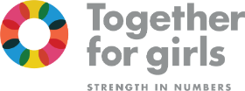 | CD- 2 - I like the bright colors and the use of overlapping space  JG - 3 - Agree!  LS - agree  DW - love the colours and the sense of collaboration
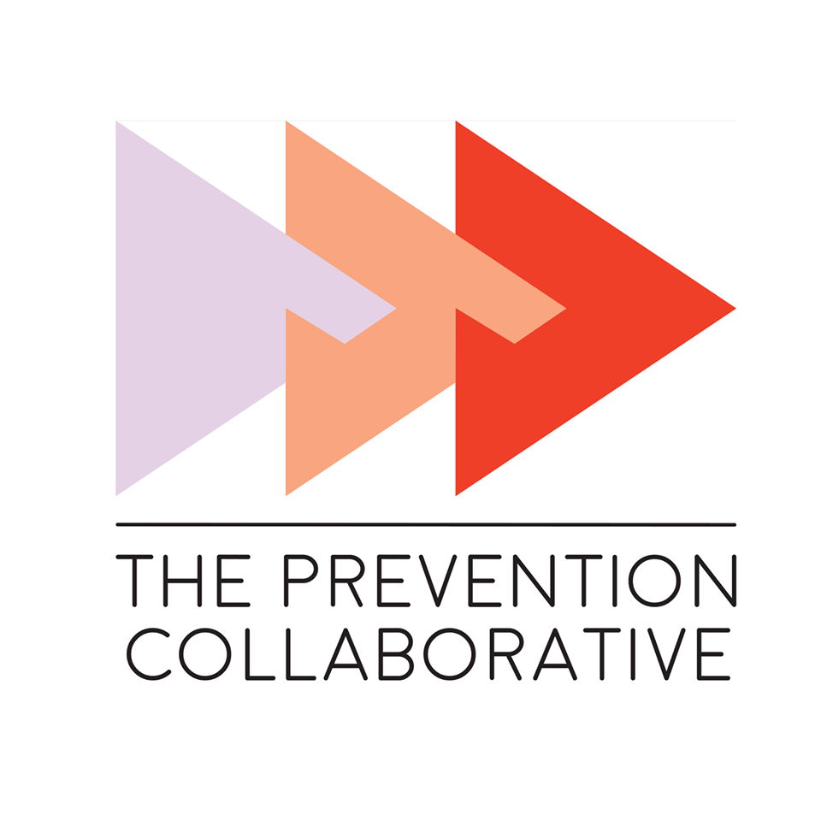 | JG - 1 - I like this, I think it shows linkages but also diversity of members/components, and shows forward momentum. It’s quite big, though, compared to the text.  LS - I like the overlapping shapes and color shades to show advancement  DW- not so keen on this one, would make a good logo for a firm of architects, though it does show linkages in a way. If we were able to show books perhaps, it does indicate our emphasis on learning.
 | JG - a note to make sure the logo we settle on is sufficiently different from this one - as a lot of the collaboration forward ones from David’s search look similar  DW - we should probably avoid this look of people holding hands. I do like it (and made one for a partner in Mozambique just like this 10 years ago) but I think it has become somewhat cliched. The inter-connectedness and collaboration is clear, but another way of showing it would be better.
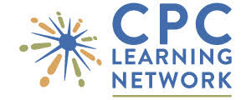 | DW- I like this one, the ‘i’ characters are presumably those people, but this time without arms. It’s a ‘hub and spoke’ effect, which is nice. Also the letters are large and clear.
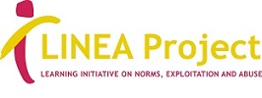 | LS- this is unique, but does not look so appealing to me. The yellow may be hard for copies.  DW - good for them for being unique, but I don’t think there is much to draw from here. The letters beneath the name are tiny, and I agree that the yellow would probably wash out in presentations.
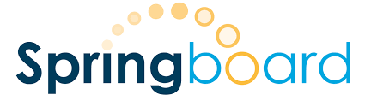 | DW - I like the sense of growth in those circles, but it’s rather plain.
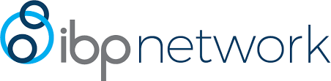 | CD - 1 - I know ibp just went through a rebranding, and I like the way they use these circles from their logo in different ways (link). I’m not sure if the circles are the most descriptive graphic element, but I like the cohesion across their brand areas.  LS- good point, Cait. Somehow circles do seem to link to norms, social networks to me.
 | JG - 2 - this logo is a little involved but I think it shows layers of collaboration and connection in a nice way  DW - unfortunately for them they have chosen a COVID molecule as their logo and I imagine they are rapidly re-branding right now! It would have been ok, though the lettering is very faint.
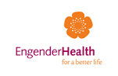 | JG - I like this logo, which is a little unusual/off the beaten path, but also has dots in the middle that I read as points of connection (maybe wrongly). I do think the way the components fit together is a little odd.  DW - Interesting - I see it quite differently. In this case I can’t get away from the word ‘flower’ and I’m not sure what that says to the typical viewer.
 | JG - I think this logo uses bright colours and it does seem to show movement, but having different-sized squares indicates a less democratic ethos to me.  DW - very bold colours, which I like, though it seems a little non-human. If I were them I might try to focus more on the women, and less on the research in their visuals.

Comments on Generic “Collaboration Logos”

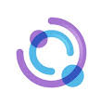 | CD- This one stood out to me. I could picture the people more in the shape of “LC” and similarly sized (rather than big and small, indicating child/parent)  DW - agreed, this is very nice, again with unusual colours. They seem to be playing on the letter ‘C’ here. I wonder if our 'L' for Learning could be portrayed as an open book, i.e. open upwards, tilted at an angle?
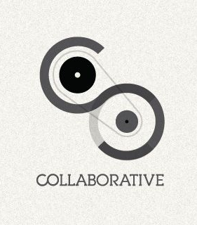 | CD- This idea stood out too. The idea of gears or connected parts that build on and move each other.  DW - also nice, though could do with some colours IMHO
 | JG: This is a small graphic/visual we used on a previous product (LC Summit Top Themes doc). I think it falls in line with a lot of our brainstorming here and could be used as inspiration.
 | We work together in a collaborative process of learning, so visually that might be a circular/repeated process of learning and growing (3D spiral, like tornado), or left to right growth.
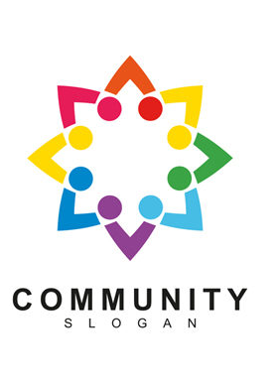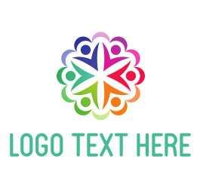 | The advantage of this type is to show people/ human element  DW - This is a nice, more modern way of showing those inter-connected people. I like it, and the colours.
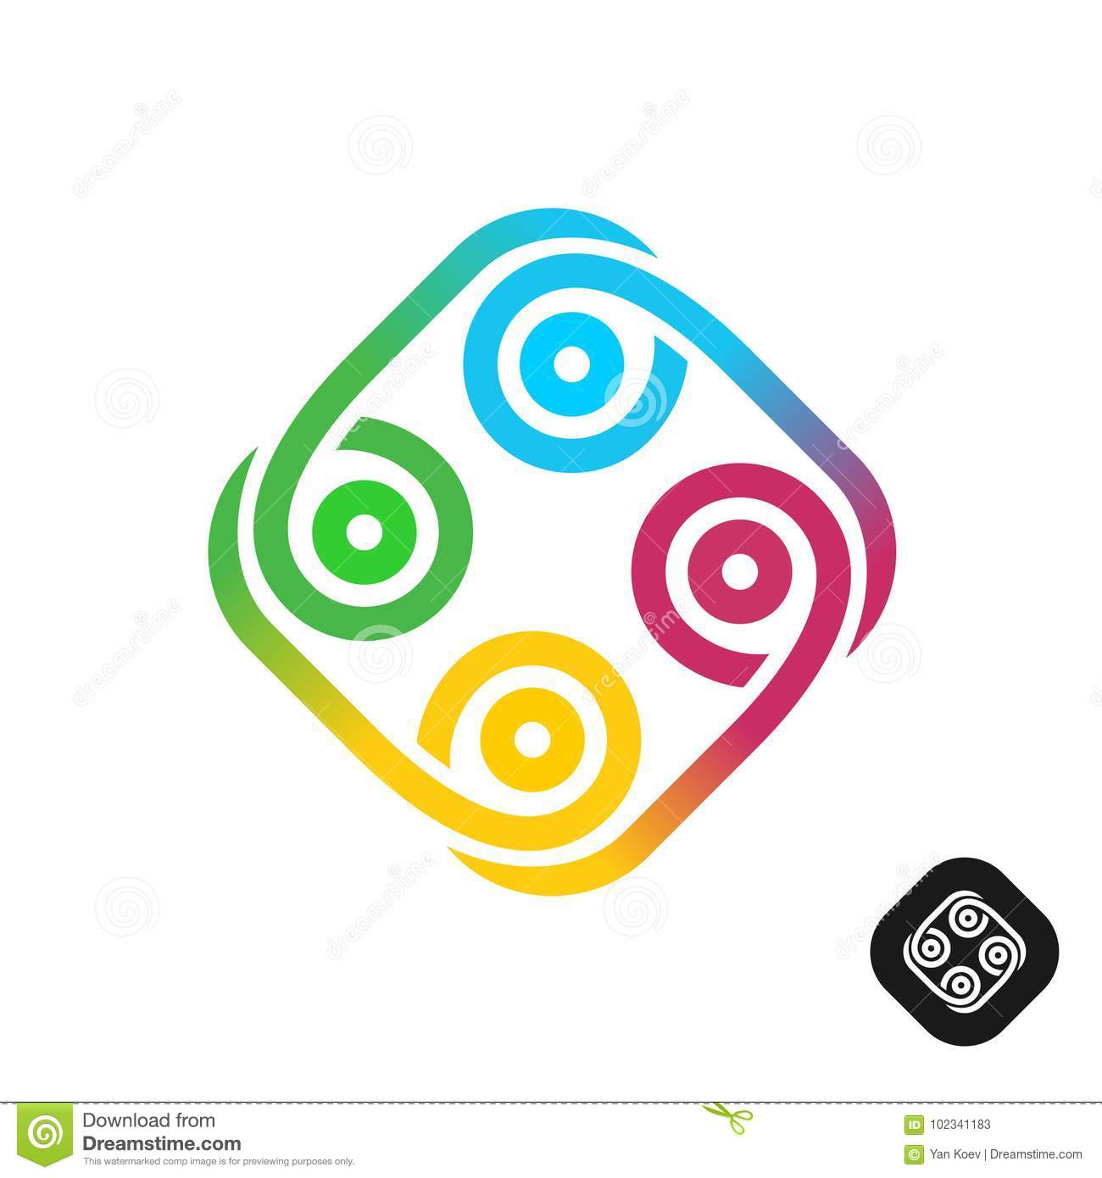 | LS - possible to reference cultural designs, as well as collaboration.  DW - interesting, like a mix of some of the others, including the one with ‘gears’. I wonder what would be made of it though.
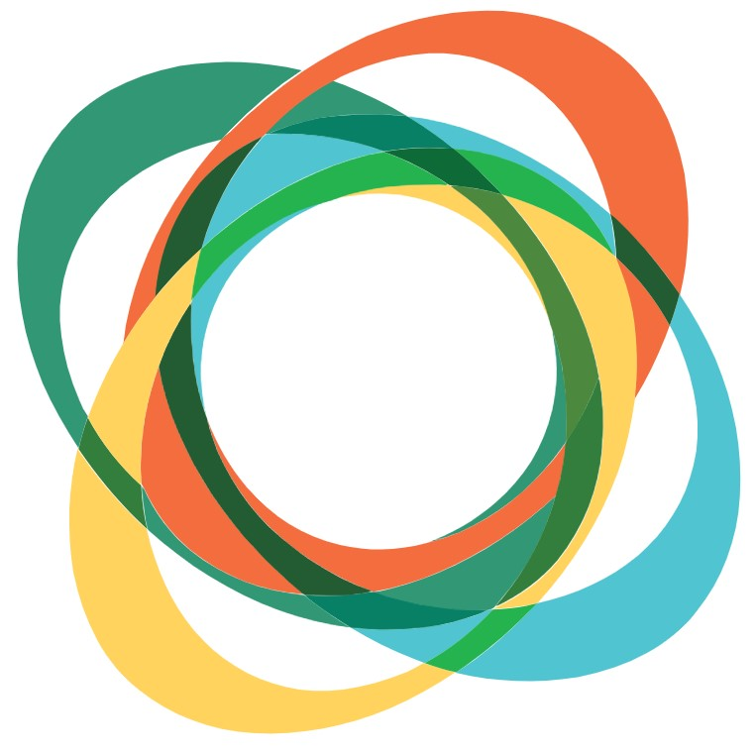 | CD- I like the variety of the thickness/shapes here and the use of overlapping space.

