Here are the 3 different scent names and their quote

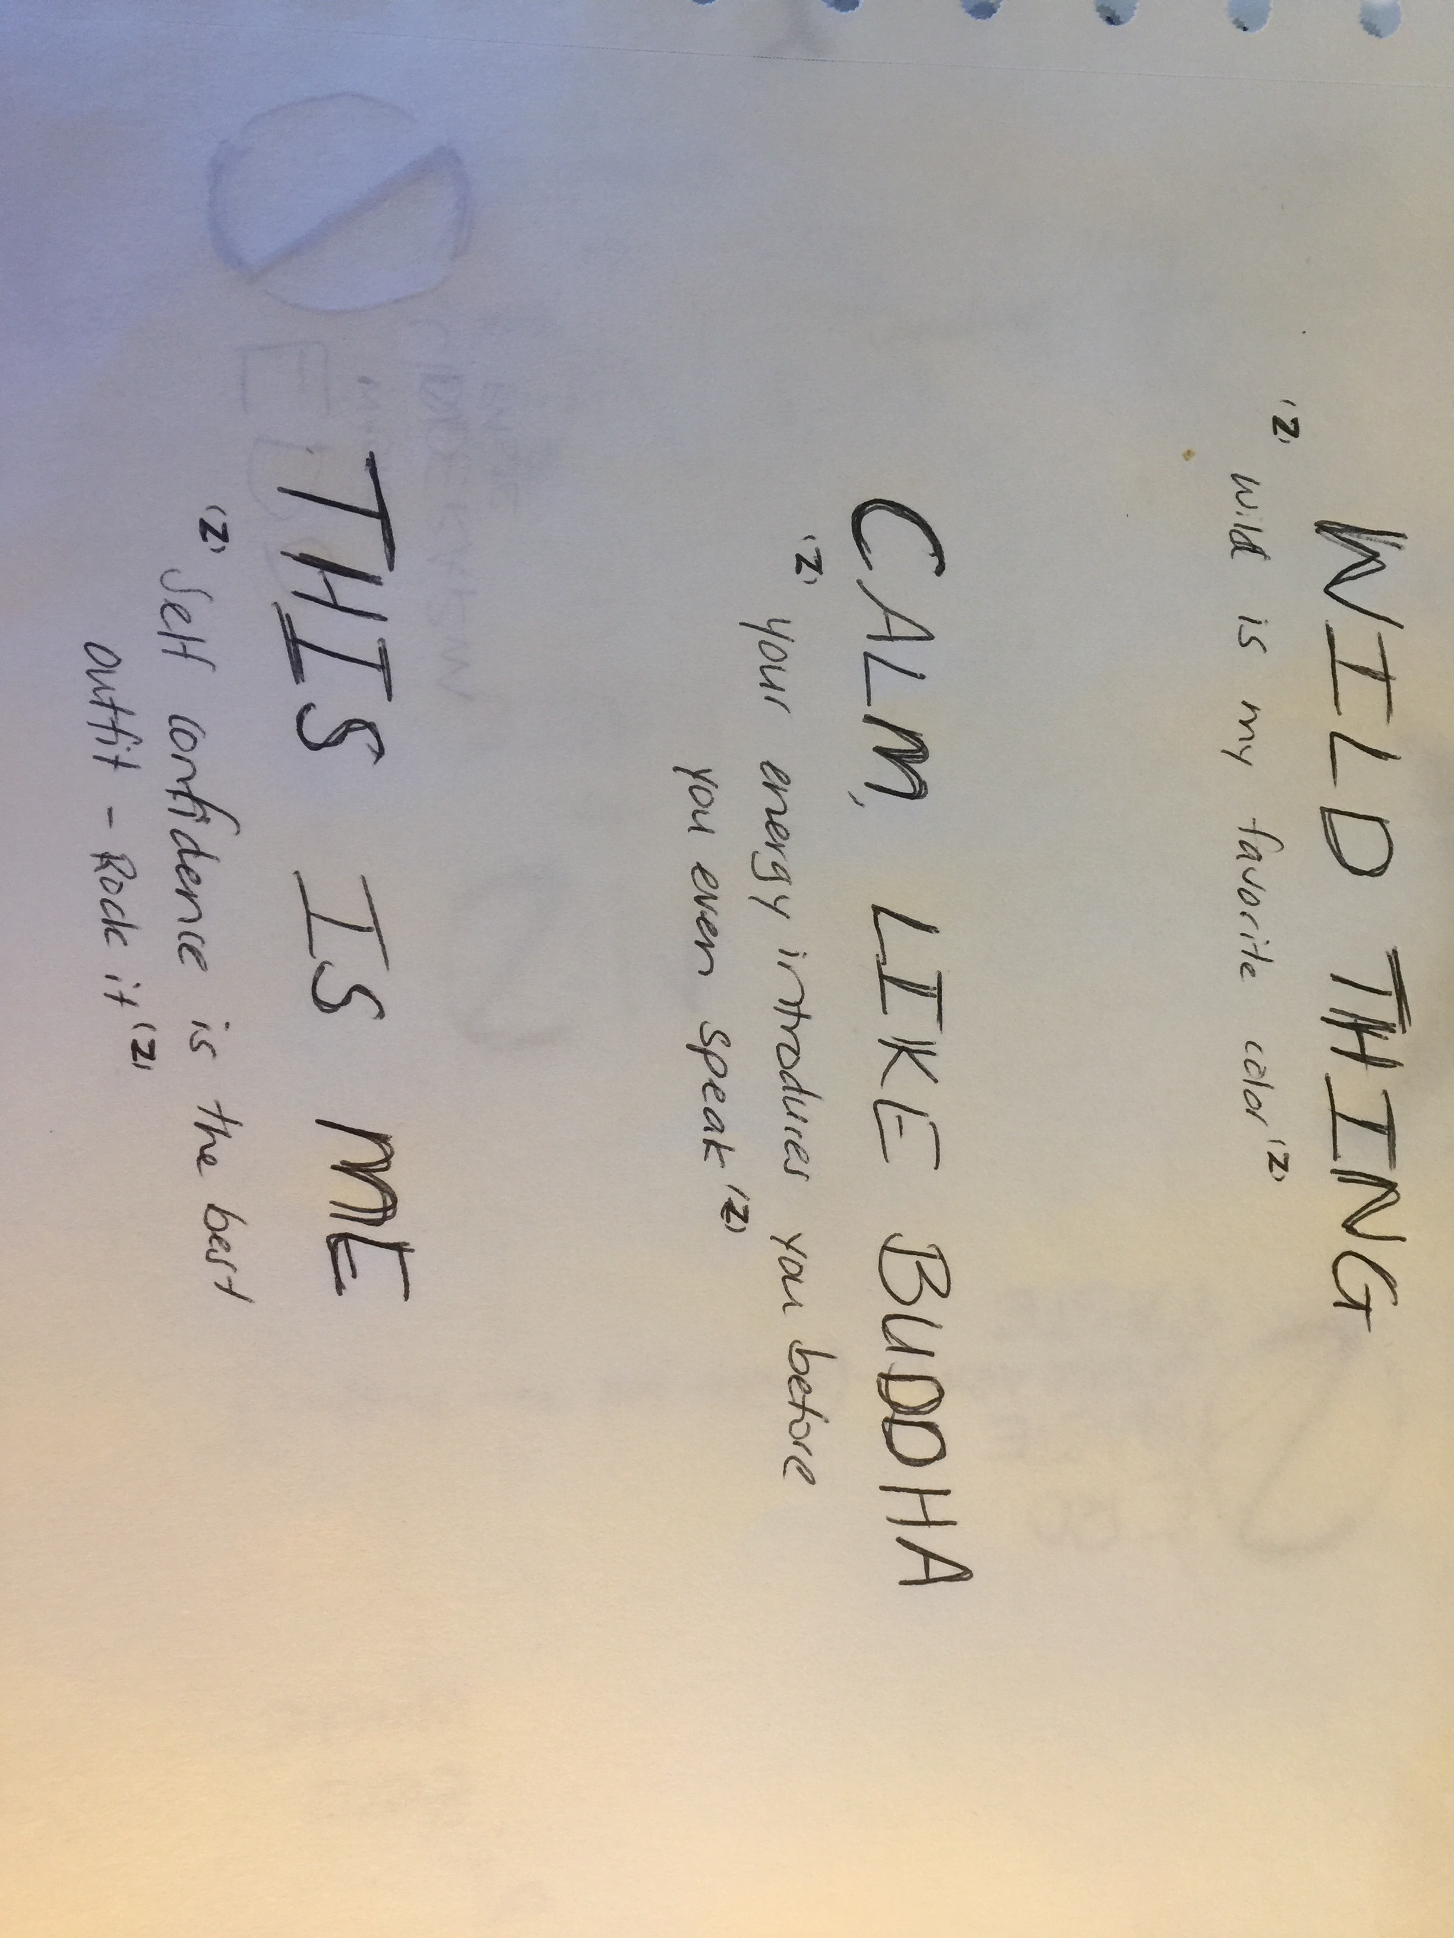
I thought we could use the emblem at quote markers (instead of “ “)

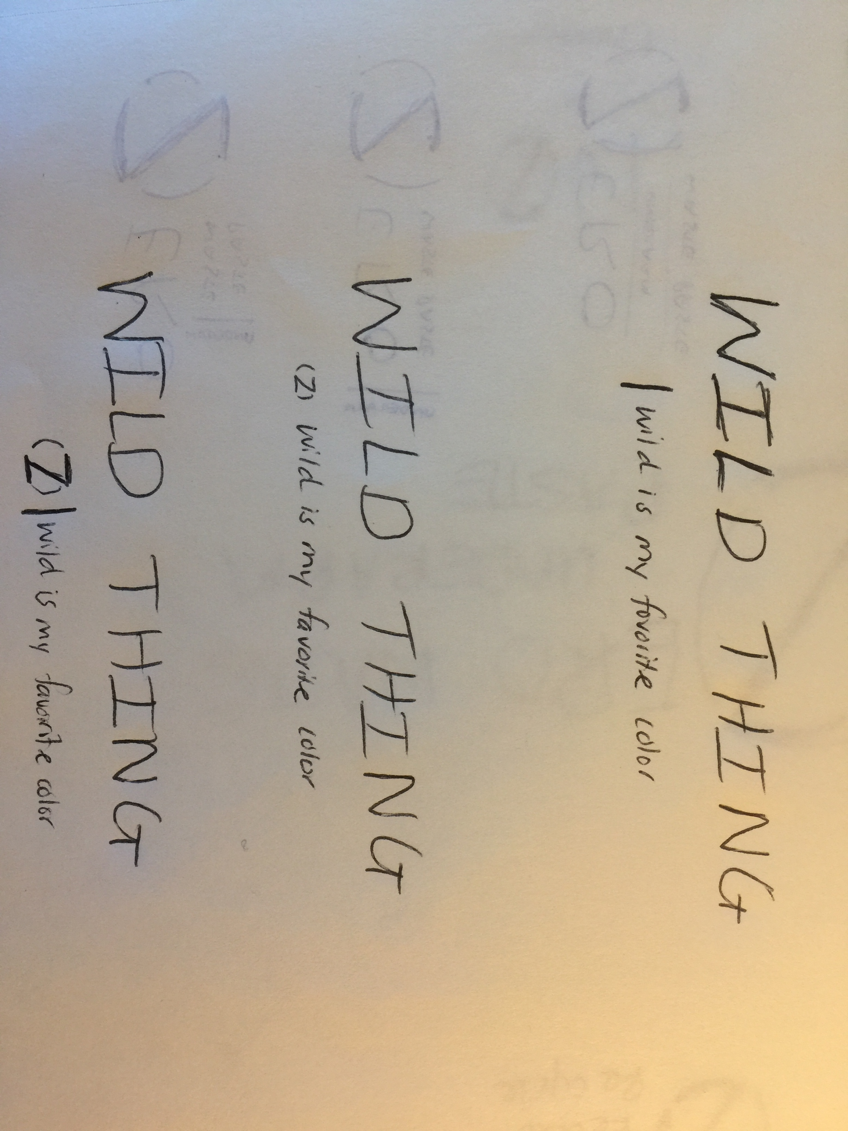
Here are some different ideas for the lay out. If you have other ideas I’d be happy to see them also.

These need to be:
- Black on transparent background and
- White on transparent background
Many thanks

