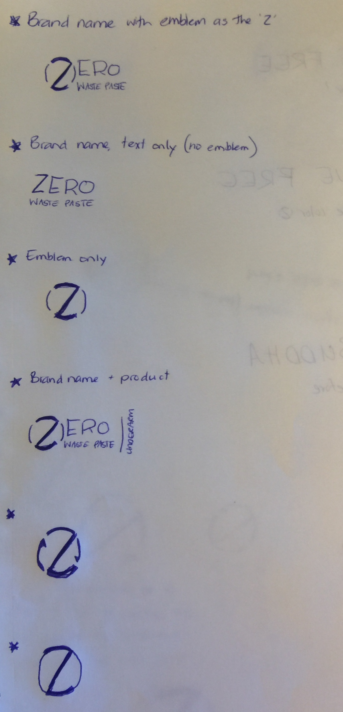
Hi LG
- If all of these can be in black, white and transparent
- Can we use the emblem with skinner lines than the Z and the font you have in design#: 26109225 But the emblem is the Z of Zero as in the first image below
I really like where this has got to! Thanks


Like this one of yours but the emblem is
The Z

Same fonts as above but no emblem

