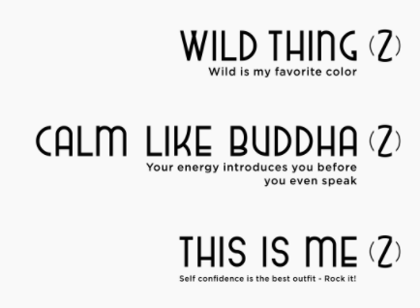

This alignment (aligned to the right)

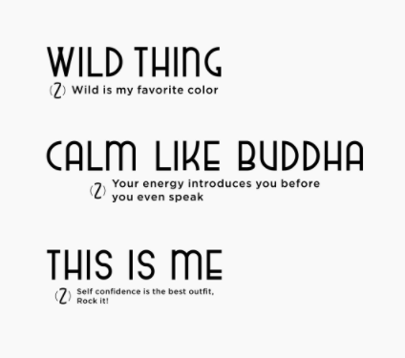

With this small emblem but on the right of the quote

I’m not sure if the size of the ‘this is me’ quote here is meant to be smaller than the others but I think they should be all the same size.

FONT
I know I said the font should be the same, but now I see it, I feel it’s ‘too much’ to busy to look at and read, and looks a bit too playful. Can we try a font that still is in theme but a bit more sophisticated for these scent names?

Can we see a couple of other font ideas?

Many thanks

