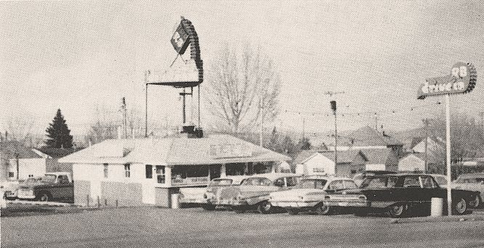
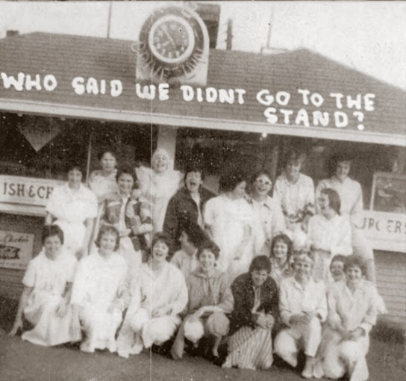
The RB Drive-in is still in business at 932 Helena Ave. (the R-B's address is also listed as 930 Helena Avenue)

Bill Higgins, Jr. of Nashville, Tennessee writes: My father opened the Root Beer Stand in about 1945. He owned the property and could get sugar during rationing. A number of High School and College kids worked there. Dad sold to Bill Staniger, a fireman and his wife, who expanded the menu. The parking lot was the end of "the drag" which went up Last Chance Gulch and back.
Bill's father, William Higgins Sr., also operated the Tower Shopping Center on 11th Ave. Many thanks to Bill for e-mailing this information.
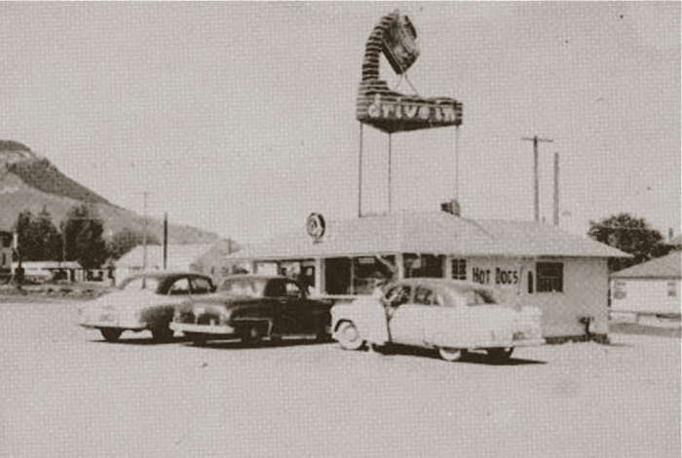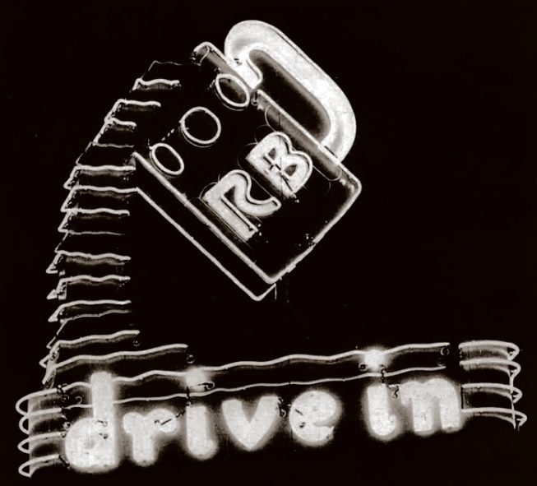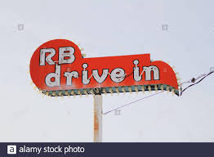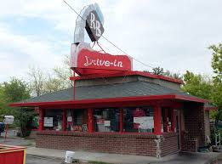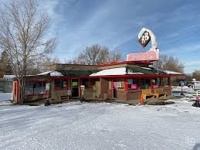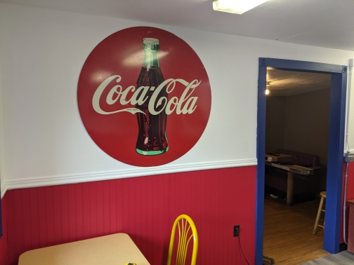
We would like to stay with the font on the neon rb drive in sign. Our colors are red white and blue. But we are also fond of red or white or blue.

