Logo Requirements, 03.01.2021

Background re my business:
- External consulting as a freelancer for IT, organizational changes and strategy projects for banking and real estate companies
- Transformation projects cover implementation of new IT systems, implementation of new processes, digitalization, automation and efficiency gains or cost reduction to make companies fit for the future

Logo Text:
- Dr. Alexander Upitz
- Consulting
- Initials are optional: AU

Colours:
- Must have: #36648B (maybe just an accent)
- Optional:
  - #2A2A2A
  - #E4E4E4
  - Black
  - White

Orientation:
- horizontal

Dependencies:
- look & feel needs to fit my website
- logo will be added to the header
- www.alexander-upitz.de

Messages which my logo should represent:
- Key message: Transformation, Change, Fit for Future, Project (delivery)
- Optional: Success, Performance, aim-oriented, Structure, Dynamic, Digitalisation, Strength

Some logo examples that I ike:
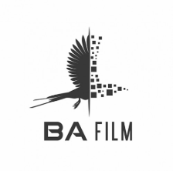
Very good example for change/transformation/digitalisation etc.

