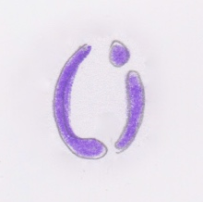

I like that it’s a small ‘l’ and ‘i’ in a circle



I like the font and the color purple

