Book Title

"Eat. Move. Improve. A Practical Nutrition, Motivation to Move, and Mindset Guide Creating Momentum Toward Improved Health and Wellness"

Book Summary
Believe in you. Trust in You. Eat. Move. Improve. is a book committed to you. Behavior change and improved health can be challenging. You must feel empowered to make decisions and changes create momentum in the right direction. But, you may not always have the knowledge to do that. This book provides you with practical and fun tools and tips to improve your nutrition, motivation to move, and mindset. You are awesome. You are beautiful. You have the power to control your destiny and future. All you have to do is Eat, Move, and Improve!

About the Author

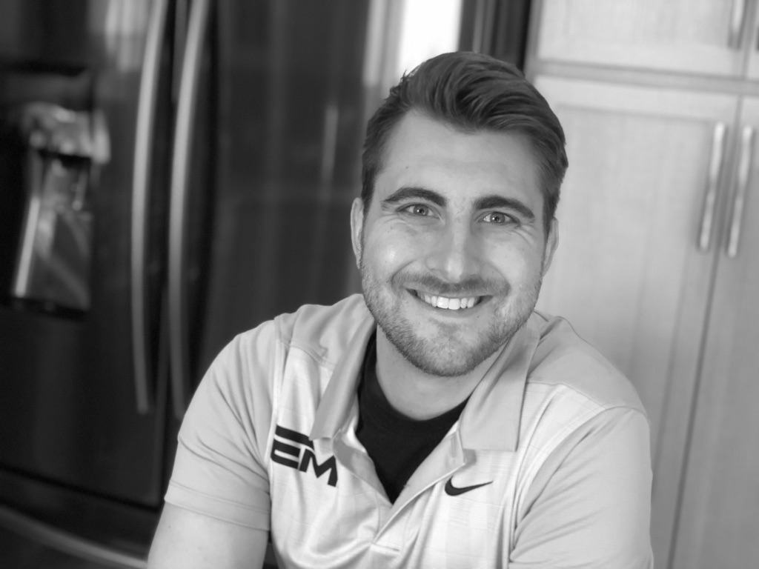

Anthony DiMarino is a Registered Dietitian and Certified Personal Trainer from Cleveland, OH. He graduated from the Ohio State University and currently works as a health coach in the healthcare industry. His passions are fitness, nutrition, science, and motivation. He has extensive knowledge and experience in wellness, healthcare, and disease treatment and disease. Anthony has worked with hundreds of people through counseling, consulting, and coaching in an effort to make a difference in their long-term health. In his spare time, he enjoys exercising, watching movies, and trying out new foods.

