INTRePID website brief
1) Home Page

INTRePID
INTernational ConsoRtium of Primary Care BIg Data Researchers

The logo

Interactive map of the world highlighting Canada, Australia, China (including Hong Kong), Norway, Singapore, South Korea, Sweden, United Kingdom, United States

Map would have the following highlights
-Canada highlight Toronto so can click on it and it would bring you to the Canada page
-Australia highlight Melbourne so can click on it and it would bring you to the Australia page
-China highlight Shenzen so can click on it and it would bring you to the China page
-Norway highlight Bergen and Oslo so can click on these cities and would bring you to the Norway page
-Singapore highlight Singapore so can click on it and it would bring you to the Singapore page
-South Korea highlight Seoul …
-Sweden highlight Uppsala…
-United Kingdom highlight Oxford
-United States highlight Denver…

Home page would ideally depict primary care/family medicine and big data research and international
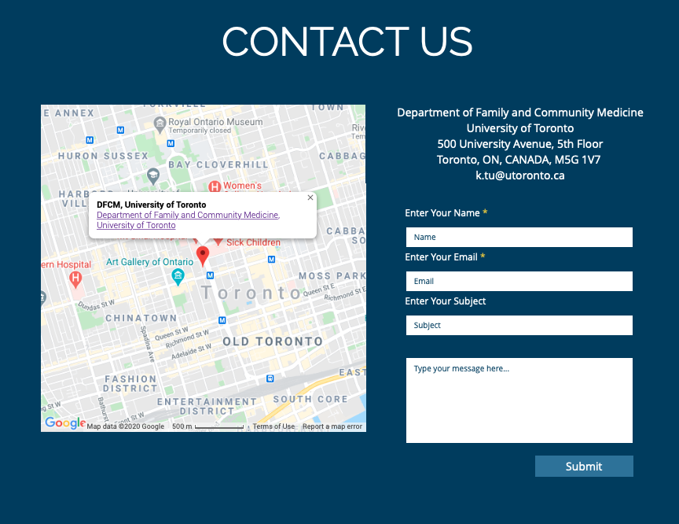

Example Home Page

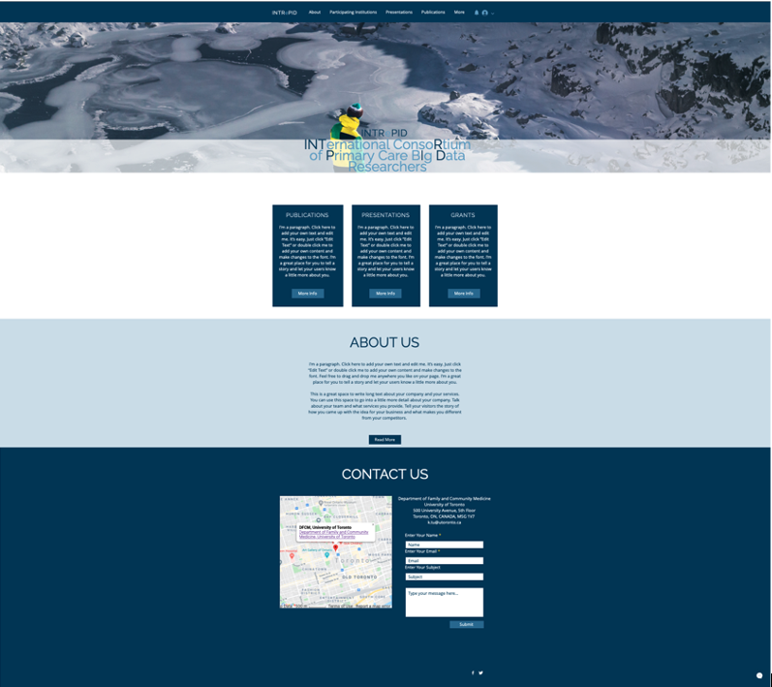

2) About us
We are family physicians and primary care researchers from 9 different countries around the world. We have access to electronic medical record data and/or health insurance claims data in our respective countries. We intend to perform international comparative studies in primary care. Our first project is to study the impact of the COVID-19 pandemic on primary care in our respective countries and around the world.

International Investigator Leads

Canada
 Karen Tu-Founder
Professor Department of Family and Community Medicine | Temerty Faculty of Medicine | University of Toronto
Research Scientist | North York General Hospital
Associate Director UTOPIAN Data Safe Haven
Family Physician | Toronto Western Hospital Family Health Team
Email: k.tu@utoronto.ca
https://www.dfcm.utoronto.ca/content/karen-tu

Australia

 Jo-Anne Manski-Nankervis
Associate Professor | Department of General Practice | University of Melbourne
Chair | RACGP Expert Committee – Research
Chief Investigator | Centre of Research Excellence
Email: jomn@unimelb.edu.au
https://findanexpert.unimelb.edu.au/profile/139216-jo-anne-manski-nankervis

 Christine Hallinan
Data Science and Statistics Lead | Department of General Practice | University of Melbourne
Research Fellow | Australian Centre for Cannabinoid Clinical and Research Excellence (ACRE)
Email: hallinan@unimelb.edu.au
https://findanexpert.unimelb.edu.au/profile/421256-christine-hallinan

China

 William CW Wong
Clinical Associate Professor & Chief of Research | Professor Department of Family Medicine and Primary Care | The University of Hong Kong
Honorary Consultant | Department of Family Medicine & Primary Healthcare | Hong Kong West Cluster
Chief of Service | Department of General Practice | HKU-Shenzhen Hospital
Email: wongwcw@hku.hk
https://www.fmpc.hku.hk/en/Our-Team/Academic-Academic-related-and-Medical-Staff/Dr-William-Chi-Wai-WONG/Dr-William-Chi-Wai-WONG

Norway
 Signe A Flottorp
Research Director | Norwegian Institute of Public Health
Researcher Department of General Practice | Institute of Health and Society |University of Oslo
Email: Signe.Flottorp@fhi.no
https://www.fhi.no/en/about/departments-and-centres/reviews-and-health-technology-assessments/signe-agnes-flottorp/
 Kjetil E Telle
Director Health Services Research | Norwegian Institute of Public Health (NIPH)
Adjunct Professor | University of Stavanger
Email: KjetilElias.Telle@fhi.no
https://www.fhi.no/en/about/departments-and-centres/management-and-staff-for-health-services/kjetil-elias-telle/
 Knut-Arne Wensaas
Associate Professor | Department of Global Public Health and Primary Care | University of Bergen
Email: knew@norceresearch.no
https://www.uib.no/en/persons/Knut-Arne.Wensaas

Singapore
 Lay Hoon Goh
Senior Consultant | Department of Family Medicine | National University Health System
Assistant Professor | Division of Family Medicine | National University of Singapore
Head & Senior Consultant – Well Programme | Alexandra Hospital
Senior Consultant | National University Polyclinics
Email: lay_hoon_goh@nuhs.edu.sg
https://www.nuhs.edu.sg/family-medicine/Documents/Dr%20Goh%20Lay%20Hoon_profile%20%28u%29.pdf
 Jye Ling Zheng
Medical Informatics Assistant Director | National University Health System (Singapore)
Email: zheng_jye_ling@nuhs.edu.sg
https://www.nuhs.edu.sg/family-medicine/Documents/Dr%20Ling%20Zheng%20Jye_profile.pdf

South Korea
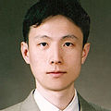 Jae-Hyun Park
Professor | Department of Social and Preventative Medicine | Sungkyunkwan University School of Medicine
Email: pjaehyun@skku.edu
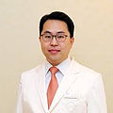 Dong Wook Shin
Associate Professor | Department of Family Medicine | Samsung Medical Center | Sungkyunkwan University School of Medicine
Department of clinical research design and evaluation | SAIHST | Sungkyunkwan University
Department of digital health | SAIHST | Sungkyunkwan University
Email: dwshin.md@gmail.com
https://www.samsunghospital.com/gb/language/m_english/common/doctorProfile.do?dr_no=2207

Sweden
Robert S Kristiansson
Chief Medical Officer | Region Uppsala
PhD Student | Department of Public Health and Caring Sciences | Uppsala University
Email: rokr@icloud.com
https://katalog.uu.se/profile/?id=N4-1324

United Kingdom
Simon de Lusignan
Professor | Nuffield Department of Primary Care Health Sciences | University of Oxford
Vice Chancellor’s Fellow | Faculty of Health and Medical Sciences | University of Surrey
Director | Royal College of General Practitioners Research and Surveillance Centre
Email: simon.delusignan@phc.ox.ac.uk
https://www.phc.ox.ac.uk/team/simon-de-lusignan

United States
Wilson D Pace
Chief Medical Officer | DARTNet Institute
Professor Department of Family Medicine | University of Colorado
Director | American Academy of Family Physicians National Research Network
Email: wilson.pace@dartnet.info
https://isrn.net/about/experts/wilsonpace

Example lead investigator webpage:

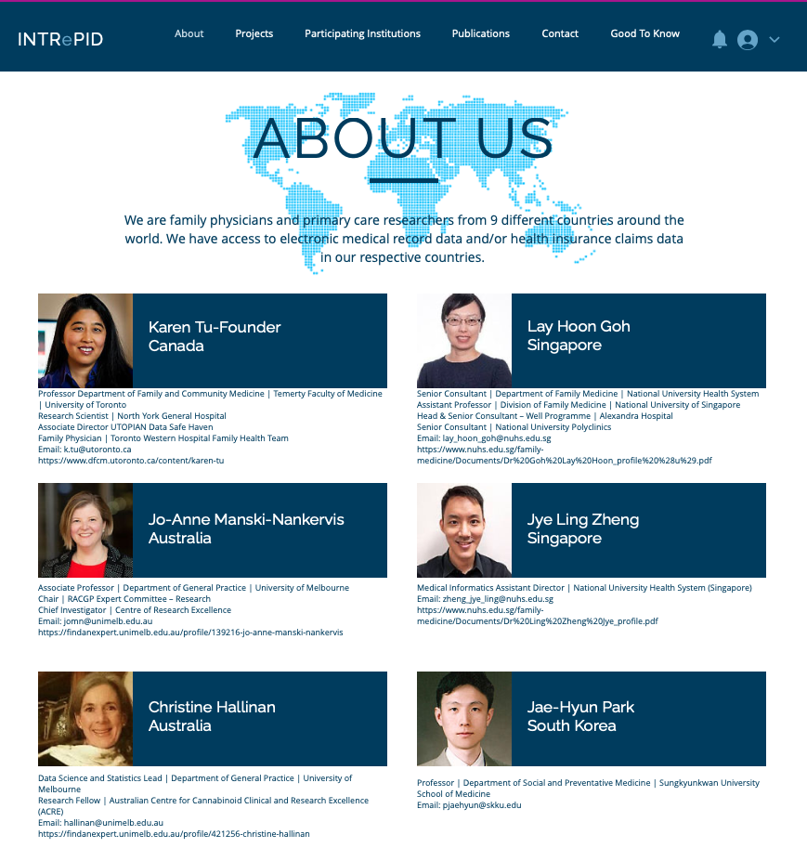
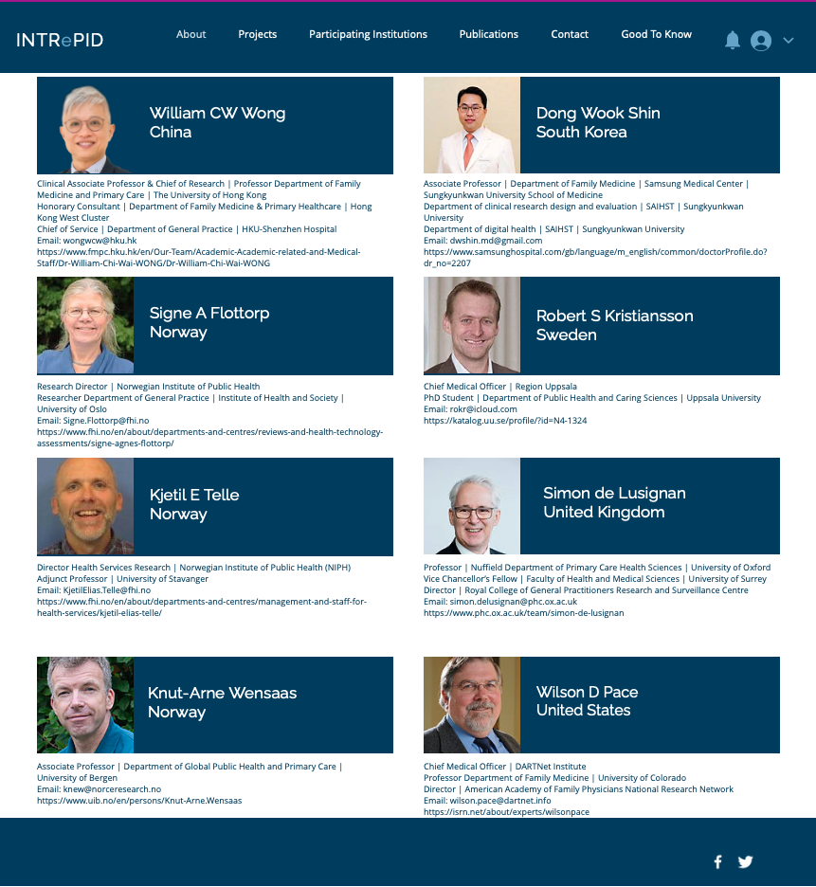
3} INTRePID co-investigator webpage with country specific sections
Each country will have it’s own section on the webpage, ideally from clicking on the country name on the lead investigator page can automatically bring you to the country specific section of the co-investigator webpage
Canada-INTRePID investigators
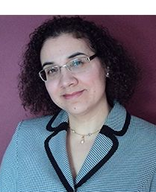 Debra Butt
Associate Professor Department of Family and Community Medicine | Temerty Faculty of Medicine | University of Toronto
Family Physician | Scarborough General Hospital
Email: debra.butt@sympatico.ca
https://www.dfcm.utoronto.ca/content/debra-butt
 Noah Crampton
Lecturer | Department of Family and Community Medicine | Temerty Faculty of Medicine | University of Toronto
Family Physician | Toronto Western Hospital Family Health Team
Email: noah.crampton@uhn.ca
https://www.dfcm.utoronto.ca/content/noah-crampton
Michelle Greiver
Associate Professor | Department of Family and Community Medicine | Temerty Faculty of Medicine | University of Toronto
Gordon F. Cheesbrough Chair in Family and Community Medicine, North York General Hospital
Director | University of Toronto Practice-Based Research Network (UTOPIAN)
Lead - Digital Health for Research and Care, Diabetes Action Canada
Adjunct Scientist, ICES
Email: michelle.greiver@nygh.on.ca
https://www.dfcm.utoronto.ca/content/michelle-greiver
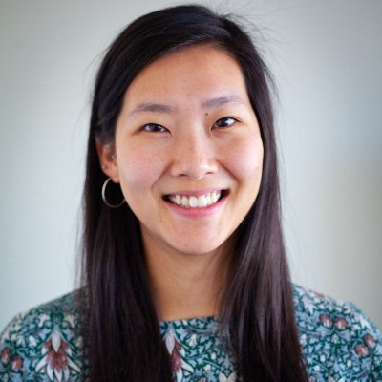 Catherine Ji
Lecturer | Department of Family and Community Medicine | Temerty Faculty of Medicine | University of Toronto
Family Physician | Toronto Western Hospital Family Health Team
Email: catherine.ji@uhn.ca

Tezeta Mitiku
Psychiatrist | University of Ottawa
Email: tezeta.mitiku@gmail.com
https://hopitalmontfort.com/en/mitiku
 Braeden O’Neill
Associate Professor | Department of Family and Community Medicine | Temerty Faculty of Medicine | University of Toronto
Family Physician | Unity Health Toronto
Email: braden.oneill@gmail.com
https://www.dfcm.utoronto.ca/content/braden-oneill
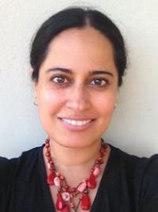 Sumeet Sodhi
Lecturer | Department of Family and Community Medicine | Temerty Faculty of Medicine | University of Toronto
Family Physician | Toronto Western Hospital Family Health Team
Email: Sumeet.Sodhi@uhn.ca

Ellen Stephenson
Post Doctoral Fellow | Department of Family and Community Medicine | Temerty Faculty of Medicine | University of Toronto
Email: ellen.stephenson@utoronto.ca

Sumeet Kalia
UTOPIAN Analyst | Department of Family and Community Medicine | Temerty Faculty of Medicine | University of Toronto
Email: sumeet.kalia@nygh.on.ca

Chris Meaney
Biostatistician | Department of Family and Community Medicine | Temerty Faculty of Medicine | University of Toronto
Email: Christopher.Meaney@utoronto.ca

China--INTRePID investigators
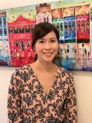 Amy Ng
Clinical Associate | Department of Family Medicine and Primary Care | University of Hong Kong Shen Zhen
Email: amyppng@hku.hk
https://www.fmpc.hku.hk/en/Our-Team/Academic-Academic-related-and-Medical-Staff/Dr-Amy-Pui-Pui-Ng/Dr-Amy-Pui-Pui-NG

Lucy Li
Resident | Department of Family Medicine and Primary Care | University of Hong Kong
Email: liz@hku-szh.org

Norway-INTRePID investigators
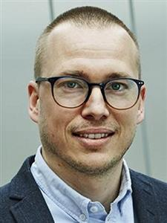 Jonas Minet Kinge
Senior Researcher-Health Economics | Department Centre for Fertility and Health | Norwegian Institute of Public Health
Email: JonasMinet.Kinge@fhi.no
https://www.fhi.no/en/more/research-centres/Centre-for-fertility-and-health/employees/jonas-minet-kinge/
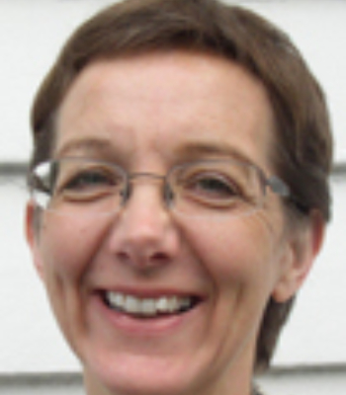 Tone Morken
Research Professor | NORCE
Email:tomo@norceresearch.no
https://www.norceresearch.no/en/persons/tone-morken
 Valborg Baste
University of Bergen
Email: Valborg.Baste@uib.no
https://www.uib.no/en/persons/Valborg.Baste

Sweden-INTRePID investigators
Björn Wettermark
Professor | Department of Pharmacy | Uppsala Universitet
Email: bjorn.wettermark@farmaci.uu.se
https://katalog.uu.se/profile/?id=N19-2675
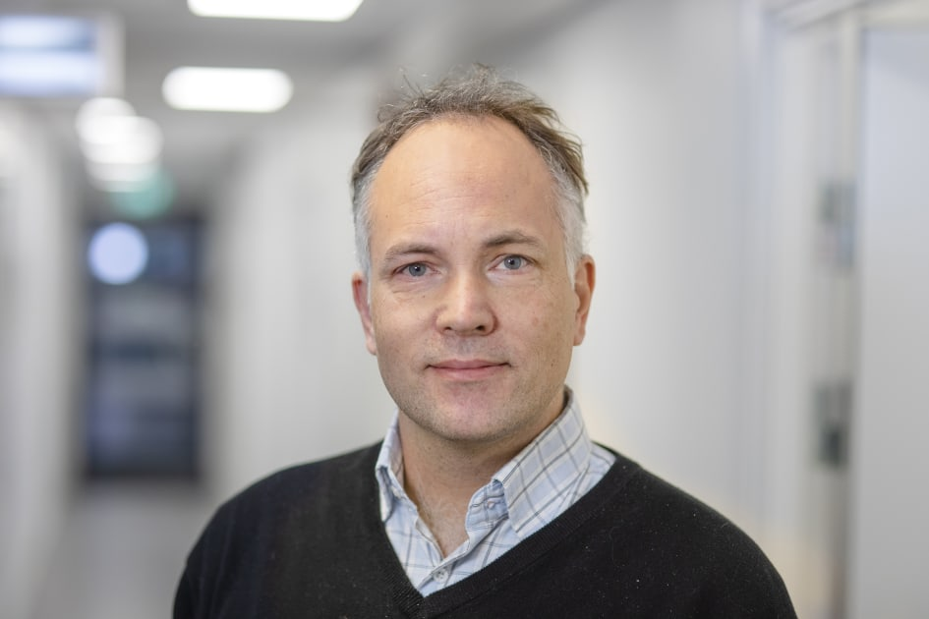 Mats Martinell
Senior Lecturer Department of Public Health and Caring Sciences | Uppsala Universitet
Email: mats.martinell@pubcare.uu.se
https://katalog.uu.se/profile/?id=N9-642

UK--INTRePID investigators

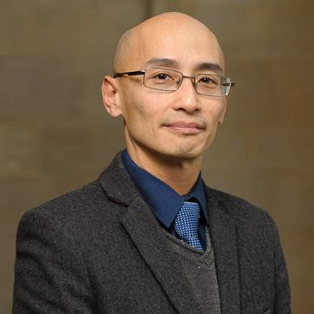 Uy Hoang
Research Fellow | Nuffield Department of Primary Care Health Sciences | Medical Sciences Division| University of Oxford
Email: uy.hoang@phc.ox.ac.uk
https://www.phc.ox.ac.uk/team/uy-hoang

US--INTRePID investigators
Amanda Ratigan
Epidemiologist | Director of Analytics for DARTNET
amanda.ratigan@dartnet.info

4) Participating Institutions







5) Publications

TBD

6) Presentations

48th North American Primary Care Research Group (NAPCRG) Annual Meeting. Virtual 2020/11. Tu K, de Lusignan S, Tu K, de Lusignan S, Goh LH, Hallinan C, Kristiansson RS, Pace W, Park JH, Telle KE, Wensaas KA, Wong WCW, Zheng JL, Butt D, Crampton N, Griever M, Ji C, O’Neill B, Stephenson E, Walsh R, Manski-Nankervis J. INTRePID-INTernational ConsoRtium of Primary Care BIg Data Researchers: Studying the Pandemic Impact on Primary Care Around the World. [Poster]

7) Grants

Tu K (PI) Development of the Development of the INTernational ConsoRtium of Primary Care BIg Data Researchers – INTRePID. NYGH Exploration Fund. $7500. 2020/07-2021/07.

Tu K (PI), Selby P (Co-PI), Butt D, Crampton N, Ji C, Melamed O, Mitiku T, Moineddin R, Mulsant B, O’Neill B, Rouleau K, Rudzicz F, Sodhi S. Evaluating the impact of COVIF-19 pandemic on primary care using real world data: focus mental health. CIHR Operating Grant: COVID-19 Mental Health and Substance Use Service Needs and Delivery​. $200,000. 1/9/2020-1/9/2021.

Tu K. Rathlyn Foundation Primary Care EMR Research and Discovery Fund. Rathlyn Foundation. $500,000. 2020/12-2025/12. $500,000.

8) INTRePID in the news

TBD

9) Need to have a members only section-password protected where can post meeting minutes, meeting schedules, other forum areas such as supporting documents for impractability of obtaining consent, data hostaging by vendors, other international comparative studies…

