

Supreme Fertility
Program

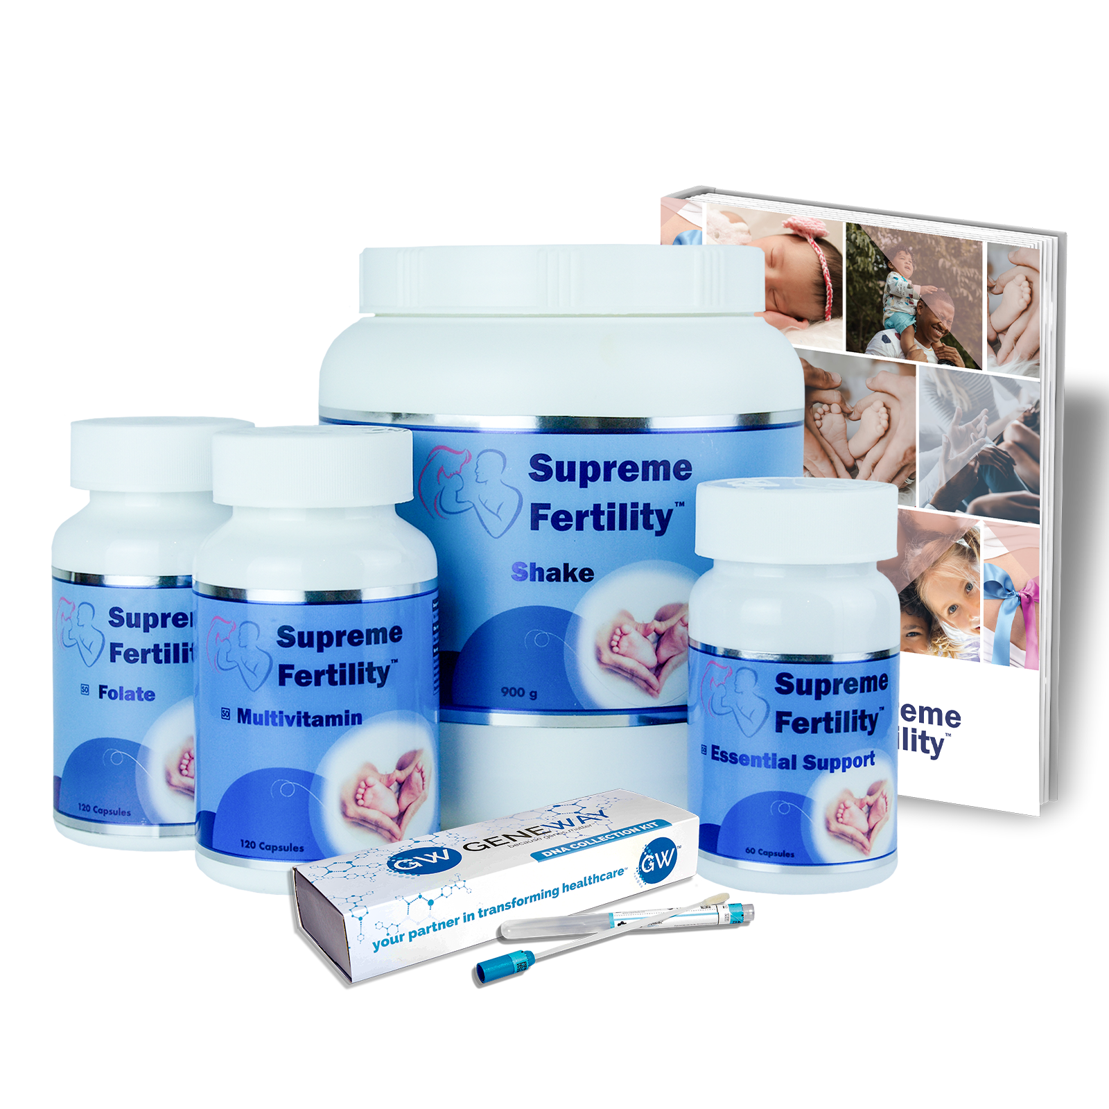
4 in 1 Fertility program for patients planning on starting a family, struggling with unexplained infertility, PCOS, recurrent miscarriages, ovarian insufficiency, or in preparation of IVF and assisted reproductive techniques.

CONSIDERATIONS FOR THE SUPREME FERTILITY PROGRAM
Irrespective if patients are planning to fall pregnant naturally, pursuing IVF, or trying to fall pregnant again after a miscarriage the quality of the egg and sperm is crucial. It takes approximately three months for an egg to reach maturity and 74 days for the spermatogenic cycle to reach completion. This is a crucial window of time.
An embryo’s potential to develop into a pregnancy is dependent on many different factors, having the correct number and quantity of chromosomes is essential. Chromosomal abnormalities have a profound impact on fertility. Embryo’s formed from chromosomally abnormal eggs have low potential for continued development.

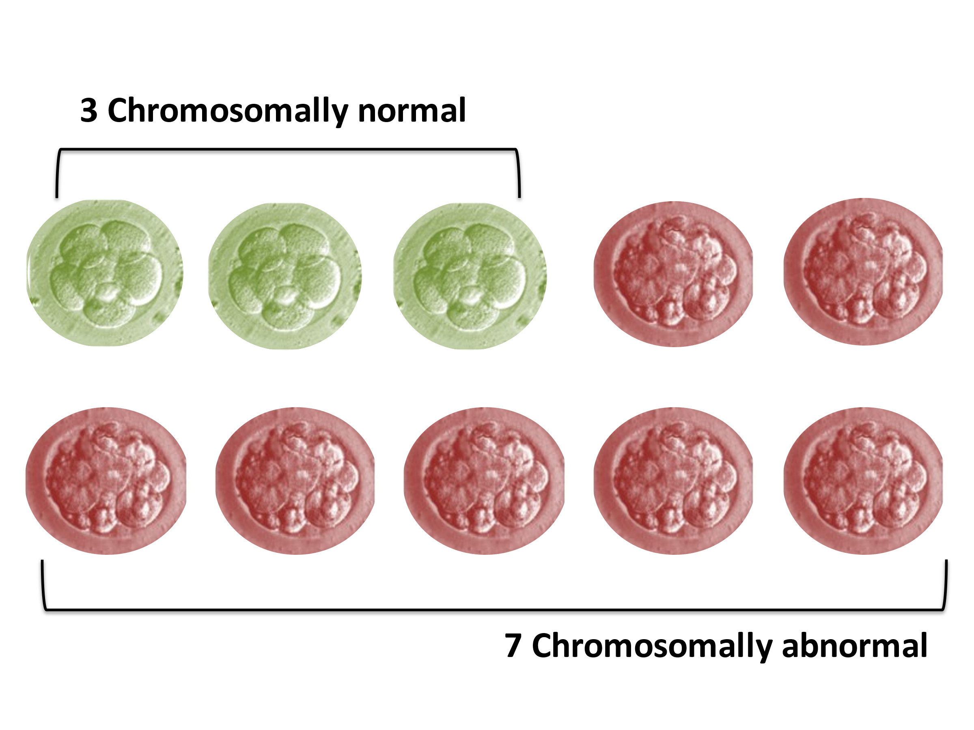
Figure 1: Chromosomally normal and abnormal embryo's
Women >40: more than 50% of eggs may be chromosomally abnormal
Women <35: 25% of eggs may be chromosomally abnormal
Studies have shown that dietary and supplement intervention, and removal of environmental toxins in this time may improve embryo quality, impact embryo development, and translate into improved clinical outcomes.
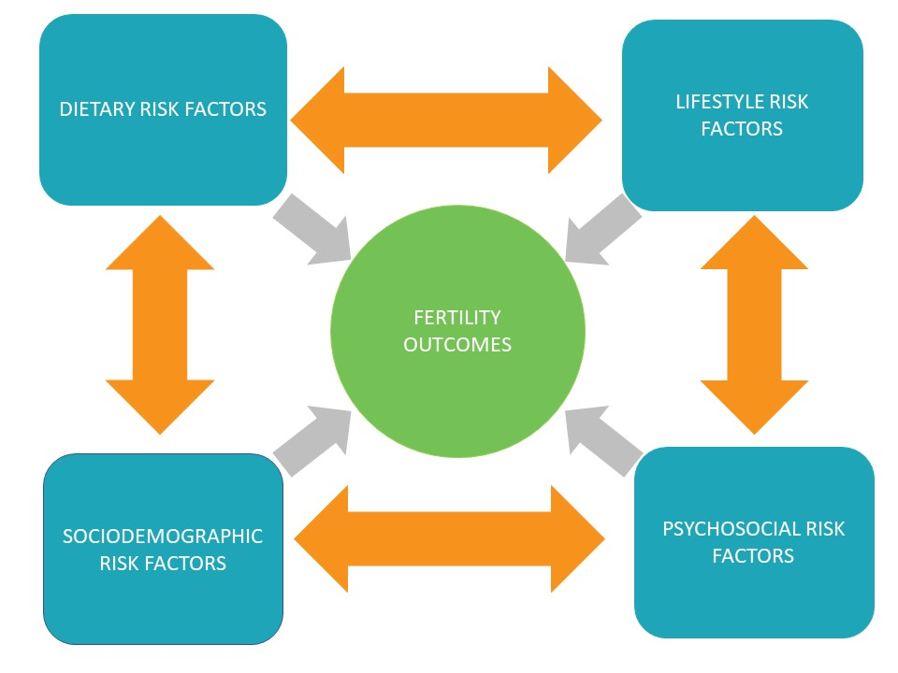

ACTIVE VS INACTIVE
Providing the male and female with the right supplementation, dietary and lifestyle recommendations in this critical window is of utmost importance. Many of them may have genetic variations that may hinder effective bioavailability in the system. For example, B vitamins found in supplements are supplied in their inactive form, requiring methylation by the liver to convert them into their active form which can be used by the body. This requires an enzyme called methylenetetrahydrofolate reductase (MTHFR). A large percentage of the population is affected by a mutation in the MTHFR gene which instructs the body to produce this enzyme. As much as 50% of the population may be affected. MTHFR mutations affect the body’s ability to metabolise unmethylated forms of B vitamins namely folate and B12. The Supreme Wellness multivitamin contains the active forms of both folate and vitamin B12 which are immediately bioavailable for use by the body.
SUPREME FERTILITY DNA PANEL LOOKS AT THE FOLLOWING GENE VARIANTS:
There is a growing awareness amongst healthcare practitioners to ensure that patients receive quality supplements in the active forms because of MTHFR variations. The MTHFR gene is not the only one affecting male and female fertility. Studies have highlighted many other important genes that can play a role and affect methylation, hormone balance, oxidative stress, inflammation, and other key areas. As a result the Supreme Fertility DNA panel provides insight into the following gene variants:
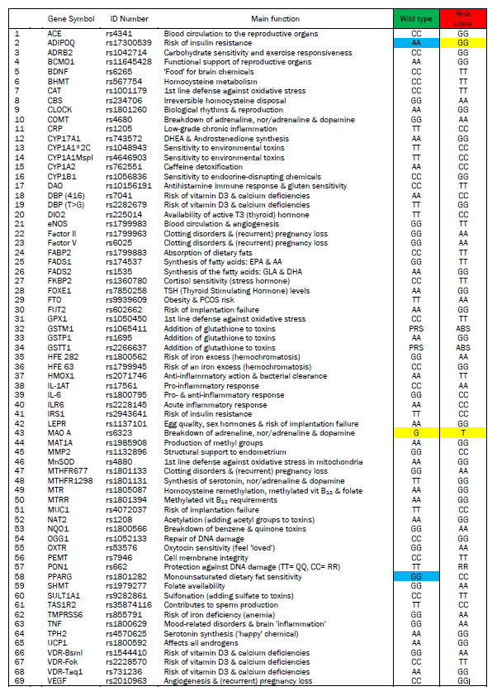
SUPREME FERTILITY PANEL INVESTIGATES GENE VARIANTS AFFECTING THE FOLLOWING:

- Blood Clotting
- Thyroid Function
- General Sub-fertility
- Endometriosis
- PCOS
- Stress
- Iron homeostasis
- Vitamin D and Calcium
- Omega 3 & 6 Levels
- Methylation
- Hormone Balance
- Detoxification
- Oxidative Stress

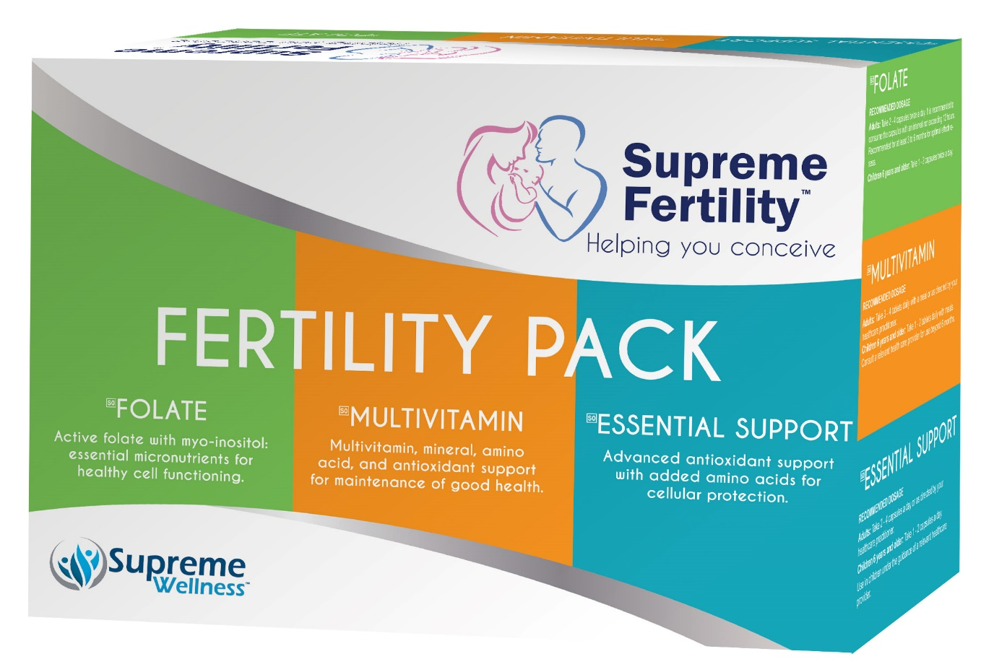
SUPREME FERTILITY SUPPLEMENT PACK
SAHPRA Licensed Manufacturer meeting all GMP requirements

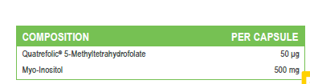
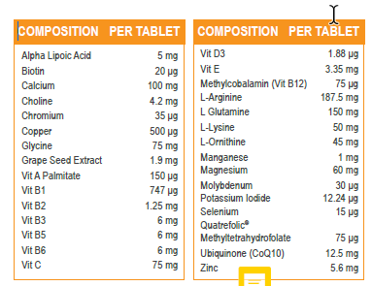

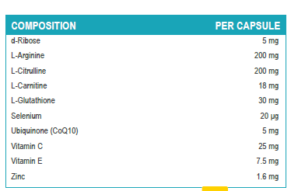

THE SUPREME FERTILITY PROGRAM CONSISTS OF:
- Male and female DNA testing for genetic variants
- Customised supplement intervention
- Dietary optimisation
- Lifestyle modification

WHO IS THE PROGRAM RECOMMENDED FOR?
- Couples planning on starting a family
- PCOS
- Endometriosis
- Unexplained infertility
- Recurrent miscarriages
- Before IVF or other assisted reproductive procedures
- Premature ovarian insufficiency
- Older couples

Supreme Wellness (PTY) Ltd
1153 Justice Mahomed Street, Brooklyn, Pretoria | TEL: (012) 940 1569| info@supremewel.co.za |
www.supremewellness.co.za

REFERENCES
- Hassold T, Hall H, Hunt P. The origin of human aneuploidy: where we have been, where we are going. Hum Mol Genet. 2007;16(Spec No. 2):R203–R208. (“Hassold and Hunt 2007”); Macklon 2002; Sher G, Keskintepe L, Keskintepe M, Ginsburg M, Maassarani G, Yakut T, Baltaci V, Kotze D, Unsal E.Oocyte karyotyping by comparative genomic hybridization provides a highly reliable method for selecting "competent" embryos, markedly improving in vitro fertilization outcome: a multiphase study. Fertil Steril. 2007 May;87(5):1033-40.
- Kermack, A. J., Lowen, P., Wellstead, S. J., Fisk, H. L., Montag, M., Cheong, Y., Osmond, C., Houghton, F. D., Calder, P. C., & Macklon, N. S. (2020). Effect of a 6-week "Mediterranean" dietary intervention on in vitro human embryo development: the Preconception Dietary Supplements in Assisted Reproduction double-blinded randomized controlled trial. Fertility and sterility, 113(2), 260–269. https://doi.org/10.1016/j.fertnstert.2019.09.041
- Fett, R. (2019). It Starts with the Egg. Franklin Fox Publishing LLC.
- Patrick J Stover, Influence of human genetic variation on nutritional requirements, The American Journal of Clinical Nutrition, Volume 83, Issue 2, February 2006, Pages 436S–442S, https://doi.org/10.1093/ajcn/83.2.436S
- Packer, Lester, and Carol Colman. The Antioxidant Miracle : Put Lipoic Acid, Pycnogenol, and Vitamins E and C to Work for You. New York, Wiley, 1999.
- Helmut Sies. Oxidative Stress : Eustress and Distress. Amsterdam Elsevier Academic Press, 2020.
- Salazar-Flores, Joel, et al. “Effects of Mercury, Lead, Arsenic and Zinc to Human Renal Oxidative Stress and Functions: A Review.” Journal of Heavy Metal Toxicity and Diseases, vol. 04, no. 01, 2019, 10.21767/2473-6457.10027. Accessed 16 Jan. 2020.
- Smith D. A. et al. Is folic acid good for everyone? Am J Clin Nutr. 2008
- Bailey SW, Ayling JE. The extremely slow and variable activity of dihydrofolate reductase in human liver and its implications for high
- folic acid intake. Proceedings of the National Academy of Sciences of the United States of America. 2009Tsang BL et al. Assessing the association between the methylenetetrahydrofolate reductase (MTHFR) 677C>T polymorphism and blood folate concentrations: A systematic review and meta-analysis of trials and observational studies. Am. J. Clin. Nutr. 2015
- Jamil K. Clinical Implications of MTHFR Gene Polymorphism in Various Diseases. Biol Med. 20144
- Ulrich CM, Potter JD. Folate supplementation: too much of a good thing? Cancer Epidemiol Biomarkers Prev. 2006
- Wilcken B et al. Geographical and ethnic variation of the 677C>T allele of 5,10 methylenetetrahydrofolate reductase (MTHFR): findings from over 7000 newborns from 16 areas worldwide. J Med Genet. 2003
- Seremak-Mrozikiewicz A et al. The signifi cance of 1793G>A polymorphism in MTHFR gene in women with fi rst trimester recurrent
miscarriages. Neuro Endocrinol Lett. 2010
- Bailey SW, Ayling JE. The extremely slow and variable activity of dihydrofolate reductase in human liver and its implications for high folic acid intake. Proc Natl Acad Sci U S A. 2009 Sep 8;106(36):15424-9. Epub 2009 Aug 24.
- Robien A et al. Pharmacogenetics of folate-related drug targets in cancer treatment. Pharmacogenomics. 2005
- Dean, C. Magnesium-The missing link to better health. Better Nutrition Magazine 2011.
- Mahan, L.K. et al. Krause’s Food and the Nutrition Care Process. 13th edition. United States of America. Saunders, an imprint of Elsevier Inc. 2012

‌

