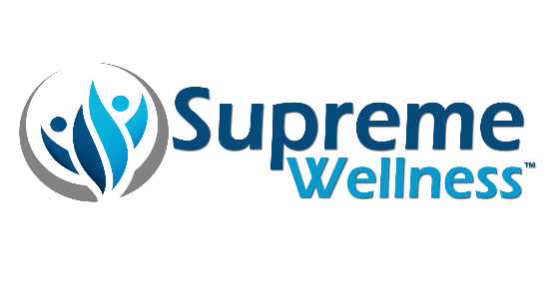
Supreme Wellness
Essential
Support

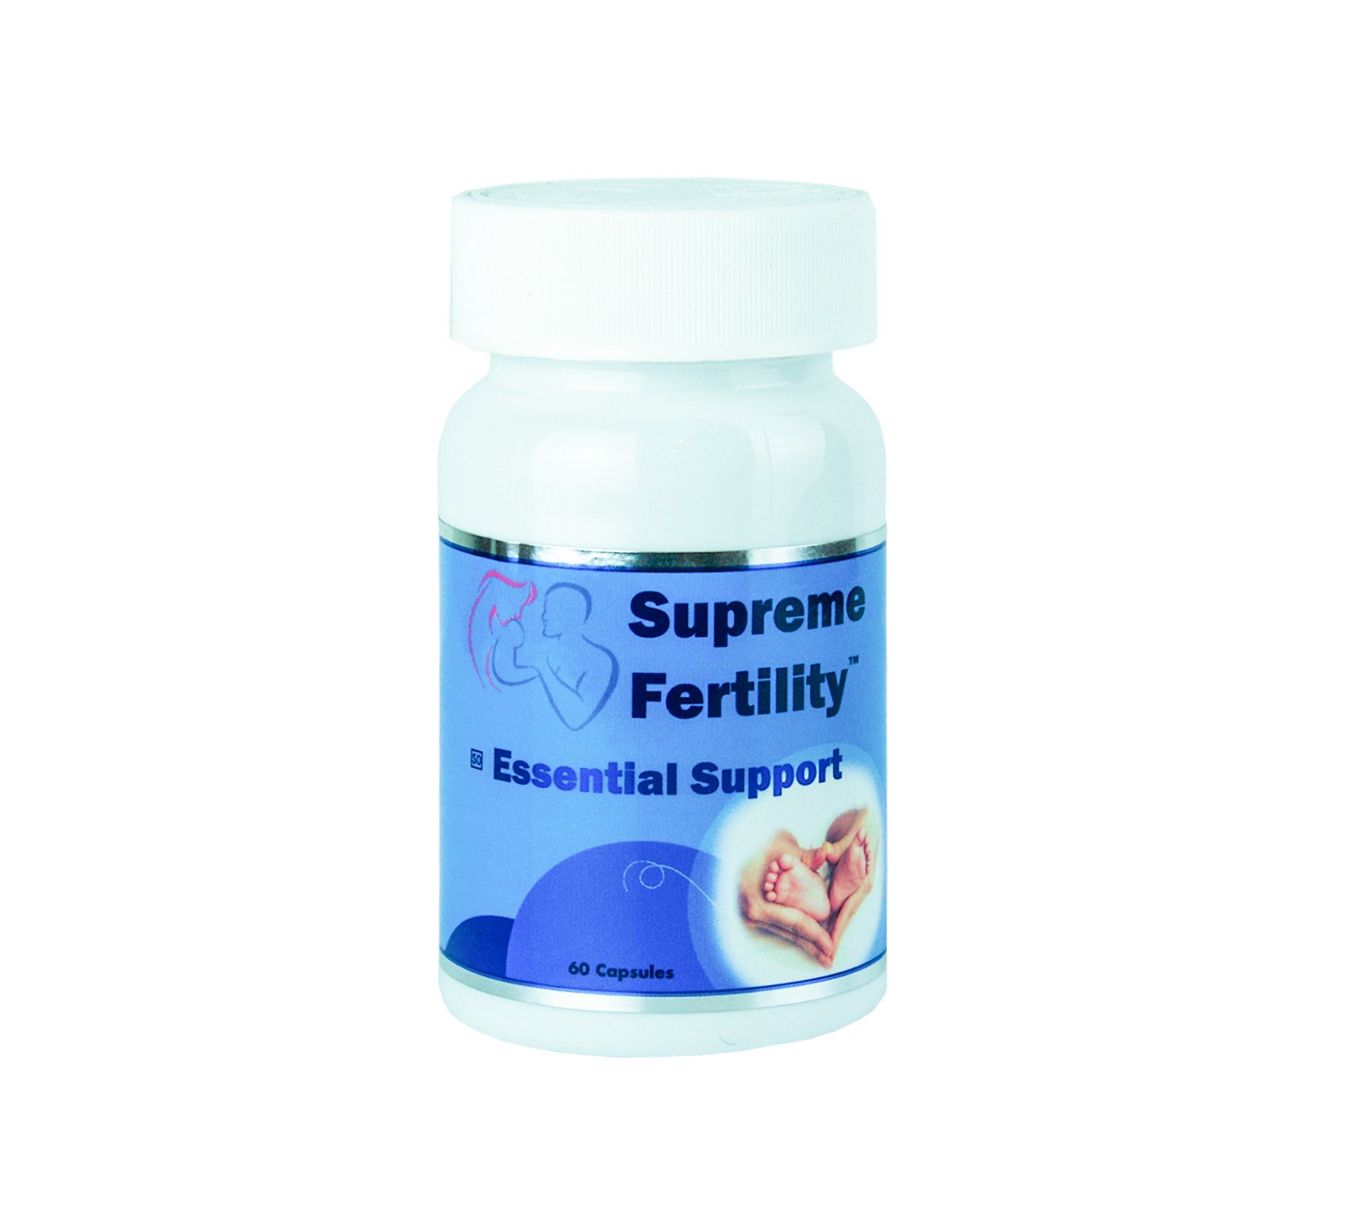
Advanced antioxidant support
with added amino acids for cellular protection.

ANTIOXIDANTS AND OUR NEEDS IN THE MODERN WORLD

Free radicals, or reactive oxygen species (ROS), are waste substances produced by cells as the body processes food and reacts to the environment. If the body cannot process and remove free radicals efficiently, oxidative stress can result. Free radicals are causal factors in nearly every known disease, from heart disease to arthritis to cancer to cataracts to infertility. Free radicals are a major causative factor in the ageing process itself.
Antioxidants help neutralises free radicals and this is thought to boost overall health. The body produces some antioxidants, known as endogenous antioxidants, e.g. glutathione. If genetic mutations are present, the body’s ability to produce these antioxidants is significantly reduced. Antioxidants that are obtained from the diet are called exogenous and are not produced by genetic enzymes, e.g. vitamin C.
Antioxidants engulf free radicals causing a change in molecular structure. This causes the antioxidant itself to become a free radical, although relatively weak and not likely to cause additional harm. Within the body there exists a dynamic interplay between five key antioxidants, often referred to as the network antioxidants. These are vitamin C, vitamin E, Co Q10, lipoic acid and glutathione. These network antioxidants work together to boost and strengthen the entire system, and when used together they enhance the activity of each other and help maintain antioxidant balance.

Figure 1: Key Network Antioxidants
Network antioxidants can “recycle” or regenerate each other after they have neutralised free radicals, improving their antioxidant potential.
When vitamin E disarms free radicals, it becomes a weak free radical itself. Vitamin C and Coenzyme Q10 can donate electrons and help recycle this weak free radical back into an antioxidant. The same occurs when vitamin C or glutathione engulf free radicals, they too become weak free radicals in the process. Lipoic acid and vitamin C can help recycle these back into their antioxidant form.

ANTIOXIDANTS FRIEND OR FOE
Free Radicals & Reactive Oxygen Species

Low Exposure
Specific targets
High Exposure
Unspecific targets

Oxidative Eustress
(Redox Signalling)

Oxidative Distress
(Disrupted Redox Signalling)

Adaptive responses
(e.g. NF-kB, Nrf2, HIF)

Pathophysiology Disease
Physiology Health

In addition to neutralising free radicals, antioxidants play an important role in maintaining good health by helping control genes.
Genes play a critical role in the ability to fight disease, antioxidants switch genes on and off in accordance with bodily needs. The antioxidant network signals genes, which determine whether trillions of cells eat, live, die, or multiply.

Essential Support supports gene variations in:
BCMO1 | MnSOD | CAT
CRP | EPHX1 | HMOX1
GPX | GSTs | ILs
eNOS | NQO1 | PON1
SULT | TNF

SUPREME WELLNESS ESSENTIAL SUPPORT

The unique blend of bioactive compounds in Supreme Wellness Essential Support functions on various pathways responsible to counteract oxidative stress.
ELEMENTAL AMOUNTS DELIVERED IN A SINGLE ESSENTIAL SUPPORT CAPSULE
d-Ribose | 5 mg
L-Arginine | 200 mg
L-Citrulline | 200 mg
L-Carnitine | 18 mg
L-Glutathione | 30 mg
Selenium | 20 μg
Ubiquinone (CoQ10) | 5 mg
Vitamin C | 25 mg
Vitamin E | 7.5 mg
Zinc | 1.6 mg
SAHPRA Licensed Manufacturer meeting all GMP requirements

ACTIVITIES AND PROCESSES THAT CAN INCREASE OXIDATIVE STRESS

- Age
- Alcohol
- Chemotherapy
- Environmental pollution
- Excessive exercise
- Exposure to chemicals such as pesticides and drugs
- Genetic Variations
- Heavy Metals
- Industrial solvents
- Inflammation
- Injury
- Ischemia and reperfusion damage
- Mitochondrial activity
- Ozone
- Poor Diet
- Radiation
- Smoking
- UV Exposure

DISEASE RISK WITH INCREASED OXIDATIVE STRESS

- Alzheimer’s
- Arthritis
- Atherosclerosis
- Cancer
- Cataracts
- Diabetes
- Female infertility
- Gum disease
- Heart Disease
- Inflammation
- Male Infertility
- Parkinson’s
- Premature ageing
- Stroke

Supreme Wellness (PTY) Ltd
1153 Justice Mahomed Street, Brooklyn, Pretoria | TEL: (012) 940 1569| info@supremewellness.co.za |
www.supremewellness.co.za

REFERENCES
- Packer, Lester, and Carol Colman. The Antioxidant Miracle : Put Lipoic Acid, Pycnogenol, and Vitamins E and C to Work for You. New York, Wiley, 1999.
- Helmut Sies. Oxidative Stress : Eustress and Distress. Amsterdam Elsevier Academic Press, 2020.
- Salazar-Flores, Joel, et al. “Effects of Mercury, Lead, Arsenic and Zinc to Human Renal Oxidative Stress and Functions: A Review.” Journal of Heavy Metal Toxicity and Diseases, vol. 04, no. 01, 2019, 10.21767/2473-6457.10027. Accessed 16 Jan. 2020.
‌

