

Supreme Wellness
Multivitamin

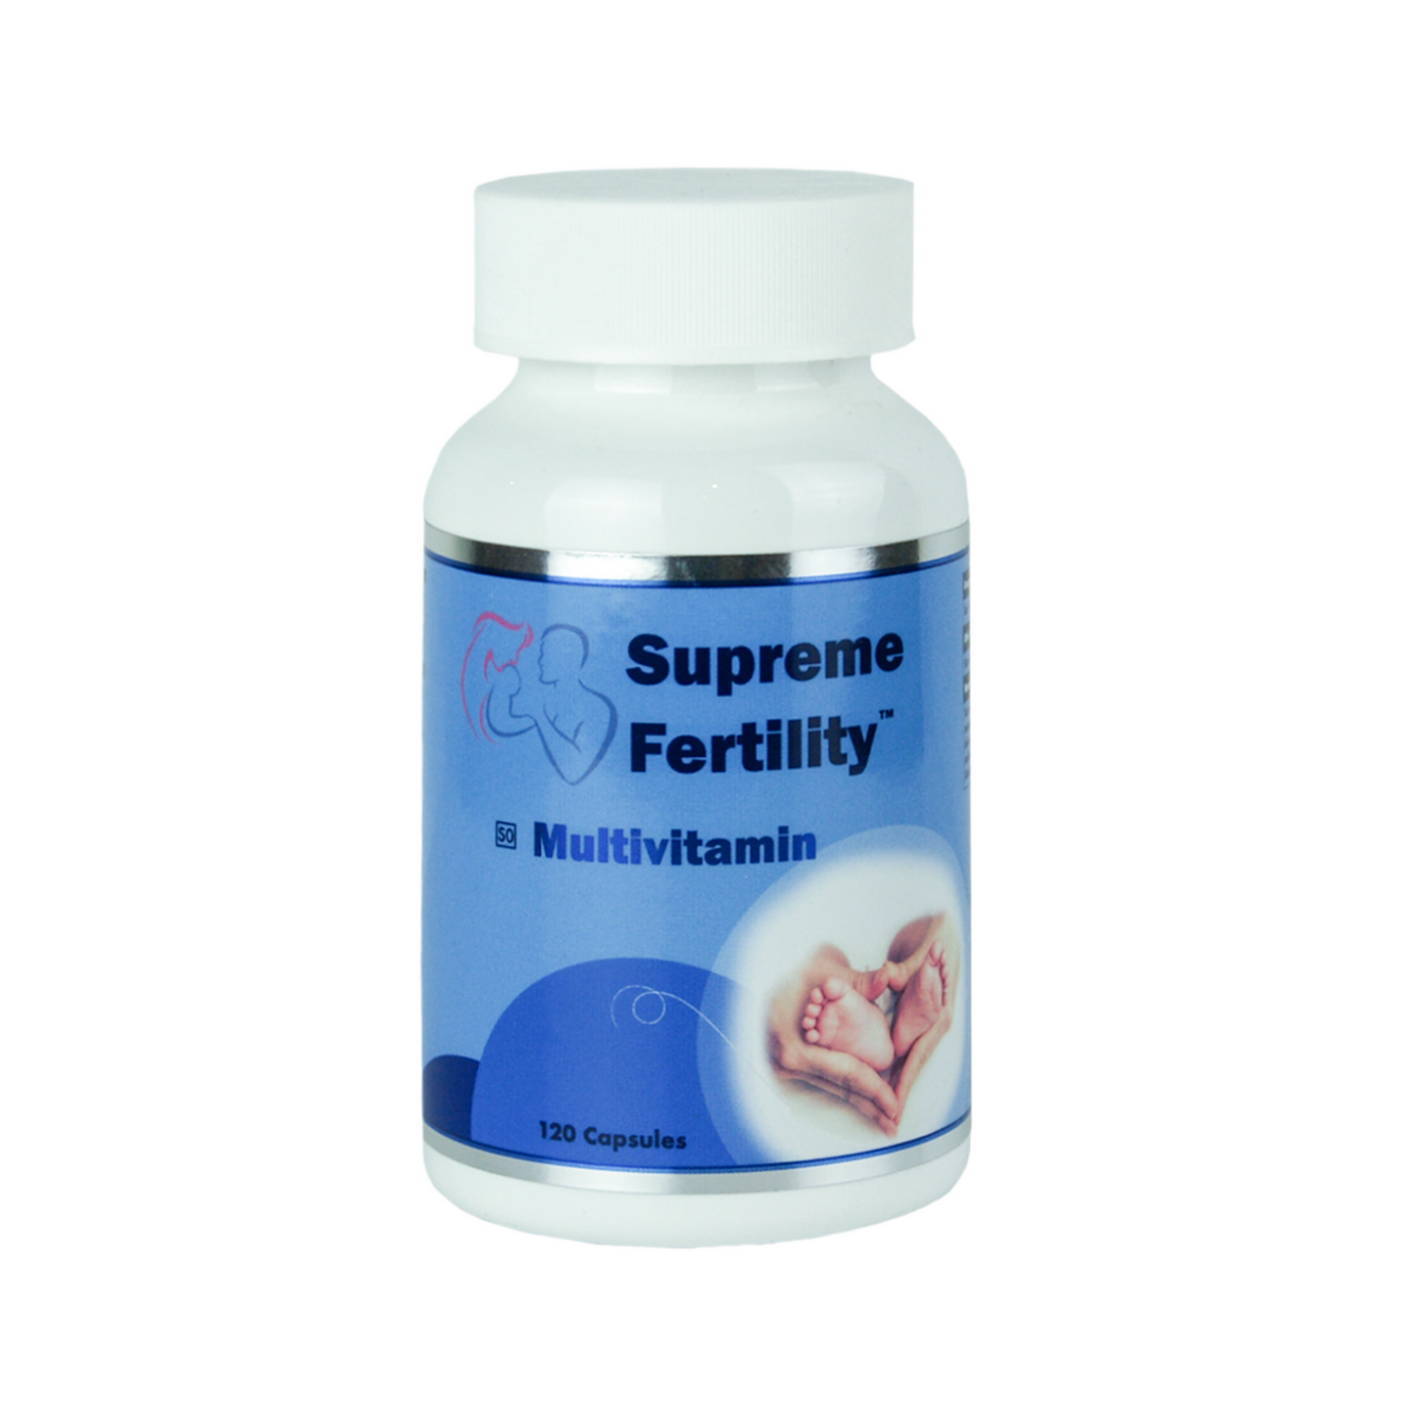
5 in 1 Multivitamin, mineral, amino acid, and
antioxidant support for maintenance of good health in adults and children above six years of age.

CONSIDERATIONS FOR SUPPLEMENTS
ACTIVE VS INACTIVE
Most B vitamins found in supplements are supplied in their inactive form, requiring methylation by the liver to convert them into their active form which can be used by the body. This requires an enzyme called methylenetetrahydrofolate reductase (MTHFR). A large percentage of the population is affected by a mutation in the MTHFR gene which instructs the body to produce this enzyme. As much as 50% of the population may be affected. MTHFR mutations affect the bodies ability to metabolise unmethylated forms of B vitamins namely folate and B12. Supreme Wellness multivitamin contains the active forms of both folate and vitamin B12 which are immediately bioavailable.
DYNAMIC INTERPLAY
Antioxidants engulf free radicals causing a change in molecular structure. This causes the antioxidant itself to become a free radical, although relatively weak and not likely to cause additional harm. Within the body there exists a dynamic interplay between five key antioxidants, often referred to as the network antioxidants. These are vitamin C, vitamin E, Co Q10, lipoic acid and glutathione. These network antioxidants work together to boost and strengthen the entire system, and when used together they enhance the activity of each other and help maintain antioxidant balance. Supreme Wellness Multivitamin contains four of the five key network antioxidants.
GENETIC VARIATIONS AND NUTRITIONAL REGIMENS
Many genetic polymorphisms confer both advantage and risk, depending on the health outcome of interest. Understanding the physiologic and biochemical consequences of specific gene variants, required cofactor support and the mechanisms that confer disease protection or risk enables the rational design of dietary and nutritional approaches that can provide maximum patient benefit.
Genetic variation has an important influence on human nutritional requirements, and the introduction of genomics has both highlighted the complexity of the interaction between genes and diet and offered opportunities to provide optimal nutrition for individuals to ultimately reduce the risk of chronic diseases and increase health and well-being into old age.

SUPREME WELLNESS MULTIVITAMIN SUPPORTS GENE VARIATIONS IN:

BCMO1 | BHMT | BHMT
CAT | CBS | COMT
DBP | eNOS | GPX
GSTM1 | GSTP1 | GSTP1
HMOX1 | MAT1A | MnSOD
MTHFR | MTR | MTR
MTRR | NQO1 | OGG1
PEMT | PON1 | SHMT
VDR

SUPREME WELLNESS MULTIVITAMIN

The body cannot produce most vitamins, minerals and trace elements and is dependent on a regular supply in the diet. An optimum daily diet is often not always possible, and an adequate supply of these vital substances is important for well-being and good health.
SAHPRA Licensed Manufacturer meeting all GMP requirements
DELIVERED IN A SINGLE SUPREME WELLNESS MULTIVITAMIN TABLET
Amino Acids
Glycine | 75 mg
L-Arginine | 187.5 mg
L-Glutamine | 150 mg
L-Lysine | 50 mg
L-Ornithine | 45 mg
Antioxidants
Alpha Lipoic Acid | 5 mg
Grape Seed Extract | 1.9 mg
Selenium | 15 μg
Ubiquinone (CoQ10) | 12.5 mg
Vitamin A Palmitate | 150 μg
Vitamin C | 75 mg
Vitamin E | 3.35 mg
Zinc | 5.6 mg
Vitamin B Complex
Vitamin B1 | 747 μg
Vitamin B2 | 1.25 mg
Vitamin B3 | 6 mg
Vitamin B5 | 6 mg
Vitamin B6 | 6 mg
Methylcobalamin (Vit B12) | 75 μg
Quatrefolic® Methyltetrahydrofolate | 75 μg
Other vitamins, minerals and nutrients
Biotin | 20 μg
Calcium | 100 mg
Choline | 4.2 mg
Chromium | 35 μg
Copper | 500 μg
Magnesium | 60 mg
Manganese | 1 mg
Molybdenum | 30 μg
Potassium Iodide | 12.24 μg
Vitamin D3 | 1.88 μg

INCREASED NEED FOR MULTIVITAMIN SUPPORT

- Alcohol
- Chronic medication users
- Coffee and stimulants
- Compromised digestive ability
- Depression
- Diabetes
- Elderly
- Excessive exercise
- Female infertility
- Gastrointestinal problems
- Genetic Variations
- Impaired methylation
- Junk food addicts
- Lactating
- Male infertility
- Mood disorders
- Obesity
- Oral contraceptive use
- Poor diet
- Pregnant
- Smoking
- Stress
- Vegans
- Vegetarians

WHY SUPPLEMENT?
Todays fast-paced digital world leaves most of us burning the candle at both ends, reaching for meals on the go, choosing fast and convenient or skipping them entirely. Fast food such as this is often lower in vitamins, minerals, and essential fibre because of the processing, preparation, and reduced soil quality during manufacture. Junk food is also higher in calories, sugar, fat, artificial sweeteners, preservatives, sodium any many other chemicals detrimental to human health and well-being.

Supreme Wellness Multivitamin is a 5-in-1 combination supplement that contains:
- amino acids
- antioxidants
- B-complex vitamins
- other vitamins
- minerals
This affects our bodies ability to maintain optimal nutrient levels and remain toxin free.
Optimal nutrient levels are essential to:
- Promote growth and development
- Maintain general health
- Support essential bodily processes
- Protect against illness and chronic disease
- Support genetic variants
- Help metabolise fats, carbohydrates, and proteins
If diet and lifestyle is not optimal, consider adding a multivitamin and mineral supplement to your daily regimen.

WHY CHOOSE SUPREME WELLNESS MULTIVITAMIN
Supreme Wellness Multivitamin is a 5-in-1 combination supplement that contains: amino acids, antioxidants, B-complex vitamins, other vitamins and minerals providing added nutritional support to help promote, well-being, vitality and healthy ageing.

Supreme Wellness (PTY) Ltd
1153 Justice Mahomed Street, Brooklyn, Pretoria | TEL: (012) 940 1569| info@supremewellness.co.za |
www.supremewellness.co.za

REFERENCES
- Patrick J Stover, Influence of human genetic variation on nutritional requirements, The American Journal of Clinical Nutrition, Volume 83, Issue 2, February 2006, Pages 436S–442S, https://doi.org/10.1093/ajcn/83.2.436S
- Packer, Lester, and Carol Colman. The Antioxidant Miracle : Put Lipoic Acid, Pycnogenol, and Vitamins E and C to Work for You. New York, Wiley, 1999.
- Helmut Sies. Oxidative Stress : Eustress and Distress. Amsterdam Elsevier Academic Press, 2020.
- Salazar-Flores, Joel, et al. “Effects of Mercury, Lead, Arsenic and Zinc to Human Renal Oxidative Stress and Functions: A Review.” Journal of Heavy Metal Toxicity and Diseases, vol. 04, no. 01, 2019, 10.21767/2473-6457.10027. Accessed 16 Jan. 2020.
- Smith D. A. et al. Is folic acid good for everyone? Am J Clin Nutr. 2008
- Bailey SW, Ayling JE. The extremely slow and variable activity of dihydrofolate reductase in human liver and its implications for high
- folic acid intake. Proceedings of the National Academy of Sciences of the United States of America. 2009Tsang BL et al. Assessing the association between the methylenetetrahydrofolate reductase (MTHFR) 677C>T polymorphism and blood folate concentrations: A systematic review and meta-analysis of trials and observational studies. Am. J. Clin. Nutr. 2015
- Jamil K. Clinical Implications of MTHFR Gene Polymorphism in Various Diseases. Biol Med. 20144
- Ulrich CM, Potter JD. Folate supplementation: too much of a good thing? Cancer Epidemiol Biomarkers Prev. 2006
- Wilcken B et al. Geographical and ethnic variation of the 677C>T allele of 5,10 methylenetetrahydrofolate reductase (MTHFR): fi ndings from over 7000 newborns from 16 areas worldwide. J Med Genet. 2003
- Seremak-Mrozikiewicz A et al. The signifi cance of 1793G>A polymorphism in MTHFR gene in women with fi rst trimester recurrent
miscarriages. Neuro Endocrinol Lett. 2010
- Bailey SW, Ayling JE. The extremely slow and variable activity of dihydrofolate reductase in human liver and its implications for high folic acid intake. Proc Natl Acad Sci U S A. 2009 Sep 8;106(36):15424-9. Epub 2009 Aug 24.
- Robien A et al. Pharmacogenetics of folate-related drug targets in cancer treatment. Pharmacogenomics. 2005
- Dean, C. Magnesium-The missing link to better health. Better Nutrition Magazine 2011.
- Mahan, L.K. et al. Krause’s Food and the Nutrition Care Process. 13th edition. United States of America. Saunders, an imprint of Elsevier Inc. 2012

‌

