
Supreme Fertility
FOLATE
QUATREFOLIC



FOLATE AND OUR NEEDS IN THE MODERN WORLD
Most folate consumption is coming from folic acid, the synthetic version in supplements which is also added to foods. Folic acid (like food folate) is inactive and must be metabolised to 5-methyltetrahydrofolate (5-MTHF) to become metabolically active. Today we know that this is a complex metabolic process. Many people taking folic acid supplements may still be gravely folate deficient; this is because numerous genetic variations can impair the conversion of folic acid into the bioactive form in many people. Despite this folate intake is often poor in the diets of many people for various reasons. Natural folates are susceptible to oxidation and 90% can also be destroyed by cooking. Typical folates also have a low and incomplete bioavailability. ^{[1,2]}

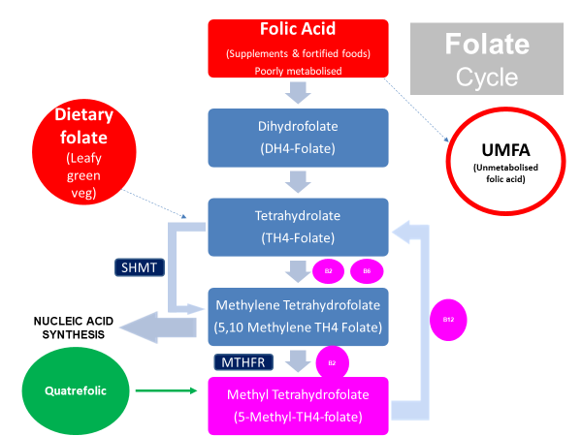

MTHFR Polymorphisms
The methyltetrahydrofolate reductase (MTHFR) is a polymorphic enzyme. Various genetic variations can occur which may impair MTHFR activity and the resulting conversion of folic acid into 5-MTHF. 57% of the population is estimated to have a MTHFR polymorphism and do not produce adequate or effective MTHFR.

The emerging field of nutrigenomics has now shed light on how MTHFR polymorphism’s are implicated in chronic disease states. Folate and dietary folate may contribute to supporting adequate methylation and overall health^{.[3]}

There are currently more than 50 identified MTHFR variants, the two prime variants are C677T and A1298C. The number identifies the location on the MTHFR gene and the letters to the amino acid position. The MTHFR gene is reported as either heterozygous or homozygous. ^{[4]}

Compared to a normal MTHFR enzyme, polymorphic variants may function at 55% to 70% efficiency. Homozygous implies two genes are affected which may mean an enzyme efficiency decrease to approximately 7% to 10% compared to normal. Also, more common in those predisposed to cancer, heart disease and autism. The mutation frequency can exceed 90% of these populations. [5]

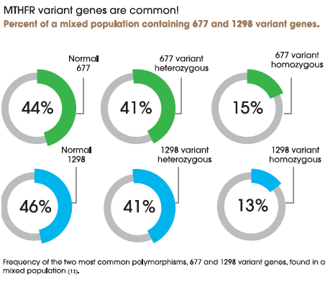
1: Source Quatrefolic White Paper

MTHFR gene mutations may affect over 40% of the world population, which to date has been largely ignored.
Current population data shows gaps especially in some ethnic groups or large geographical areas: about 50% women in Caucasian (higher in the North American Caucasians, Italian and the Hispanics), Mexico (34.8%) and in the North part of China (around 20%) (6,7]

“UMFA”, UNMETABOLISED FOLIC ACID IN SERUM
Studies have now found an increase in the serum of unmetabolized folic acid (UMFA) levels with increased concern over potential risk of adverse effects. Evidence suggests that high intake (≥1 mg/d) of folic acid may worsen some pre-existing cancers or progression of precancerous lesions, such as in the colon and prostate. In older women, with high levels of UMFA, the natural killer cell activity has been reported to be decreased. Evidence also suggests that UMFA can mask vitamin B12 deficiency and potentially worsen neurological damage with prolonged B12 deficiency. ^{[8,]}
QUATREFOLIC
QUATREFOLIC, THE “ACTIVE FORM” OF FOLATE DOES NOT ADD TO THE BUILD UP OF UMFA IN THE BLOOD.

INCREASED NEED FOR FOLATE

- Dietary intake is inadequate
- Pregnancy and lactation
- Genetic variations
- Liver disease
- Digestive system disorders
- Preconception both males and females
- Male Infertility
- Female Infertility
- Mood/Depression
- Post-menopausal
- Anaemia
- Cardiovascular Disease
- Hyperhomocysteinemia
- Aging & Older People (Mild Cognitive Impairment)
- Smokers
- Excessive alcohol intake

MEDICATIONS COMPROMISING FOLATE

- Methotrexate
- Phenytoin
- Trimethoprim/Sulphamethoxazole
- Sulfasalazine
- Metformin
- Triamterene
- Pyrimethamine
- Barbiturates

CONSIDERATIONS FOR SUPPLEMENTS
Animal studies and human clinical trial confirm that Quatrefolic® has a superior bioavailability profile over (6S)-5-methyltetrahydrofolate calcium salt and folic acid. In a single dose, balanced, two sequences, two periods, two treatments randomized crossover study.

AN EVOLUTION IN FOLATE SUPPLEMENTATION
Why is Quatrefolic in Supreme Fertility Folate your first-choice supplement?

Stability
Bioavailability
Solubility
Safety

REFERENCES
- Smith D. A. et al. Is folic acid good for everyone? Am J Clin Nutr. 2008
- Bailey SW, Ayling JE. The extremely slow and variable activity of dihydrofolate reductase in human liver and its implications for high
- folic acid intake. Proceedings of the National Academy of Sciences of the United States of America. 2009Tsang BL et al. Assessing the association between the methylenetetrahydrofolate reductase (MTHFR) 677C>T polymorphism and blood folate concentrations: A systematic review and meta-analysis of trials and observational studies. Am. J. Clin. Nutr. 2015
- Jamil K. Clinical Implications of MTHFR Gene Polymorphism in Various Diseases. Biol Med. 20144
- Ulrich CM, Potter JD. Folate supplementation: too much of a good thing? Cancer Epidemiol Biomarkers Prev. 2006
- Wilcken B et al. Geographical and ethnic variation of the 677C>T allele of 5,10 methylenetetrahydrofolate reductase (MTHFR): fi ndings from over 7000 newborns from 16 areas worldwide. J Med Genet. 2003
- Seremak-Mrozikiewicz A et al. The signifi cance of 1793G>A polymorphism in MTHFR gene in women with fi rst trimester recurrent
miscarriages. Neuro Endocrinol Lett. 2010
- Bailey SW, Ayling JE. The extremely slow and variable activity of dihydrofolate reductase in human liver and its implications for high folic acid intake. Proc Natl Acad Sci U S A. 2009 Sep 8;106(36):15424-9. Epub 2009 Aug 24.
13. Robien A et al. Pharmacogenetics of folate-related drug targets in cancer treatment. Pharmacogenomics. 2005

