2021 Perennial Plant of the Year® T-shirt Design Brief

Text to include:

Calamintha nepeta subsp. Nepeta

2021 Perennial Plant of the Year®

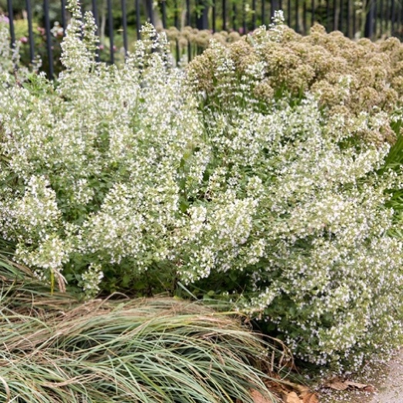
Images of the plant for inspiration:
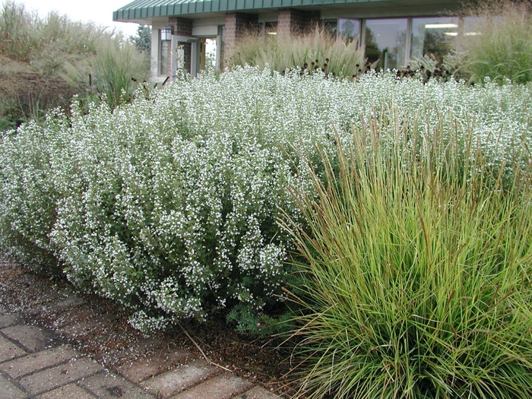

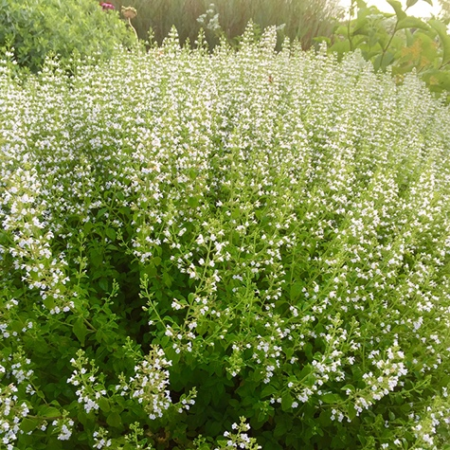
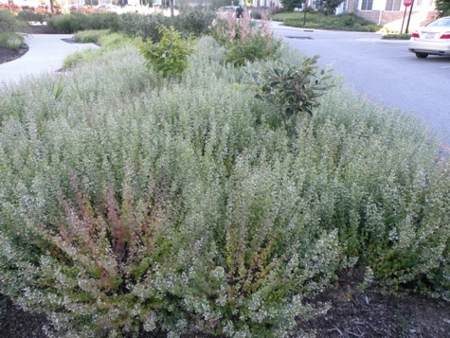

Our organization’s pantones (these do not necessarily need to be used)
