Brand research

Target Audience:
This veterinary practice will service the entire demographic of the population from young single professionals, to families, OAP’s and everything inbetween. They will have a range of incomes and values; some will want the cheapest care, whilst others will want the best service. I am not aiming to attract those who want the cheapest care, rather those who want value for money and exceptional service.

Competitors:
(In relevant order/distance from me) Top 4 are the main competitors, the others are more than 10 miles away. I have made comments on them.
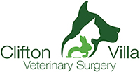
We care for pets in Cornwall | Clifton Villa Veterinary Surgery (clifton-villa.co.uk)
I like this logo, perhaps the best of all of them, mainly because I like the illustration, its clear but simple. I don’t like this green its very clinical.


stclementvets.co.uk
Not very clear illustration, also the use of primary colours….represents their Primal service.


Vets In Truro | Truro's Longest Established Vets | City Road Vets
Not awful, not very animal related. But fairly smart and can be abbreviated (to just the stamp)

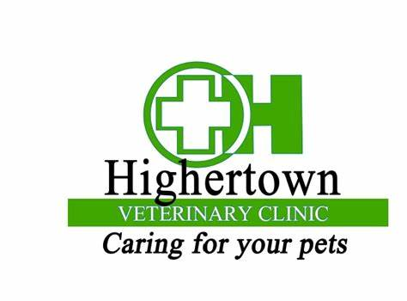
Too human clinical.

Your Local Truro Vet Clinic in Cornwall - Highertown Vet

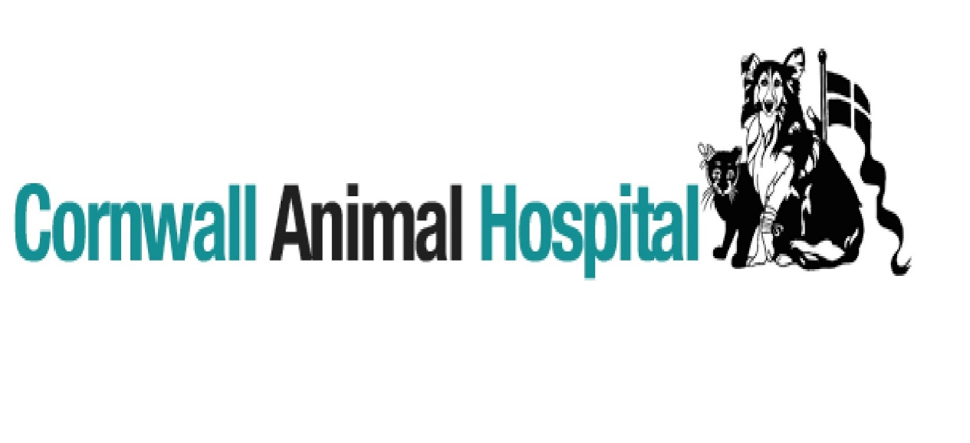
Illustration not very clear/too complicated
Cornwall Animal Hospital - We take care of pets in CornwallCornwall Animal Hospital | We take care of pets in Cornwall
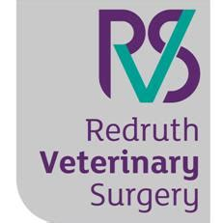
Welcome to Redruth Veterinary Surgery | North Street | Redruth | Cornwall (redruthvetsurgery.co.uk)
Just words is dull- picture/ illustration is a must for me.

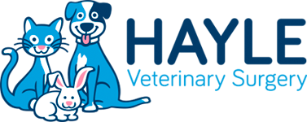
Hayle Veterinary Surgery (haylevets.co.uk)
Too much cartoon here.
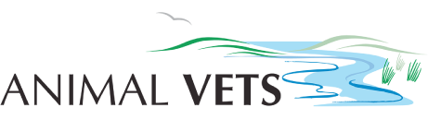
Animal Vets
The river seem a bit unrelevant, they are based in Hayle so I guess that is the connection.

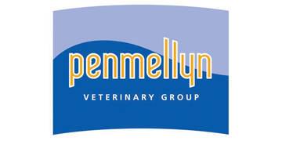
Penmellyn Vets | Local vets in Cornwall - Penmellyn Vets
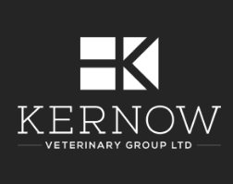
Vets In Cornwall | Local Vets In And Around Cornwall - Kernow Vet Group
Vets in Truro | Open on Sundays | Vets4Pets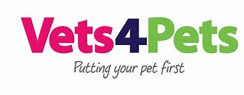
Too commercial.
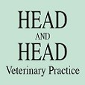
Head & Head Vets In Helston | Vets In Cornwall (headandhead.co.uk)
Is this even a logo.

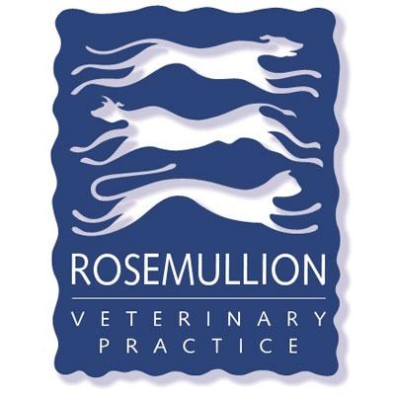
We care for pets in Cornwall | Rosemullion Veterinary Practice (rosemullionvets.com)
Looks old fashioned

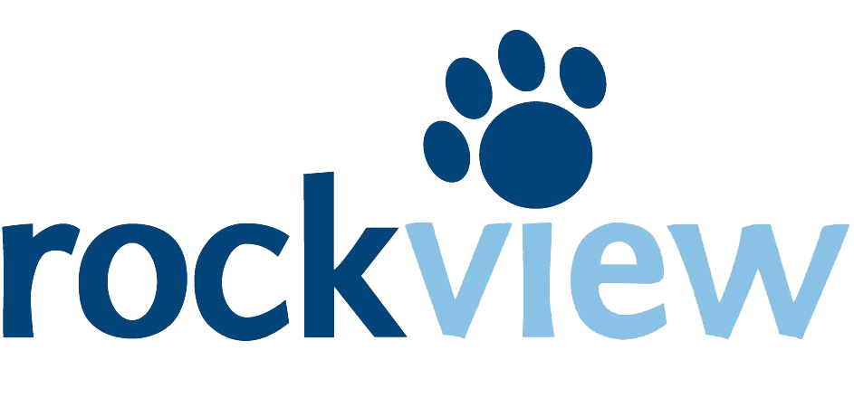
Rock View Vets | Affordable Veterinary Care
Not a fan of the colours, want to stay away from this kind of Blue as is the same colour schemes as PDSA charity practice.

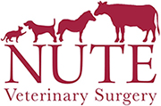

We care for pets in Wadebridge | Nute Veterinary Surgery (wadebridgevet.co.uk)
I like the animals on top of the letters- bringing the illustration into use with the words.

I am not sure if I want Edhen Veterinary Surgery to emphasis the Edhen or the Veterinary bit. I like the way the NUTE logo works in terms of the wording front size. But I don’t want EDHEN in CAPS, Edhen looks much nicer. This excersise has made me realise how important fonts are, I don’t want curvy and curly… comic sans… no thank you, something professional and traditional without typewriter effect or times new roman!

Brand Values:
First draft visions/values:
An independent practice that provides consistency, flexibility with a focus on communication with a down to earth approach to developing a plan for each individual case
This will be achieved by 4 main strategies:
- ‘small is beautiful’- independent and focusing on relationship with clients and delivering an exceptional trusted professional service.
- Vet; client relationship- we plan on working together with our clients to keep them informed at every step of the way delivering our knowledge to them so they can make informed decision about their beloved pets.
- Always wanting the best for each animal, working with a range of budgets and family situations to come up with a solution and a treatment plan that will work logistically and be successful.
- Team approach- the team will be trusting of each other and all staff will understand each others roles and so that they work together; delivering a service to the client that makes them feel like the entire team have contributed towards their experience with us.

