PASTURE RAISED EGGS

CA SEFS Compliant
medium, Grade AA
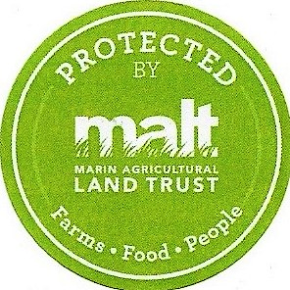
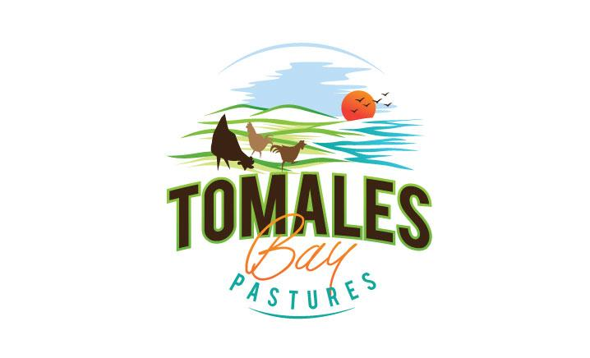
Corn & Soy Free Diet

Pack Date:117
Sell-By Date:05.26.17
14990 State Route One, Marshall CA, 94940
CA 3066
1 Dozen- Keep Refrigerated

CA SEFS Compliant
medium, Grade AA

PASTURE RAISED EGGS
Corn & Soy Free Diet

Pack Date:117
Sell-By Date:05.26.17
14990 State Route One, Marshall CA, 94940
CA 3066
1 Dozen- Keep Refrigerated

