Design example we like

Slide:

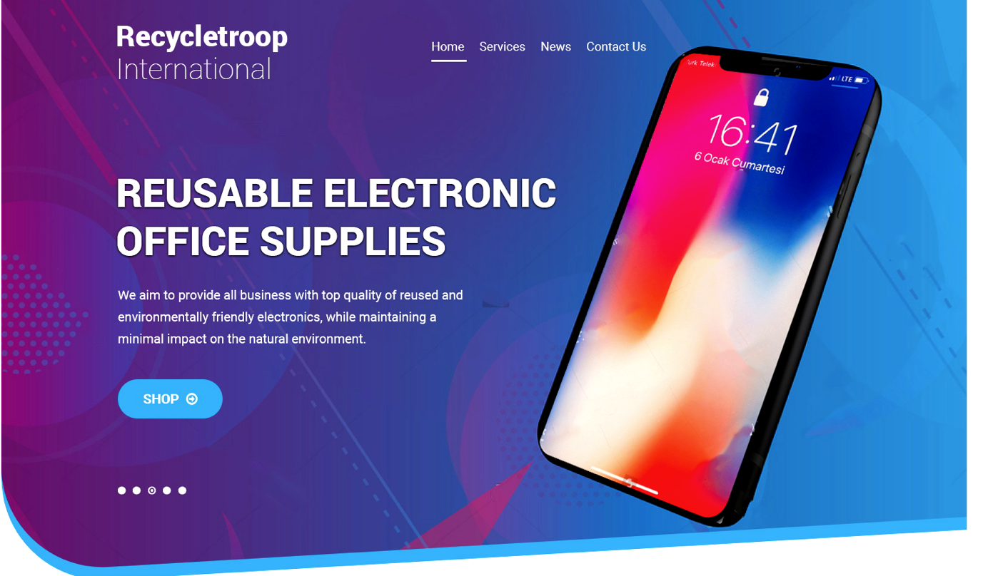
The blue outline of the slide can be removed, and if possible make the slide fully rectangular like the below image:
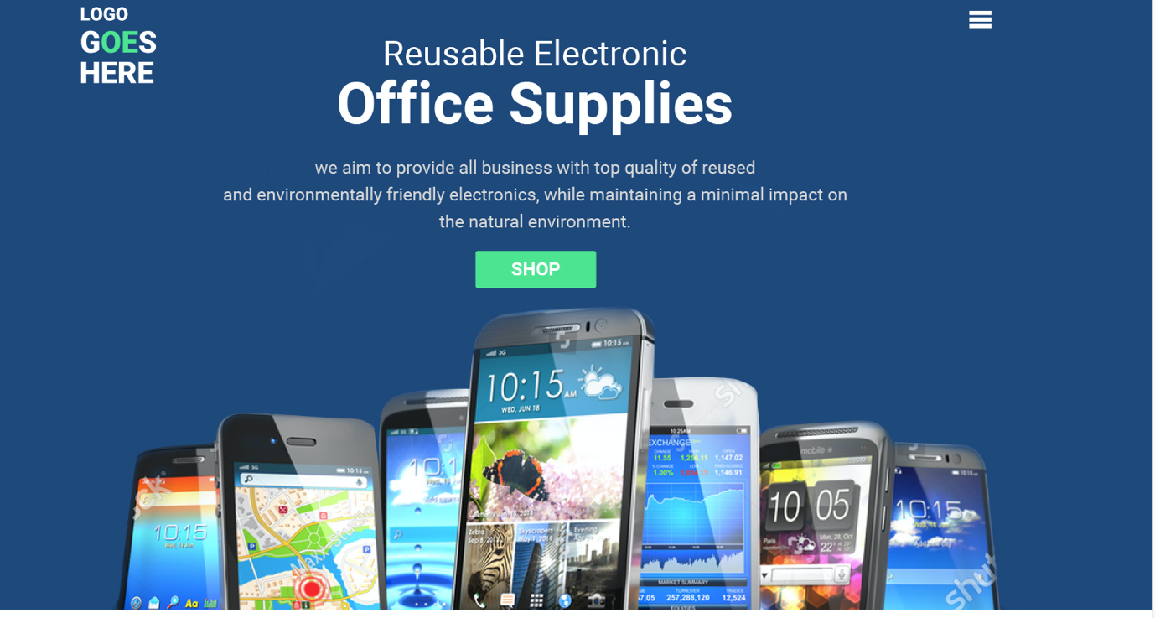

The background for the slide should be similar to the first image, you can see it’s a “tech” background. And as for the website color theme, we want Blue, green and white like below image. Please also note that the slide can display a combination of the following products: Laptop, iPhone, iPad, Apple watch. The products should not be with broken displays.

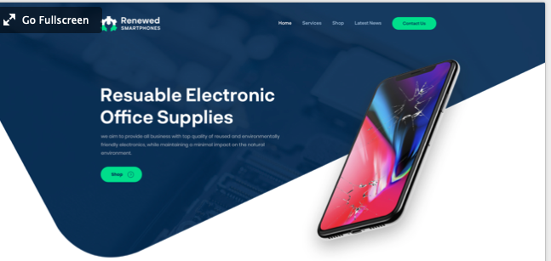

For the next section after slide, we like the below example, the colors should batch our overall theme colors.
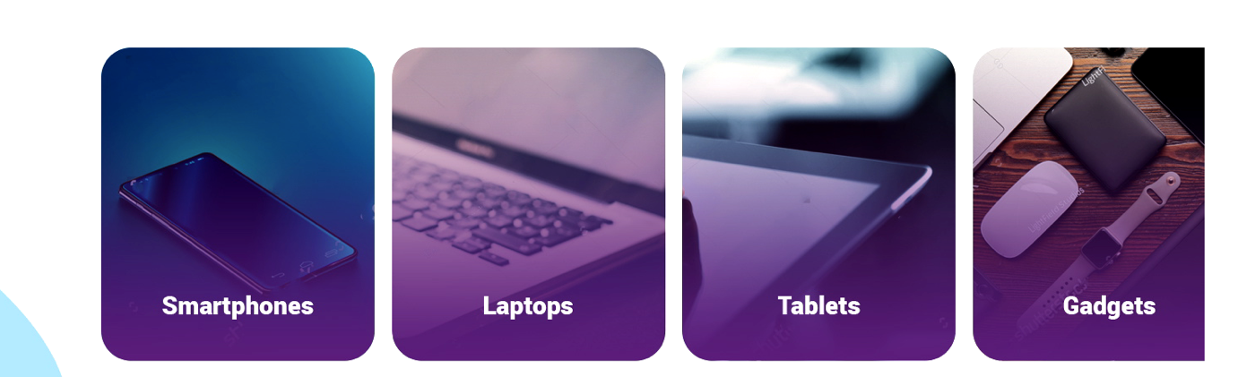

Next section is a bit about what we do:

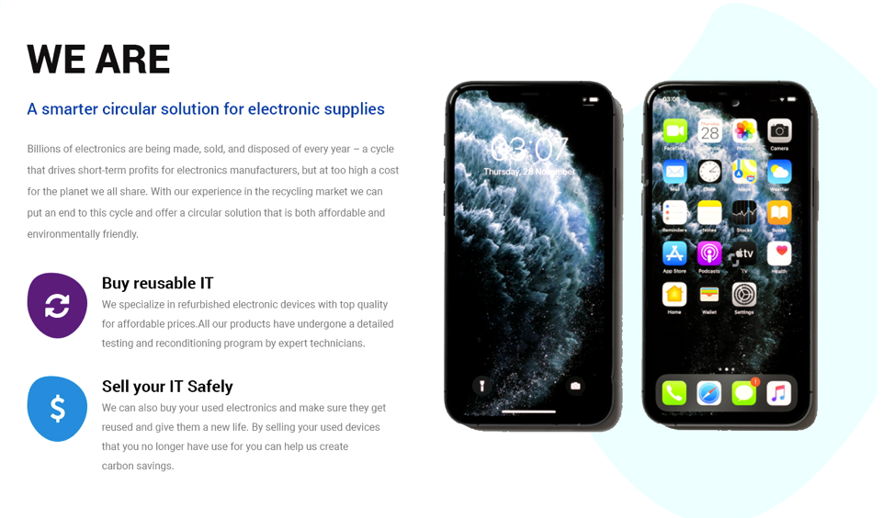
This design is good, just need to change the image to something similar as below:

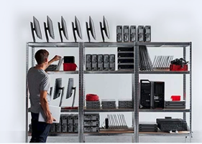

Next section is an overview of our services and the below designs is good:

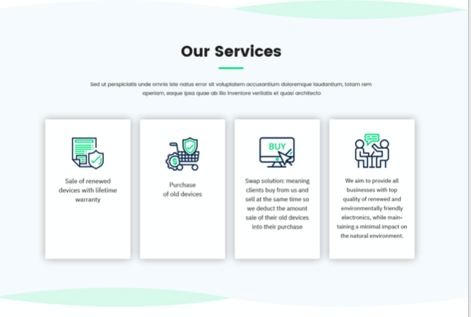

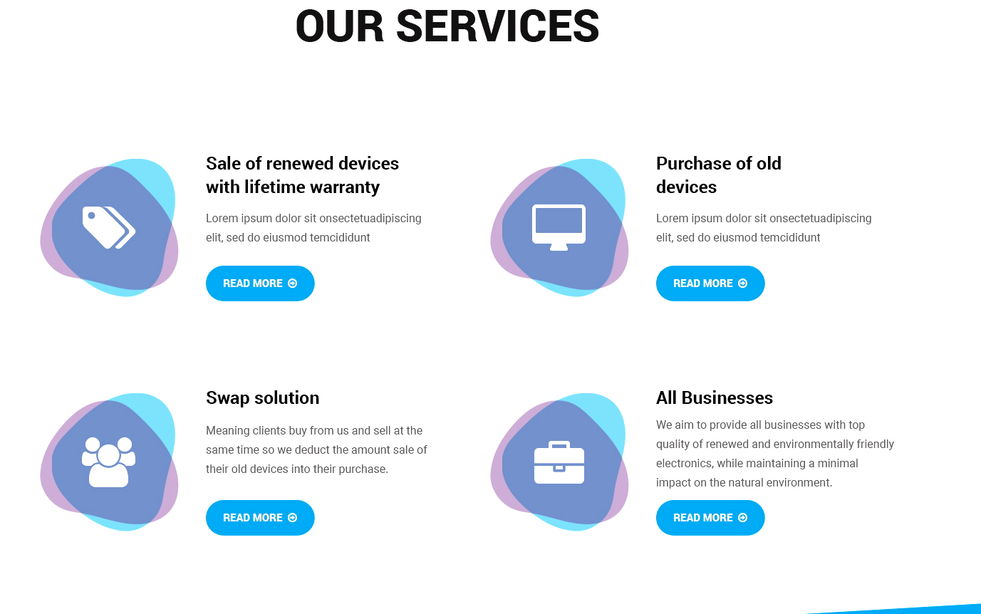

The symbols need to change, we need symbols matching the services:
- Sale Renewed devices (perhaps incorporate a recycling symbol and devices symbol)+ 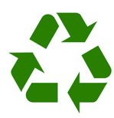

- purchase of old devices (integrate the device with Dollar symbol) 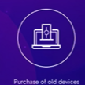

- Swap ( integrate the swap symbol) 
- All businesses (incorporate perhaps globe with leaf) 

Next section we want to show similar to this:


The text should be: Save up to 60% on our renewed devices

Next section we need is to show clients price examples of our devices since we will not have a webshop integrated we want to give clients an idea oof what prices we offer and a good way to do this is something like this:

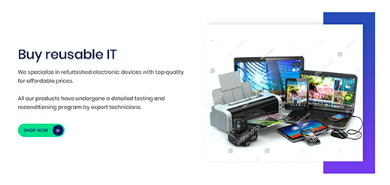

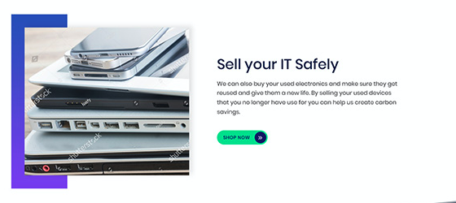

For these two above, we will show one for laptop, we will write the brand name of the laptop first for example: DELL 5470.
And for the price comparison between buying new or buying from us:
Our price: 590$
New price: 1390$
Total saved: 60%

For the next box we will do same but for iPhone:

Model name: iPhone XS 256 GB
Our price: 550$
New price: 790$
Total saved: 30%

Next section we need to add testimonials, and good example is this:

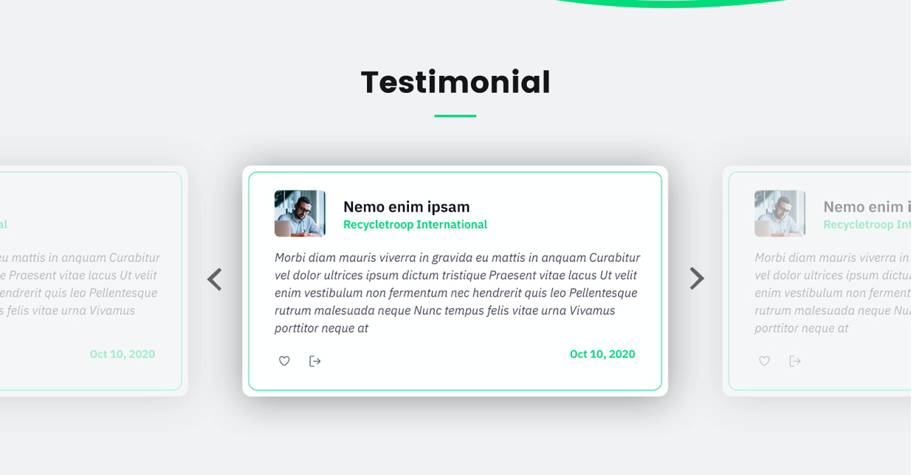

Next section:

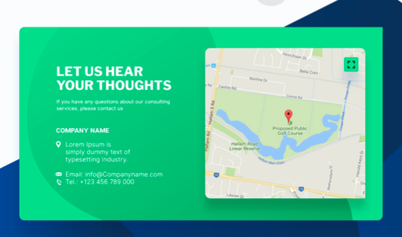

This one will be incorporated with our footer.
