Here are theme exacmples we like :
http://preview.themeforest.net/item/tekhfixers-mobile-device-repair-wordpress-theme/full_screen_preview/23115924?_ga=2.113801223.1411919418.1606926108-731024577.1604572554

https://xecgroup.se

http://themes.webdevia.com/phonerepair/

some of our competitors website which you can check and use content from. Their design not so good , so we need better more modern one:
https://www.inrego.com
http://www.mobii.eu

- Slide

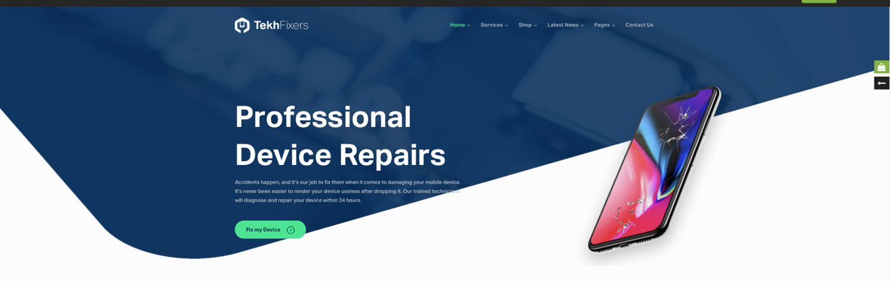

Logo and company name: pending

Slide big text: REUSABLE ELECTRONIC OFFICE SUPPLIES
Slide small text: we aim to provide all business with top quality of reused and environmentally friendly electronics, while maintaining a minimal impact on the natural environment.

The green button name should be: SHOP

- After slide section
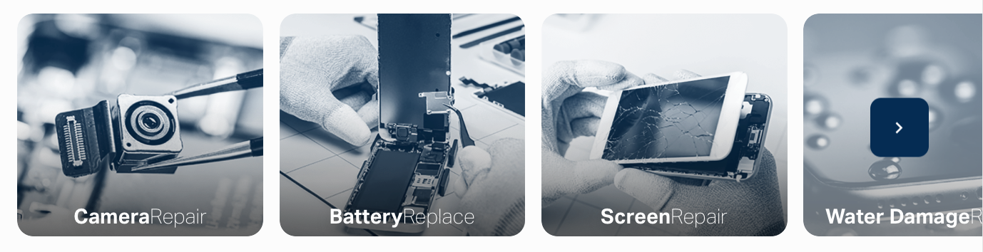

The names for each of these boxes will be:

- Smartphones
- Laptops
- Tablets
- Gadgets

- Information section
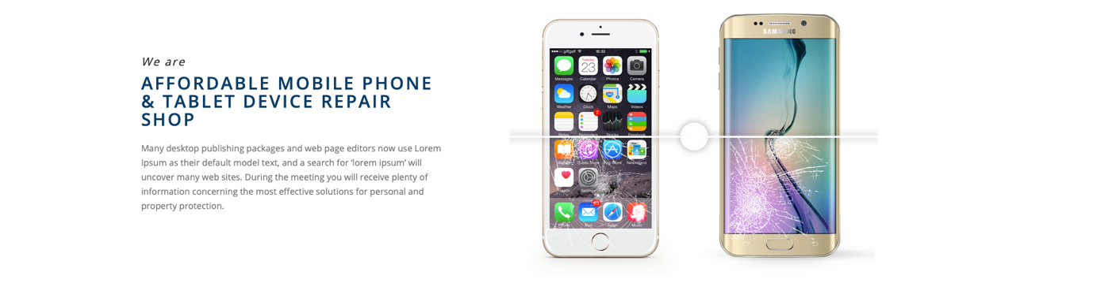

Content for this:

We are
A smarter circular solution for electronic supplies
Billions of electronics are being made, sold, and disposed of every year – a cycle that drives short-term profits for electronics manufacturers, but at too high a cost for the planet we all share. With our experience in the recycling market we can put an end to this cycle and offer a circular solution that is both affordable and environmentally friendly.

Buy reusable IT
We specialize in refurbished electronic devices with top quality for affordable prices.
All our products have undergone a detailed testing and reconditioning program by expert technicians.

Sell your IT Safely
We can also buy your used electronics and make sure they get reused and give them a new life. By selling your used devices that you no longer have use for you can help us create carbon savings.

