Logo Design Brief

Job Type
Logo and Business Card Design

Industry / Entity Type
Facilitation Team

Task Outline
Create a logo and business card design

Task Description
This project is to design a logo and business card for a start-up facilitation team, “The Page-Turner” that aim to facilitate knowledge, training and practices related to the metal health and personal growth.

The meaning of “The Page-Turner” is a very exciting, interesting book. Our life is also like a book and we are the writer who can create our life in an interesting and exciting way. Our team purpose is to provide and facilitate required information, knowledge and training related to mental health and personal growth to the people who might need them, so that they can shape their life better and turn it into a Page-Turner. This is the message we would like to deliver through this logo.

Hope you can relate to that and create your best one for us. Thank you in advance!

Logo Text
“ The Page-Turner ”
Tagging: “ Turn the page. Write a new story! ”

Logo Styles of Interest
Emblem Logo
Logo enclosed in a shape

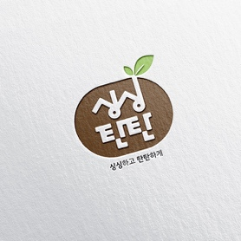

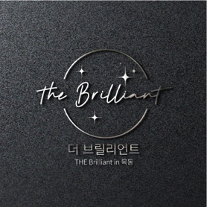

Pictorial / Combination Logo

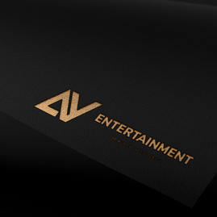


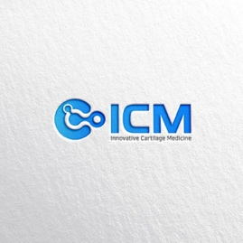

Deadline
10th Dec 2020

Color References

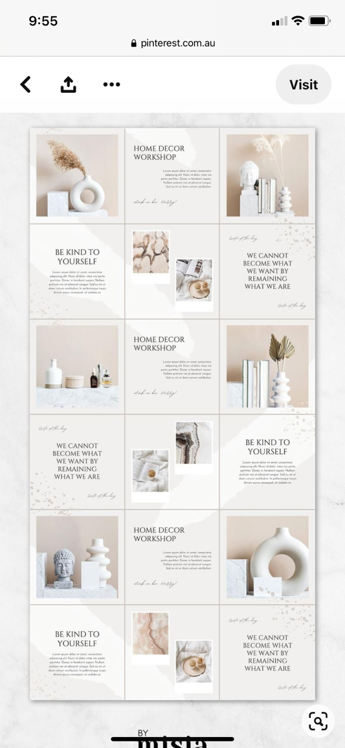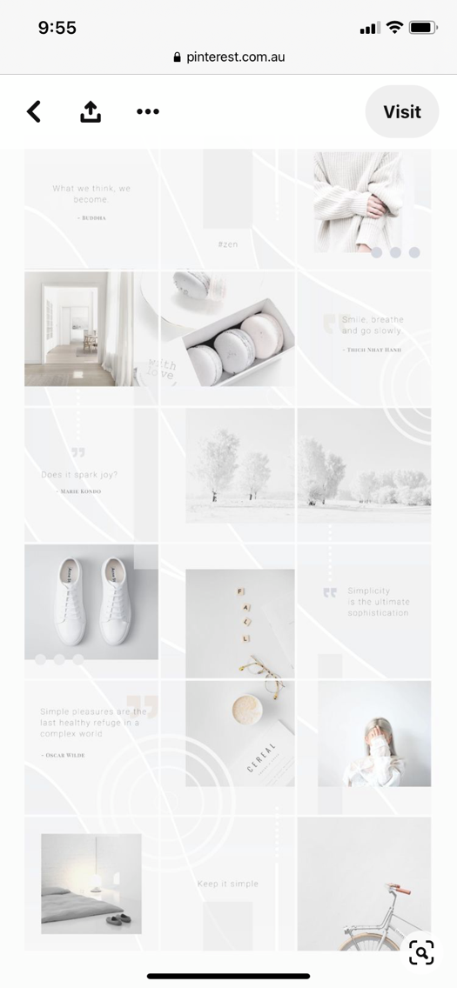

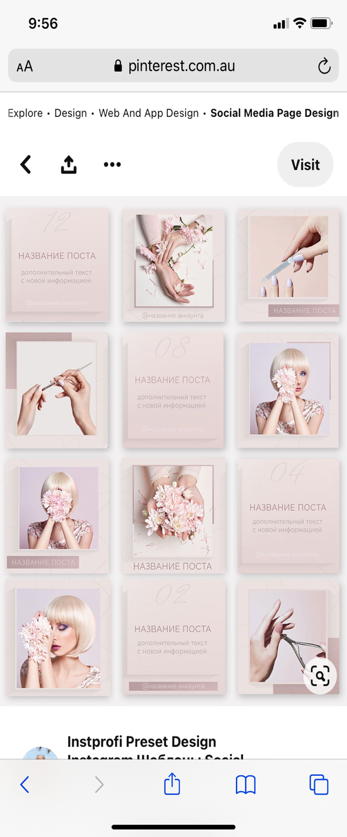

Logo Design Requirements

Must Have:
- We would like the logo that reflect the meaning of our purpose.
- The logo can be included a book and fountain pen, should look simple and attractive.

Nice to Have:
- We are open to colours and creativity; however, we prefer the calm and supportive colour family.
(please refer to the color references photos above)

