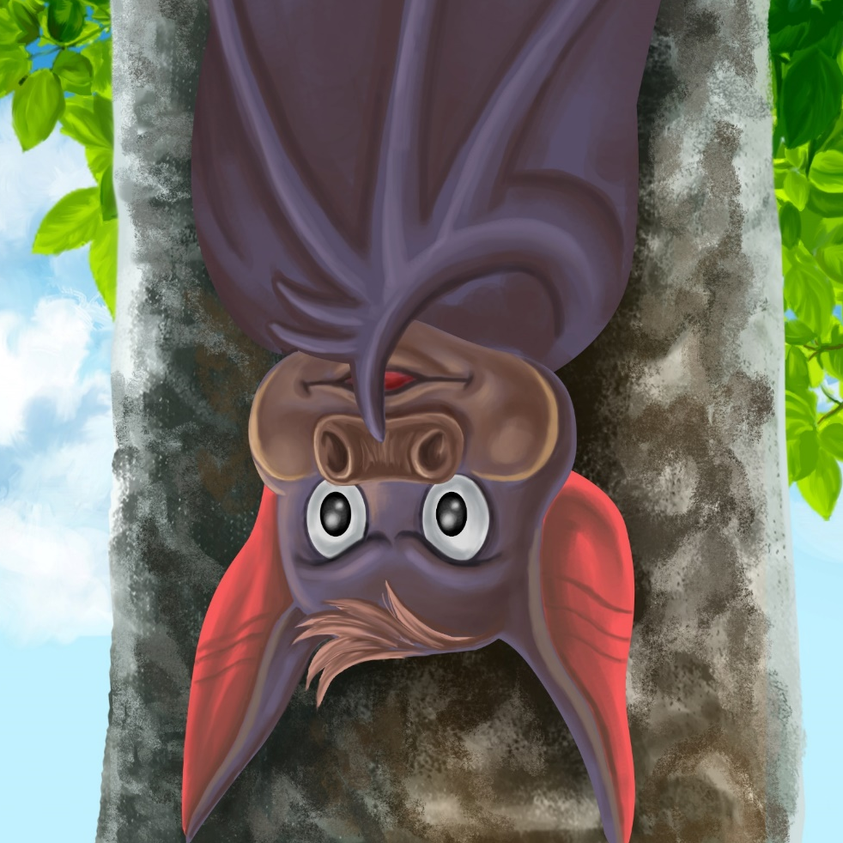
Bat Needs
a Nap
By Maggie Boston
Illustrations by Susan Trisna

Bat Needs a Nap
Book 8

This reader for young children is part of a reading series for the Better Start Literacy Approach. Each book provides reading practice for children to decode and understand short words with a focus on target consonants and vowels. The reader has been designed to support class teaching activities that are part of the Better Start Literacy Approach.

The Better Start Literacy Approach has been developed through the University of Canterbury Child Well-being Research Institute. The lead research team includes:
Professor Gail Gillon, Associate Professors Brigid McNeill and Alison Arrow, Drs Amy Scott and Amanda Denston and Professor Angus Macfarlane.

To access these readers online in narrated and book form, please visit https://sites.google.com/view/betterstart-whānau/home and click on the ‘Children’s Readers’ tab.
Published February, 2020, UC Child Well-being Research Institute.



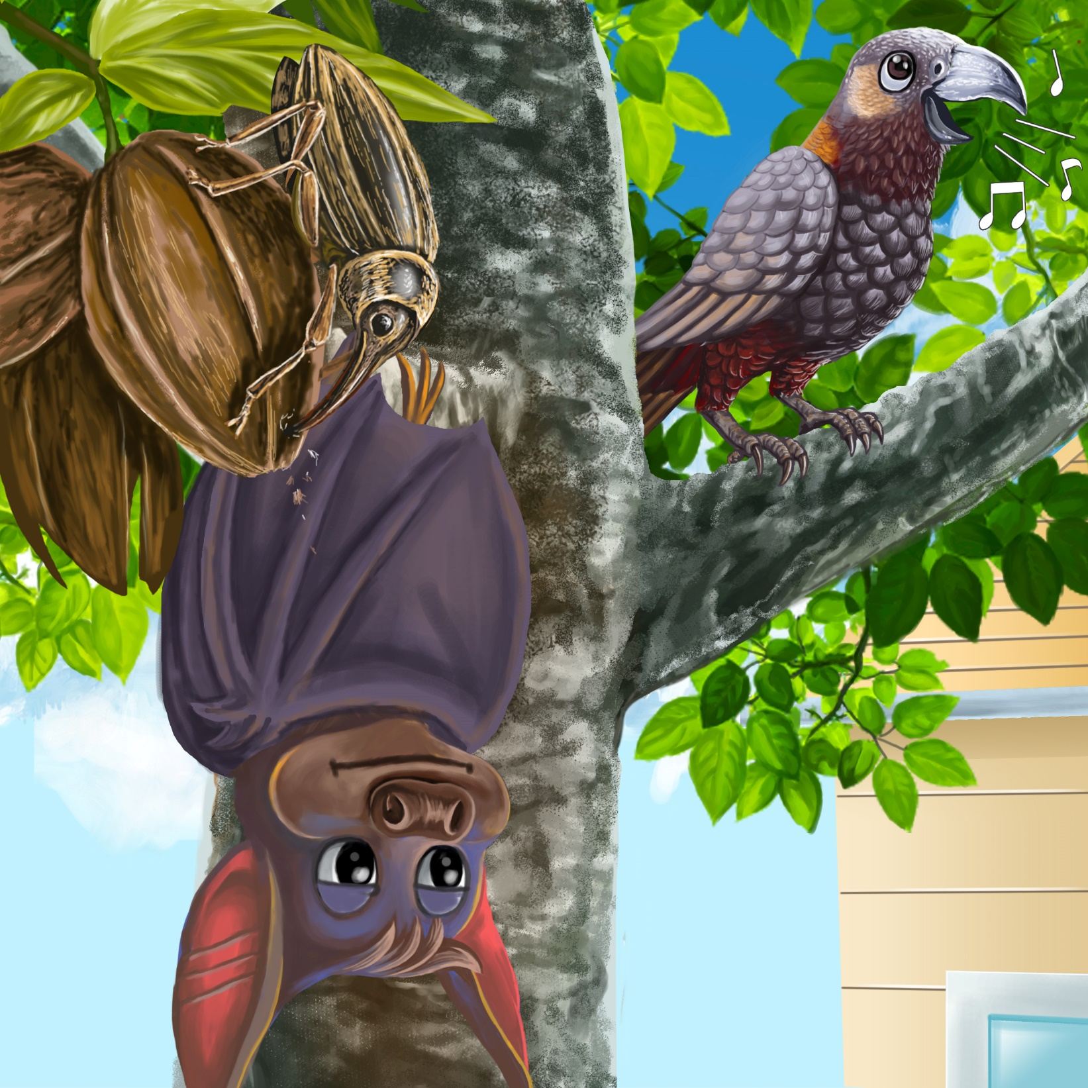
The Better Start Literacy Approach is supported by the
A Better Start National Science Challenge, a 10-year programme of research investigating practical, evidence-based solutions that make a measurable difference for our tamariki. https://www.abetterstart.nz/

Bat needs a nap, but Manu sings.
A bug taps a nut.

Bat needs a nap, but Dad cuts a log.
Nan hits a mat.
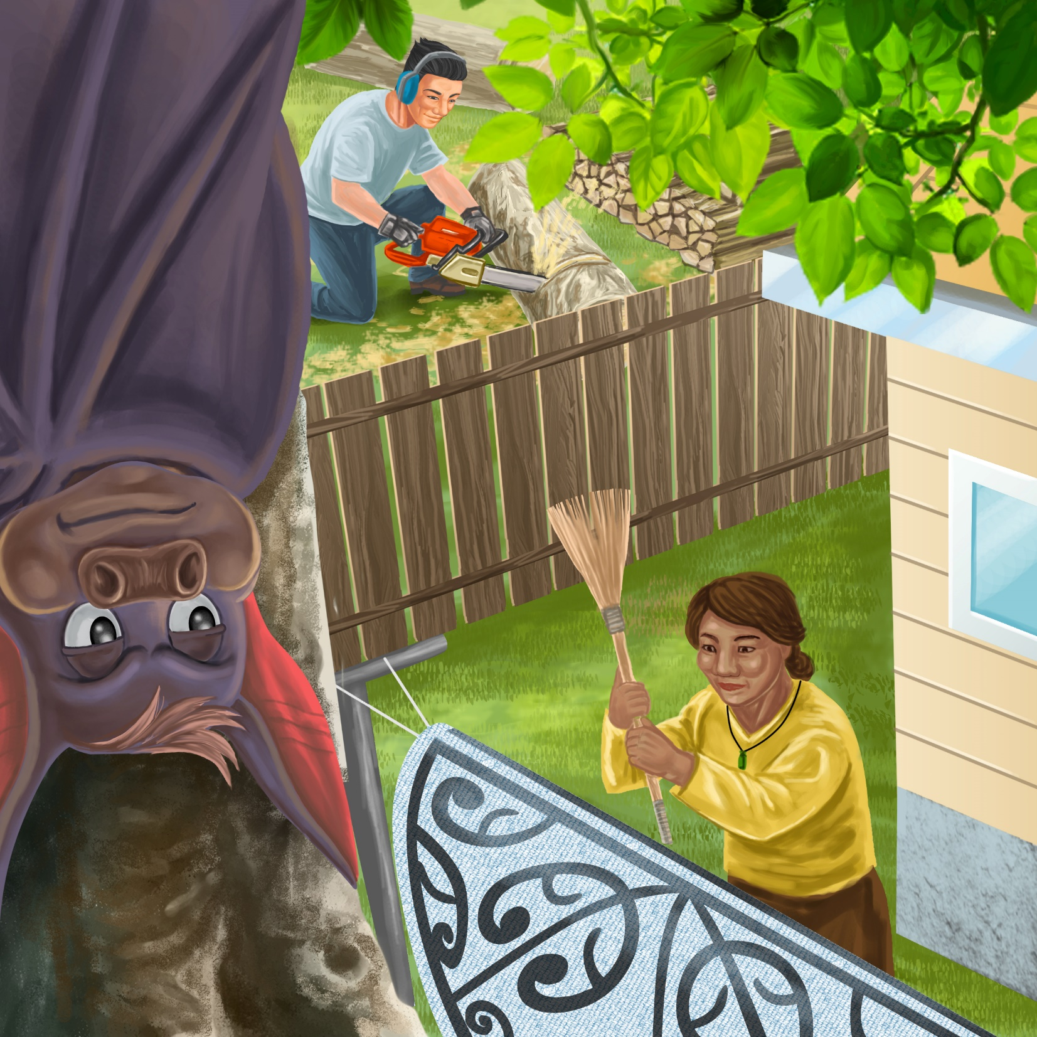

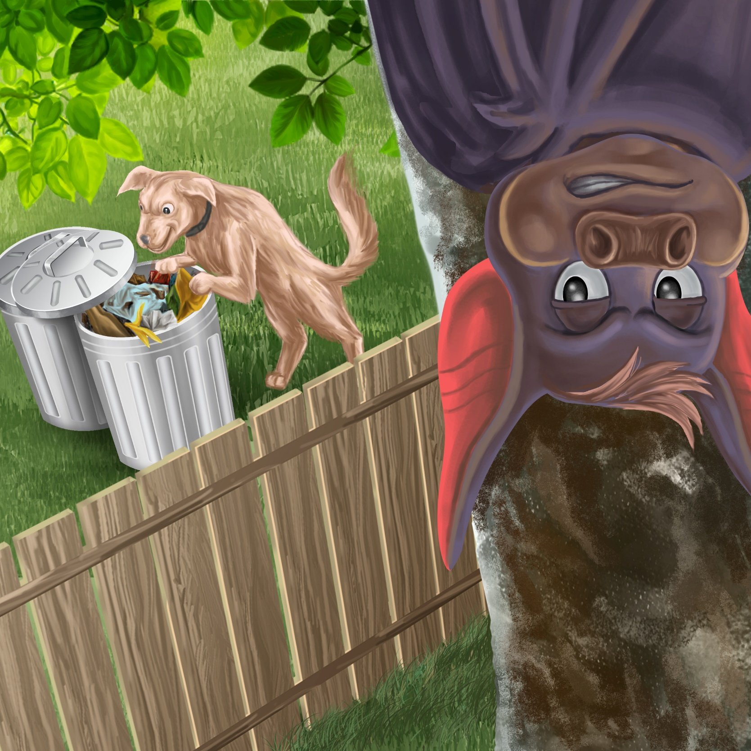

Bat needs a nap, but Don tips the lid.
The lid hits a bin.
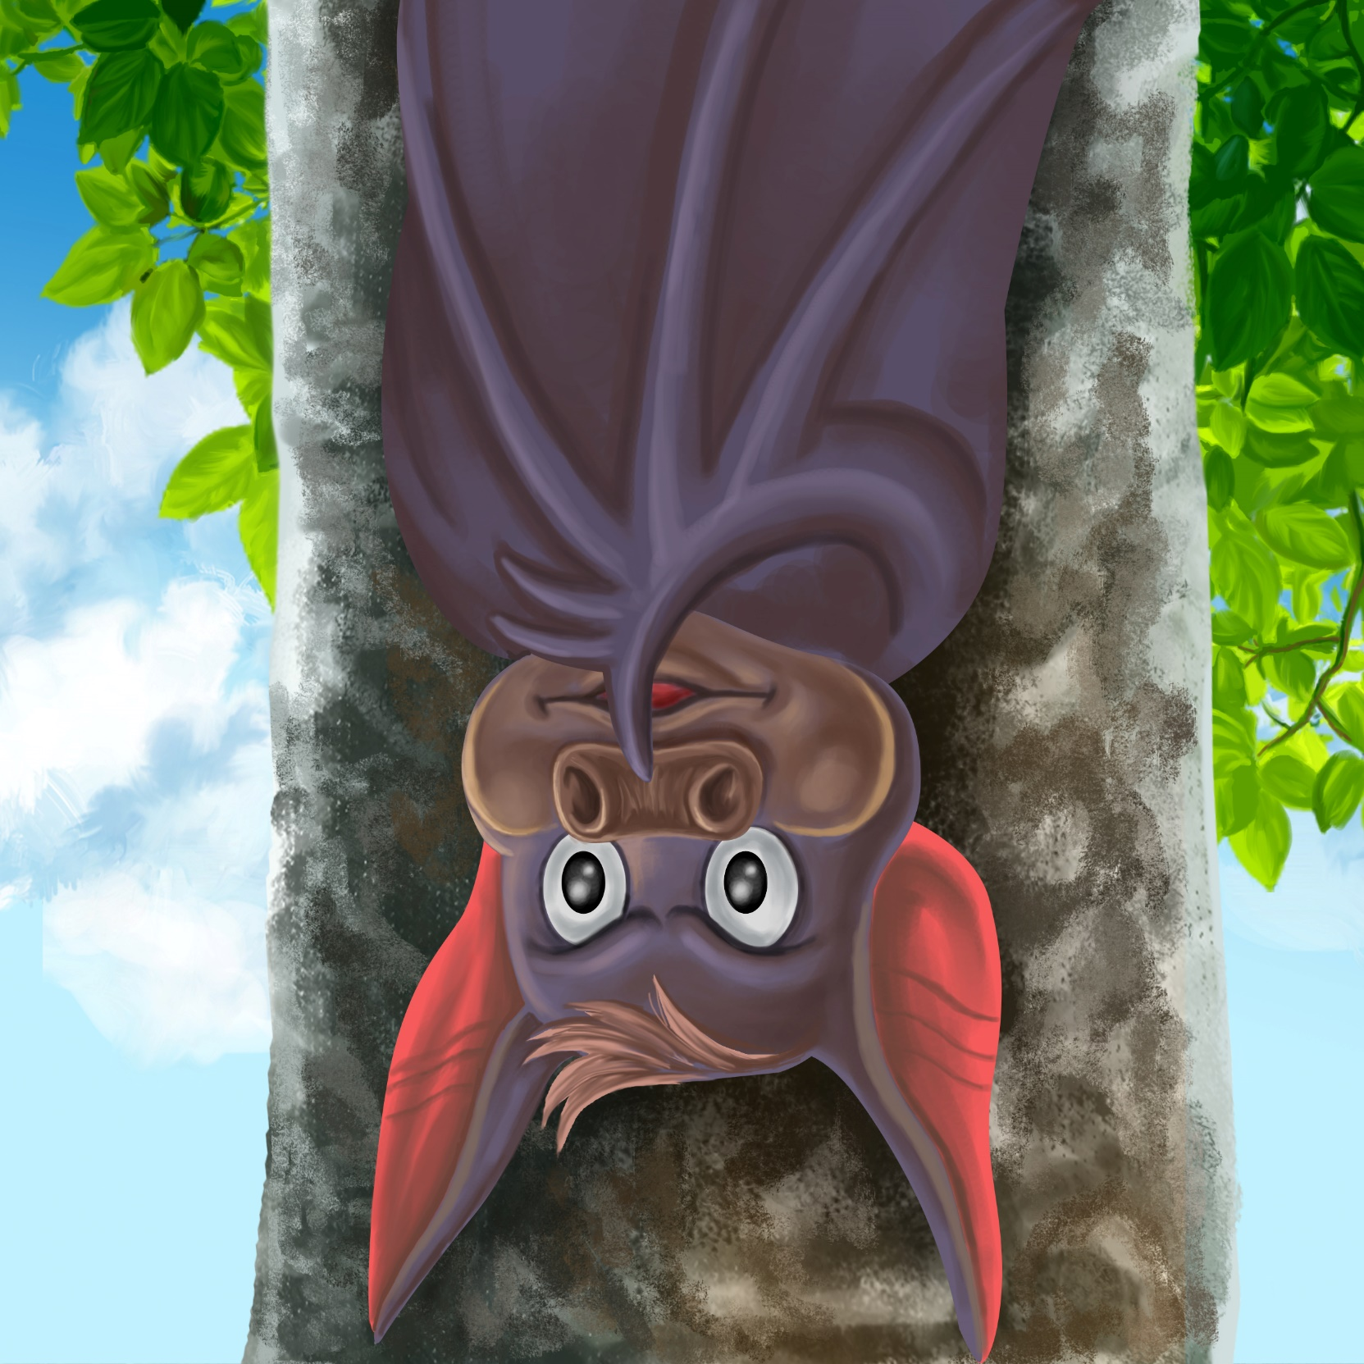

“Shhh!” says Bat.
“I need to nap.
I can not nap with this big din!”

Teaching Notes: Book 8 Bat Needs a Nap
Reading Practice: This story provides children with practice in decoding and understanding short words with a focus on words that start with n and b consonants and include a, o, and i vowels.

Introduce the text and read the story aloud together, pointing to each word as you read. Encourage children to help you “sound out” the regular words in the story (see words in bold print below). Help children sound out the word and then blend the sounds together, for example, n-a-p = nap. When reading unknown high frequency words (e.g., sings, needs), tell children the words as you read together. Give plenty of praise for children’s reading attempts and encourage re-reading to build fluency and accuracy.

Bat needs a nap, but Manu sings.
A bug taps a nut.
Bat needs a nap, but Dad cuts a log.
Nan hits a mat.
Bat needs a nap, but Don tips the lid.
The lid hits a bin.
“Shhh!” says Bat.
“I need to nap.
I can not nap with this big din!”

Phonological Awareness
Practice segmenting and blending words. Ask children to clap out each phoneme (sound) in the word: b-a-t (3 sounds, 3 claps), l-o-g (3 sounds),
h-i-t-s (4 sounds). Help children to find each word you segment on the page.
Think of all the words you can that start with an n or b sound. Find objects in the room that start with an n or b sound.

Spelling
Listen and identify where the sound changes occurs in words. Use the phrasing: “If this word spells bat, can you make it say pat. If this word says pat, can you make it say pot.”
Give plenty of praise and encouragement for reading and spelling attempts.
Change bat to pat to sat
Change din to den to pen

Vocabulary
Explain the meaning of tap: tap means to knock on something gently. Make up sentences using the word tap.

Story Discussion
Discuss why all the different sounds were keeping Bat from having a nap. Talk about a time you could not fall asleep and what you did to fix that.

Story Retell
Ask children to re-tell the story to a friend. Prompt as necessary using picture cues. Give plenty of praise and encouragement.

Print Concepts
Discuss the use of exclamation marks in the story. Exclamation marks are used to show a rise in feeling or volume (e.g., excitement or anger).

