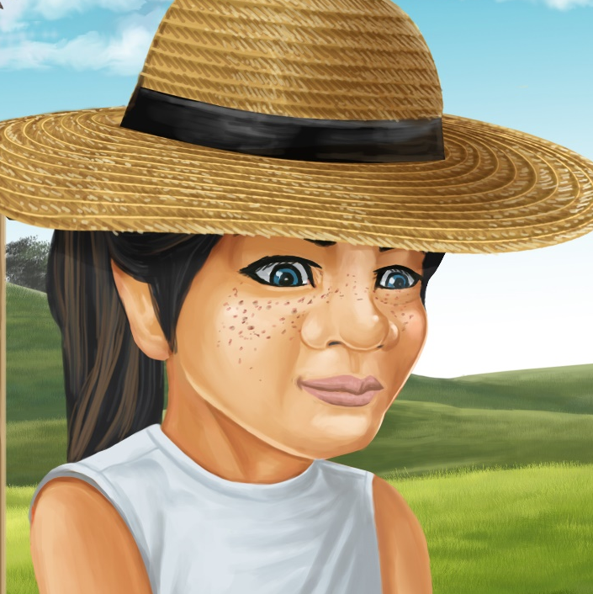

Pam’s Bee Sting
By Maggie Boston
Illustrations by Susan Trisna

Pam’s Bee Sting
Book 19

This reader for young children is part of a reading series for the Better Start Literacy Approach. Each book provides reading practice for children to decode short words with a focus on target consonants and vowels. The reader has been designed to support class teaching activities that are part of the Better Start Literacy Approach.

The Better Start Literacy Approach has been developed through the University of Canterbury Child Well-being Research Institute. The lead research team includes:
Professor Gail Gillon, Associate Professors Brigid McNeill and Alison Arrow, Drs Amy Scott and Amanda Denston and Professor Angus Macfarlane.

To access these readers online in narrated and book form, please visit https://sites.google.com/view/betterstart-whānau/home and click on the ‘Children’s Readers’ tab.
Published February, 2020, UC Child Well-being Research Institute.

The Better Start Literacy Approach is supported by the
A Better Start National Science Challenge, a 10-year programme of research investigating practical, evidence-based solutions that make a measurable difference for our tamariki. https://www.abetterstart.nz/



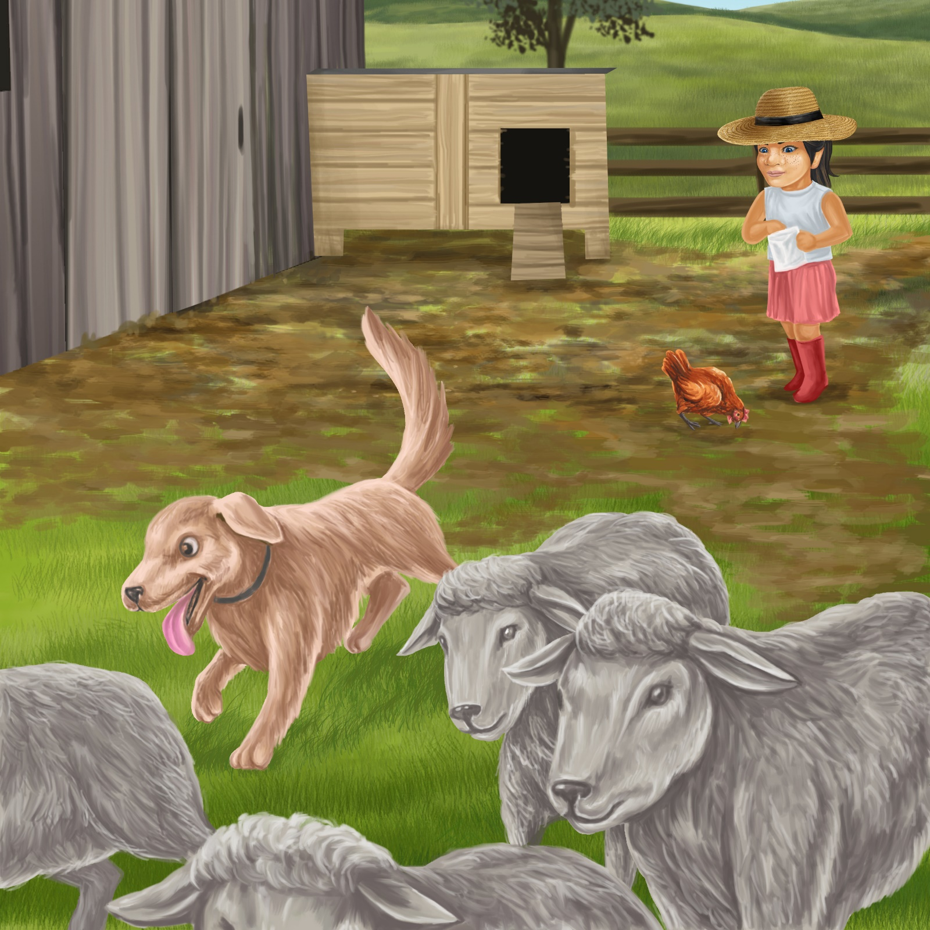

Pam and Don have fun on Pop’s farm.
Don likes to chase the sheep.
He chases the sheep down the hill.

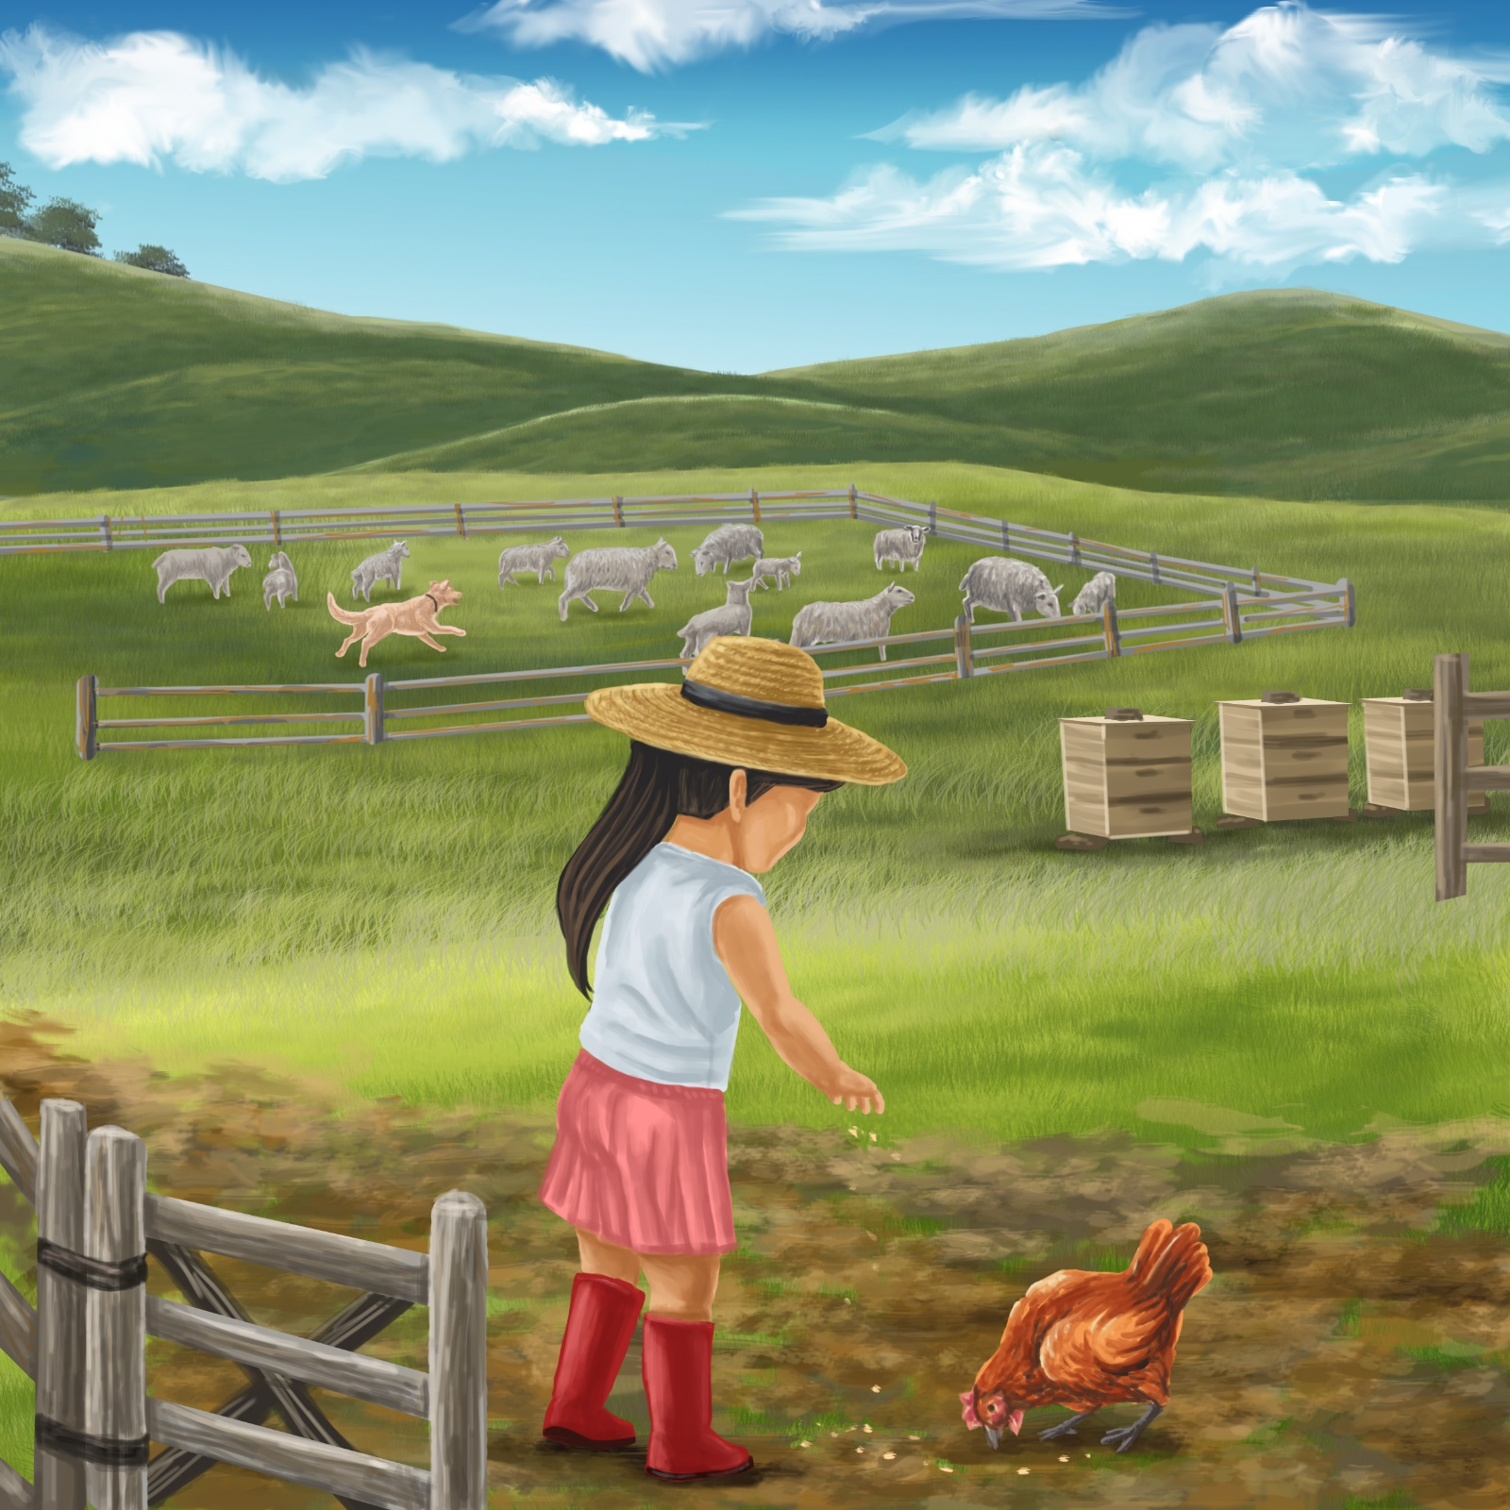

Pam likes to feed the little red hen.
She feeds the hen by the shed.
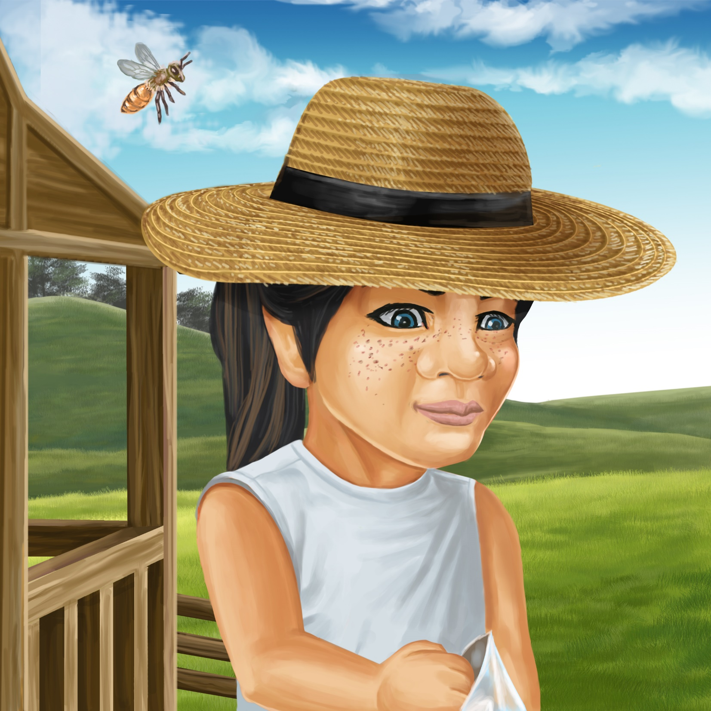

It is a hot day.
Pam has a big hat on her head.
A bee comes out of the bee hive.

The bee lands on Pam’s hat.
Pam swipes her hand at the bee.

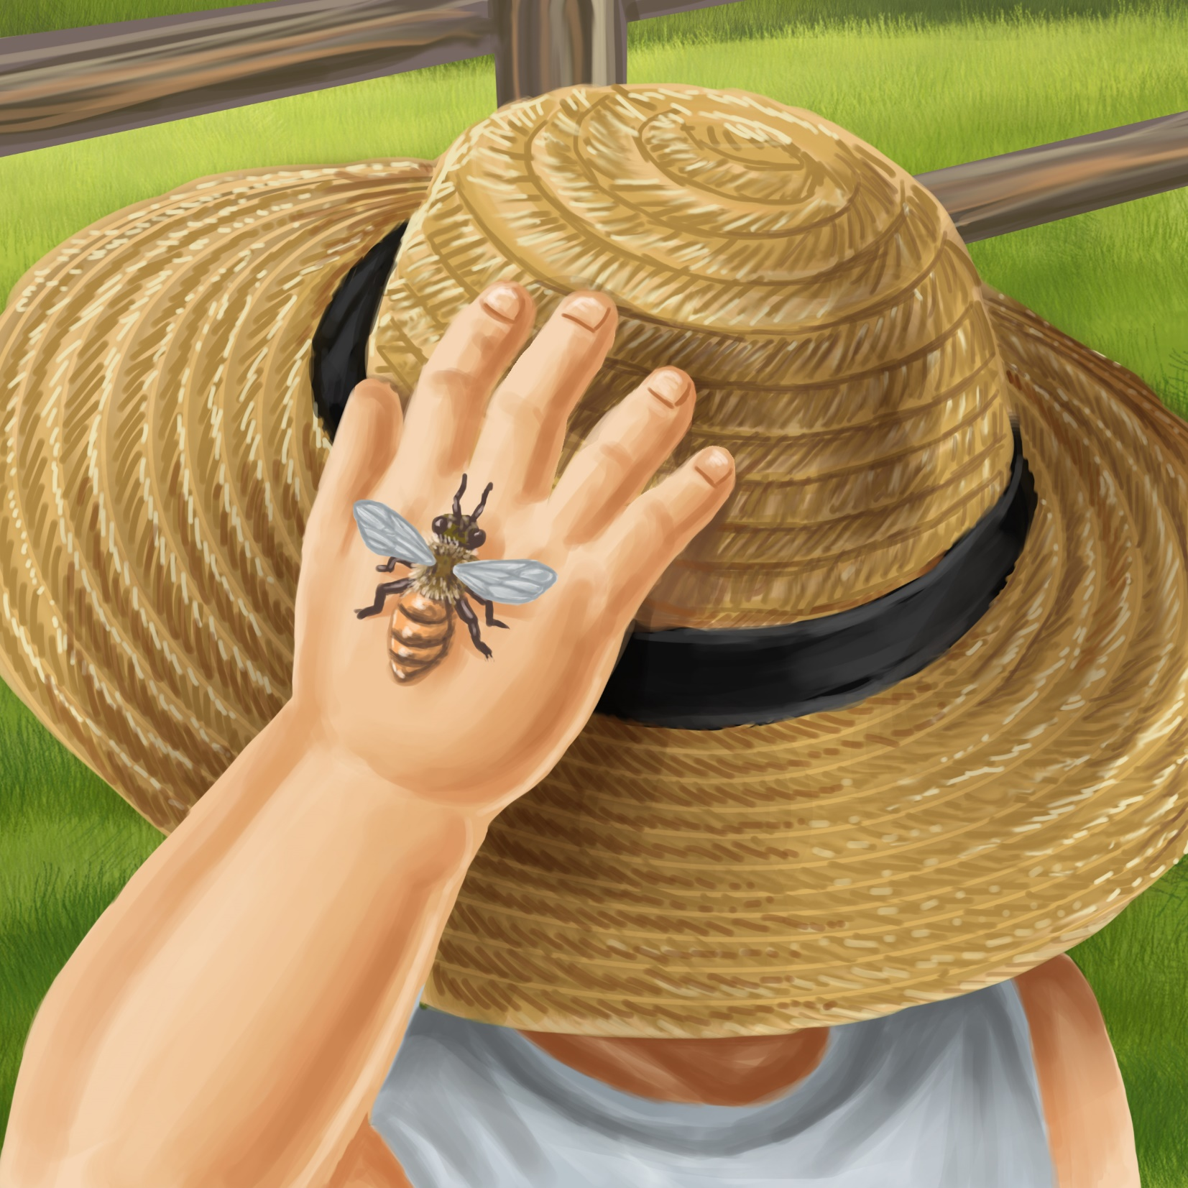
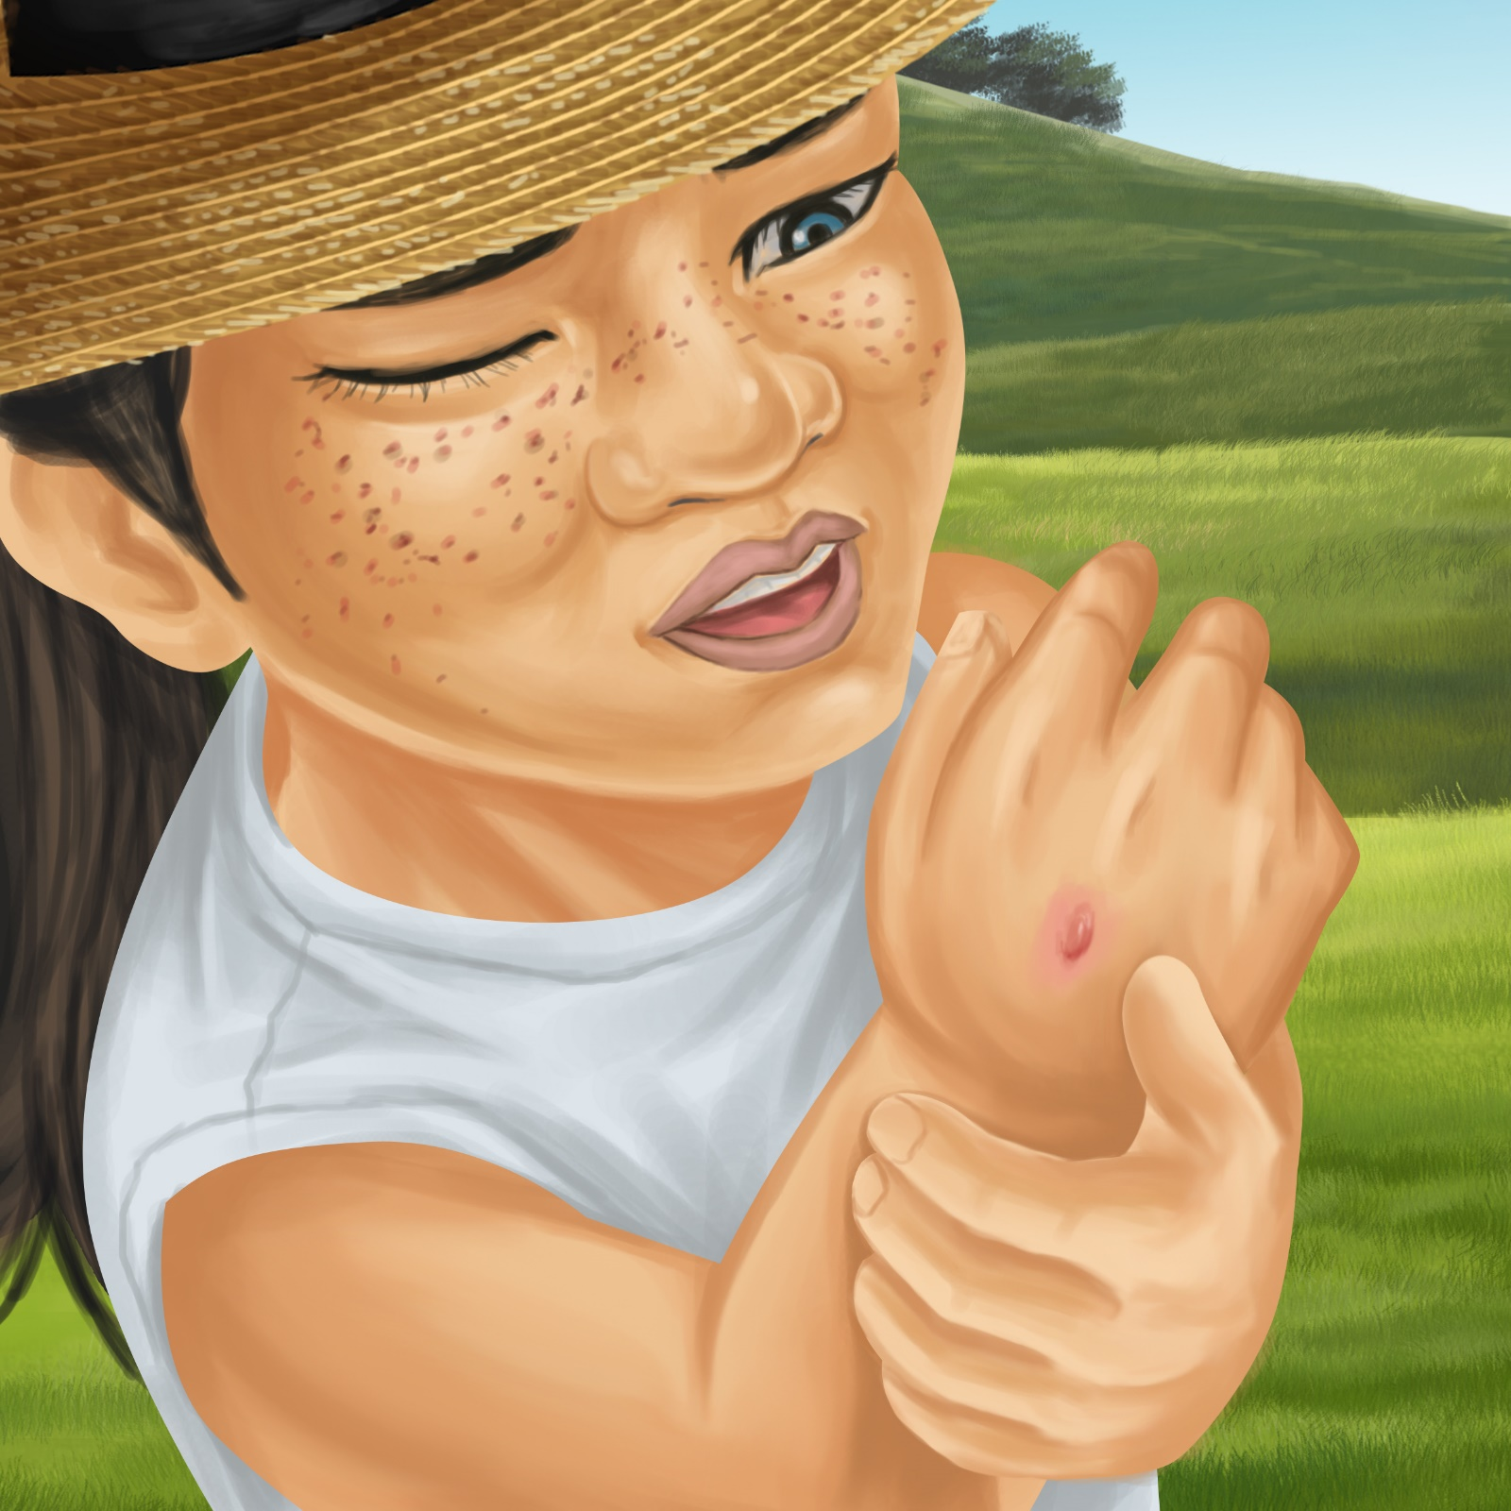

“Ouch!” says Pam.
“My hand hurts.
I have a bee sting on my hand!”

Pop stops his work in the shed.
He runs out of the shed.
He runs to Pam.

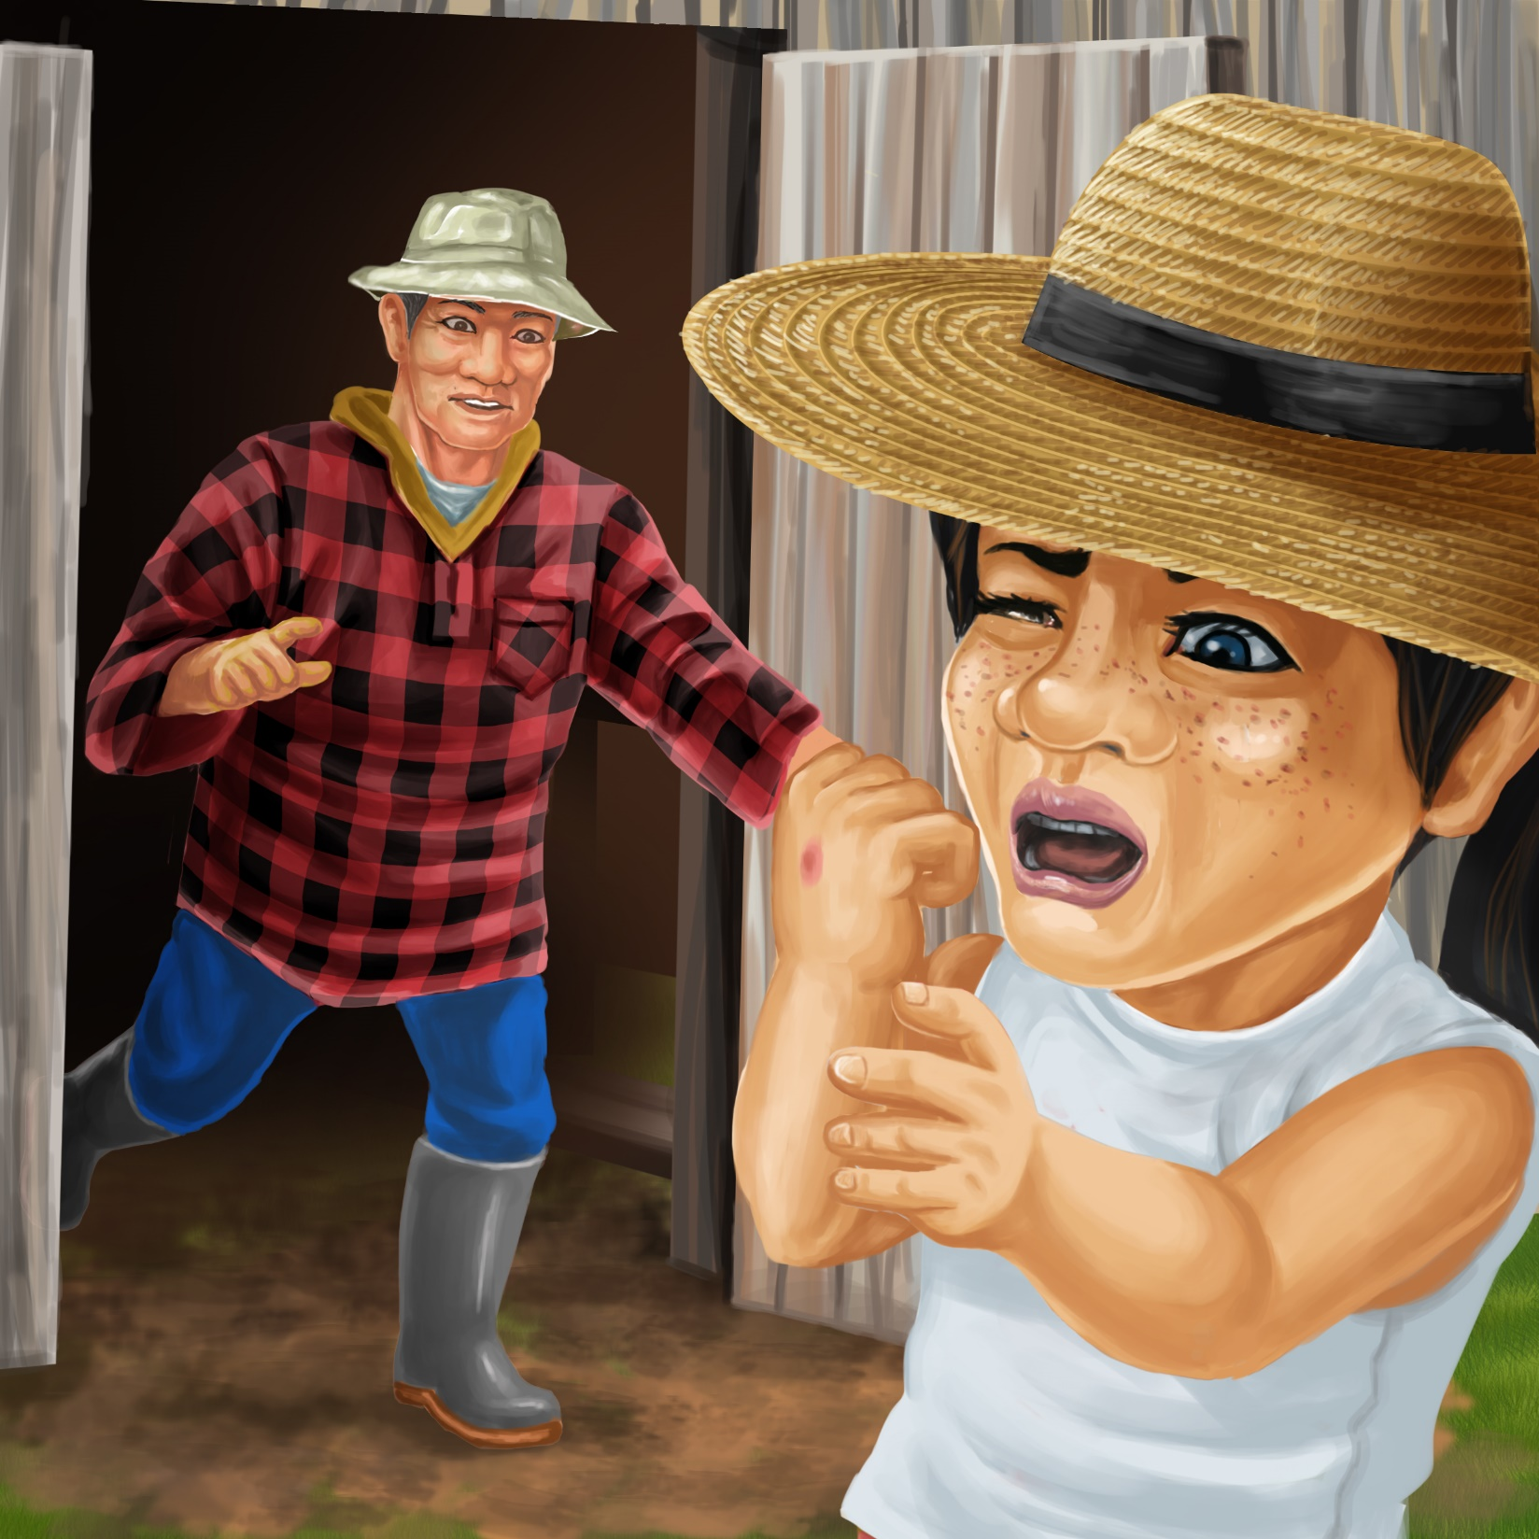
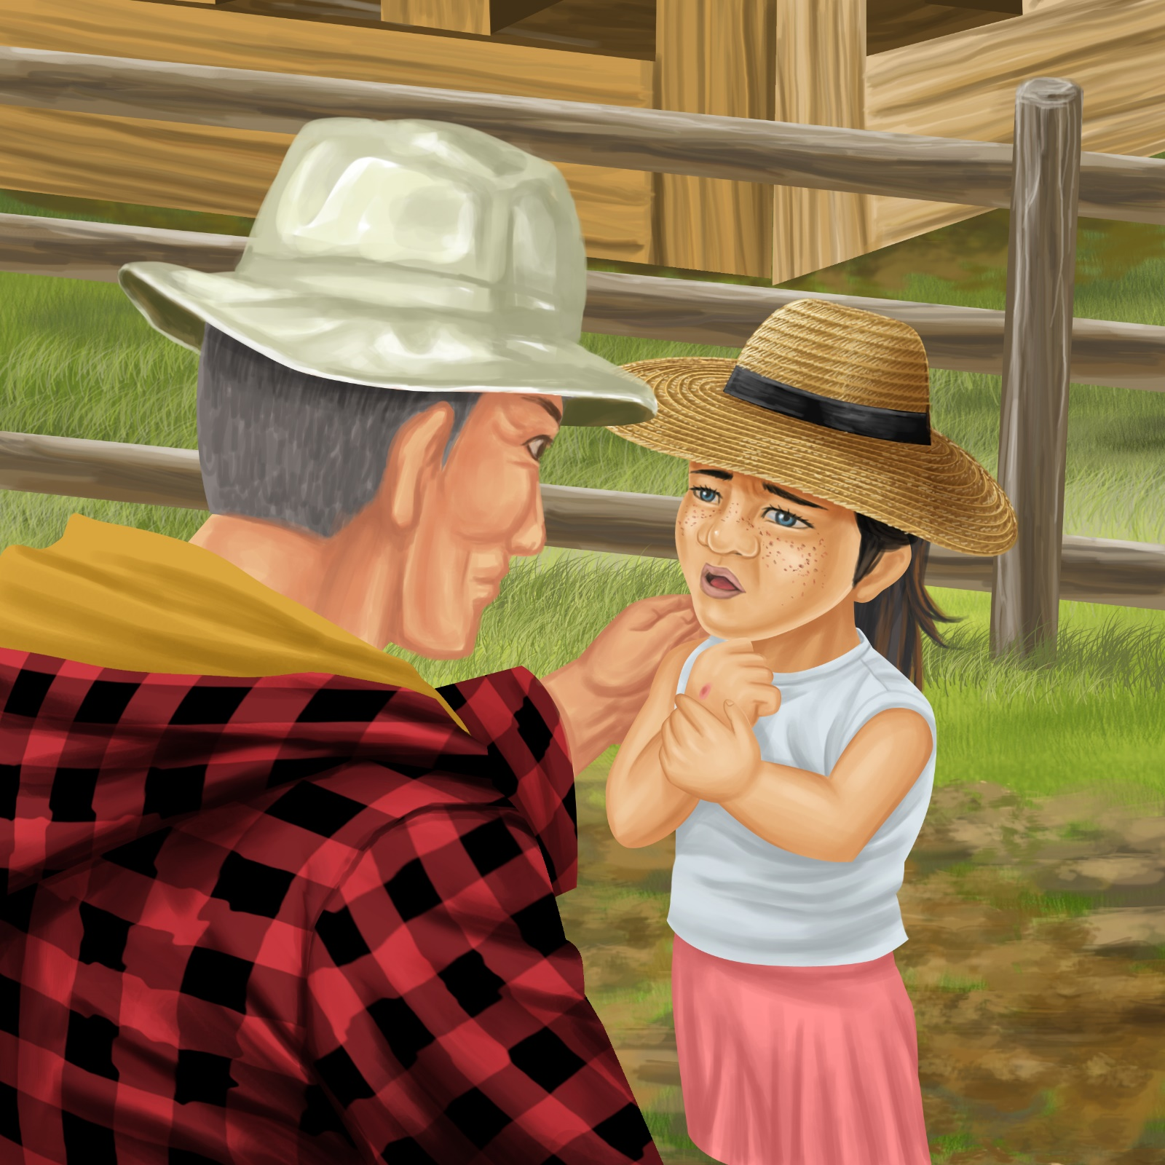

“I hope you are OK,” calls Pop.
“My hand hurts,” says Pam.
“I have a bee sting on my hand.”

“We will put a wet cloth on your hand,” says Pop.
“Soon your hand will feel better.”
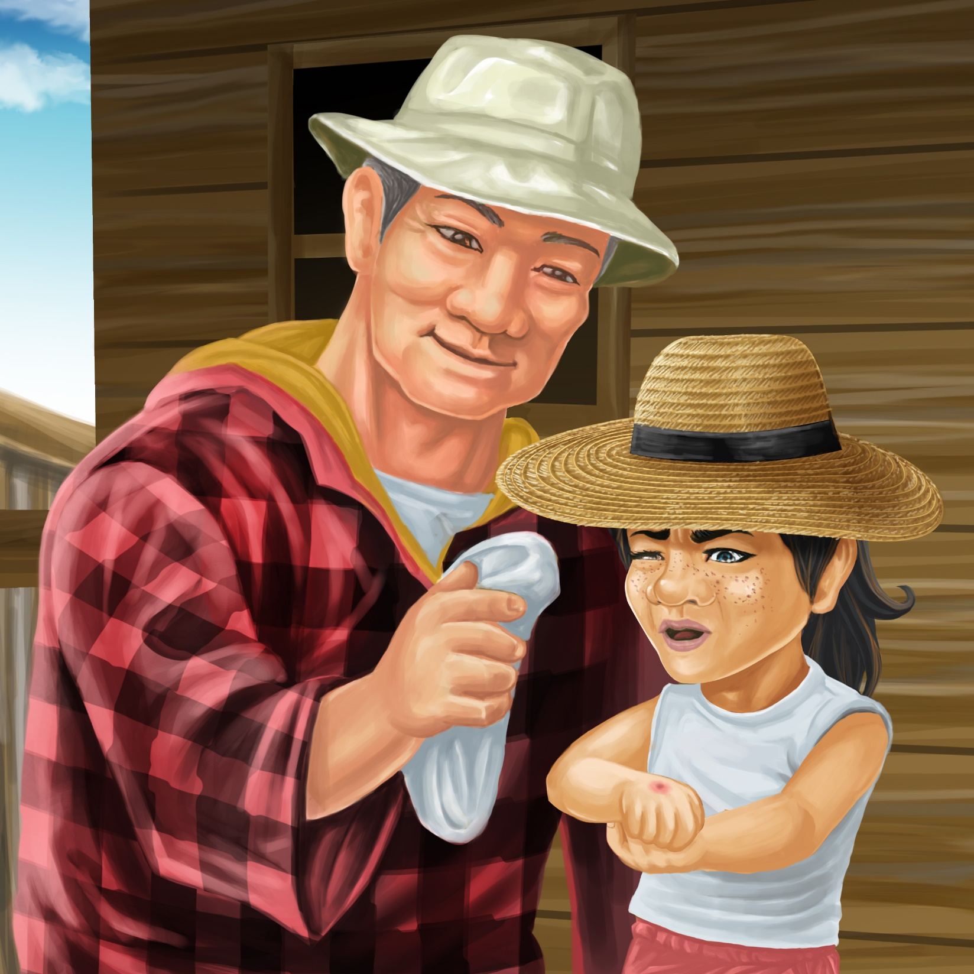
Teaching Notes: Book 19 Pam’s Bee Sting
Reading Practice: This story provides children with practice in decoding short words with a focus on words that start with consonants h and sh and include vowels a, e, o and u.

Introduce the text and read the story aloud together, pointing to each word as you read the story. Encourage children to help you “sound out” the regular words in the story. Help children sound out the word and then blend the sounds together, for example, h-a-n-d = hand. When reading unknown high frequency words (e.g., says, I, my), tell children the words as you read together. Give plenty of praise for children’s reading attempts and encourage re-reading to build fluency and accuracy.

Phonological Awareness
Practice segmenting and blending words. Ask children to clap out each phoneme (sound) in the word: h-e-n (3 sounds), h-a-n-d (4 sounds), s-t-i-ng (4 sounds), c-l-o-th (4 sounds), s-w-i-pe (4 sounds).
Help children to find each word you segment on the page.
Think of all the words you can that start with a h sound and a sh sound. Find objects in the room that start with a h sound and a sh sound.

Spelling
Listen and identify where the sound change occurs in words. Use the phrasing: “If this word spells hat, can you change it to hit. If this word says hit can you change it to bit”.
Change hand to land to lad to mad
Change hen to pen to pin to spin to spit

Vocabulary
Discuss different words the children may use for a grandfather, (e.g., Pop Poppa, Grandpa, Granddad, Koro), and grandmother (e.g., Nan, Gran, Granny, Grandma, Nana, Kuia).
Story Discussion
Ask the children whether they have ever been stung by a bee or an insect and ask them to talk about what happened.
Story Retell
Ask children to re-tell the story to a friend. Prompt as necessary using picture cues. Give plenty of praise and encouragement.
Print Concepts
Discuss the use of the exclamation mark. We use an exclamation mark to show we are excited or using a loud voice.


