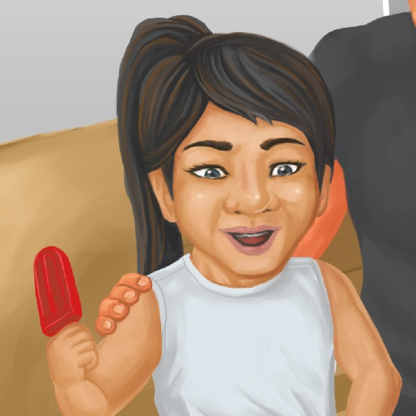

Pam’s Top
By Maggie Boston
Illustrations by Susan Trisna

Pam’s Top
Book 3

This reader for young children is part of a reading series for the Better Start Literacy Approach. Each book provides reading practice for children to decode and understand short words with a focus on target consonants and vowels. The reader has been designed to support class teaching activities that are part of the Better Start Literacy Approach.

The Better Start Literacy Approach has been developed through the University of Canterbury Child Well-being Research Institute. The lead research team includes:
Professor Gail Gillon, Associate Professors Brigid McNeill and Alison Arrow, Drs Amy Scott and Amanda Denston and Professor Angus Macfarlane.

To access these readers online in narrated and book form, please visit https://sites.google.com/view/betterstart-whānau/home and click on the ‘Children’s Readers’ tab.
Published February, 2020, UC Child Well-being Research Institute.

The Better Start Literacy Approach is supported by the
A Better Start National Science Challenge, a 10-year programme of research investigating practical, evidence-based solutions that make a measurable difference for our tamariki.
https://www.abetterstart.nz/



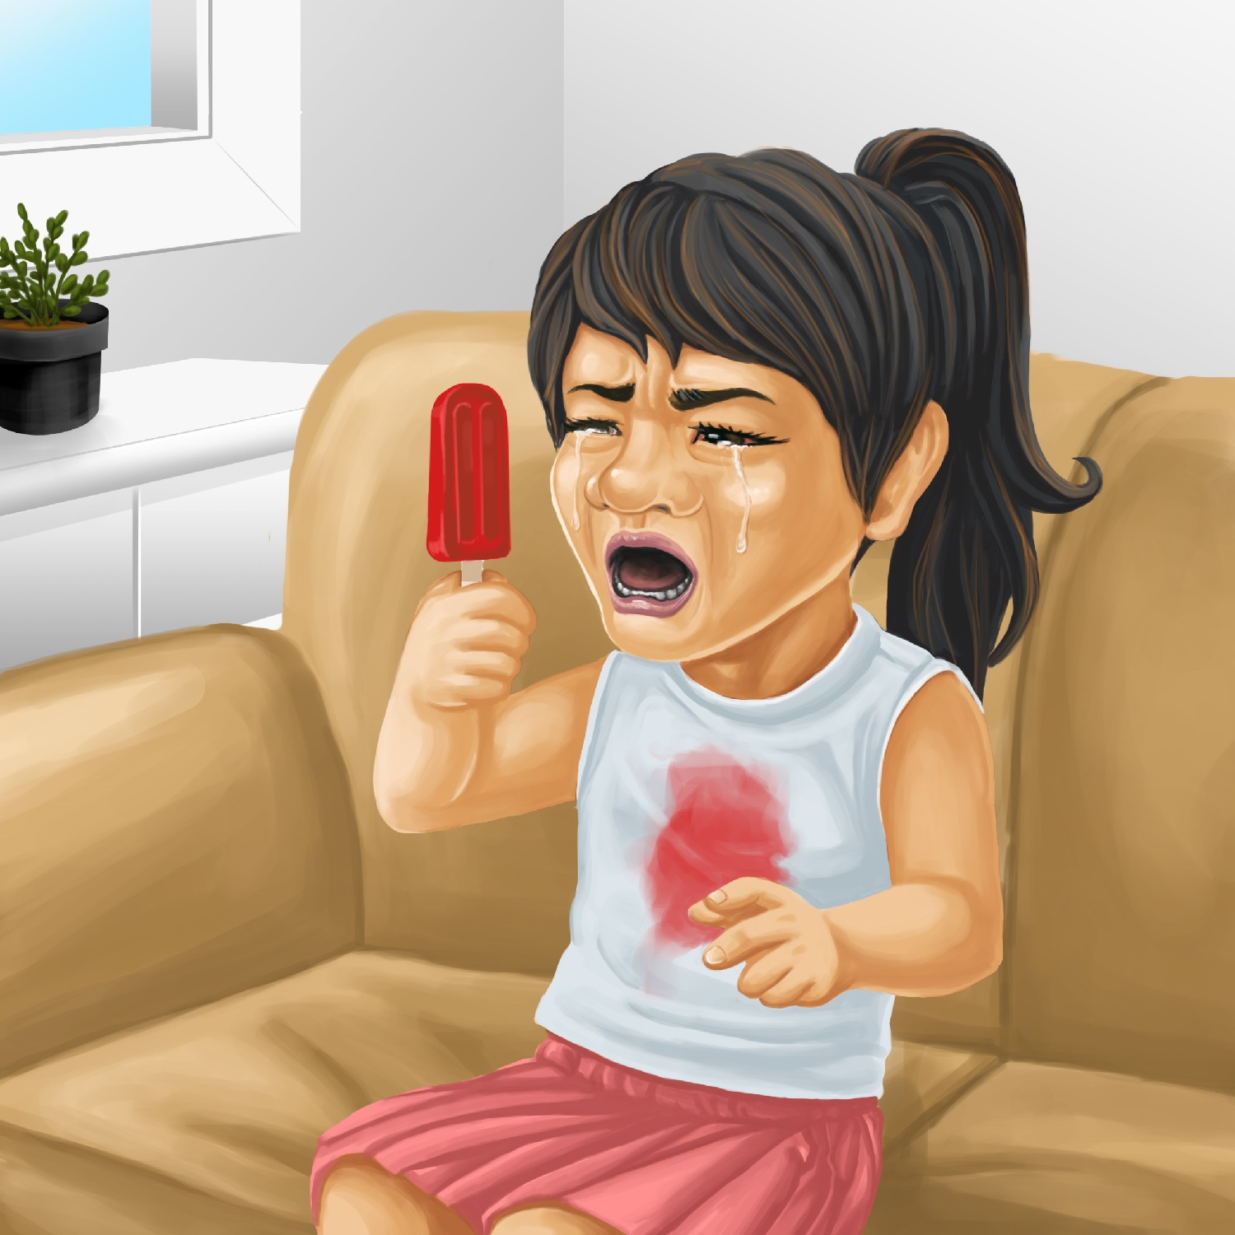

Pam began to sob.
“I am mad, I am sad!” sobbed Pam.
“My top has a big red spot!”

Dad sat beside Pam.
“I will dab the spot.”

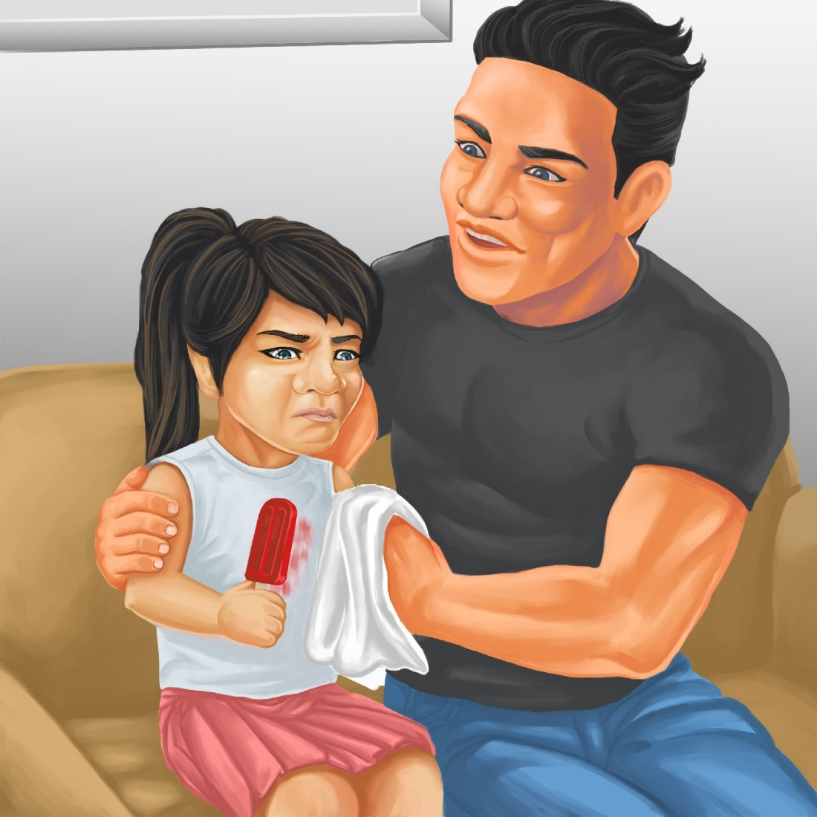

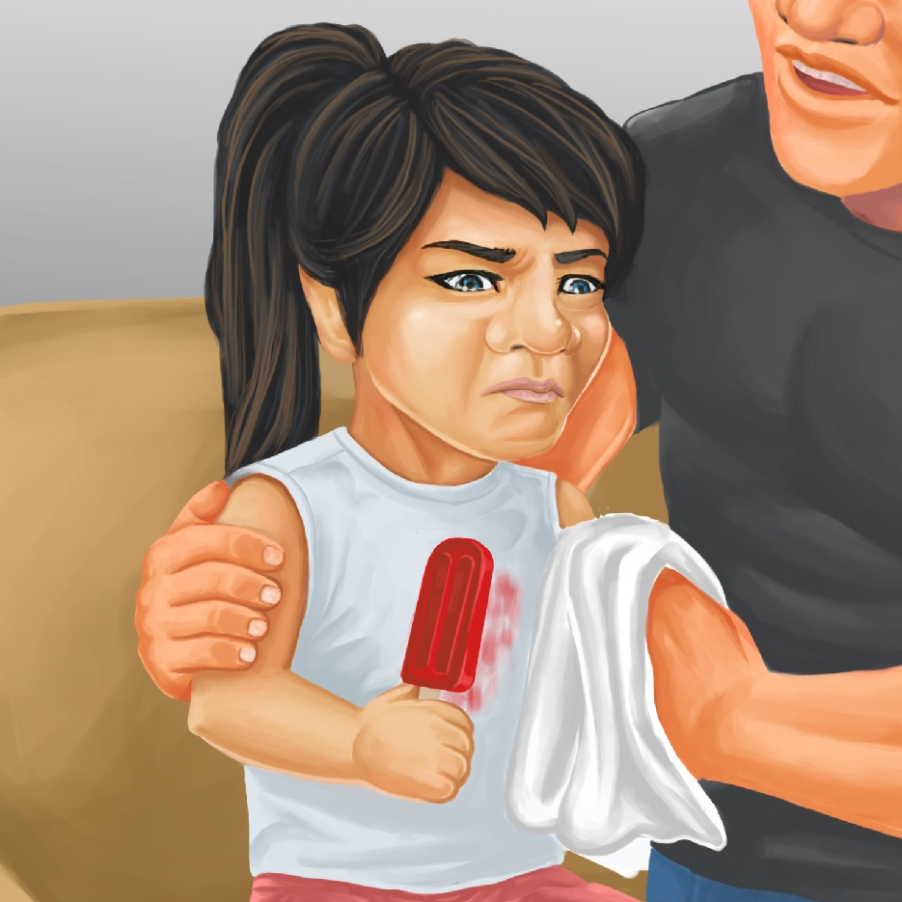

“I will dab and pat the spot clean,” said Dad.

Dab, dab, pat, pat.
Look! The big spot is now a little dot!
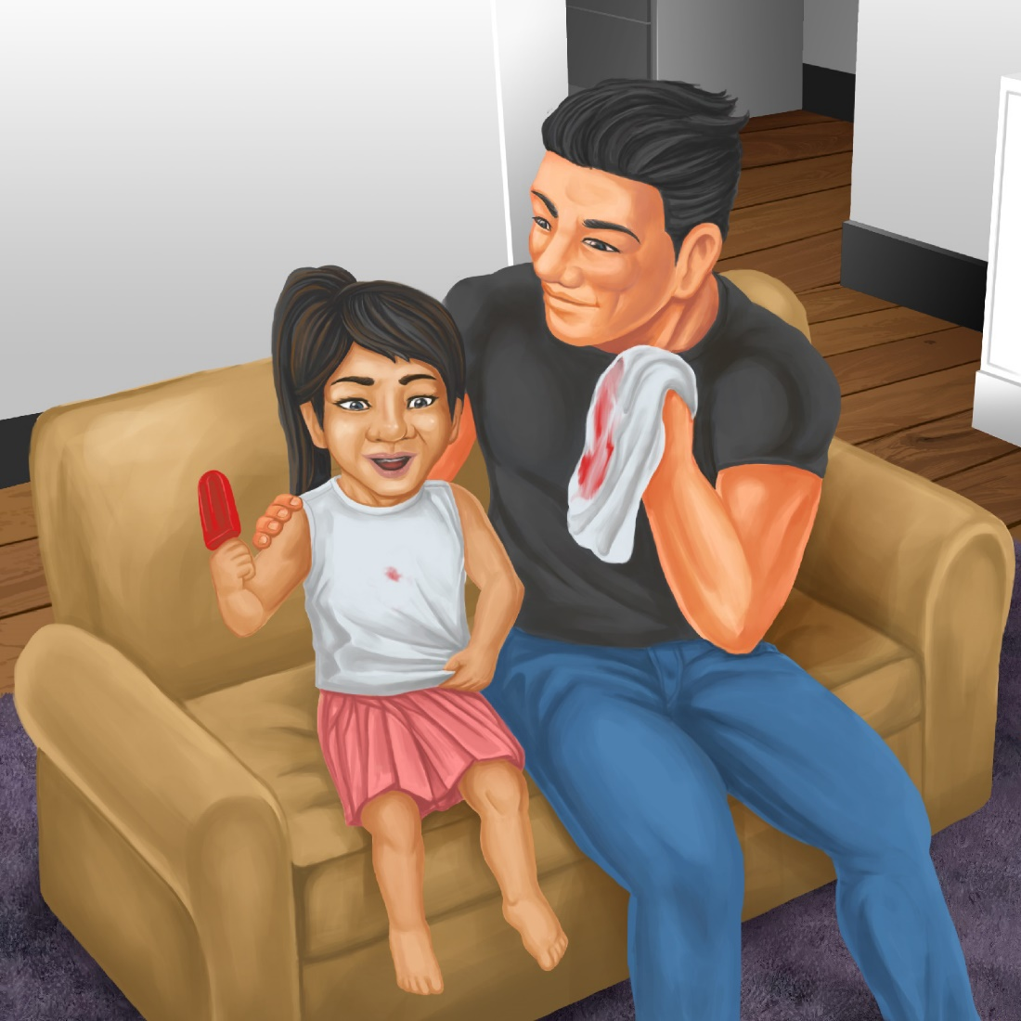
Teaching Notes: Book 3 Pam’s Top
Reading Practice: This story provides children with practice in decoding and understanding short words with a focus on words that start with p or t consonants and include a, o, and i vowels.

Introduce the text and read the story aloud together pointing to each word as you read. Encourage children to help you “sound out” the regular words in the story (see words in bold print below). Help children sound out the word and then blend the sounds together, for example, s-o-b = sob. When reading unknown high frequency words (e.g., the, my), tell children the words as you read together. Give plenty of praise for children’s reading attempts and encourage re-reading to build fluency and accuracy.

Pam began to sob.
“I am mad, I am sad!” sobbed Pam.
“My top has a big red spot!”
Dad sat beside Pam.
“I will dab the spot.”
“I will dab and pat the spot clean,” said Dad.
Dab, dab, pat, pat.
Look! The big spot is now a little dot!

Phonological Awareness
Practice segmenting and blending words. Ask children to clap out each phoneme (sound) in the word: m-a-d (3 sounds), t-o-p (3 sounds),
s-p-o-t (4 sounds). Help children to find each word you segment on the page.
Think of all the words you can that start with a p or t sound. Find objects in the room that start with a p or t sound.

Spelling
Listen and identify sound changes in words. Use the phrasing: “If this word spells Pam, can you make it say am. If this word says am can you change it to dam”.
Give plenty of praise and encouragement for reading and spelling attempts.
Change mad to sad to dad
Change spot to pot to pat

Vocabulary
Discuss concepts of big and little. Think of other words that mean big (huge, enormous, large) or little (tiny, small).

Story Discussion
Discuss why Pam was sad (this is called inference comprehension - red ice-block dripped onto her top). What makes you mad or sad? What can you do to cheer yourself up?

Story Retell
Ask the children to re-tell the story to a friend. Prompt as necessary using picture cues. Give plenty of praise and encouragement.
Print Concepts
Bring children’s attention to the lower and upper case D d and P p.

