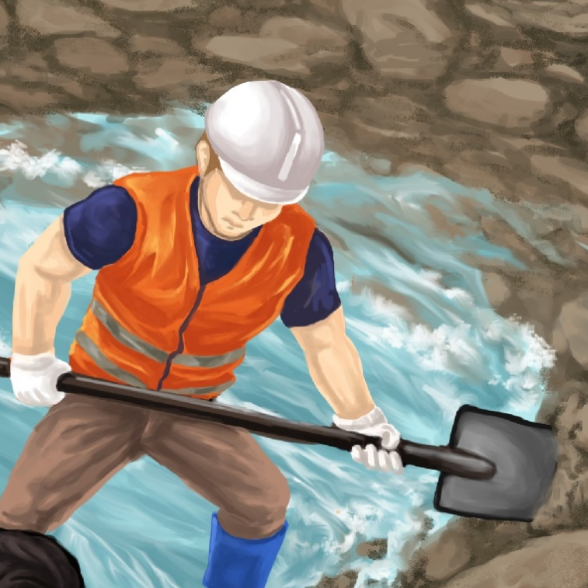

Dig the Mud
By Maggie Boston
Illustrations by Susan Trisna

Dig the Mud
Book 2

This reader for young children is part of a reading series for the Better Start Literacy Approach. Each book provides reading practice for children to decode short words with a focus on target consonants and vowels. The reader has been designed to support class teaching activities that are part of the Better Start Literacy Approach.

The Better Start Literacy Approach has been developed through the University of Canterbury Child Well-being Research Institute. The lead research team includes:
Professor Gail Gillon, Associate Professors Brigid McNeill and Alison Arrow, Drs Amy Scott and Amanda Denston and Professor Angus Macfarlane.

To access these readers online in narrated and book form, please visit https://sites.google.com/view/betterstart-whānau/home and click on the ‘Children’s Readers’ tab.
Published February, 2020, UC Child Well-being Research Institute.

The Better Start Literacy Approach is supported by the
A Better Start National Science Challenge, a 10-year programme of research investigating practical, evidence-based solutions that make a measurable difference for our tamariki.
https://www.abetterstart.nz/




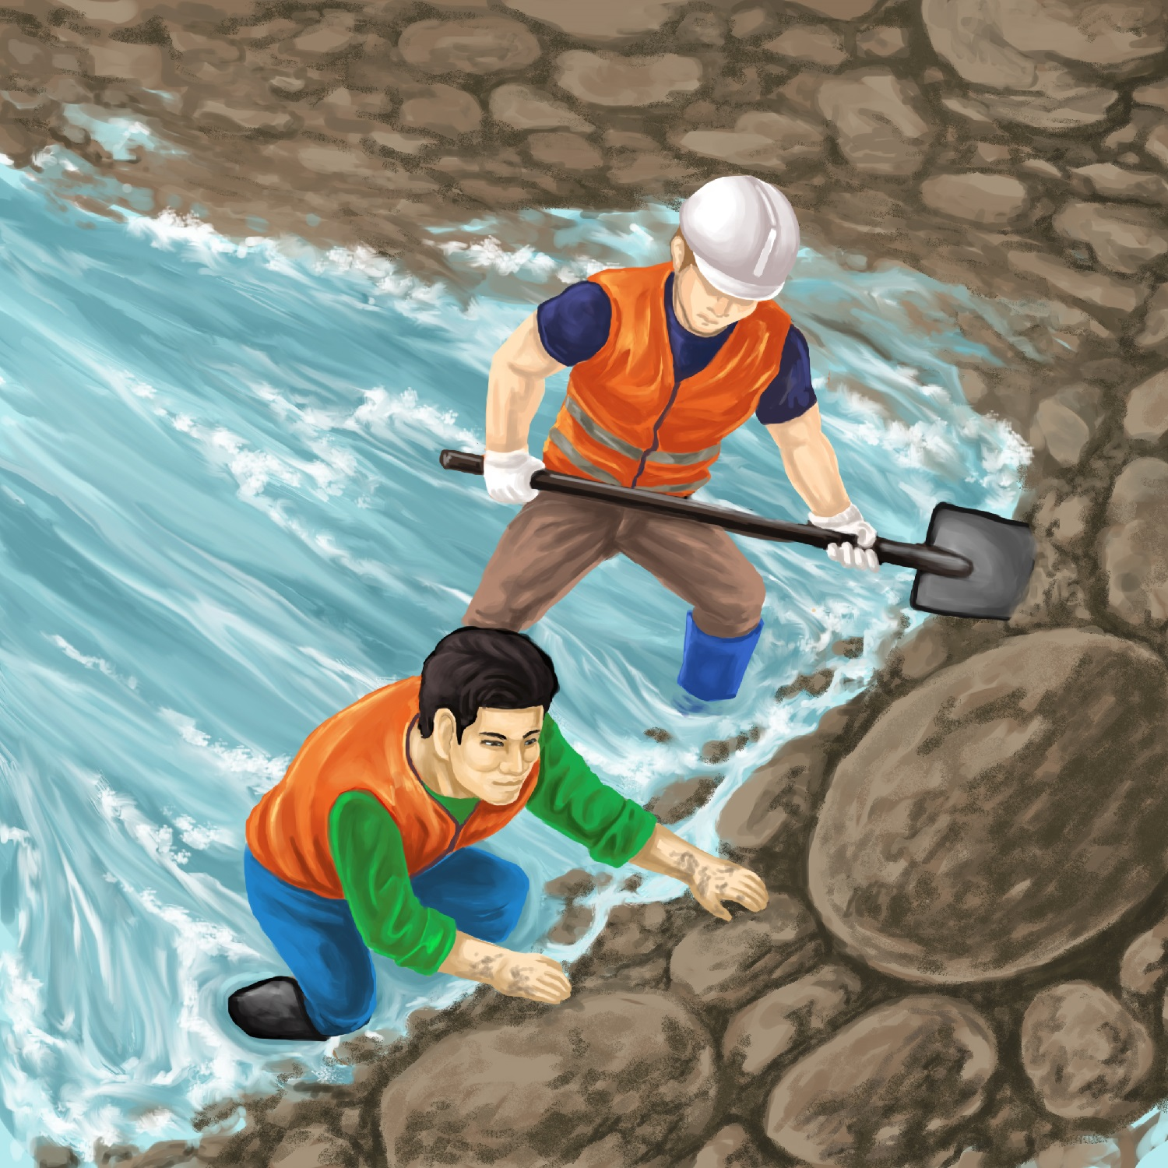

The men like to dig.
Dig, dig, dig.

The men dig the mud.
The mud makes a dam.

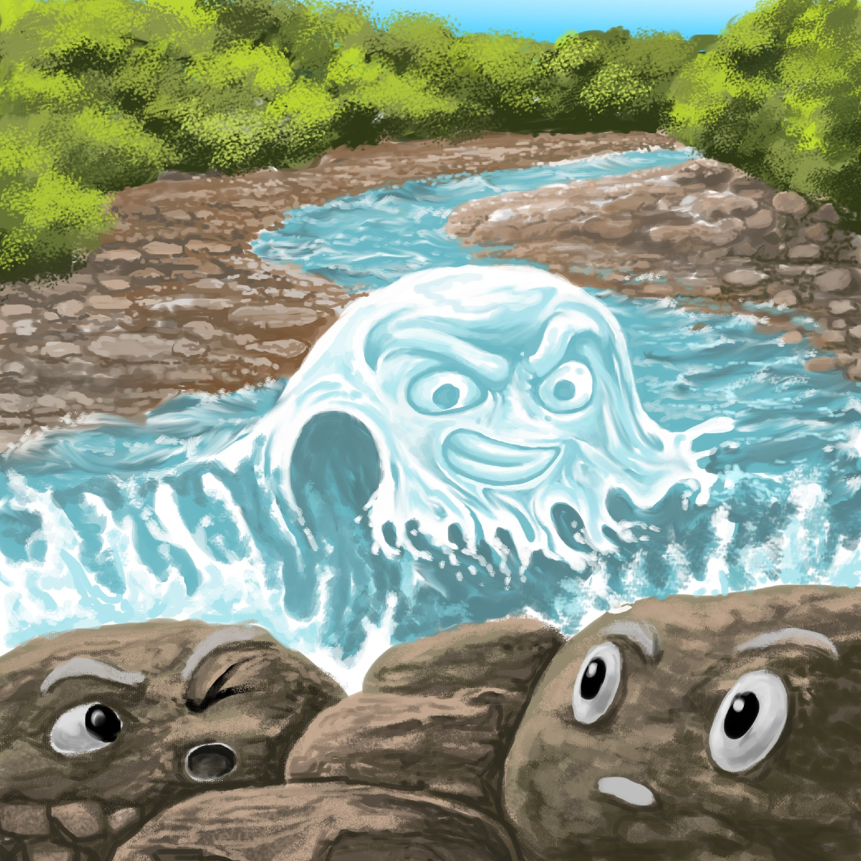

The dam stops the Awa.
Awa is mad.
Mad, mad, mad!

The men dig a gap.
Awa can go.
Go, go, go!

Teaching Notes: Book 2 Dig the Mud
Reading Practice: This story provides children with practice in decoding short words with a focus on words that start with m and d consonants and include a e i and u vowels.

Introduce the text and read the story aloud together pointing to each word as you read the story. Encourage children to help you “sound out” the regular words in the story (see words in bold print below). Help children sound out the word and then blend the sounds together, for example, d-a-m = dam. When reading unknown high frequency words (e.g., makes, the), tell children the words as you read together. Give plenty of praise for children’s reading attempts and encourage re-reading to build fluency and accuracy.

The men like to dig.
Dig, dig, dig.
The men dig the mud.
The mud makes a dam.
The dam stops the Awa.
Awa is mad.
Mad, mad, mad!
The men dig a gap.
Awa can go.
Go, go go!

Phonological Awareness
Practice segmenting and blending words. Ask children to clap out each phoneme (sound) in the word: m-a-d (3 sounds, 3 claps), d-i-g (3 sounds), s-t-o–p (4 sounds). Help children to find each word you segment on the page.
Spelling
Listen and identify sound changes in words. Use the phrasing: “If this word spells dig, can you make it say pig. If this word says pog can you change it to dog.
Change dig to pig to pog to dog
Change men to den to dan to dam
Vocabulary
Awa is a Māori word which can mean river. Check the Māori dictionary online with a sound file for correct pronunciation (https://maoridictionary.co.nz/). Talk about the name of a river near you and find out the Māori name (if it has an English name).
Story Discussion
Discuss how a dam stops water from flowing. Talk about how a dam can help make electricity, help with water supply or irrigation. Look up on the internet about a major dam in New Zealand.
Talk about a time when you might have been involved in digging mud - maybe after a flood or disaster, or after heavy rain.
Story Retell
Ask the children to re-tell the story to a friend. Prompt as necessary using picture cues. Give plenty of praise and encouragement.
Print Concepts
Bring attention to the lower and upper case version for the letter ‘d’.
Extension: Discuss use of exclamation mark. Exclamation marks are used at the end of a sentence to express a strong emotion like surprise or anger or to emphasise a point.

