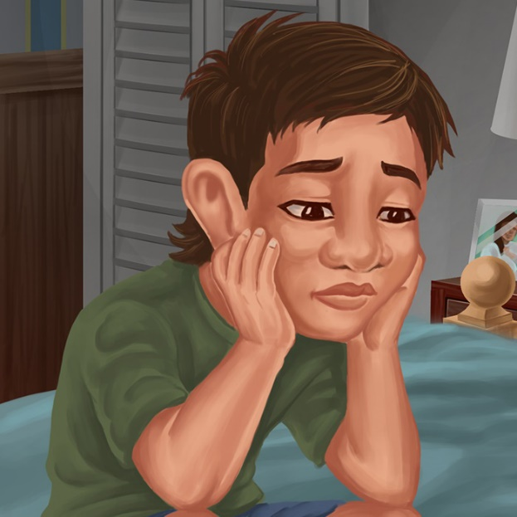
Tama and Big Ted
By Maggie Boston
Illustrations by Susan Trisna

Tama and Big Ted
Book 4

This reader for young children is part of a reading series for the Better Start Literacy Approach. Each book provides reading practice for children to decode and understand short words with a focus on target consonants and vowels. The reader has been designed to support class teaching activities that are part of the Better Start Literacy Approach.

The Better Start Literacy Approach has been developed through the University of Canterbury Child Well-being Research Institute. The lead research team includes:
Professor Gail Gillon, Associate Professors Brigid McNeill and Alison Arrow, Drs Amy Scott and Amanda Denston and Professor Angus Macfarlane.

To access these readers online in narrated and book form, please visit https://sites.google.com/view/betterstart-whānau/home and click on the ‘Children’s Readers’ tab.
Published February, 2020, UC Child Well-being Research Institute.



The Better Start Literacy Approach is supported by the
A Better Start National Science Challenge, a 10-year programme of research investigating practical, evidence-based solutions that make a measurable difference for our tamariki.
https://www.abetterstart.nz/
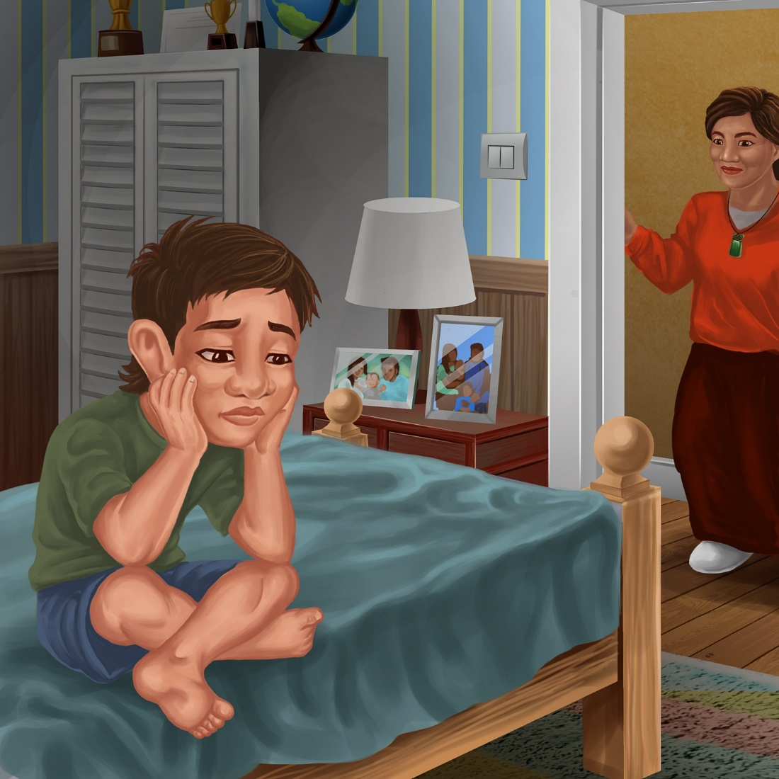

Tama sat on the bed.
Tama was sad.
He had lost Big Ted.

Nan sat on the bed.
“I am sad,” said Tama.
“My Big Ted is lost.”

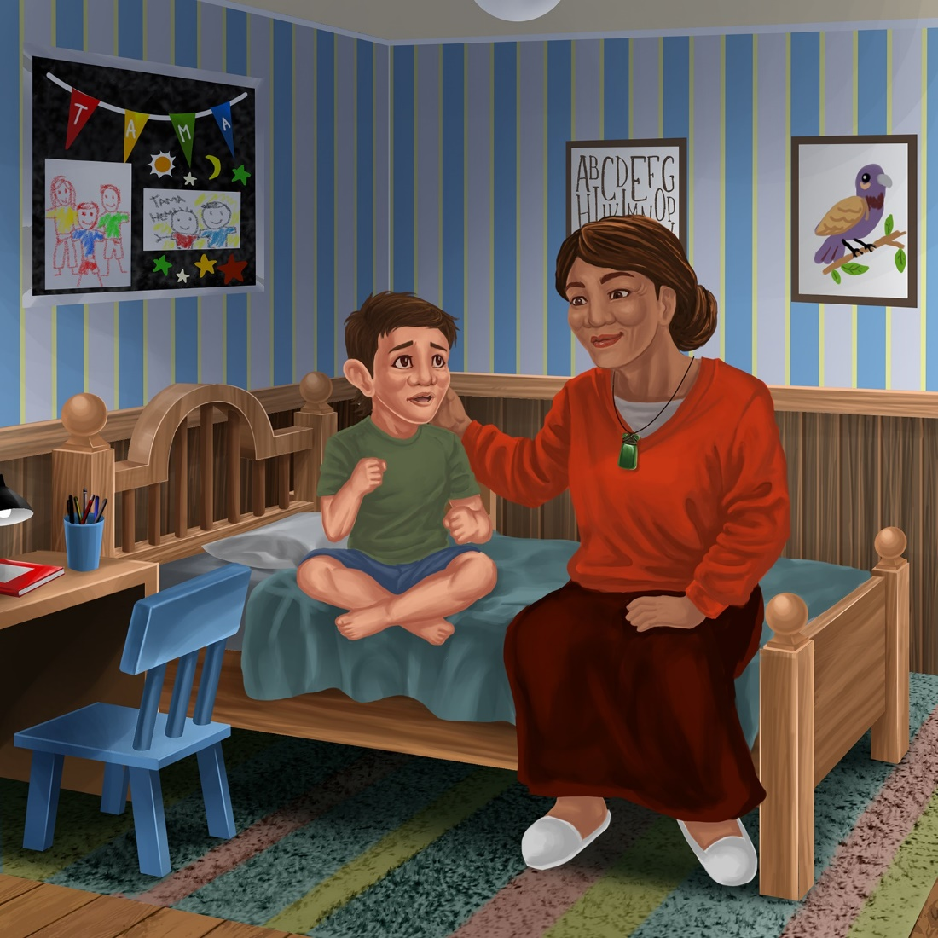

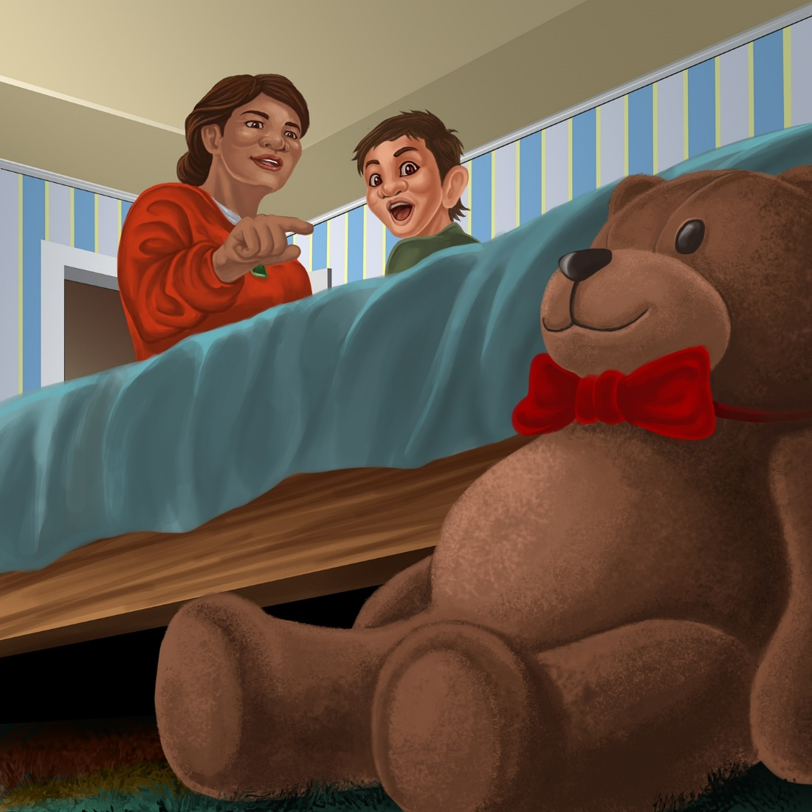

“Look!” said Nan.
“I see Big Ted!”

Big Ted was on the mat behind the bed.
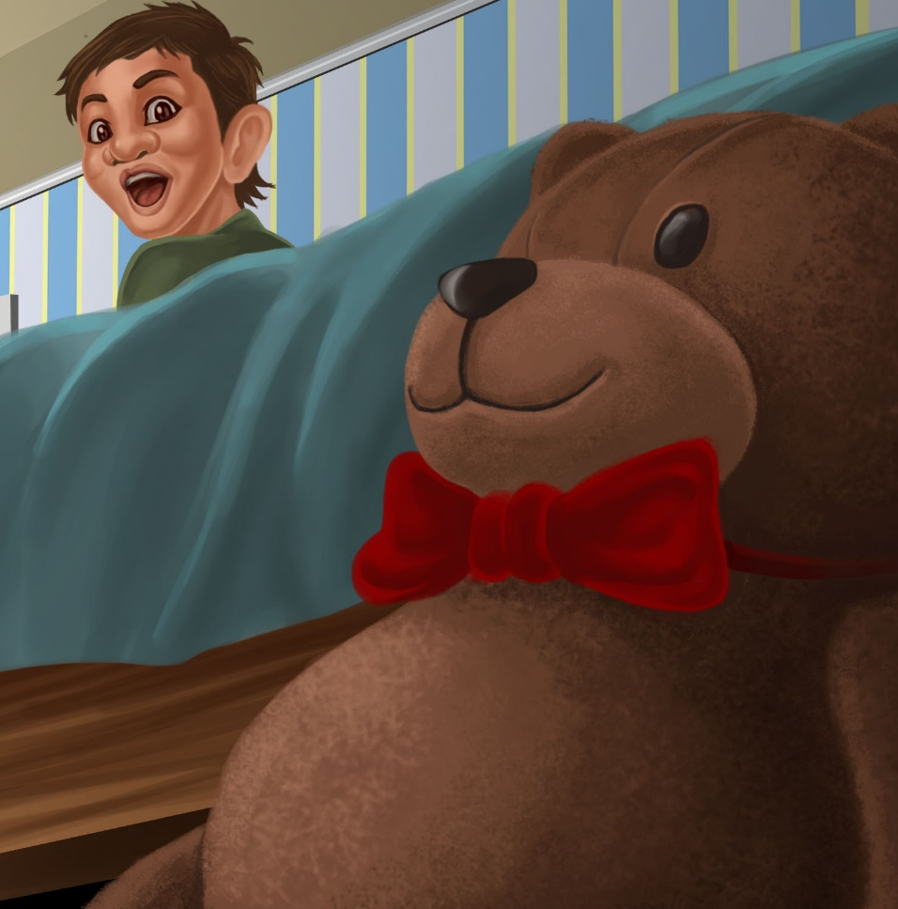
Teaching Notes: Book 4 Tama and Big Ted

Reading practice: This story provides children with practice in decoding and understanding short words with a focus on words that start with p or t consonants and include a, e, and i vowels.

Introduce the text and read the story aloud together pointing to each word as you read. Encourage children to help you “sound out” the regular words in the story (see words in bold print below). Help children sound out the word and then blend the sounds together, for example, b-e-d = bed. When reading unknown high frequency words (e.g., was, his, see), tell children the words as you read together. Give plenty of praise for children’s reading attempts and encourage re-reading to build fluency.

Tama sat on the bed.
Tama was sad.
He had lost Big Ted.
Nan sat on the bed.
“I am sad,” said Tama.
“My Big Ted is lost.”
“Look!” said Nan.
“I see Big Ted!”
Big Ted was on the mat behind the bed.

Phonological Awareness
Practice segmenting and blending words. Ask children to clap out each phoneme in the word: b-e-d (3 sounds), l-o-s-t (4 sounds). Help children to find each word you segment on the page.
Think of all the words you can that start with a p or t sound. Find objects in the room that start with a p or t sound.

Spelling
Listen and identify where the sound change occurs in words. Use the phrasing: “If this word spells Ted, can you make it say bed. If this word says bed can you change it to bad.”
Give plenty of praise and encouragement for reading and spelling attempts.
Change ted to bed to bad to dad
Change big to dig to dog

Vocabulary
Discuss different prepositions – these are words that describe the location of something, such as behind or beside. Talk about how Nan is sitting beside Tama on the bed in the picture. This could extend to other prepositions such as over, under, on top, below, beneath, above). Play a game hiding objects and encouraging children to use prepositions to describe their location. “I found the pen behind the tin.”

Story Discussion
Discuss why Tama was sad and how his Nan helped Tama. Discuss a time when you might have lost something precious and how it made you feel.

Story Retell
Ask the children to re-tell the story to a friend. Prompt as necessary using picture cues. Give plenty of praise and encouragement.
Print Concepts
Discuss the lower and upper case version for the letters T t B b and N n. Think of other names that start with these letters and sounds.

