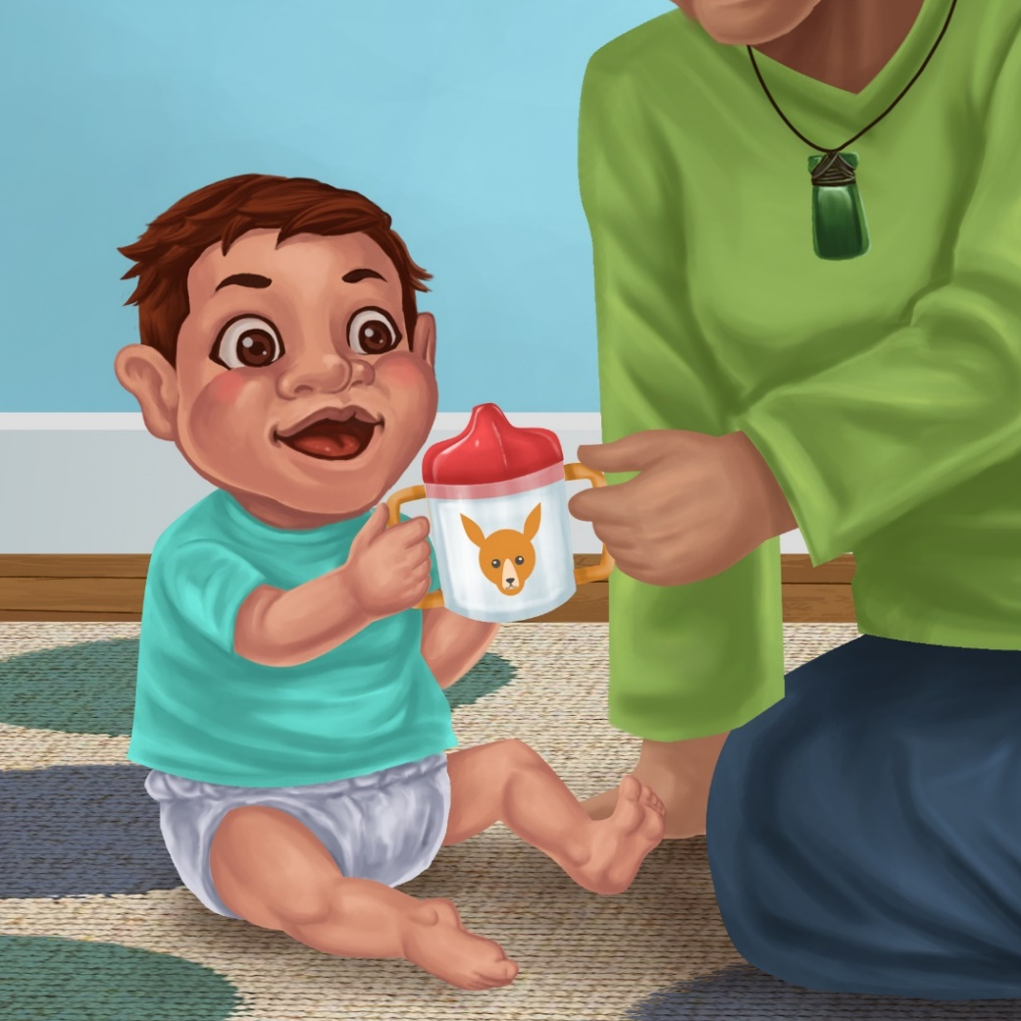

A New Cup
By Maggie Boston
Illustrations by Susan Trisna

A New Cup
Book 6

This reader for young children is part of a reading series for the Better Start Literacy Approach. Each book provides reading practice for children to decode and understand short words with a focus on target consonants and vowels. The reader has been designed to support class teaching activities that are part of the Better Start Literacy Approach.

The Better Start Literacy Approach has been developed through the University of Canterbury Child Well-being Research Institute. The lead research team includes:
Professor Gail Gillon, Associate Professors Brigid McNeill and Alison Arrow, Drs Amy Scott and Amanda Denston and Professor Angus Macfarlane.

To access these readers online in narrated and book form, please visit https://sites.google.com/view/betterstart-whānau/home and click on the ‘Children’s Readers’ tab.
Published February, 2020, UC Child Well-being Research Institute.



The Better Start Literacy Approach is supported by the
A Better Start National Science Challenge, a 10-year programme of research investigating practical, evidence-based solutions that make a measurable difference for our tamariki. https://www.abetterstart.nz/
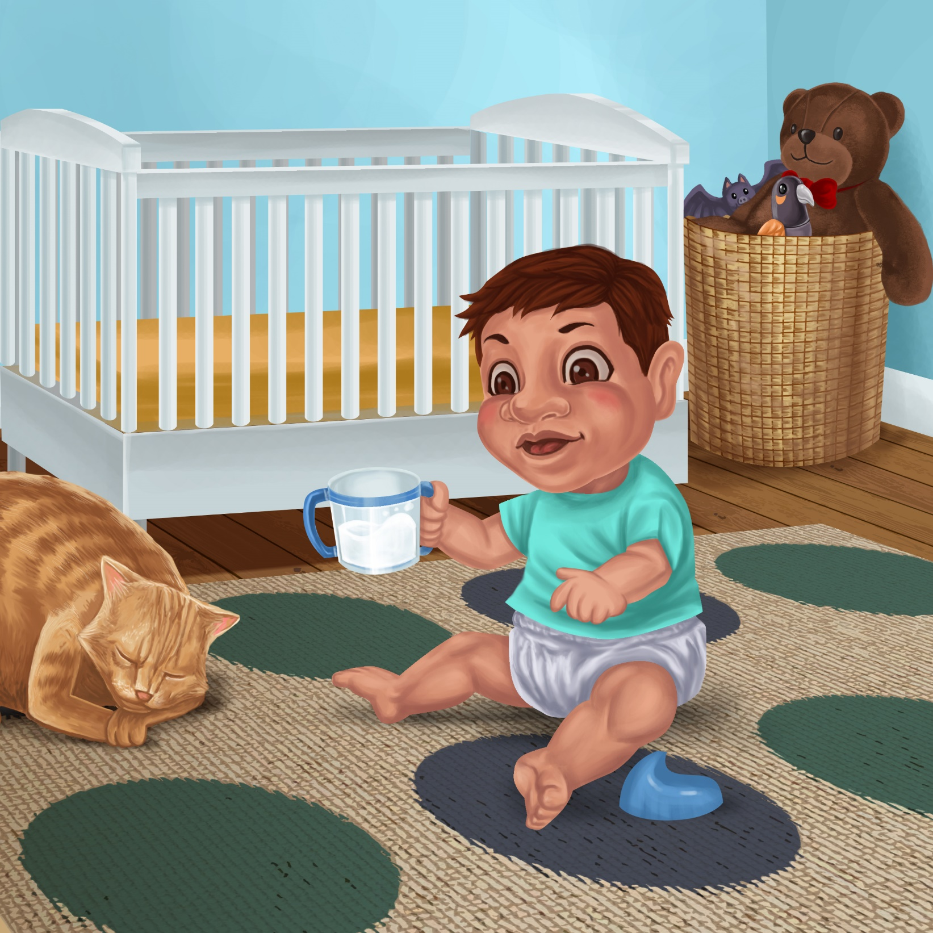

Hemi is by his cot.
He looks at his cup.
The lid is by his leg.

Mot the cat likes the cup.
Lap, lap, lap.
Mot laps up the milk.
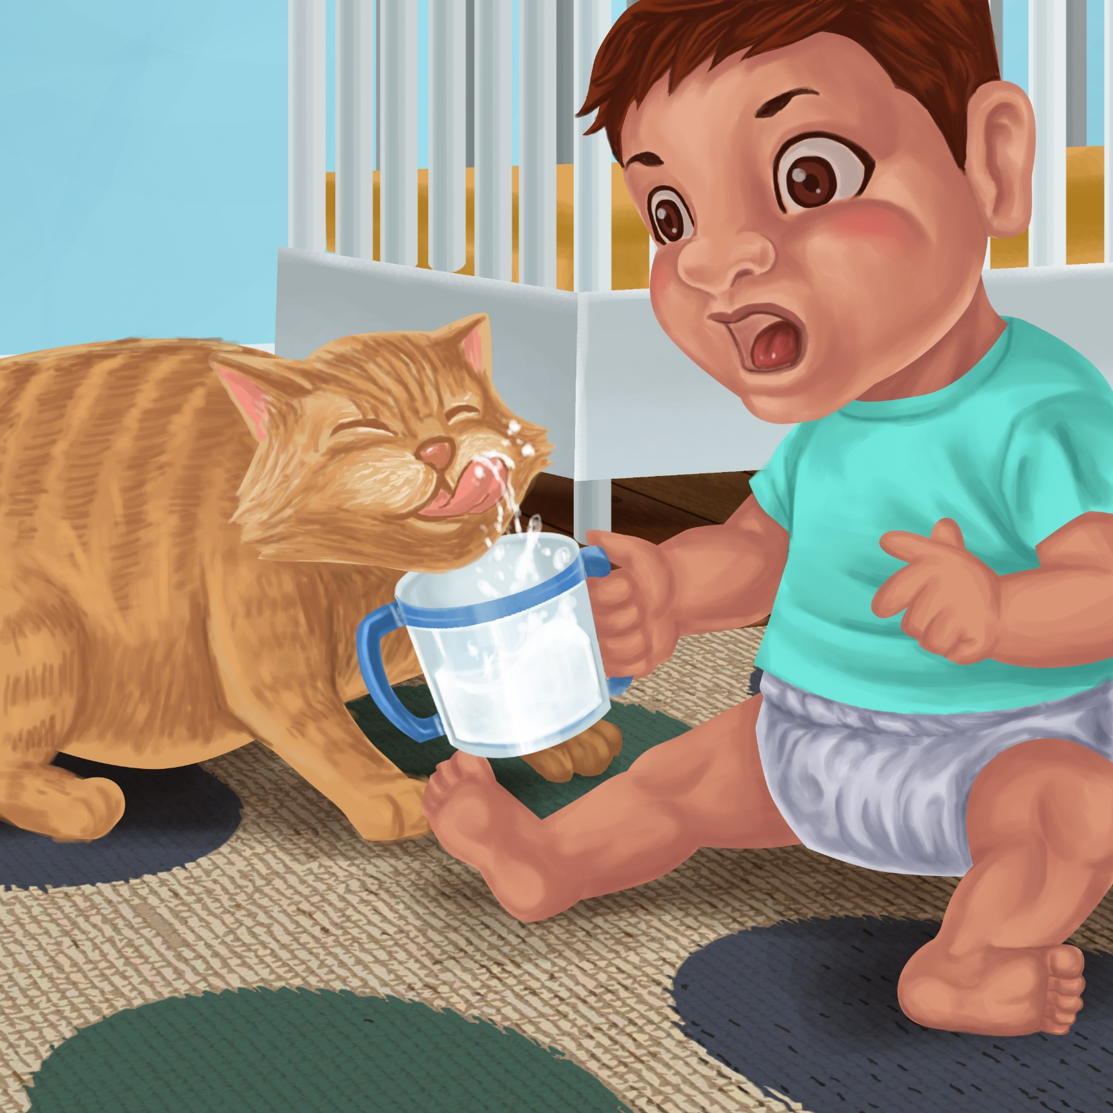

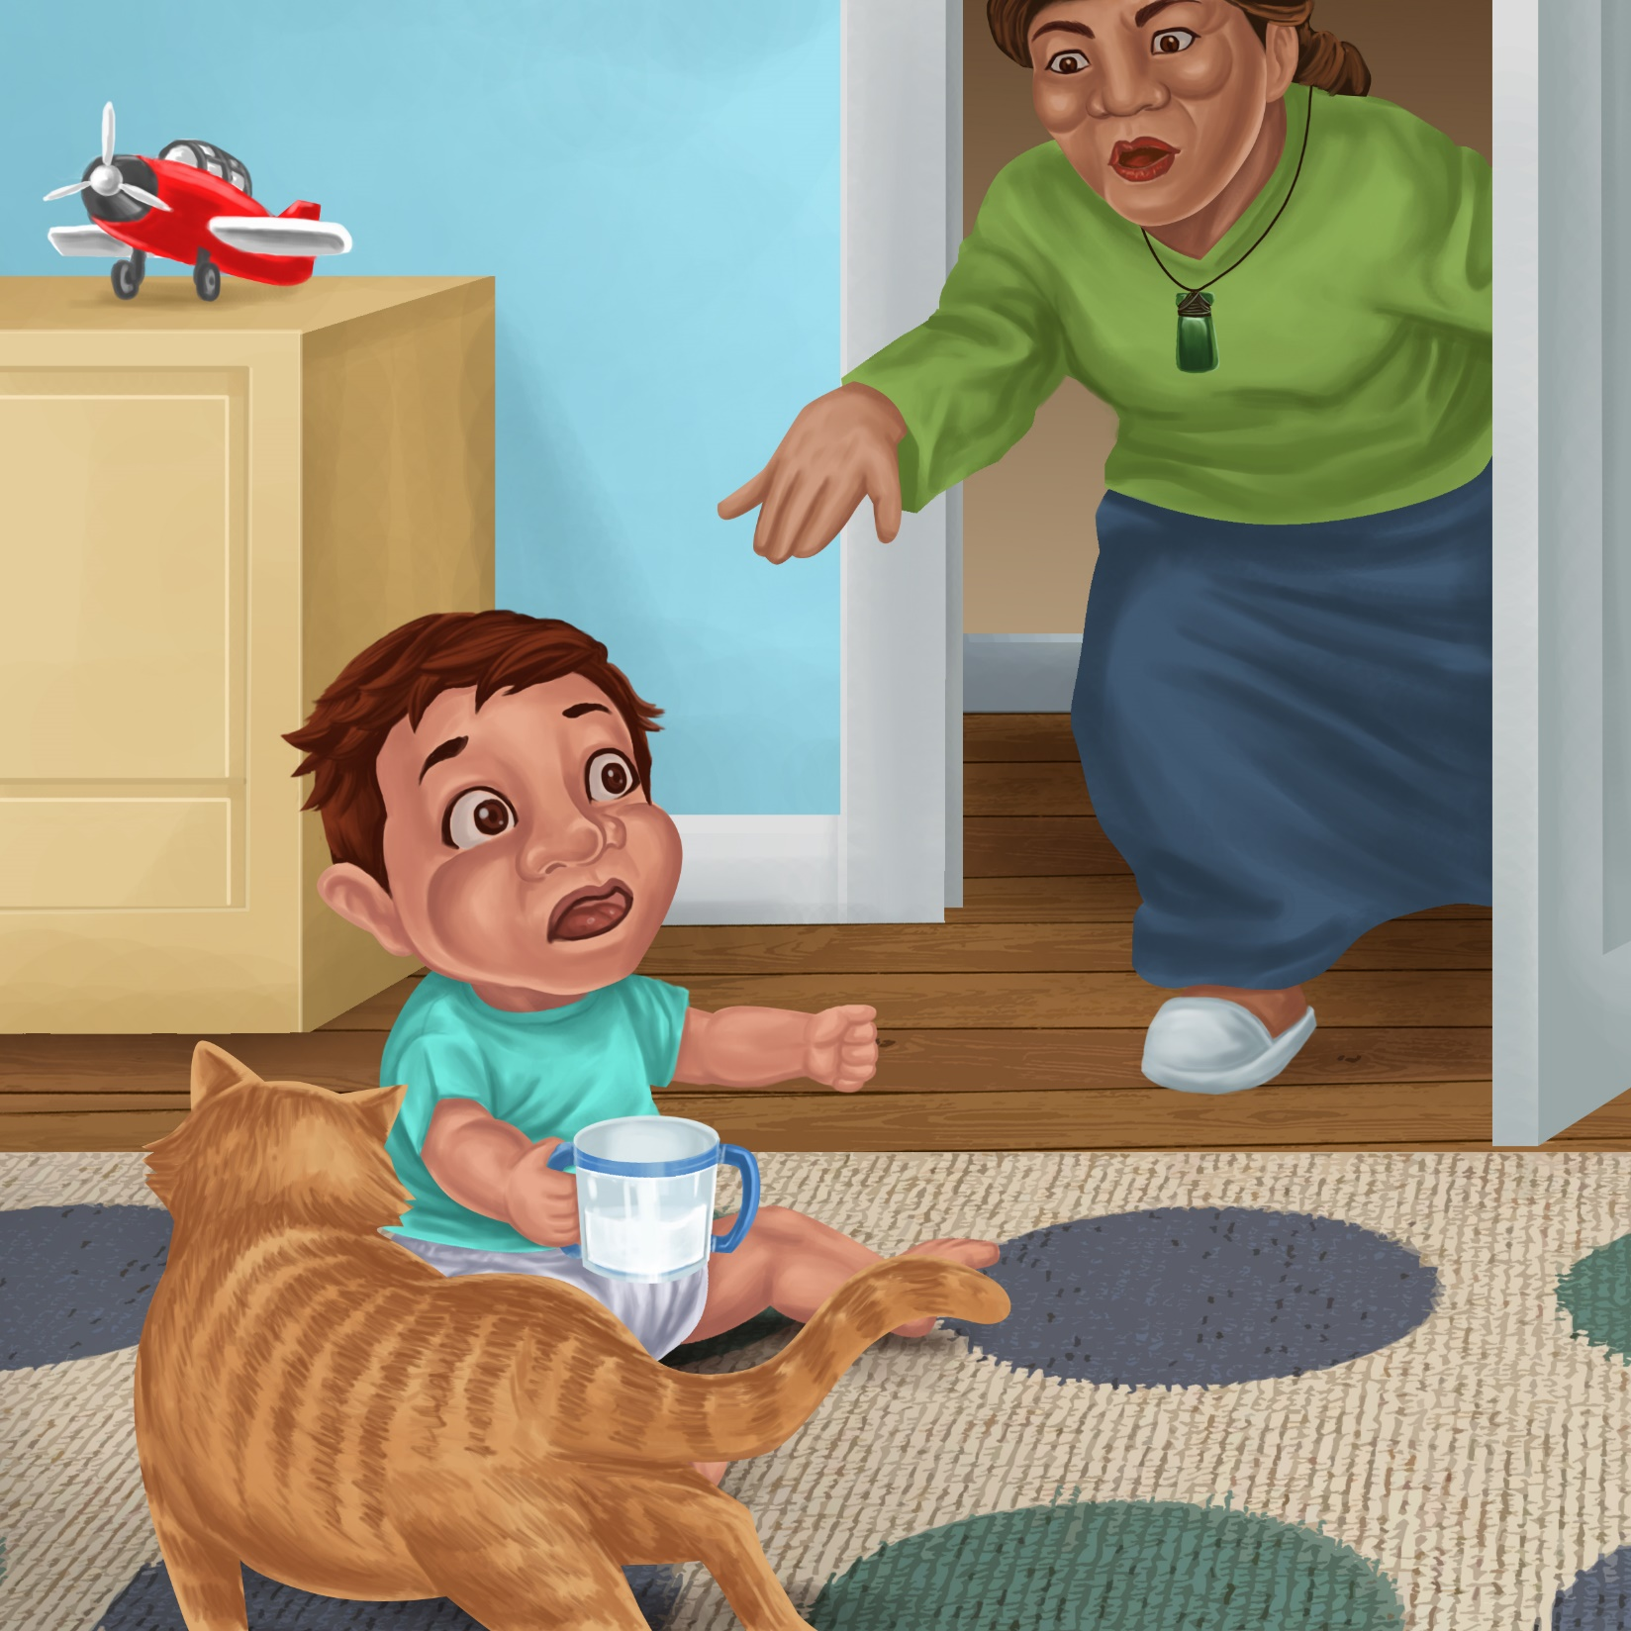

“Shoo cat!” says Nan.
“Do not lap the milk.”

Nan gets a new cup.
The lid is ON the cup!

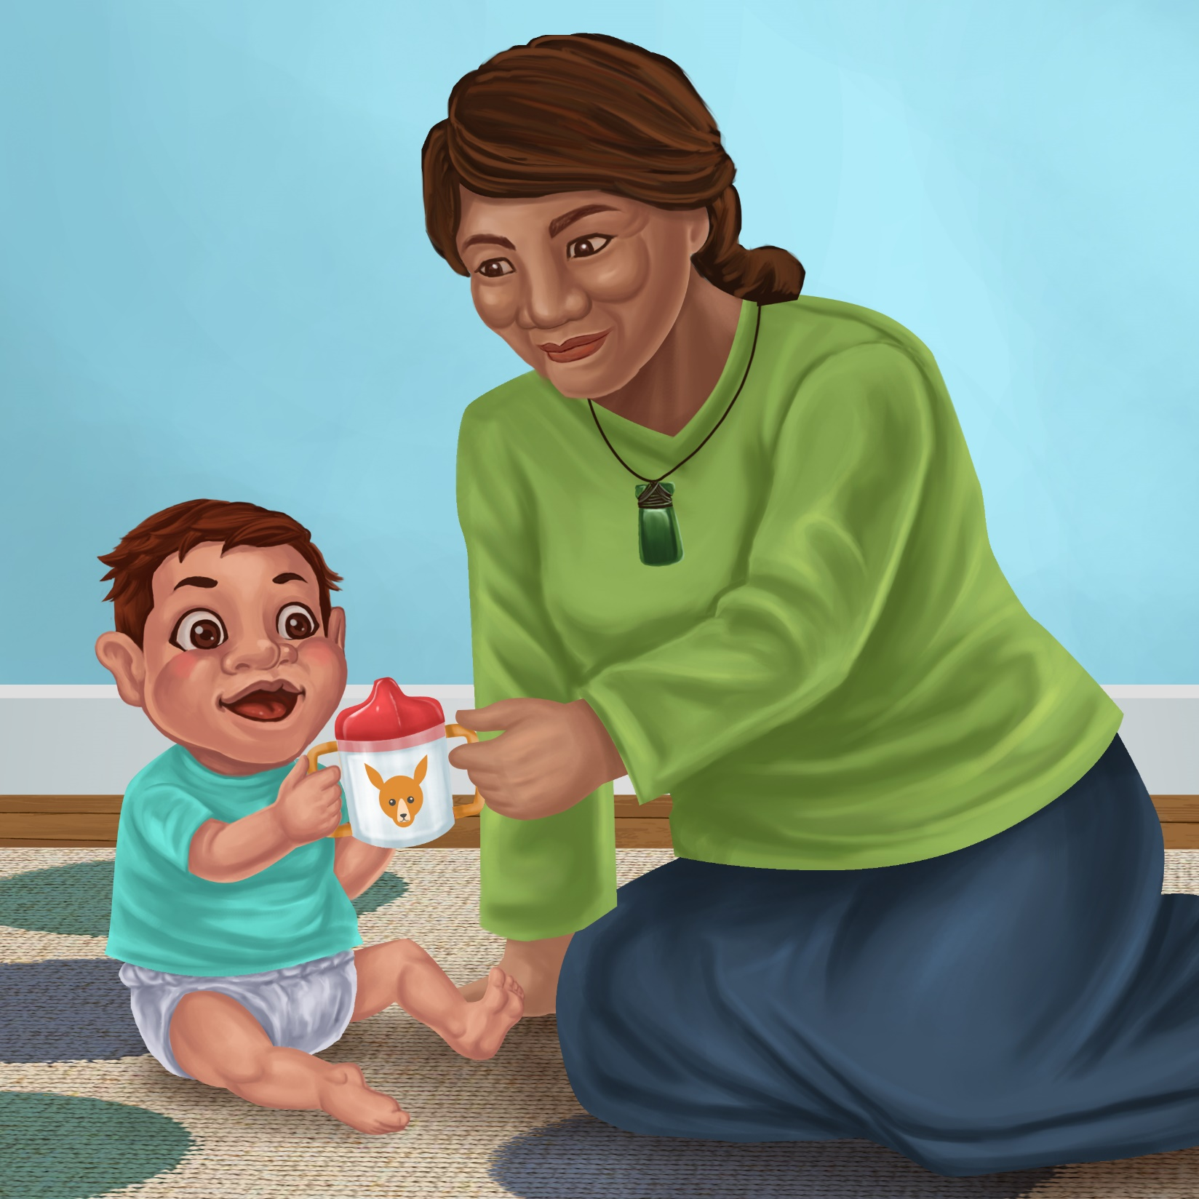
Teaching Notes: Book 6 A New Cup
Reading practice: This story provides children with practice in decoding and understanding short words with a focus on words that start with c and l and includes a, o, and i vowels.

Introduce the text and read the story aloud together, pointing to each word as you read. Encourage children to help you “sound out” the regular words in the story (see words in bold print below). Help children sound out the word and then blend the sounds together, for example, c-u-p = cup. When reading unknown high frequency words (e.g., the, says), tell children the words as you read together. Give plenty of praise for children’s reading attempts and encourage re-reading to build fluency and accuracy.

Hemi is by his cot.
He looks at his cup.
The lid is by his leg.
Mot the cat likes the cup.
Lap, lap, lap.
Mot laps up the milk.
“Shoo cat!” says Nan.
“Do not lap the milk.”
Nan gets a new cup.
The lid is ON the cup.

Phonological Awareness
Practice segmenting and blending words. Ask children to clap out each phoneme (sound) in the word: c-o-t (3 sounds, 3 claps), l-i-d (3 sounds),
l-a-p-s (4 sounds), c-u-p (3 sounds). Help children to find each word you segment on the page.
Think of all the words you can that start with a c or l sound. Find objects in the room that start with a c or l sound.

Spelling
Listen and identify where the sound change occurs in words. Use the phrasing: “If this word spells lap, can you make it say cap. If this word says cap can you change it to cop”.
Give plenty of praise and encouragement for reading and spelling attempts.
Change lap to cap to cat to mat
Change cap to cop to cot to cut

Vocabulary
Discuss the meaning of lap in this story: lap means to lick something up.
Discuss the other meanings of lap. Make up sentences using the different definitions of lap, for example running around a track in a race.

Story Discussion
Discuss why it is bad for the cat to drink out of Hemi’s cup. Talk about why it is important to keep things clean and not spread germs.

Story Retell
Ask the children to re-tell the story to a friend. Prompt as necessary using picture cues. Give plenty of praise and encouragement.

Print Concepts
Discuss the use of quotation marks (or speech marks). We use speech marks when we want to use someone else’s words in our writing.




