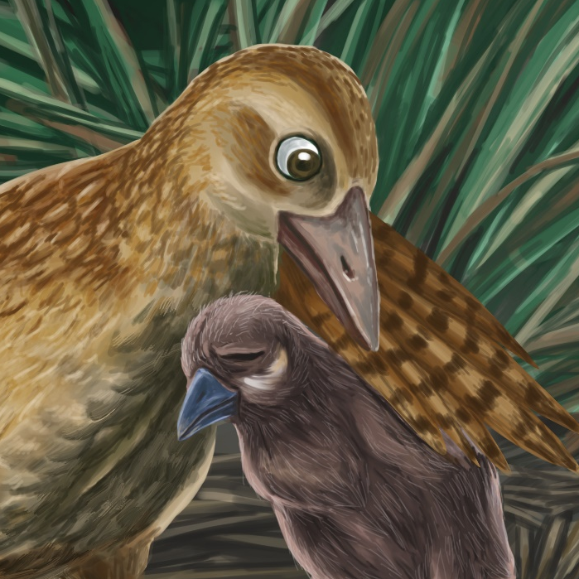

Weka Chick is Lost
By Maggie Boston
Illustrations by Susan Trisna

Weka Chick is Lost
Book 16

This reader for young children is part of a reading series for the Better Start Literacy Approach. Each book provides reading practice for children to decode short words with a focus on target consonants and vowels. The reader has been designed to support class teaching activities that are part of the Better Start Literacy Approach.

The Better Start Literacy Approach has been developed through the University of Canterbury Child Well-being Research Institute. The lead research team includes:
Professor Gail Gillon, Associate Professors Brigid McNeill and Alison Arrow, Drs Amy Scott and Amanda Denston and Professor Angus Macfarlane.

To access these readers online in narrated and book form, please visit https://sites.google.com/view/betterstart-whānau/home and click on the ‘Children’s Readers’ tab.
Published February, 2020, UC Child Well-being Research Institute.

The Better Start Literacy Approach is supported by the
A Better Start National Science Challenge, a 10-year programme of research investigating practical, evidence-based solutions that make a measurable difference for our tamariki. https://www.abetterstart.nz/



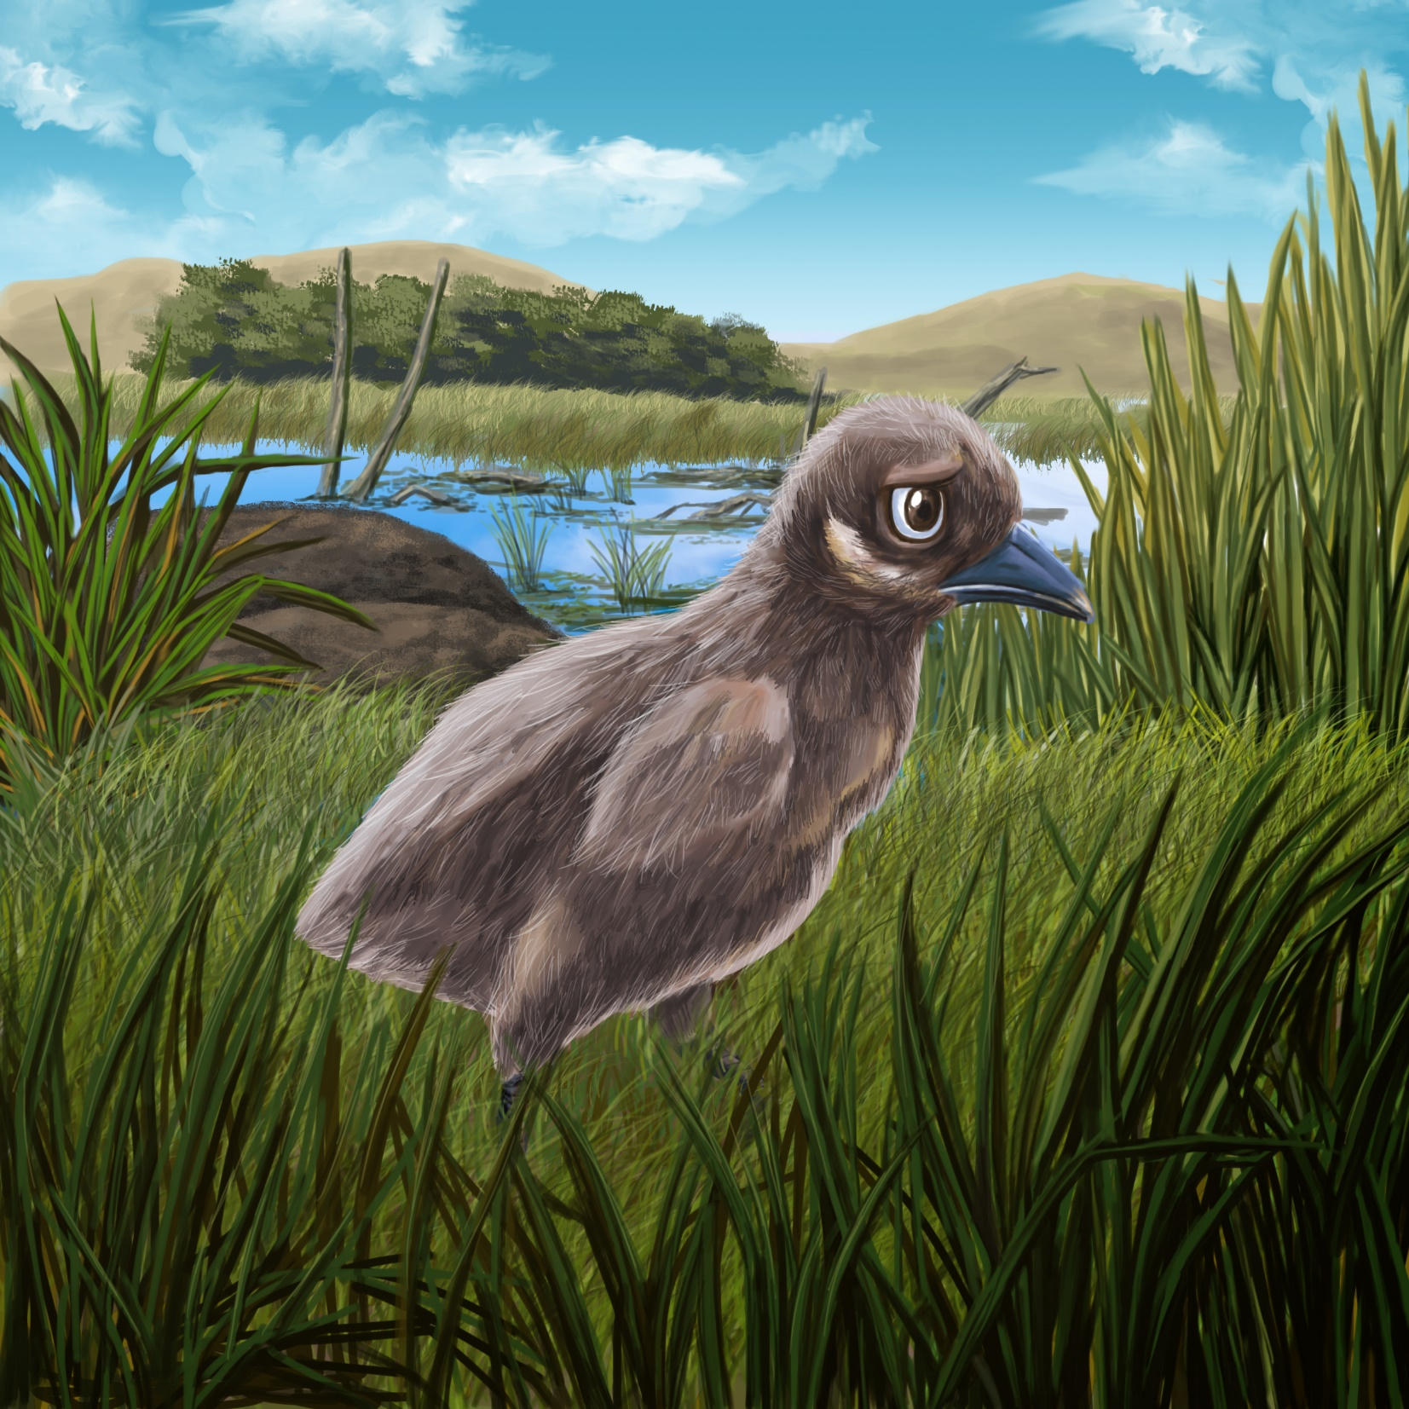

Weka Chick is sad.
“I am lost,” says Weka Chick.
“I can not see my nest.
The weeds are too big.”

Weka Chick wades into the wet land.
But, a big rat is in the weeds.
Manu sees the big rat.

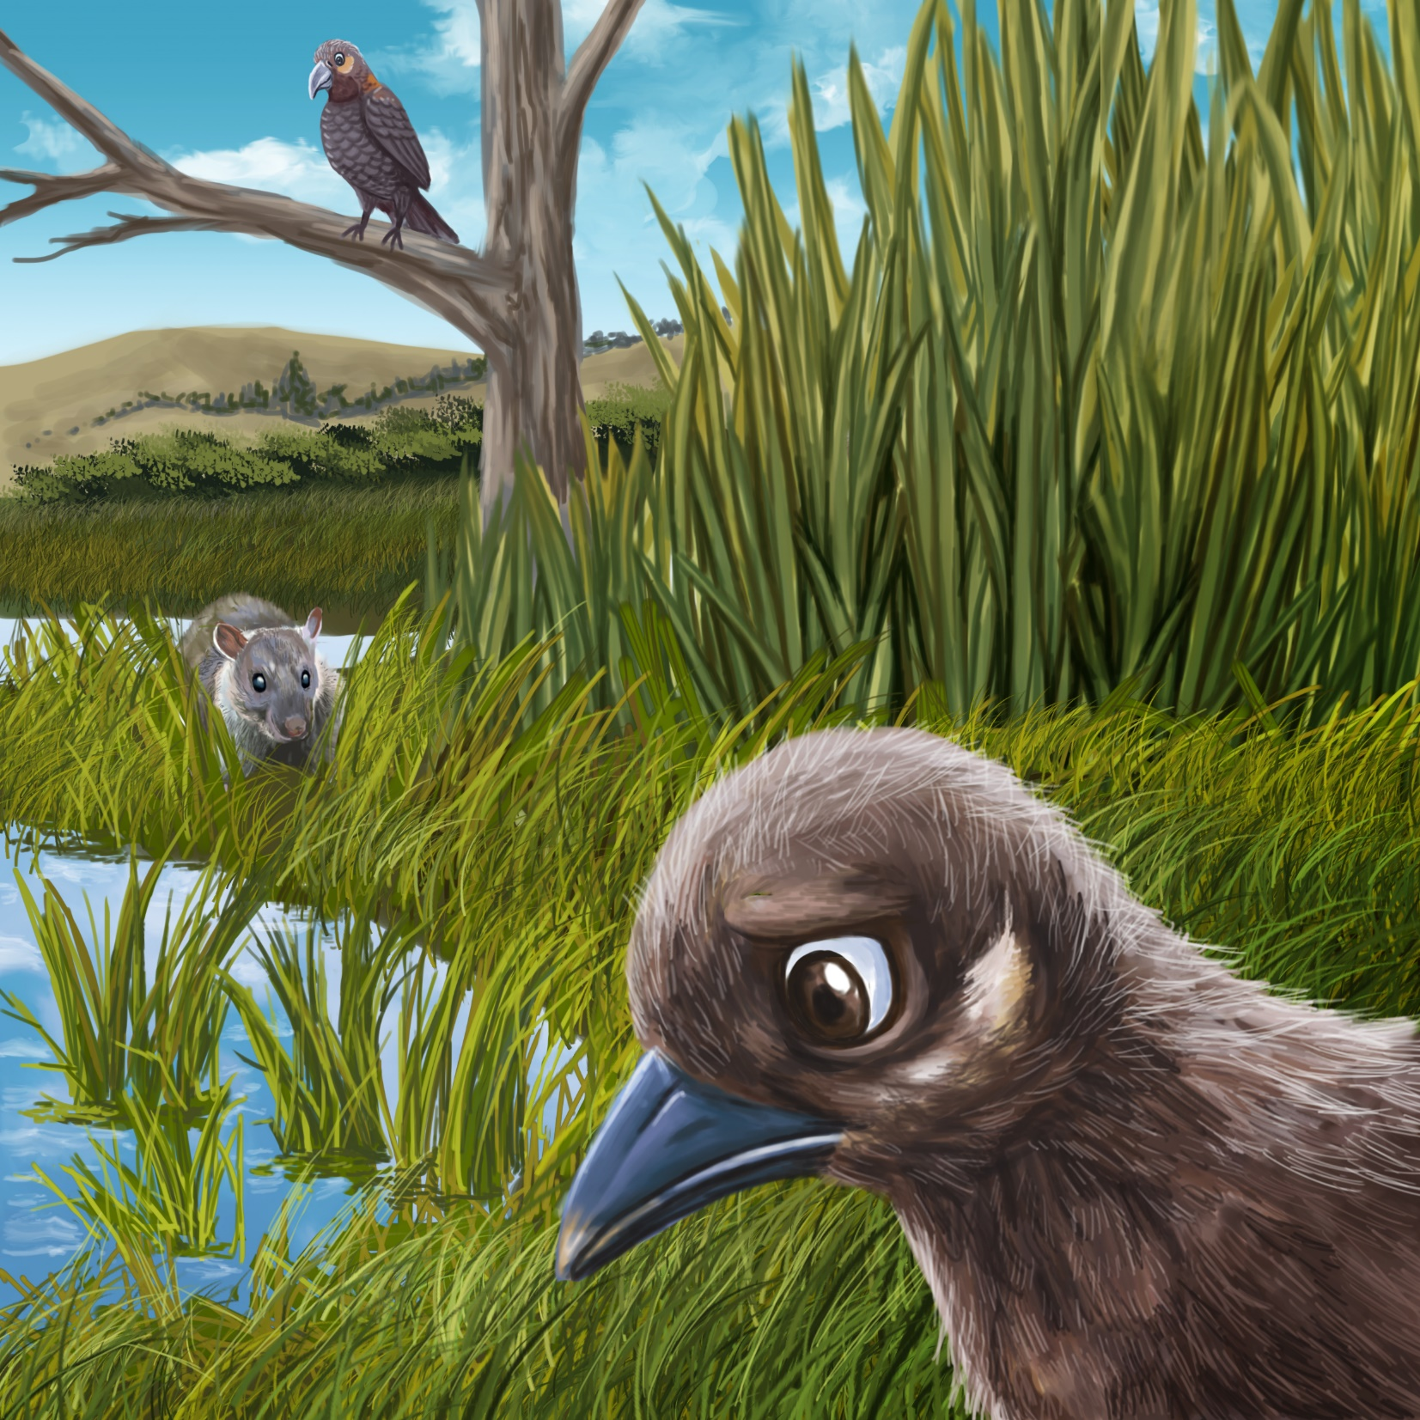
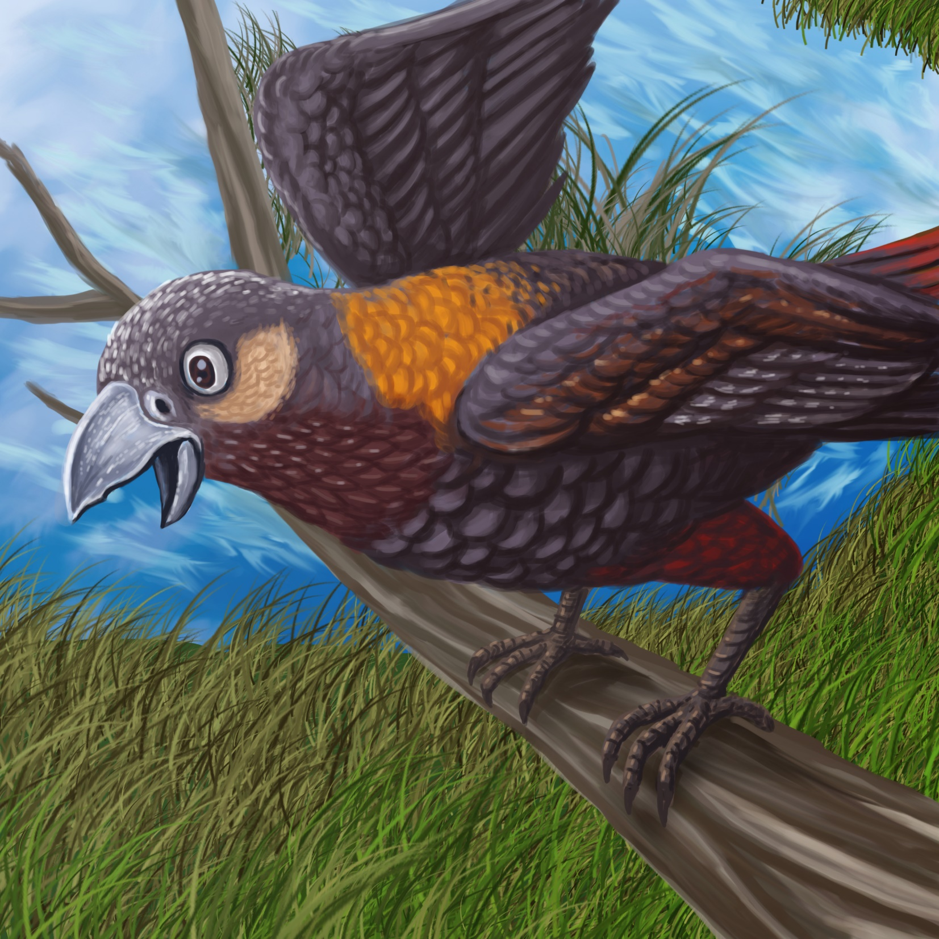

“Look out Weka Chick!” calls Manu.
“Run to your nest!
Run and hide from the big rat!”

Weka can not fly so Weka Chick must run fast.
He runs past the big weeds and into the trees.

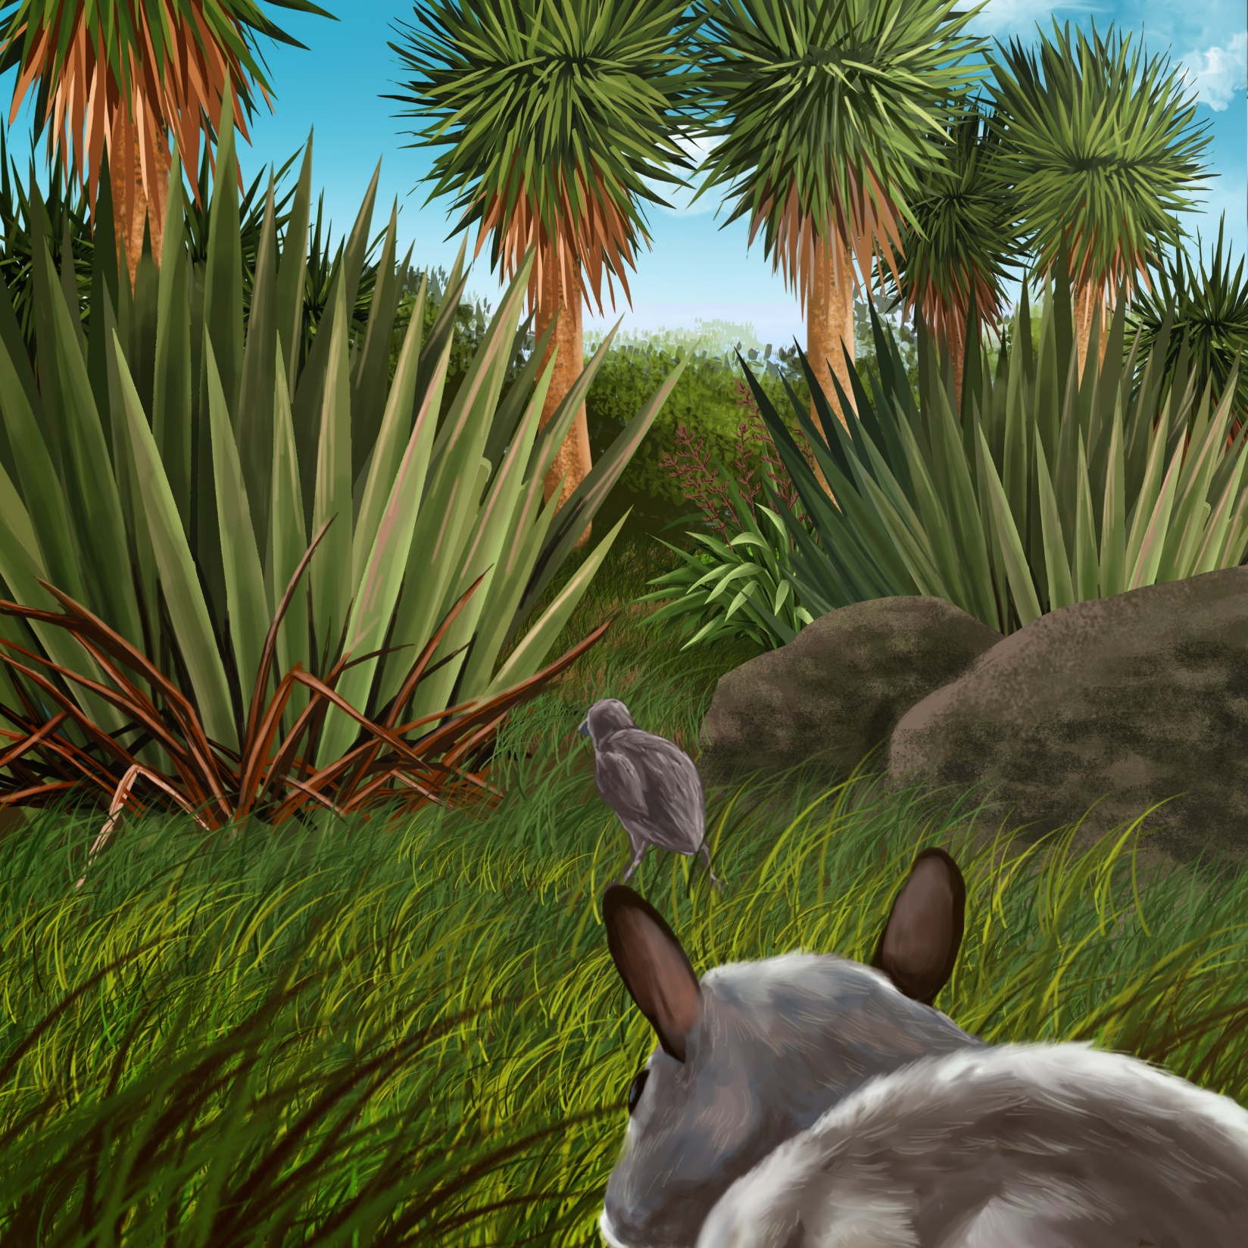
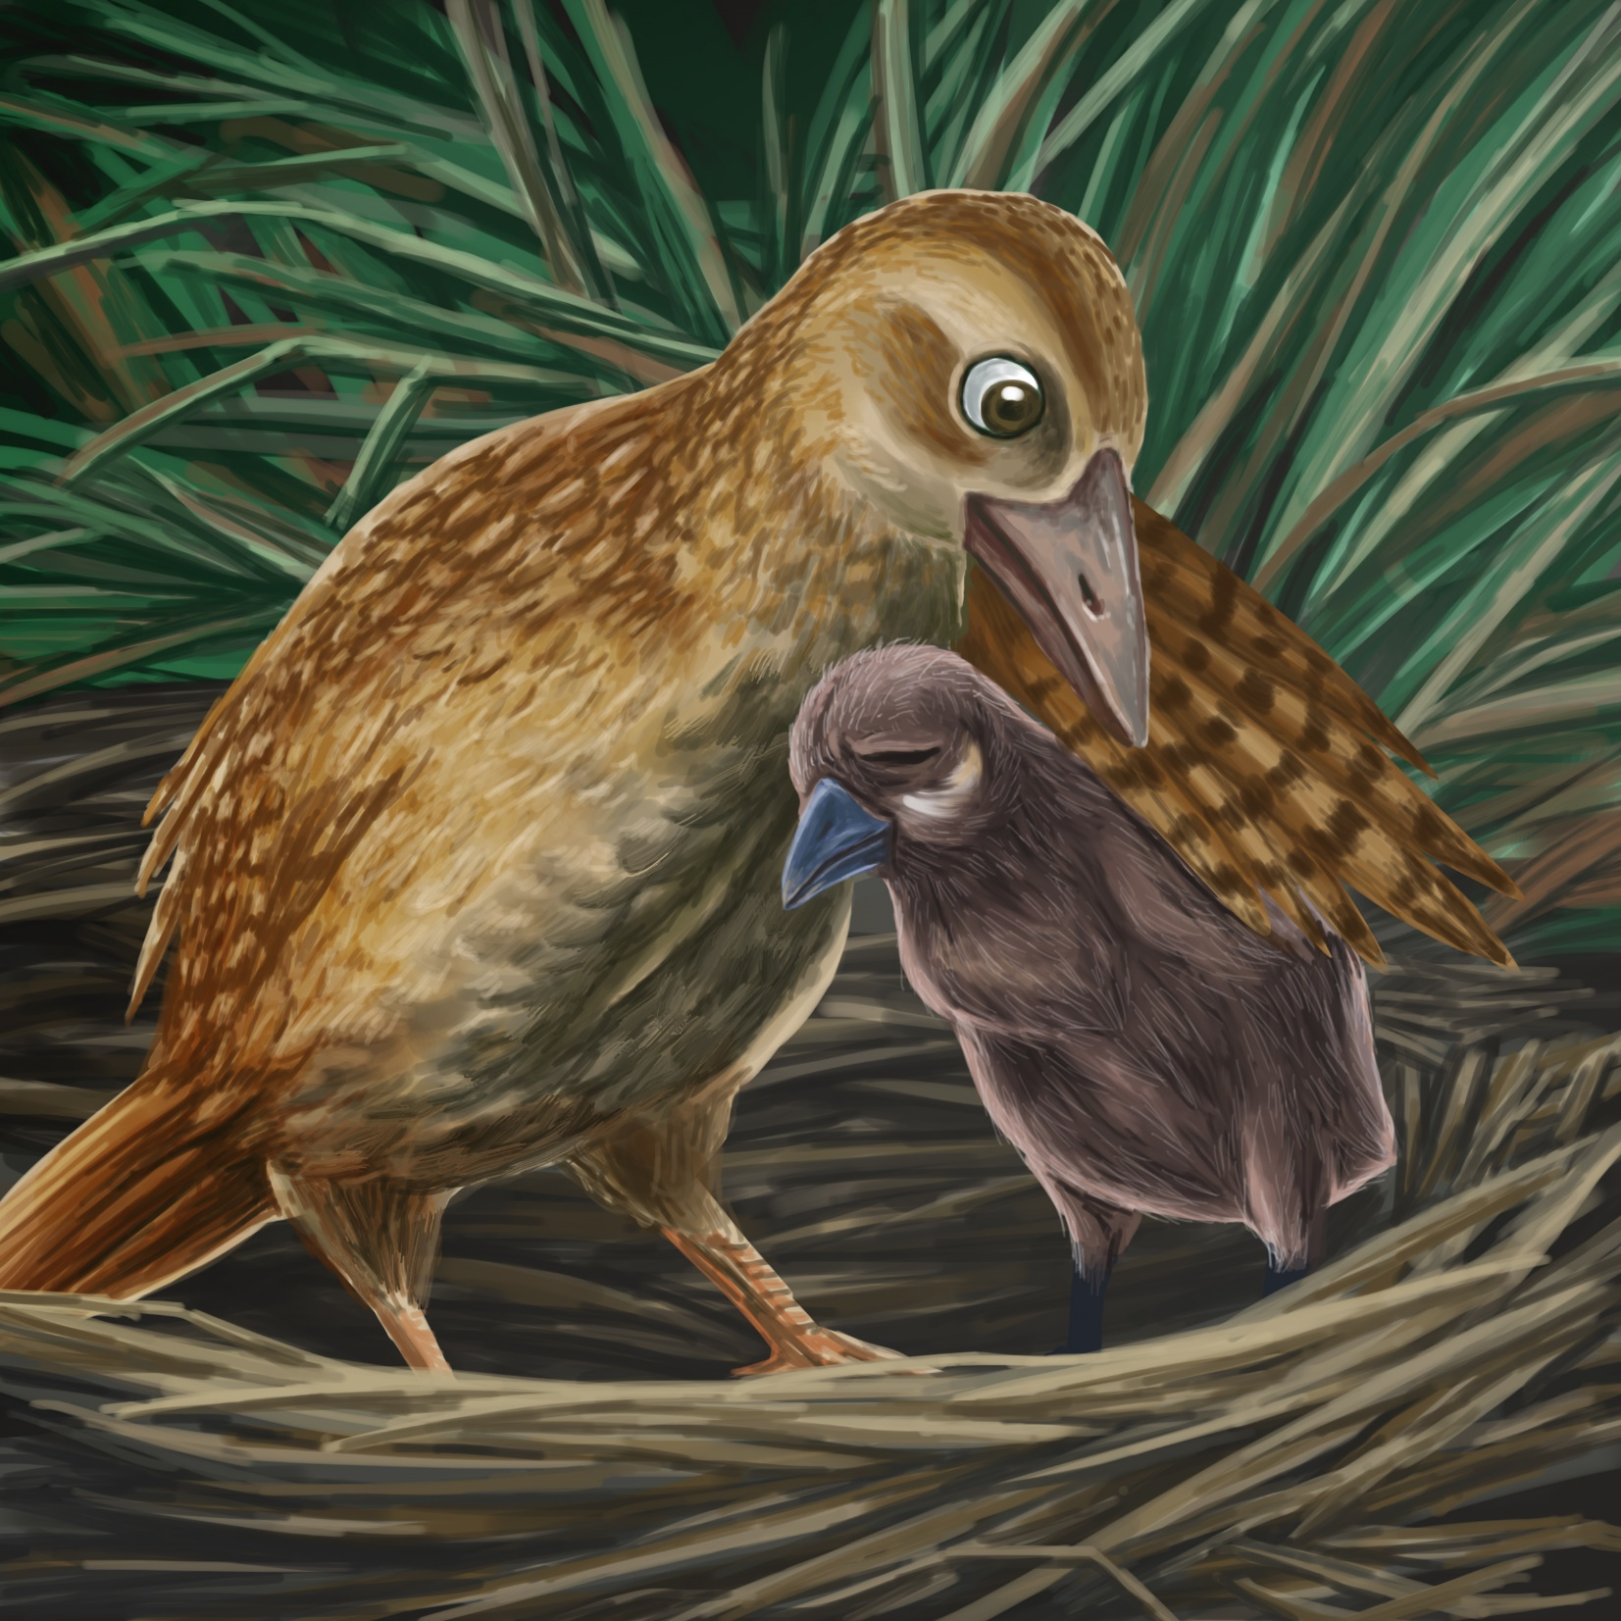

Weka Chick sees his mum.
Weka’s mum opens her wing and gives Weka Chick a big hug.
Weka Chick is safe back in his nest.
Teaching Notes: Book 16 Weka Chick is Lost
Reading Practice: This story provides children with practice in decoding short words with a focus on words that start with consonants w and ch and include vowels a, e, i and u.

Introduce the text and read the story aloud together, pointing to each word as you read the story. Encourage children to help you “sound out” the regular words in the story. Help children sound out the word and then blend the sounds together, for example, n-e-s-t = nest. When reading unknown high frequency words (e.g., her, his, sees), tell children the words as you read together. Give plenty of praise for children’s reading attempts and encourage re-reading to build fluency and accuracy.

Phonological Awareness
Practice segmenting and blending words. Ask children to clap out each phoneme (sound) in the word: b-i-g (3 sounds), n-e-s-t (4 sounds), r-a-t (3 sounds), r-o-ck-s (4 sounds), l-o-s-t (4 sounds).
Help children to find each word you segment on the page.
Think of all the words you can that start with a w sound and a ch sound. Find objects in the room that start with a w sound and a ch sound.

Spelling
Listen and identify where the sound change occurs in words. Use the phrasing: “If this word spells mum, can you make it say gum. If this word says gum can you change it to gut”.
Change run to ran to rat to rats
Change weed to seed to speed to sped

Vocabulary
Discuss the words in the story that describe how Weka Chick escaped from the big rat. He ran past the weeds and into the trees. Move around the room to show what these words mean.

Story Discussion
Ask children to discuss with a friend a time they couldn’t find their mum or dad (or nan or other adult). How did that make them feel? What did they do to find them again? What should we do if we ever get lost?

Story Retell
Ask children to re-tell the story to a friend. Prompt as necessary using picture cues. Give plenty of praise and encouragement.
Print Concepts
Discuss use of capital letters for Weka Chick and Manu’s names. Bring children’s attention to these words on the page.


