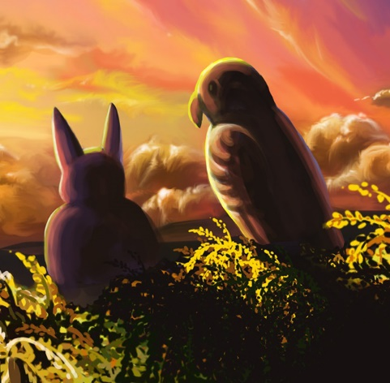

Manu and Bat
By Maggie Boston
Illustrations by Susan Trisna

Manu and Bat
Book 9

This reader for young children is part of a reading series for the Better Start Literacy Approach. Each book provides reading practice for children to decode and understand short words with a focus on target consonants and vowels. The reader has been designed to support class teaching activities that are part of the Better Start Literacy Approach.

The Better Start Literacy Approach has been developed through the University of Canterbury Child Well-being Research Institute. The lead research team includes:
Professor Gail Gillon, Associate Professors Brigid McNeill and Alison Arrow, Drs Amy Scott and Amanda Denston and Professor Angus Macfarlane.

To access these readers online in narrated and book form, please visit https://sites.google.com/view/betterstart-whānau/home and click on the ‘Children’s Readers’ tab.
Published February, 2020, UC Child Well-being Research Institute.

The Better Start Literacy Approach is supported by the
A Better Start National Science Challenge, a 10-year programme of research investigating practical, evidence-based solutions that make a measurable difference for our tamariki. https://www.abetterstart.nz/


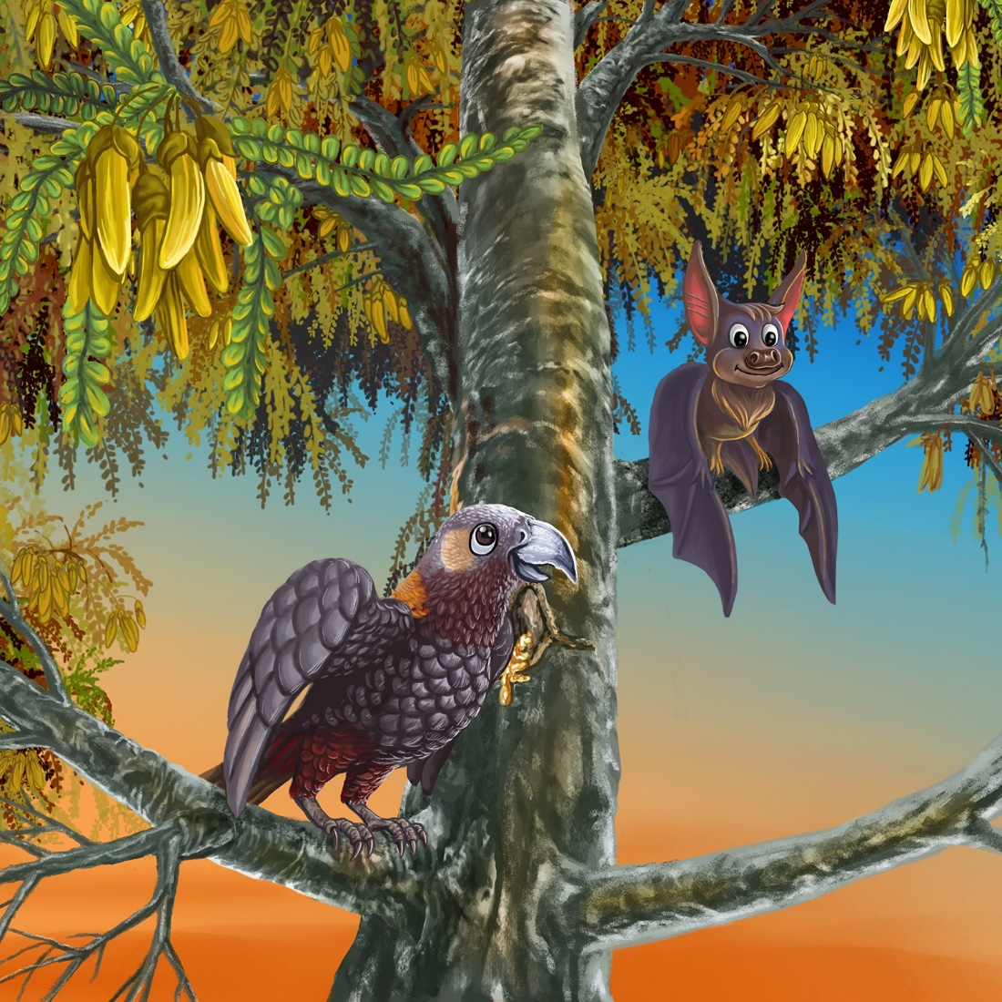

Manu sat in the tree.
Manu met Bat in the tree.

Tap, tap, tap, went Manu’s beak.
“I like the tree sap,” said Manu.
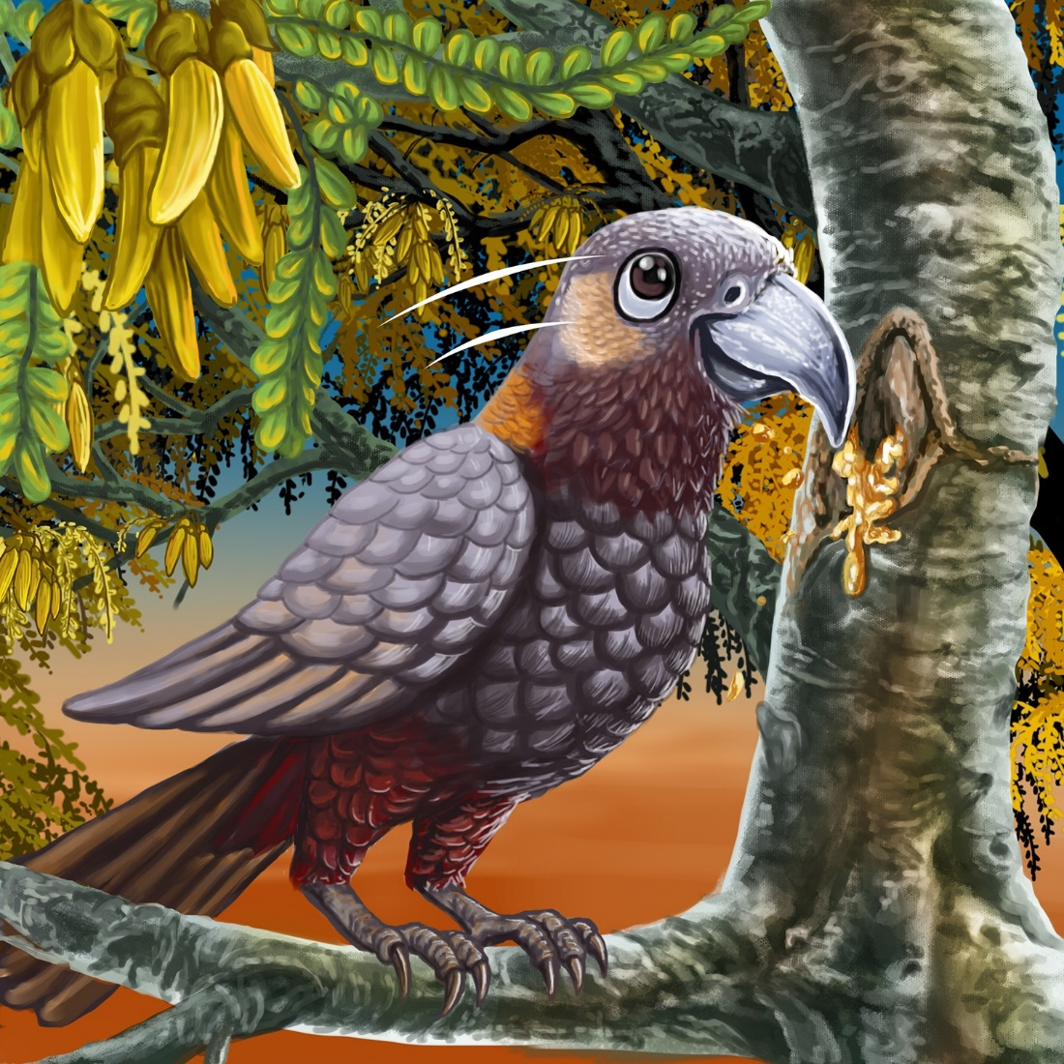

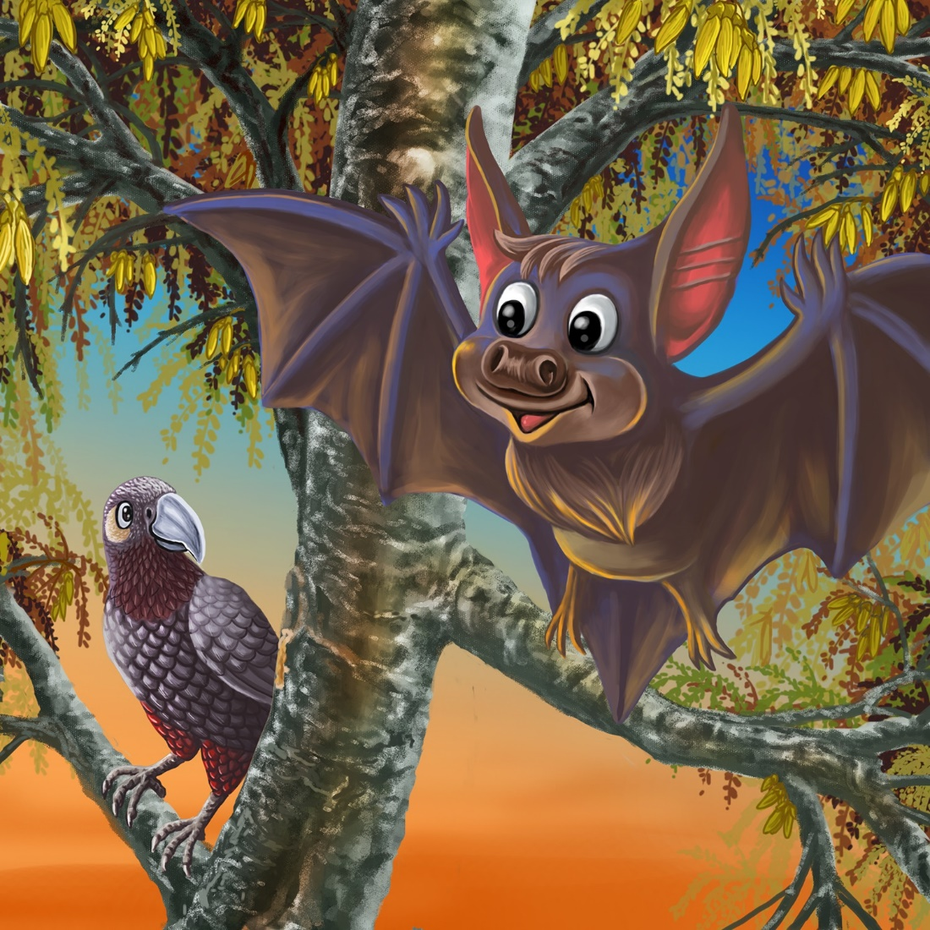

Flap, flap, flap, went Bat’s wings.
“I like the tree top,” said Bat.

Manu and Bat sat on the tree top together.

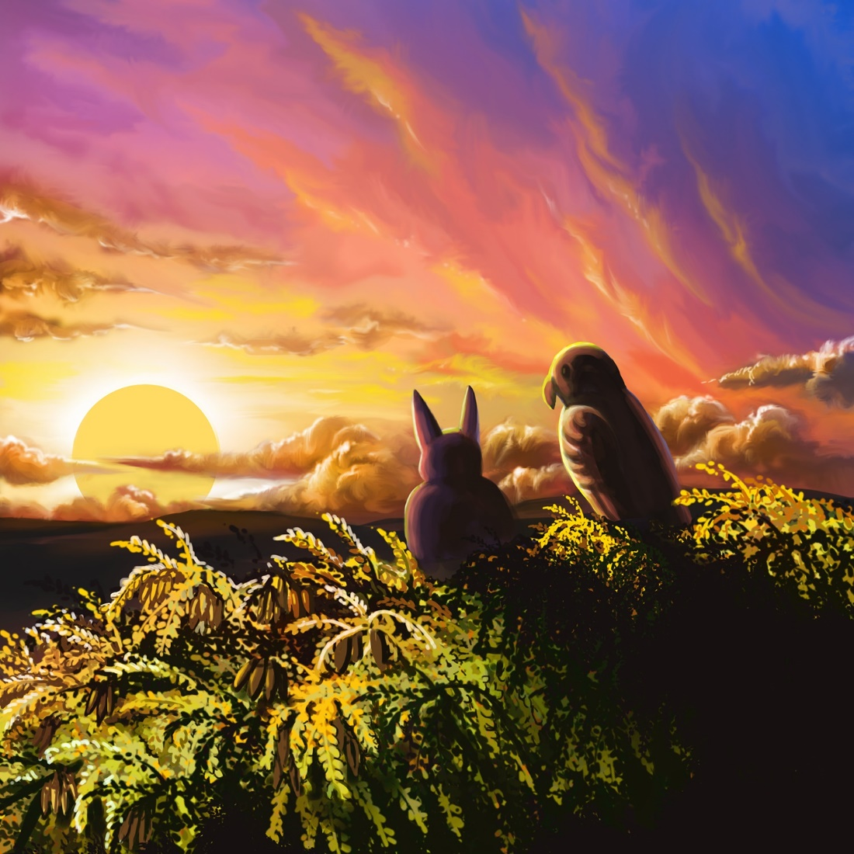

Teaching Notes: Book 9 Manu and Bat
Reading Practice: This story provides children with practice in decoding and understanding short words. It reviews consonants learnt in previous weeks (m, b, t, p) and introduces words that start with consonant blends.

Reading Practice
Introduce the text and read the story aloud together, pointing to each word as you read. Encourage children to help you “sound out” the regular words in the story (see words in bold print below). Help children sound out the word and then blend the sounds together, for example, s-a-t = sat. When reading unknown high frequency words (e.g., the, says), tell children the words as you read together. Give plenty of praise for children’s reading attempts and encourage re-reading to build fluency and accuracy.

Manu sat in the tree.
Manu met Bat in the tree.
Tap, tap, tap, went Manu’s beak.
“I like the tree sap,” said Manu.
Flap, flap, flap, went Bat’s wing.
“I like the tree top,” said Bat.
Manu and Bat sat on the tree top together.

Phonological Awareness
Practice segmenting and blending words with blends. Ask children to clap out each phoneme (sound) in the word: f-l-a-p (4 sounds, 4 claps), t-o-p
(3 sounds). Help children find each word you segment on the page.
Listen to the syllables in the long word “together”: to-geth-er. Clap out the syllables. Write the word broken into syllables and read each syllable and then blend word together again.

Spelling
Listen and identify where the sound change occurs in words. Use the phrasing: “If this word spells tap, can you make it say map. If this word says map can you change it to sap”.
Give plenty of praise and encouragement for reading and spelling attempts.
Change top to mop to map
Change bat to mat to map to mop

Vocabulary
Manu is the Māori word for bird. Practice using ‘manu’ in sentences:
“Manu like to fly.” “The manu sat in the tree.”
Flap means to move up and down. Birds or bats flap their wings when they are ready to fly or when they are flying. Try flapping your arms like a bird or bat’s wing.

Story Discussion
Manu met a friend in the tree and they sat together. Discuss friendship and doing things together – for example how Manu went up to the tree top because Bat liked the tree top.
Discuss how bats are nocturnal – this means they come out at dusk when the sun is setting.

Story Retell
Ask the children to re-tell the story to a friend. Prompt as necessary using picture cues. Give plenty of praise and encouragement.

Print Concepts
Discuss the use of quotation marks (or speech marks). We use speech marks when we want to use someone else’s words in our writing.

