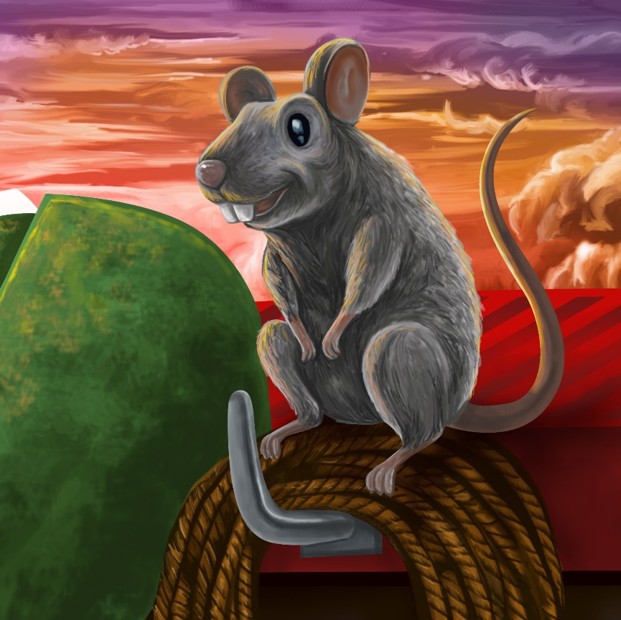

Rat’s Ride
By Maggie Boston
Illustrations by Susan Trisna

Rat’s Ride
Book 14

This reader for young children is part of a reading series for the Better Start Literacy Approach. Each book provides reading practice for children to decode short words with a focus on target consonants and vowels. The reader has been designed to support class teaching activities that are part of the Better Start Literacy Approach.

The Better Start Literacy Approach has been developed through the University of Canterbury Child Well-being Research Institute. The lead research team includes:
Professor Gail Gillon, Associate Professors Brigid McNeill and Alison Arrow, Drs Amy Scott and Amanda Denston and Professor Angus Macfarlane.

To access these readers online in narrated and book form, please visit https://sites.google.com/view/betterstart-whānau/home and click on the ‘Children’s Readers’ tab.
Published February, 2020, UC Child Well-being Research Institute.

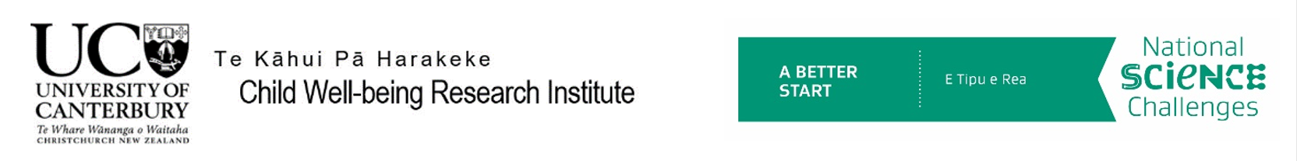
The Better Start Literacy Approach is supported by the
A Better Start National Science Challenge, a 10-year programme of research investigating practical, evidence-based solutions that make a measurable difference for our tamariki. https://www.abetterstart.nz/

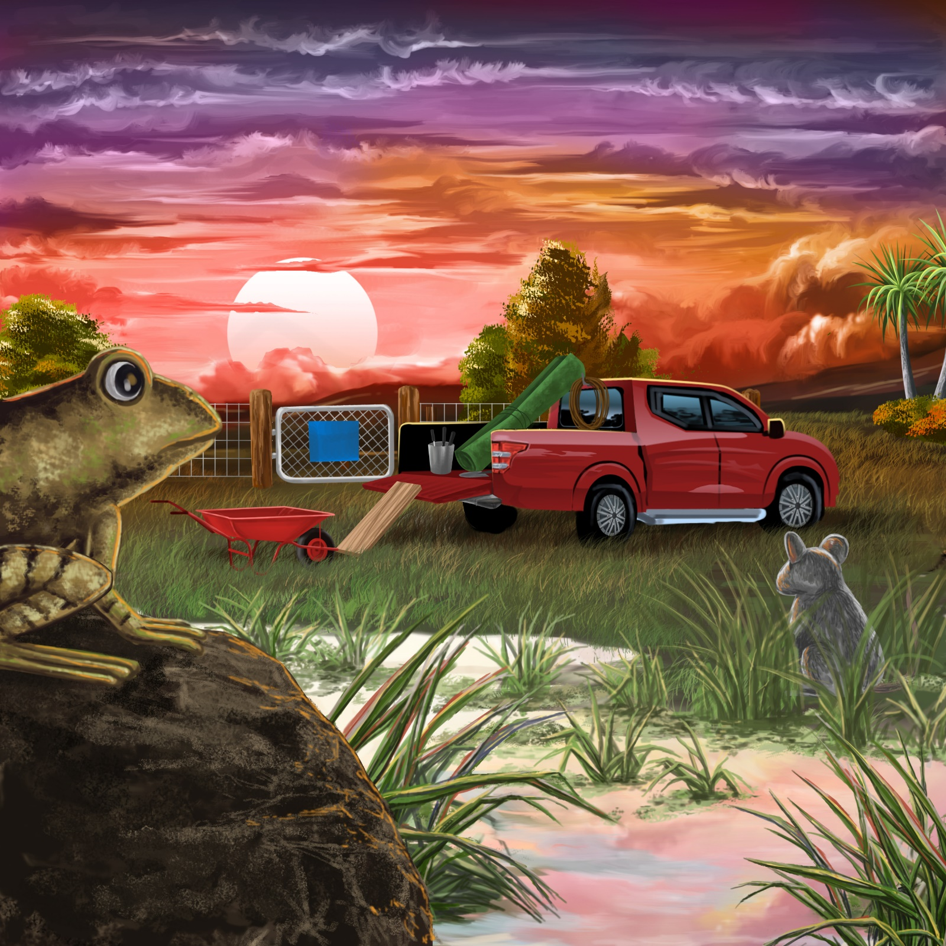

Frog sits on a big rock.
Frog sees rat in the wetland.
“Look!” says Frog, “A red truck is in the mud.”

Rat runs up the ramp.
He runs into a green rug.
He runs up a rope.
“This is fun!” says Rat.
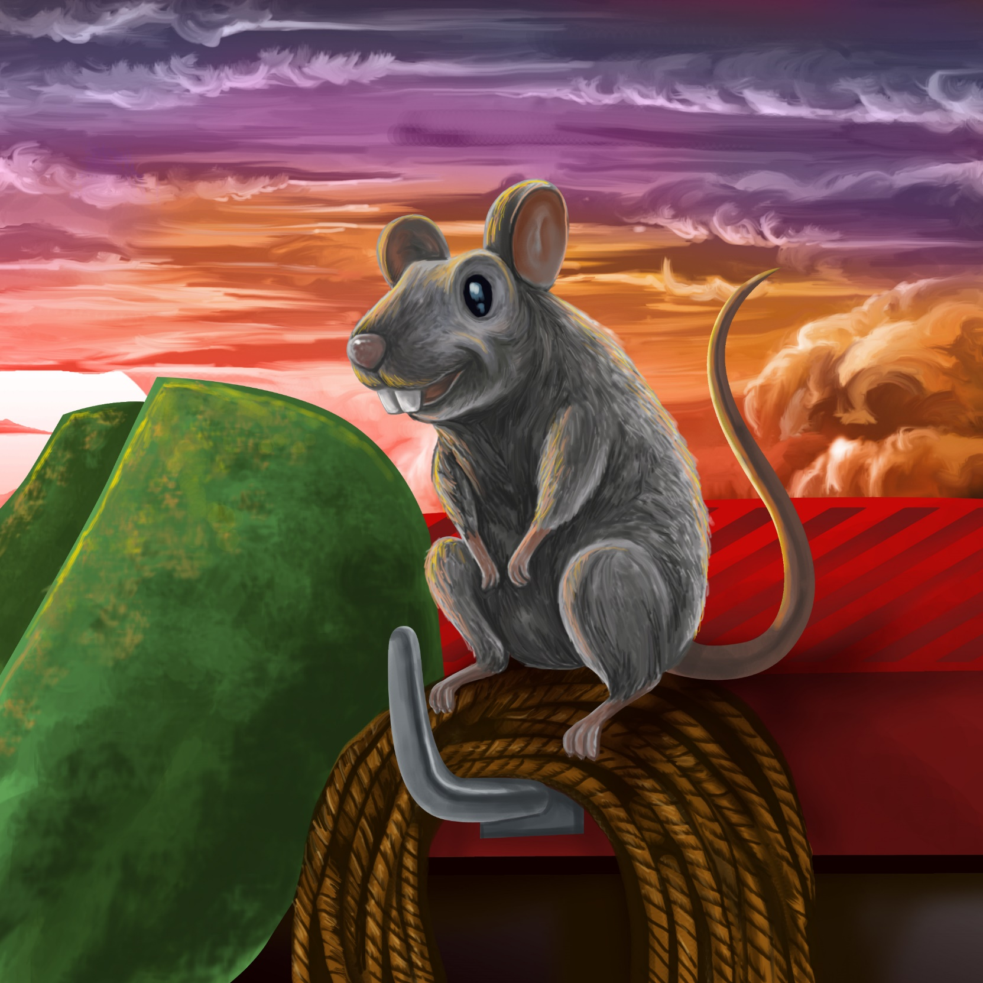

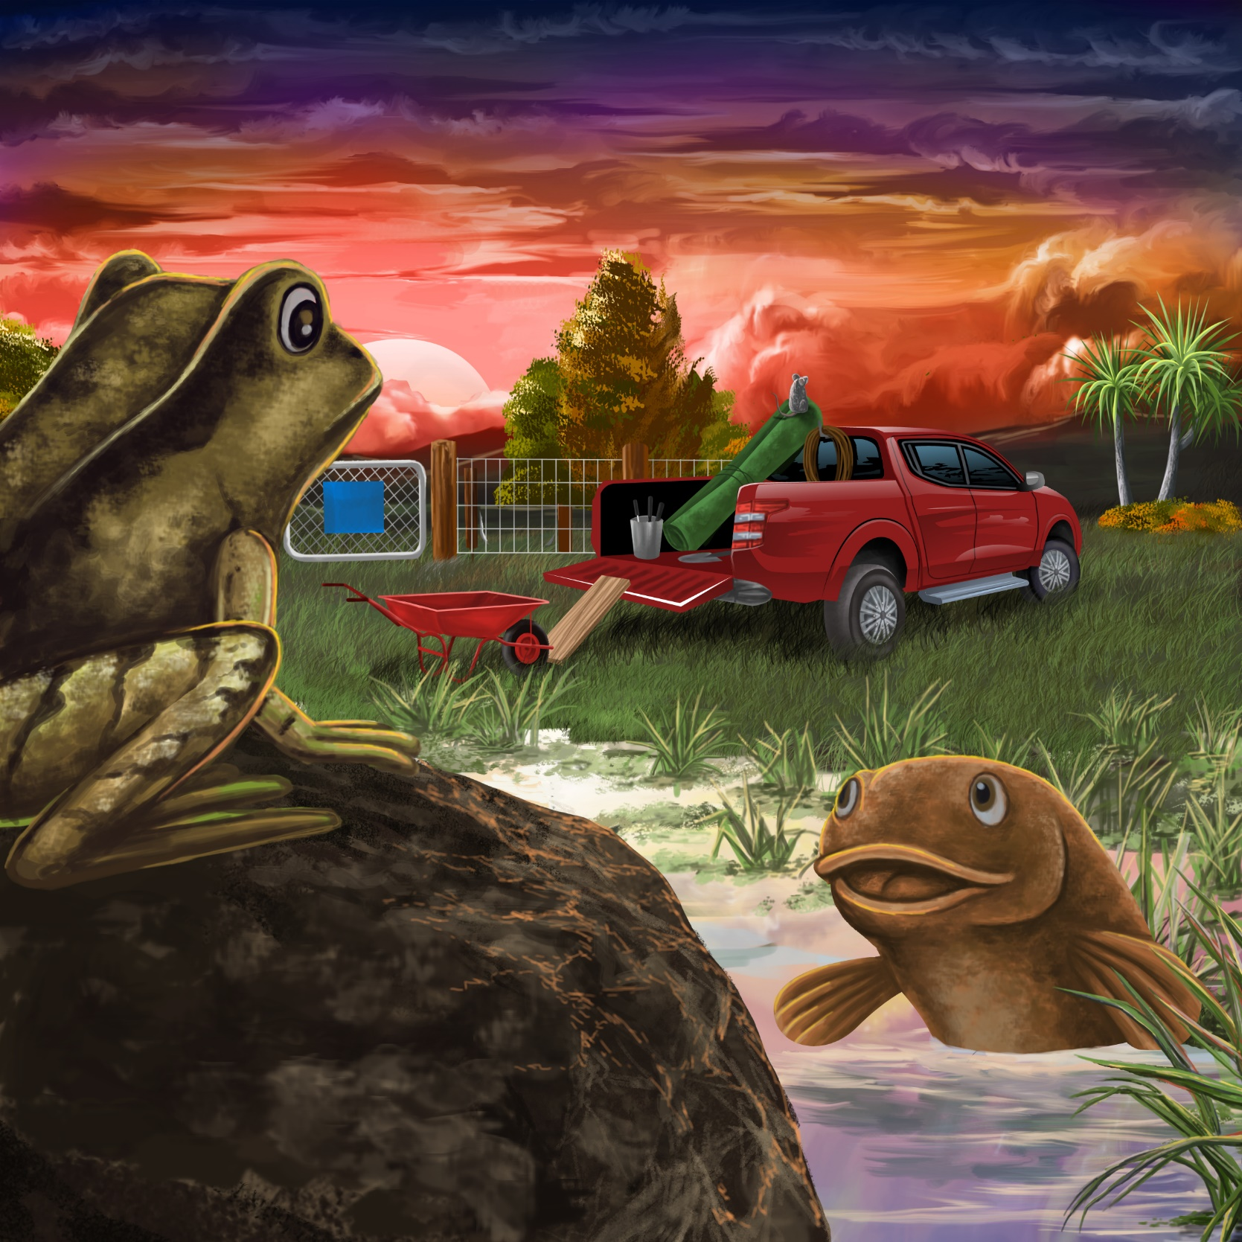

Ika the Mud fish swims by the rock.
“What can you see from the big rock?” asks Mud fish.
“I see rat on a rope!” says Frog.

Mud fish sees men by the gate.
“Get off the truck, Rat,” says Mud fish.
Rat runs down the rope.
He hides in the green rug.
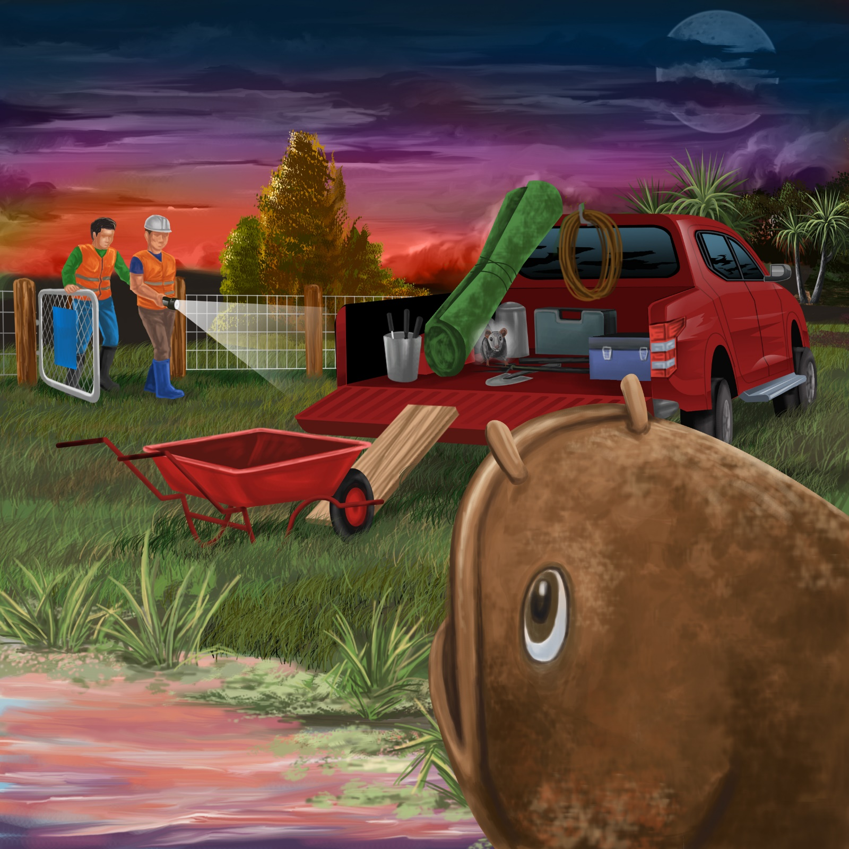
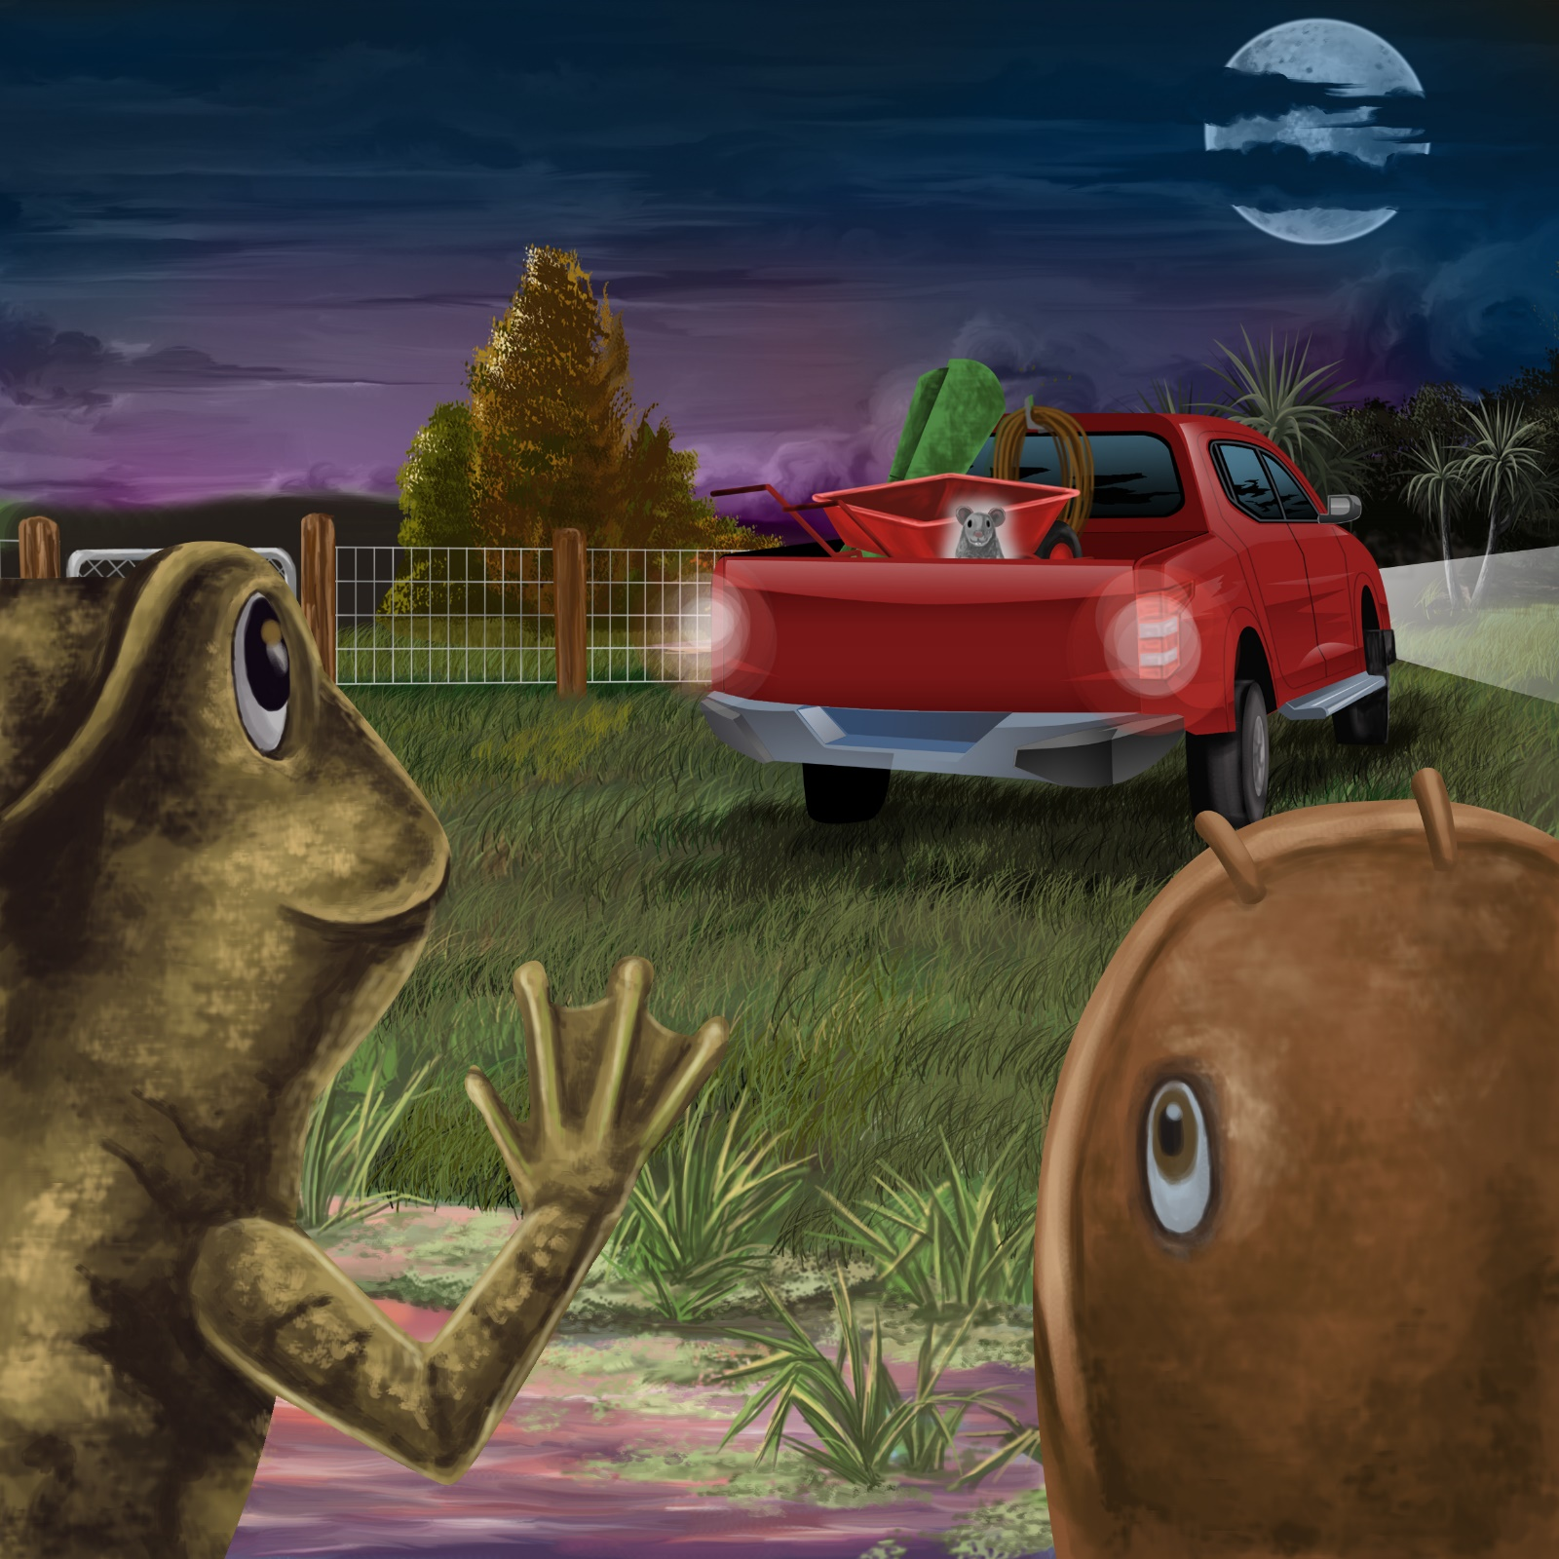

The men lift the ramp up.
They get the truck out of the mud.
“I will go for a ride!” says Rat.
“Haere rā, Rat,” says Frog.
“Safe ride!” says Mud fish.
Teaching Notes: Book 14 Rat’s Ride
Reading Practice: This story provides children with practice in decoding short words with a focus on words that include g and r consonants and in a o and i vowels.

Introduce the text and read the story aloud together, pointing to each word as you read the story. Encourage children to help you “sound out” the regular words in the story. Help children sound out the word and then blend the sounds together, for example, r-a-t = rat. When reading unknown high frequency words (e.g., sees, lift, Haere rā), tell children the words as you read together. Give plenty of praise for children’s reading attempts and encourage re-reading to build fluency and accuracy.

Phonological Awareness
Practice segmenting and blending words. Ask children to clap out each phoneme (sound) in the word: r-o-ck (3 sounds), f-r-o-g (4 sounds), r-a-m-p (4 sounds), h-i-de-s (4 sounds), s-a-f-e (4 sounds).
Help children to find each word you segment on the page.
Think of all the words you can that start with a g sound, and an r sound. Find objects in the room that start with a g or r sound

Spelling
Listen and identify where the sound change occurs in words. Use the phrasing: “If this word spells mud, can you make it say bud. If this word says bud can you change it to bid”.
Change ramp to lamp to limp to lip to tip.

Vocabulary
Haere rā is the Māori word that means goodbye. Check the Māori dictionary online with a sound file for correct pronunciation and practice saying it to each other (https://maoridictionary.co.nz).

Story Discussion
Discuss how lots of different animals live in the same habitat and help each other to survive (the ecosystem). Talk about other habitats and the different animals that live there (e.g., desserts, forests).

Story Retell
Ask children to re-tell the story to a friend. Prompt as necessary using picture cues. Give plenty of praise and encouragement.
Print Concepts
Discuss the use of use of speech marks, for example: “Look!” says Frog, “A red truck is in the mud.” We use speech marks to show someone else’s words in our writing.

