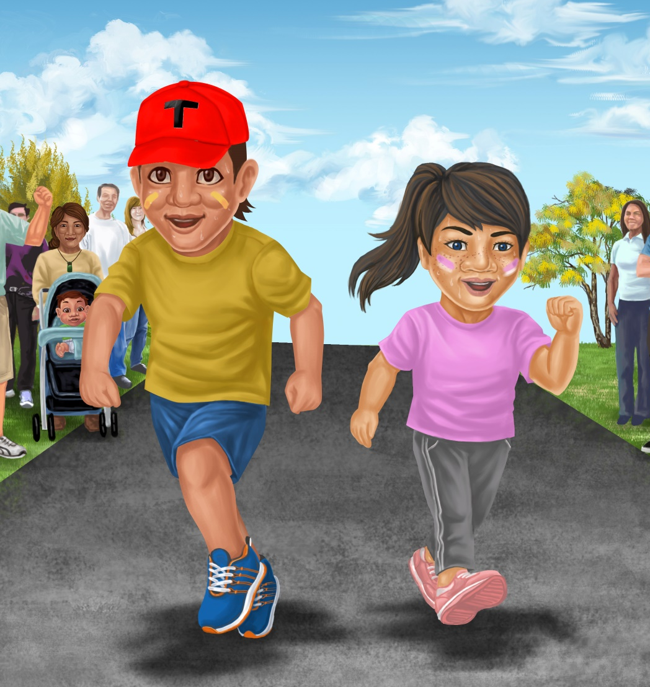

A Fun Run
By Maggie Boston
Illustrations by Susan Trisna

A Fun Run
Book 13

This reader for young children is part of a reading series for the Better Start Literacy Approach. Each book provides reading practice for children to decode short words with a focus on target consonants and vowels. The reader has been designed to support class teaching activities that are part of the Better Start Literacy Approach.

The Better Start Literacy Approach has been developed through the University of Canterbury Child Well-being Research Institute. The lead research team includes:
Professor Gail Gillon, Associate Professors Brigid McNeill and Alison Arrow, Drs Amy Scott and Amanda Denston and Professor Angus Macfarlane.

To access these readers online in narrated and book form, please visit https://sites.google.com/view/betterstart-whānau/home and click on the ‘Children’s Readers’ tab.
Published February, 2020, UC Child Well-being Research Institute.

The Better Start Literacy Approach is supported by the
A Better Start National Science Challenge, a 10-year programme of research investigating practical, evidence-based solutions that make a measurable difference for our tamariki. https://www.abetterstart.nz/




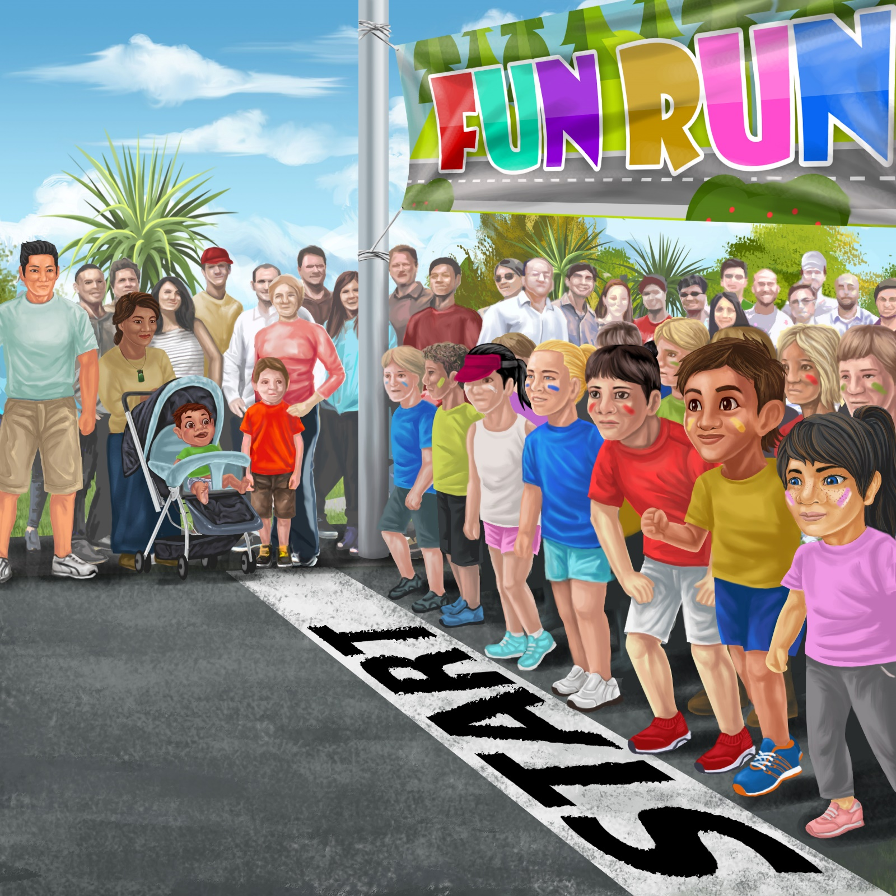

We like to run.
“I run for fun,” said Pam.
“I run to get fit,” said Tama.

But, the sun is hot. Tama and Pam need rest.

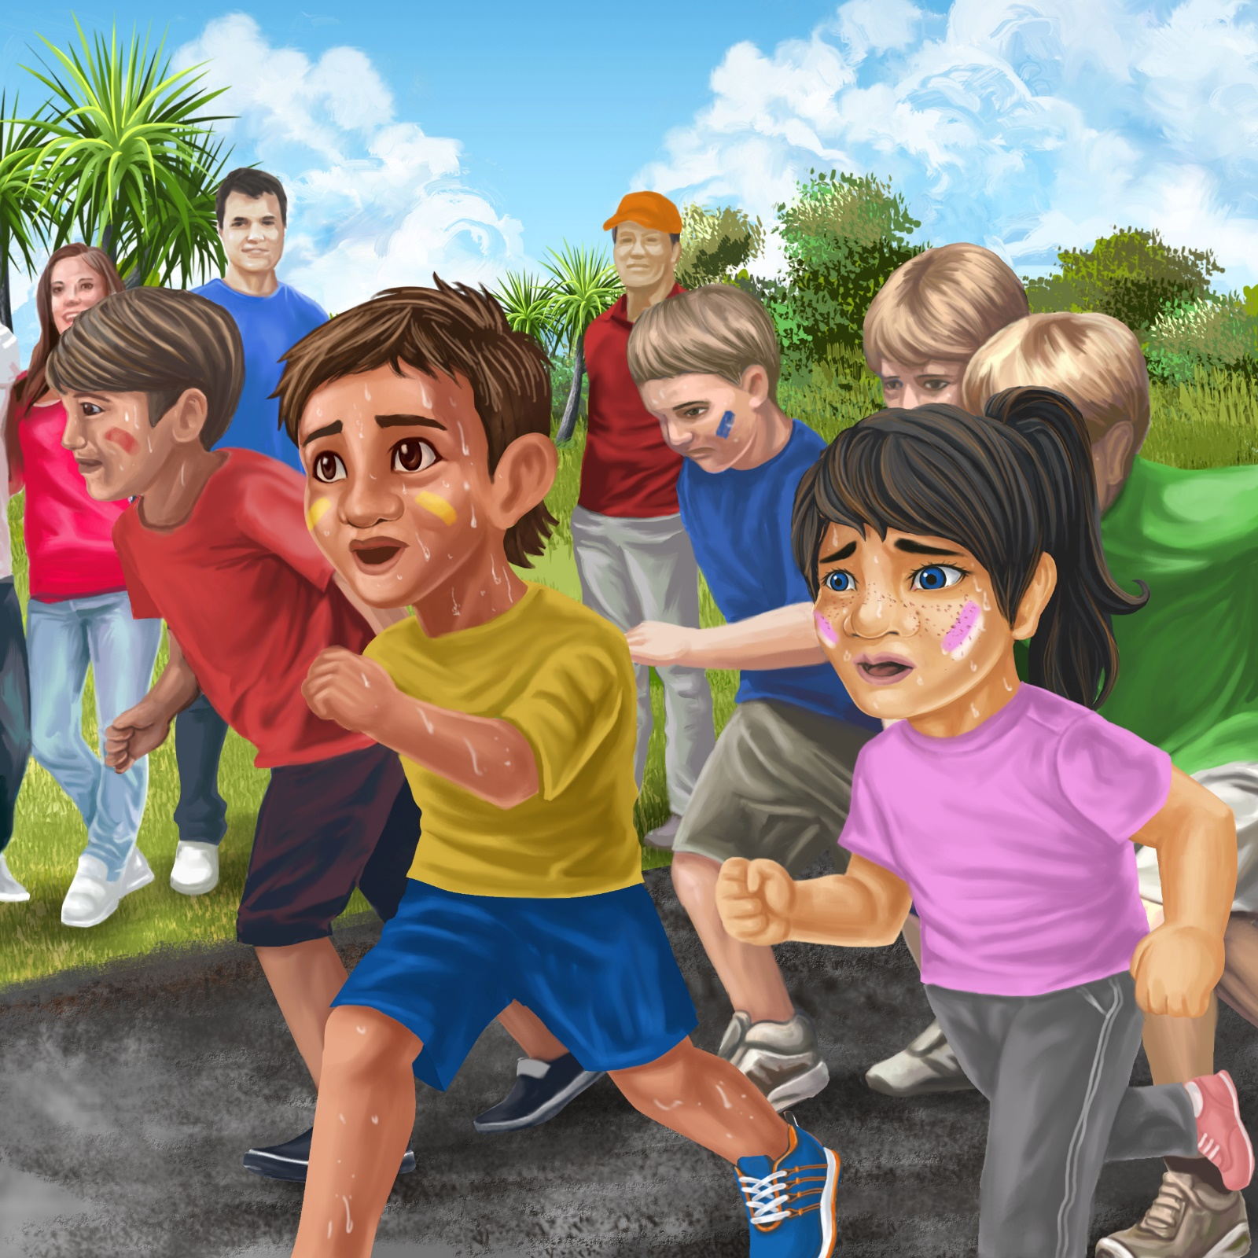



Nan gets a red cap.
“Put on your cap,” said Nan.
“Take a sip,”
said Dad.

Run Tama, run Pam.
Go, go, go!

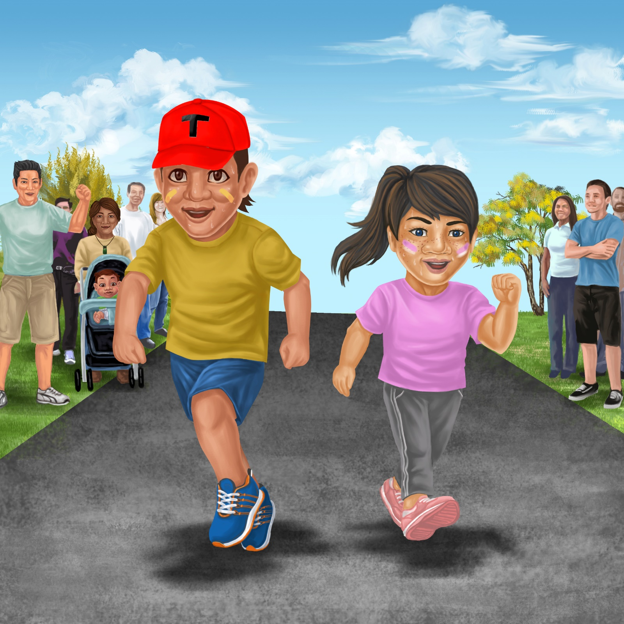
Teaching Notes: Book 13 A Fun Run
Reading Practice: This story provides children with practice in decoding short words with a focus on words that start with g and r consonants and include a, o, and i vowels.

Introduce the text and read the story aloud together, pointing to each word as you read. Encourage children to help you “sound out” the regular words in the story. Help children sound out the word and then blend the sounds together, for example, f-i-t = fit. When reading unknown high frequency words (e.g., take, said), tell children the words as you read together. Give plenty of praise for children’s reading attempts and encourage re-reading to build fluency and accuracy.

Phonological Awareness
Practice segmenting and blending words. Ask children to clap out each phoneme (sound) in the word: r-u-n (3 sounds), n-ee-d (3 sounds), c-a-p (3 sounds), r-e-s-t (4 sounds). Help children to find each word you segment on the page.
Think of all the words you can that start with an r or a g sound. Find objects in the room that start with an r or a g sound.

Spelling
Listen and identify where the sound change occurs in words. Use the phrasing: “If this word spells run, can you make it say ran. If this word says ran can you change it to rant”.
Change run to ran to rap to lap
Change rest to rust to bust to bus

Vocabulary
Discuss the meaning of the word fit. What does it mean to be fit?
Think of other words that have the same meaning as fit and put them in a sentence (e.g., healthy, powerful).

Story Discussion
Discuss why it is important to drink lots of water and keep your face out of the sun when you are outside or exercising, especially on hot days.

Story Retell
Ask children to re-tell the story to a friend. Prompt as necessary using picture cues. Give plenty of praise and encouragement.
Print Concepts
Discuss the use of the exclamation mark. We use an exclamation mark to show we are excited or using a loud voice.
Think of other sentences where you might use an exclamation mark.


