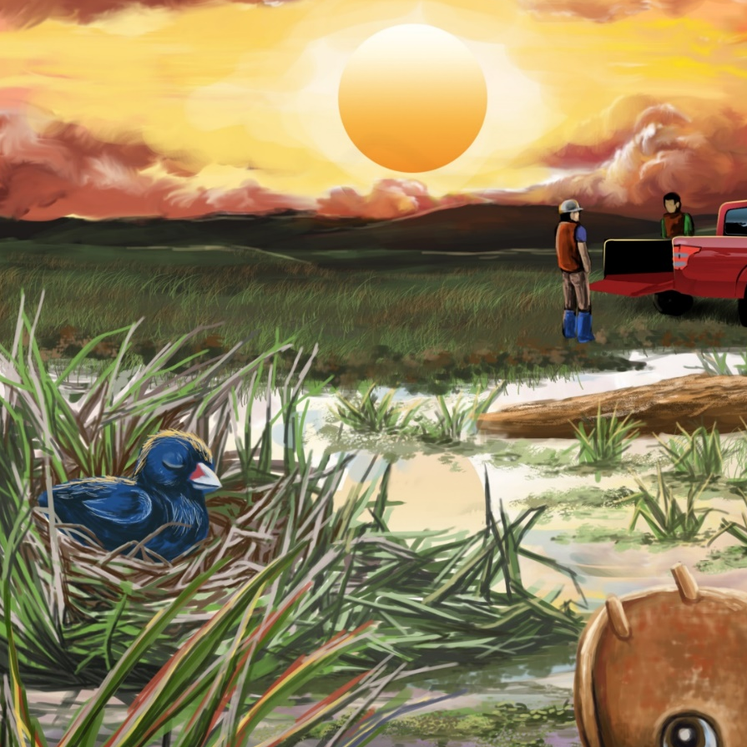

The Sun Sets in the West
By Maggie Boston
Illustrations by Susan Trisna

The Sun Sets in the West
Book 20

This reader for young children is part of a reading series for the Better Start Literacy Approach. Each book provides reading practice for children to decode short words with a focus on target consonants and vowels. The reader has been designed to support class teaching activities that are part of the Better Start Literacy Approach.

The Better Start Literacy Approach has been developed through the University of Canterbury Child Well-being Research Institute. The lead research team includes:
Professor Gail Gillon, Associate Professors Brigid McNeill and Alison Arrow, Drs Amy Scott and Amanda Denston and Professor Angus Macfarlane.

To access these readers online in narrated and book form, please visit https://sites.google.com/view/betterstart-whānau/home and click on the ‘Children’s Readers’ tab.
Published February, 2020, UC Child Well-being Research Institute.

The Better Start Literacy Approach is supported by the
A Better Start National Science Challenge, a 10-year programme of research investigating practical, evidence-based solutions that make a measurable difference for our tamariki. https://www.abetterstart.nz/

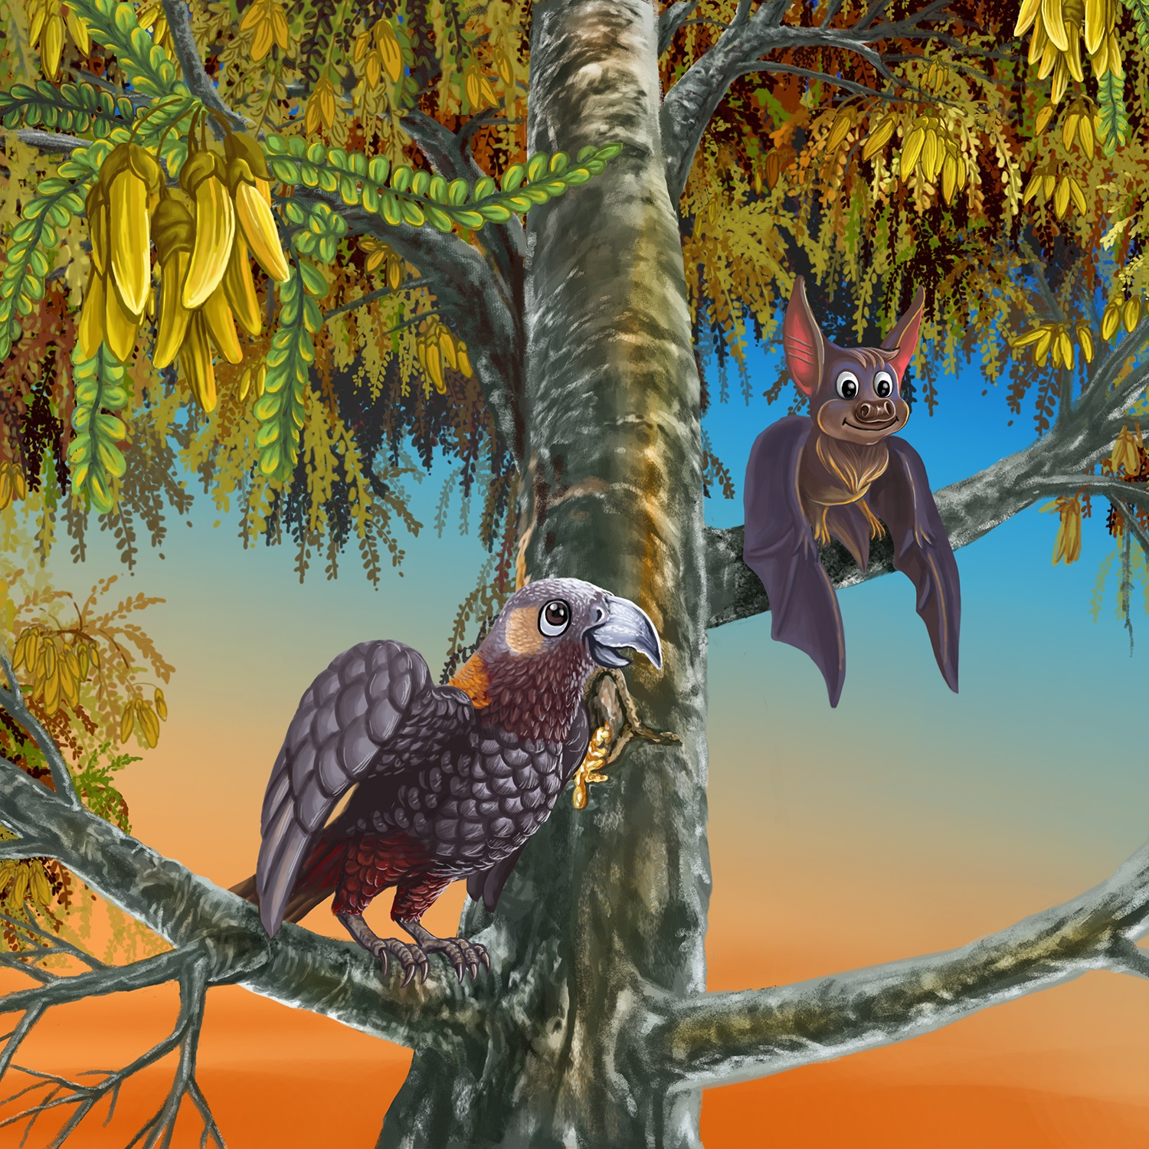

Manu and Bat sit in the tree.
The sun is setting.
What do they see?

Wētā creeps on the stick.
Kiwi wakes from his rest.
Frog sits on his rock.
The sun sets in the west.
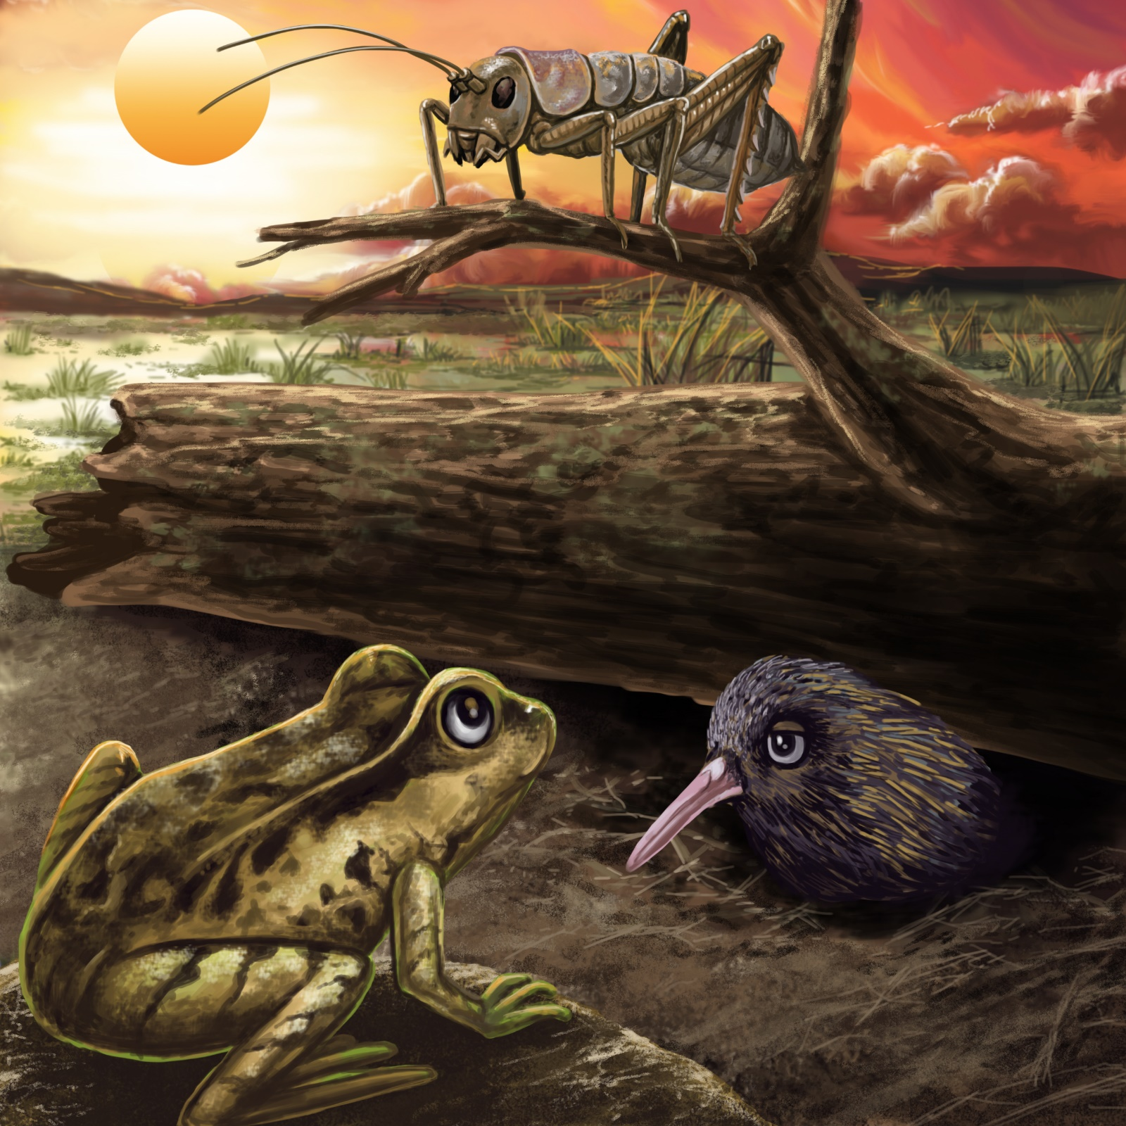

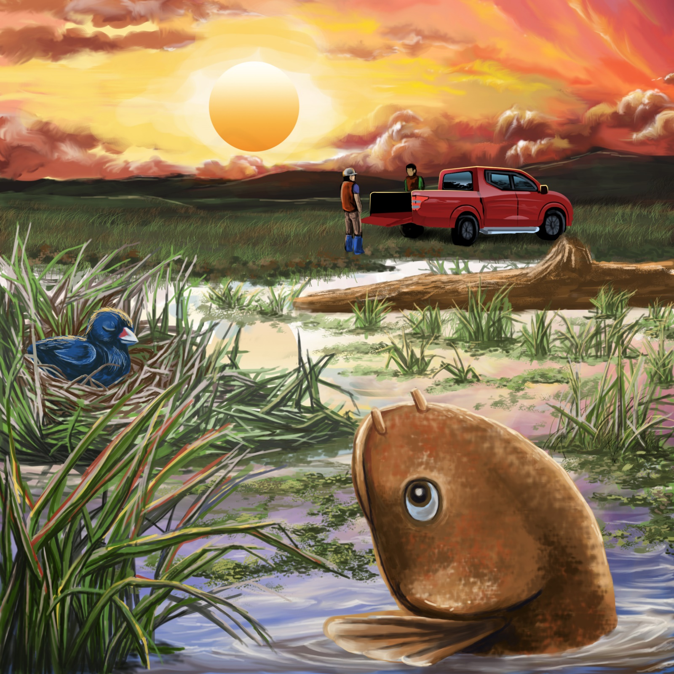

Mud fish swims in the wet land.
Chick sleeps in his nest.
The men pack the truck.
The sun sets in the west.

Tama is in his bed.
Nan’s dinner was the best.
Mot naps on the chair.
The sun sets in the west.
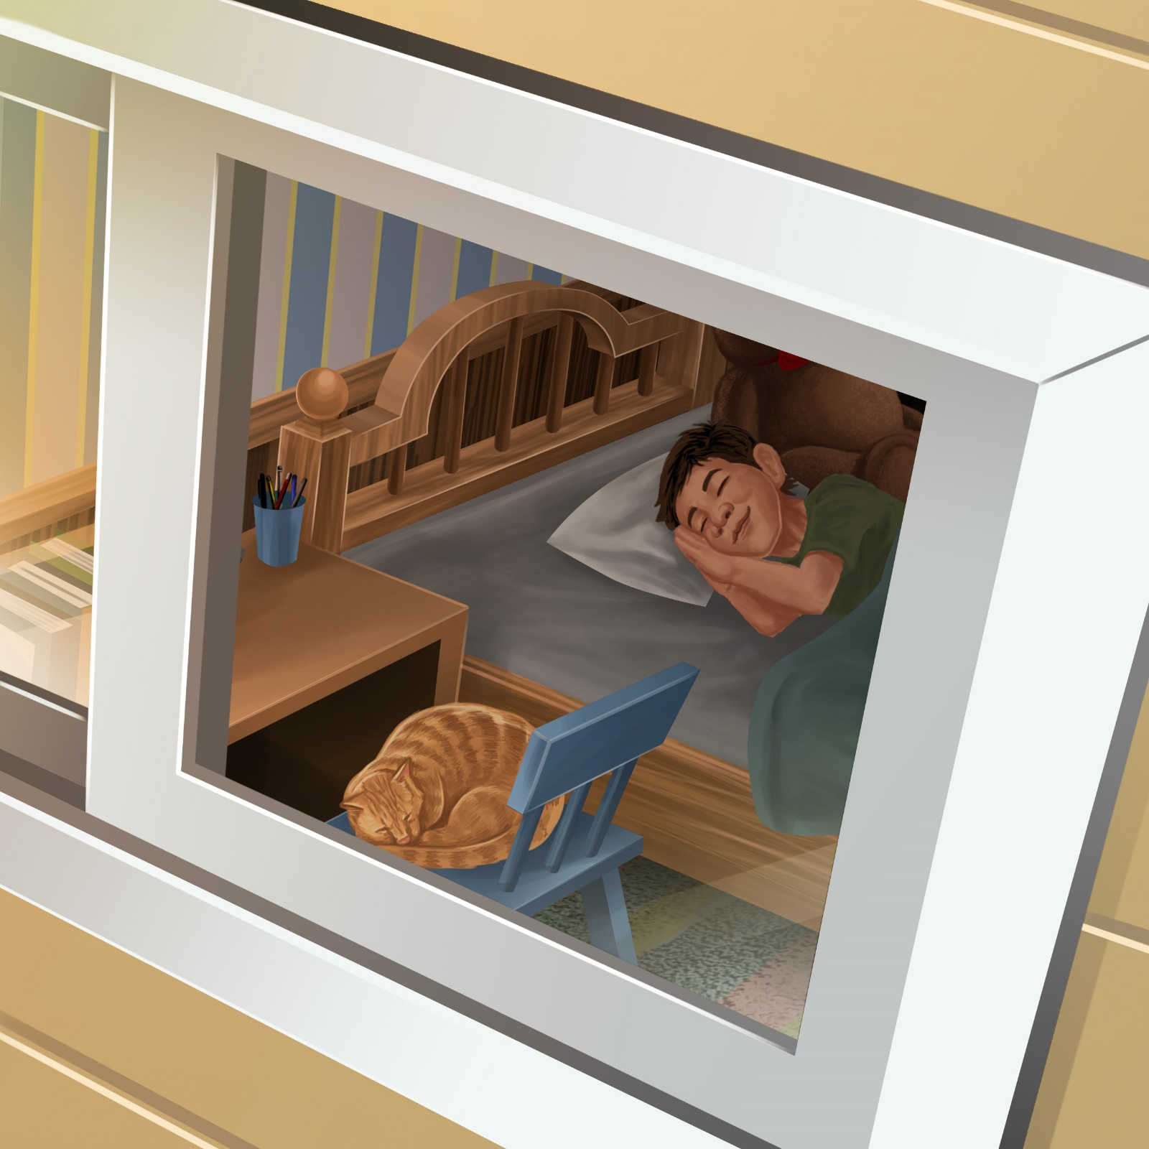

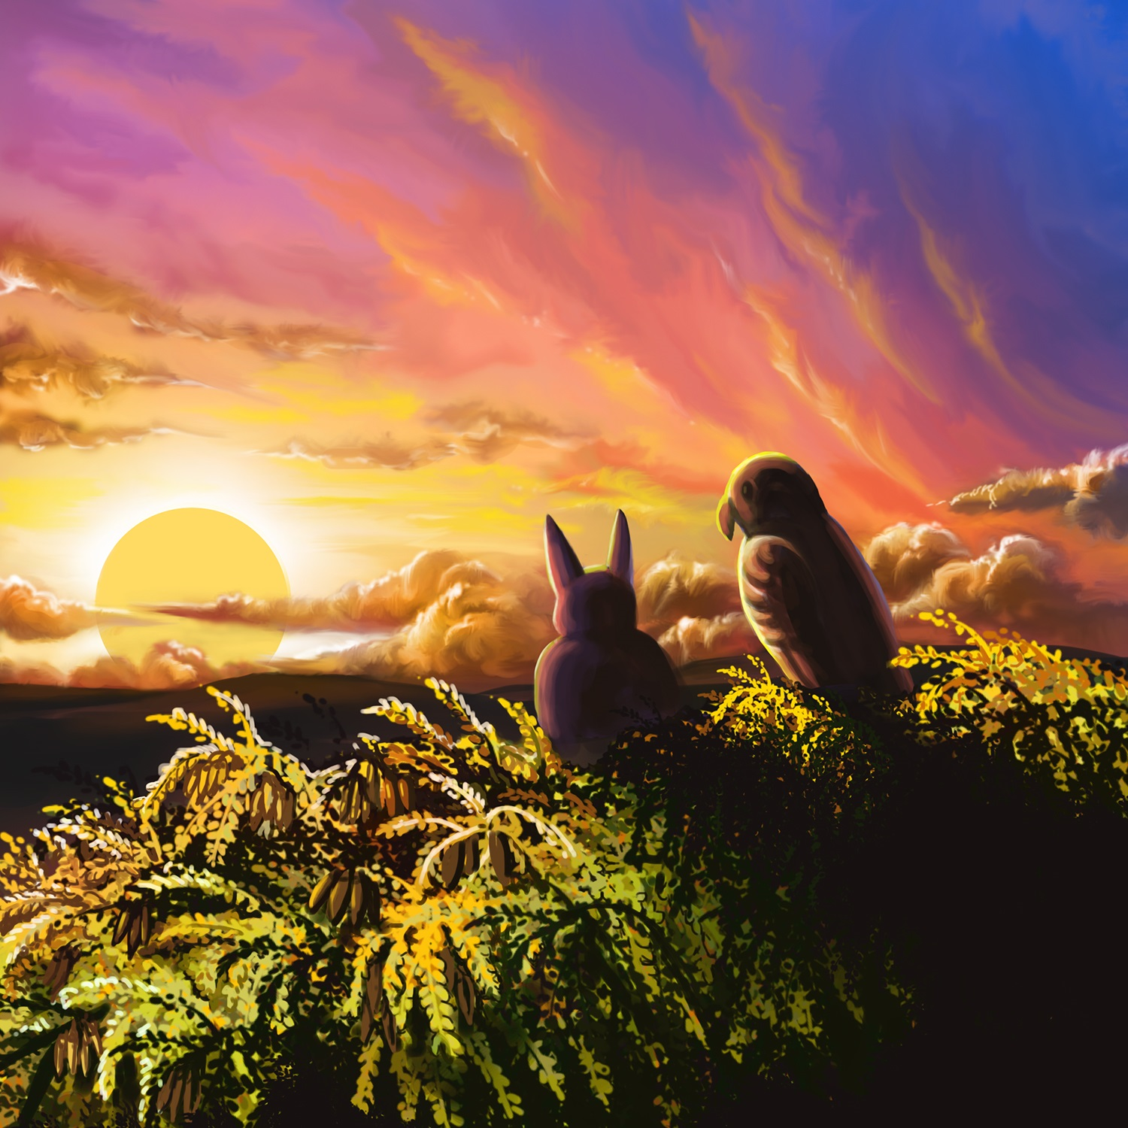

Manu and Bat sit in the tree.
“Good night,” says Manu.
“Good night,” says Bat.
The sun sets in the west.
Teaching Notes: Book 20 The Sun Sets in the West
Reading Practice: This story provides children with the opportunity to revise previously taught consonant and vowel patterns.

Introduce the text and read the story aloud together, pointing to each word as you read the story. Encourage children to help you “sound out” the regular words in the story. Help children sound out the word and then blend the sounds together, for example, s-t-i-ck = stick. When reading unknown high frequency words (e.g., like, the), tell children the words as you read together. Give plenty of praise for children’s reading attempts and encourage re-reading to build fluency and accuracy.

Phonological Awareness
Practice segmenting and blending words. Ask children to clap out each phoneme (sound) in the word: s-t-i-ck = stick (4 sounds), w-e-s-t = west (4 sounds), s-l-ee-p-s = sleeps (5 sounds), f-r-o-g = frog (4 sounds).
Help children to find each word you segment on the page.
Think of all the words you can that start with a target sound from the book, e.g., s, w, t or p. Find objects in the room that start with the same sound.

Spelling
Listen and identify where the sound change occurs in words. Use the phrasing: “If this word spells sun, can you make it say fun. If this word says fun can you change it to fan”.
Change west to nest to best to bet
Change stick to tick to tock to lock to lick

Vocabulary
Creep means to move slowly and carefully, so as to not been seen or heard. Discuss the meaning of this word and practise creeping around the room.

Story Discussion
This story takes place at dusk/early evening, when the sun is setting. Talk about what you might do when the sun is setting.

Story Retell
Ask children to re-tell the story to a friend. Prompt as necessary using picture cues. Give plenty of praise and encouragement.
Print Concepts
Bring children’s attention to the apostrophe, e.g., Nan’s dinner. This means the dinner belongs to Nan. Write some short phrases together using an apostrophe to indicate possession, e.g., Hemi’s pot, Pam’s top, Tama’s spots.


