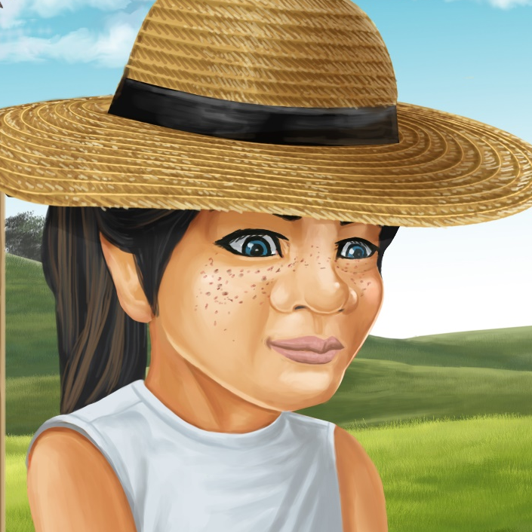

Pam’s Bee Sting
By Maggie Boston
Illustrations by Susan Trisna

Pam’s Bee Sting
Early Childhood

This reader for young children is part of a shared book reading series within the Early Childhood subset of the Better Start Literacy Approach.
Each book provides opportunities to develop children’s oral language skills and print awareness in areas that are critical for early literacy success.

This Early Childhood subset has been adapted from the readers within the Better Start Literacy Approach which has been developed through the University of Canterbury Child Well-being Research Institute. The lead research team for this Early Childhood subset includes:
Professor Gail Gillon, Associate Professor Brigid McNeill, Dr Amy Scott, Elizabeth Gibson and Professor Angus Macfarlane.

To access the Early Childhood subset of the Better Start readers online in narrated and book form, please visit
https://www.canterbury.ac.nz/childwellbeing/betterstartliteracy/
Published June, 2020, UC Child Well-being Research Institute.

The Better Start Literacy Approach is supported by the
A Better Start National Science Challenge, a 10-year programme of research investigating practical, evidence-based solutions that make a measurable difference for our tamariki. https://www.abetterstart.nz/


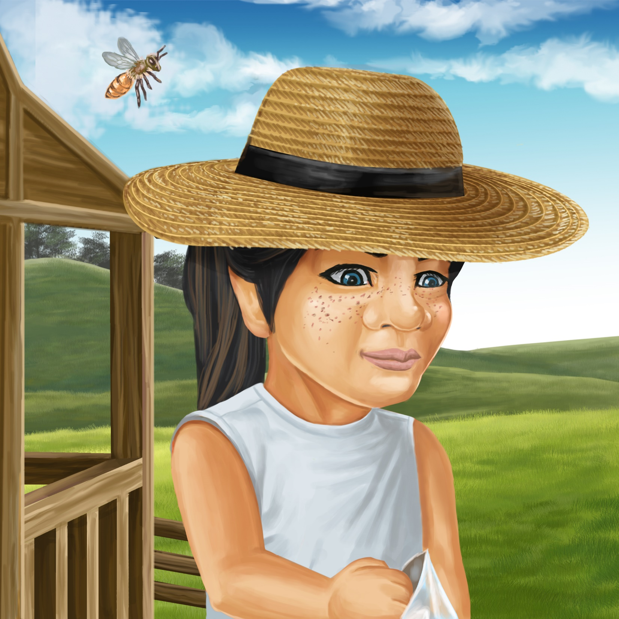
This story is about Pam. This word says Pam.
Pam starts with a “p” sound.
See the letter P that makes a “p” sound. The word says Pam.
Pam
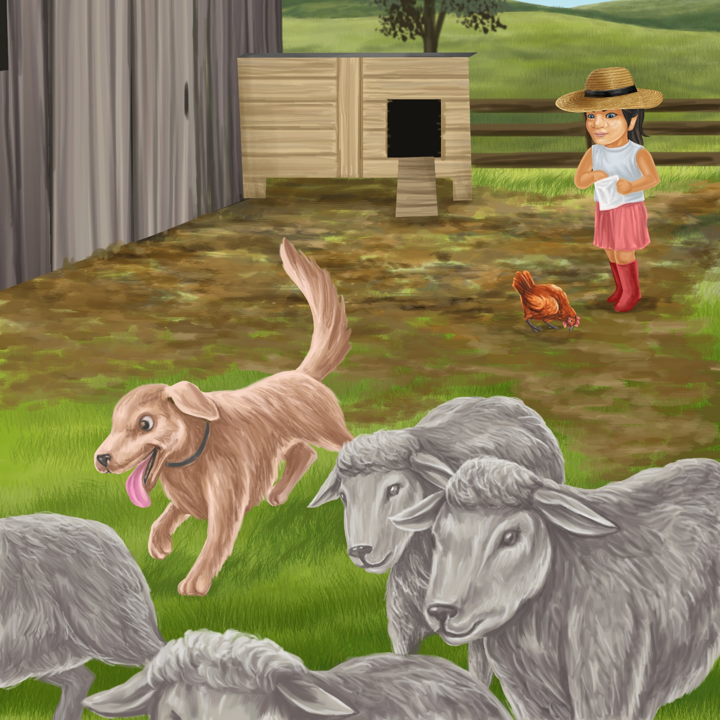

Pam and Don have fun on Pop’s farm.
Don likes to chase the sheep.
He chases a flock of sheep into a paddock.
Flock is the name for a group of sheep. The flock of sheep were running away.
Can you find the flock of sheep?
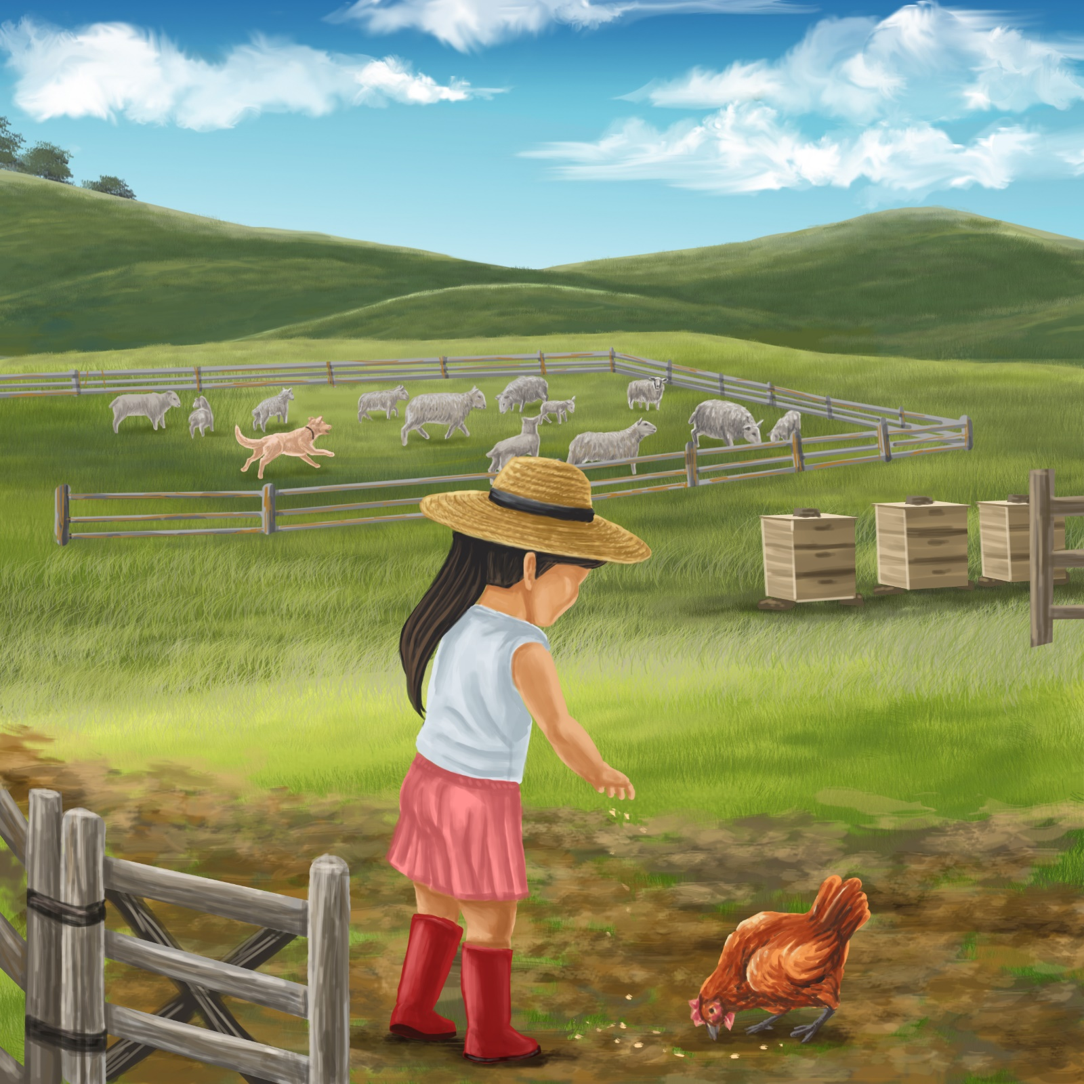

Pam likes to feed the little red hen.
She scatters the seeds by the fence.
Scatter mean to throw or toss things around. Pam scattering the seeds on the ground for the hen to eat.

It is a hot day.
Pam has a big hat on her head.
A bee comes out of the beehive.
A beehive is a little house built for honey bees. Pop has built a beehive for bees to make honey. The bee has come out of its beehive. I wonder what will happen?

The bee lands on Pam’s hat.
Pam swipes her hand at the bee.
Swipe means to hit or to swing at something. Pam is swiping her hand to try and push the bee away. Let’s pretend we are swiping at a bee on our head.
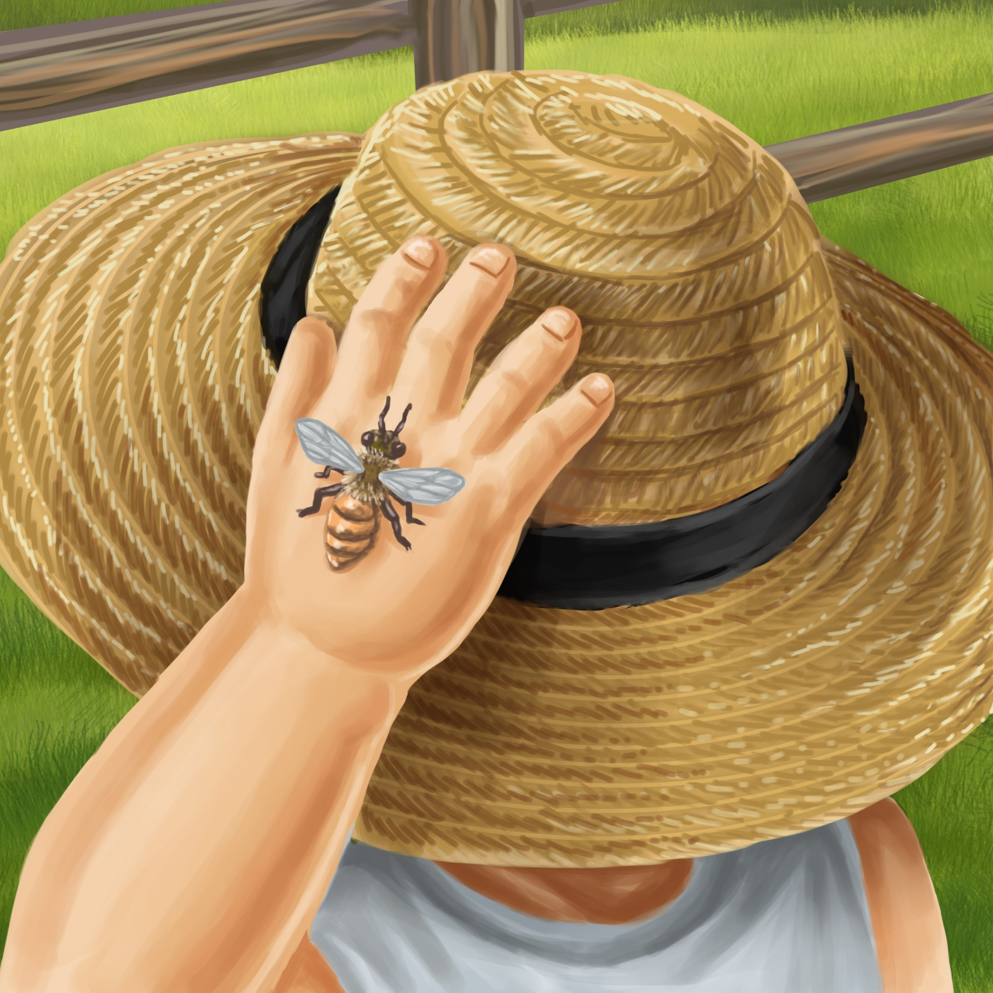
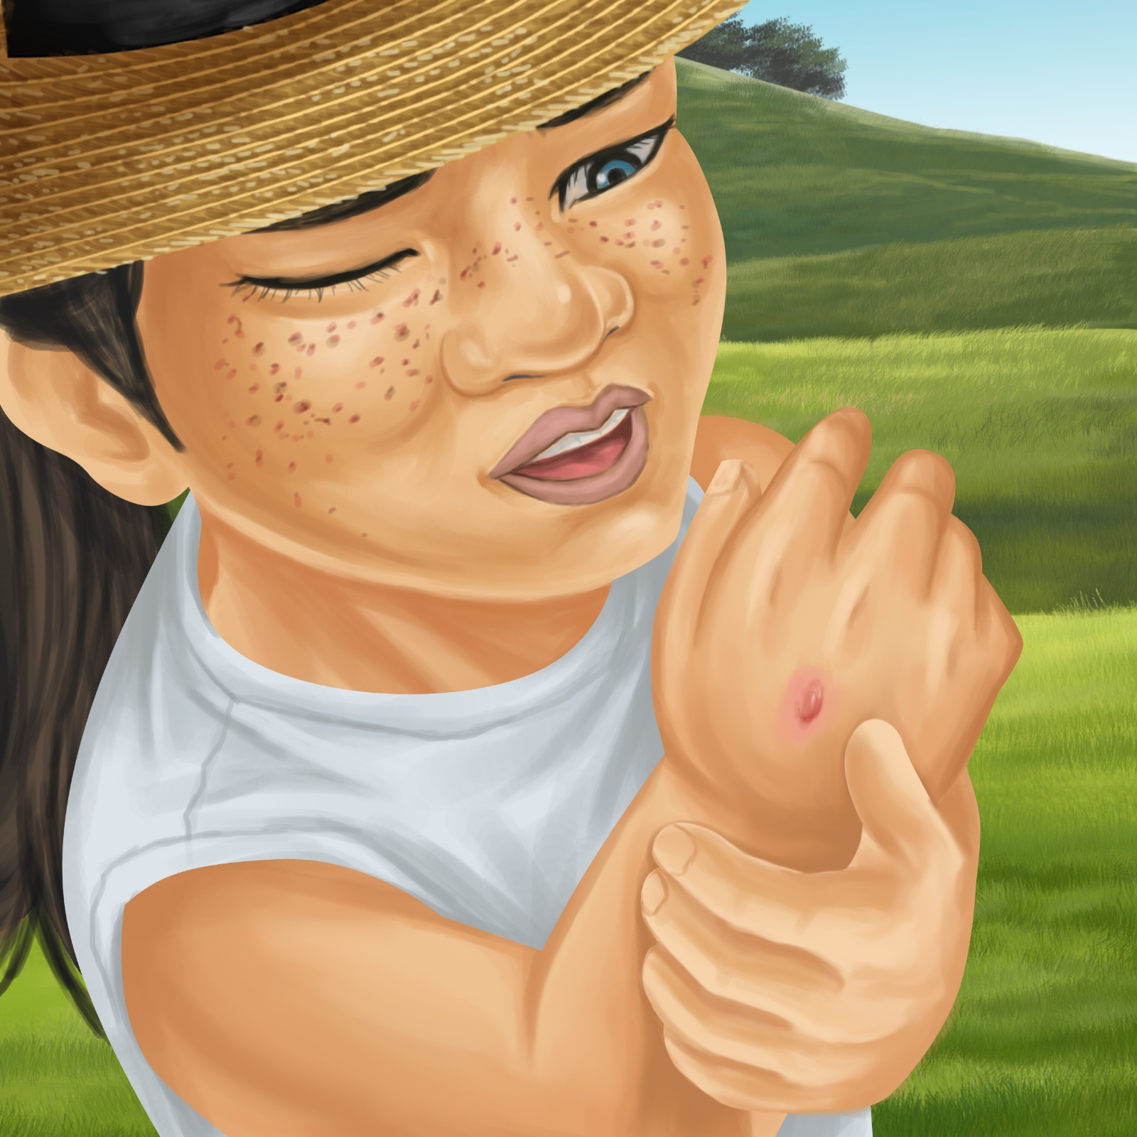

“Ouch!” says Pam.
“My hand hurts.
I have a bee sting on my hand.”

Pop stops his work in the shed.
He runs swiftly out of the shed.
He runs to Pam.
Swiftly means to do something very quickly - as fast as you can. Pop is running swiftly, as fast as he can, to help Pam.

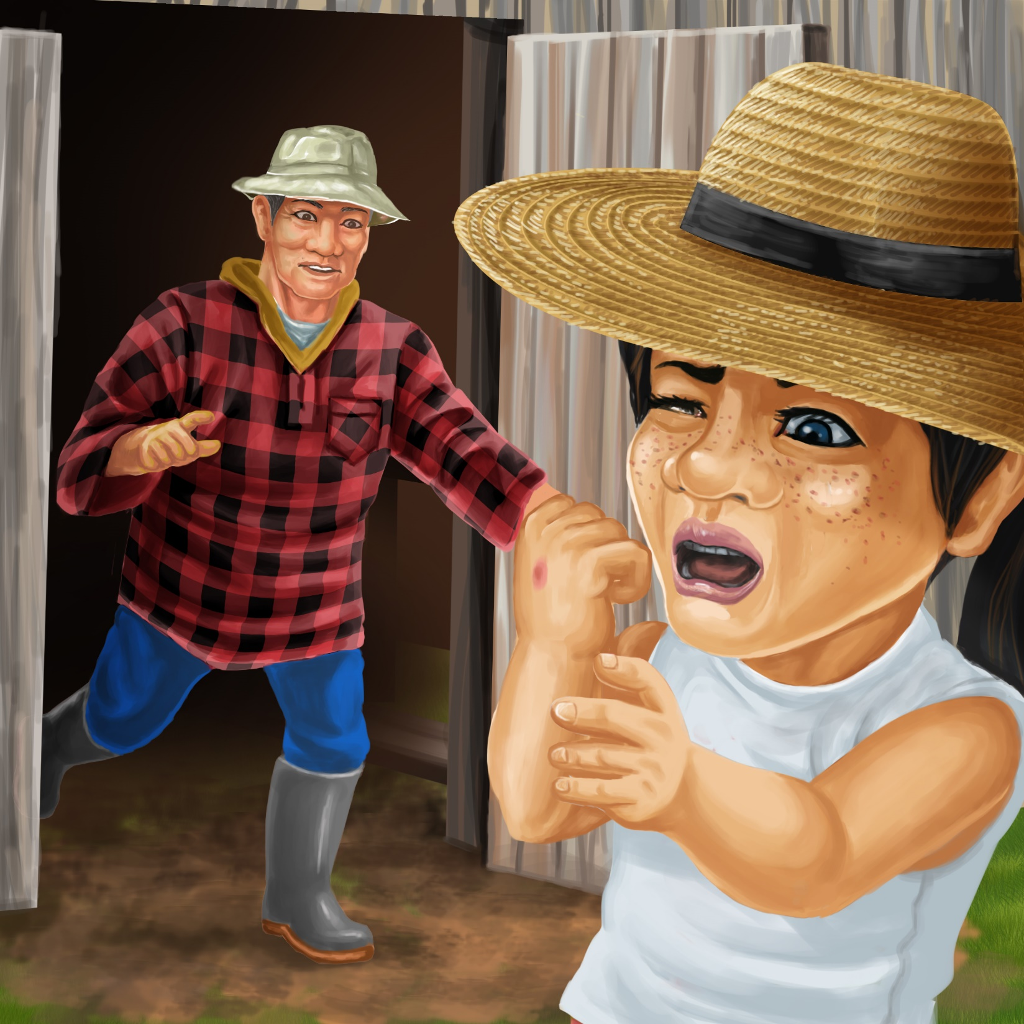
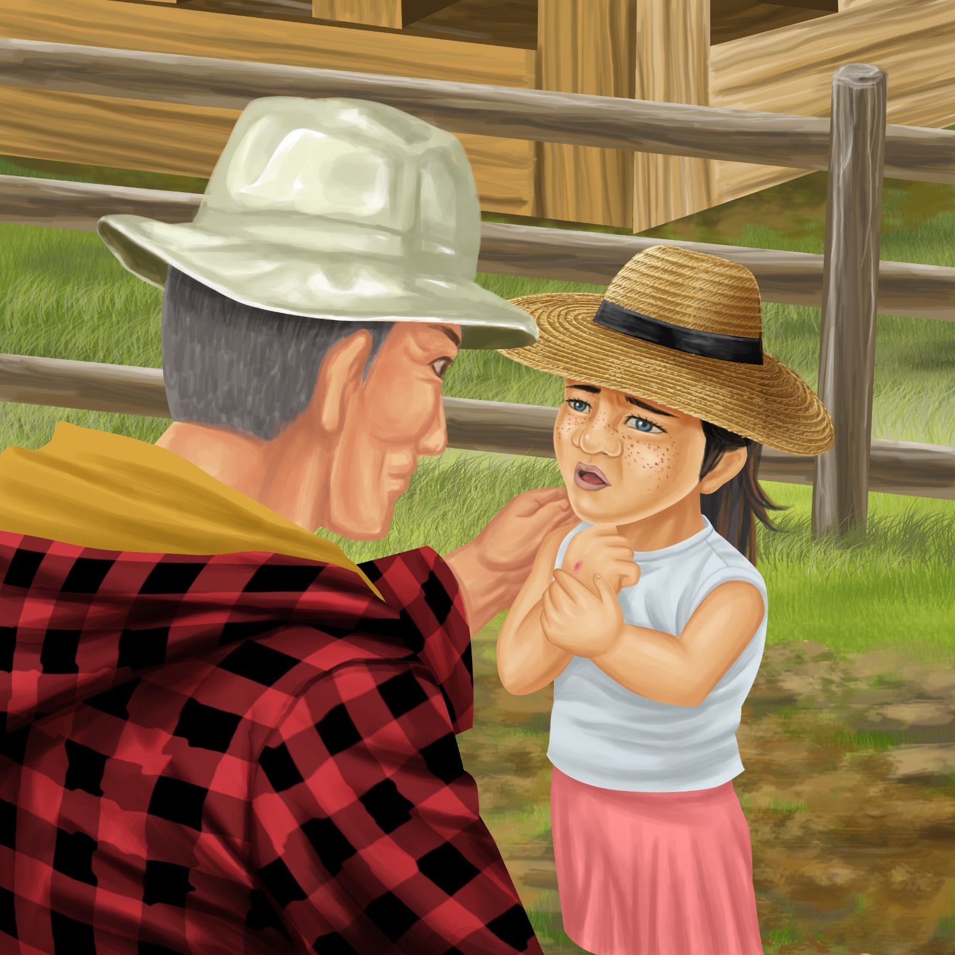

“I hope you are OK,” calls Pop.
“My hand hurts,” says Pam.
“I have a bee sting on my hand.”

“We will put some cream and a cold cloth on your hand,” says Pop.
“Soon your hand will feel better.”
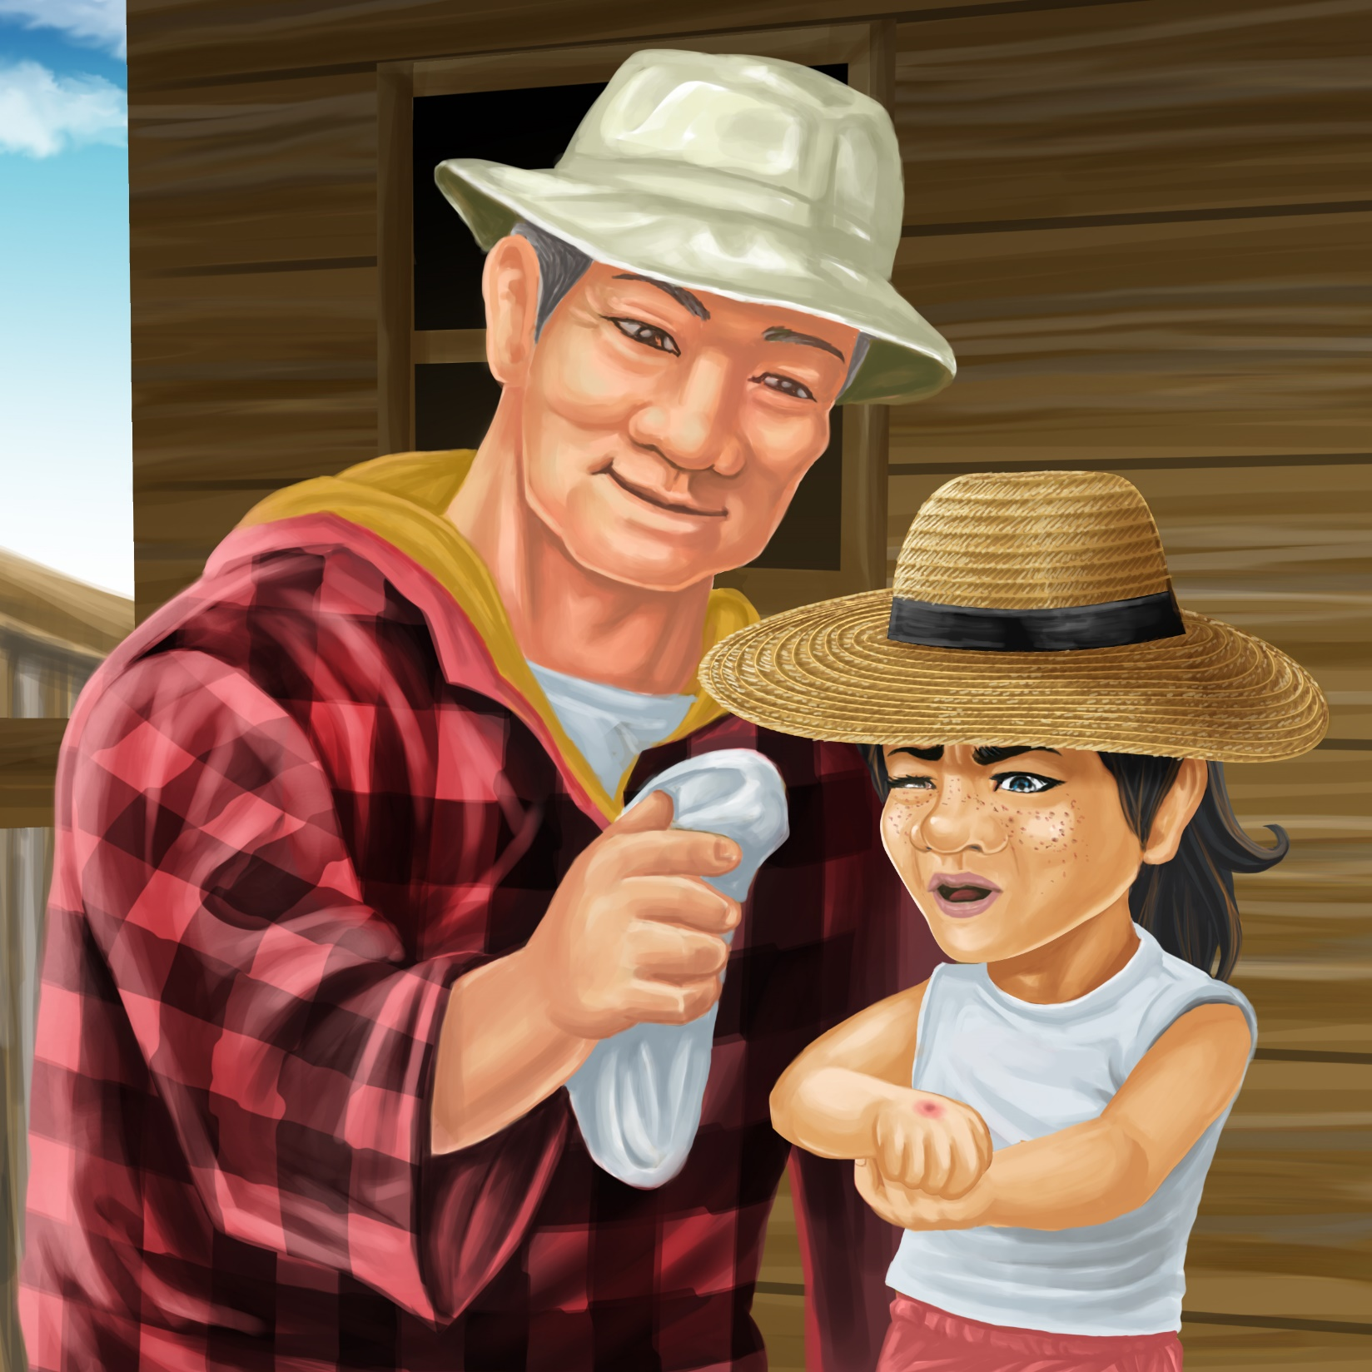

This is the letter P that makes a “p” sound.
Let’s make the “p” sound together “p”.
Watch my lips close and pop open as I make the “p” sound. Let’s say “p” together again.
The story was about Pam and Pop both their names start with the “p” sound.
P

Reading Notes: Pam’s Bee Sting
These reading notes are designed for preschool children to build their oral language skills within the “Words Can POP” framework focusing on word learning, conversations, phonological awareness, oral narrative and print awareness.

WORDS Word learning
Highlight the target words using the word elaboration techniques in each prompt box: flock, scatter, beehive, swipe, swiftly. After you have read the story revise the meaning of the target words as you summarise the story.
Extension: Select other words related to the story to discuss with the children. For example:
Farm dogs herd sheep into paddocks.
We must protect bees because they are pollinators.
Some people are allergic to bee stings.

CAN you keep the conversation going?
Engage children in a conversation about the story. Aim to keep the conversation going for five turns each. Follow the children’s lead and give children plenty of time to answer.
You may also want to ask questions to prompt the conversation and to check the children’s comprehension of the story.
Prompt Questions:
- Who is in this story?
- What happened to Pam?
- What will Pam and Pop do next?

POP
P: Phonological Awareness
Talk about rhyming words: say: “Seed and feed rhyme. They sound the same at the end. S-eed. F-eed. Can you hear that they sound the same at the end? I can think of more words that rhyme with seed and feed. Weed and need. They all rhyme”. Generate more words that rhyme with seed and feed. It’s ok if they are not a real word (like teed).
There are some more rhyming words in this story – red and shed. Generate other words that rhyme with red and shed.

O: Oral Narrative
Encourage the children to relate an aspect of the story to their life. This helps practice new words and build connections. Discuss whether the children have ever had a bee sting before or seen a bee. Imagine aloud with children: if I saw a bee I would keep still.
Or
Ask the child to re-tell the story to a friend/family member or favourite toy. You could help by saying: “Who is this story about?”
“What happened in the story?”

P: Print Awareness
Draw children’s attention to the first sound and letter in the word ‘Pam’.
Show children the letter P that makes a “p” sound.
Find words on the page (or in print around the room) that start with the letter P.
Ask children to think of objects that start with a “p” sound and write a few of these words onto paper/board, bringing children’s attention to the first sound and letter in the word (e.g., pants, poi, pantry, puzzle).

Karawhiua! Give it a go! Enjoy reading and talking about the story with your children. Remember to give children plenty of praise and encouragement to talk about the pictures and story.


