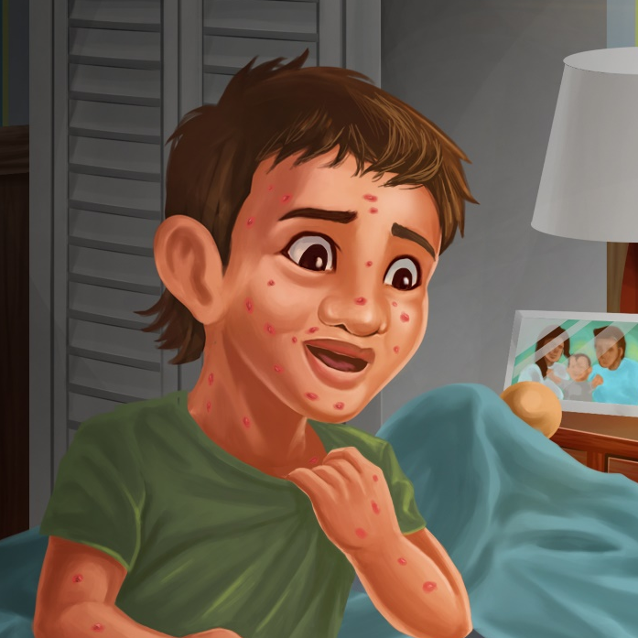

Tama has Spots
By Maggie Boston
Illustrations by Susan Trisna

Tama has Spots
Book 17

This reader for young children is part of a reading series for the Better Start Literacy Approach. Each book provides reading practice for children to decode short words with a focus on target consonants and vowels. The reader has been designed to support class teaching activities that are part of the Better Start Literacy Approach.

The Better Start Literacy Approach has been developed through the University of Canterbury Child Well-being Research Institute. The lead research team includes:
Professor Gail Gillon, Associate Professors Brigid McNeill and Alison Arrow, Drs Amy Scott and Amanda Denston and Professor Angus Macfarlane.

To access these readers online in narrated and book form, please visit https://sites.google.com/view/betterstart-whānau/home and click on the ‘Children’s Readers’ tab.
Published February, 2020, UC Child Well-being Research Institute.

The Better Start Literacy Approach is supported by the
A Better Start National Science Challenge, a 10-year programme of research investigating practical, evidence-based solutions that make a measurable difference for our tamariki. https://www.abetterstart.nz/



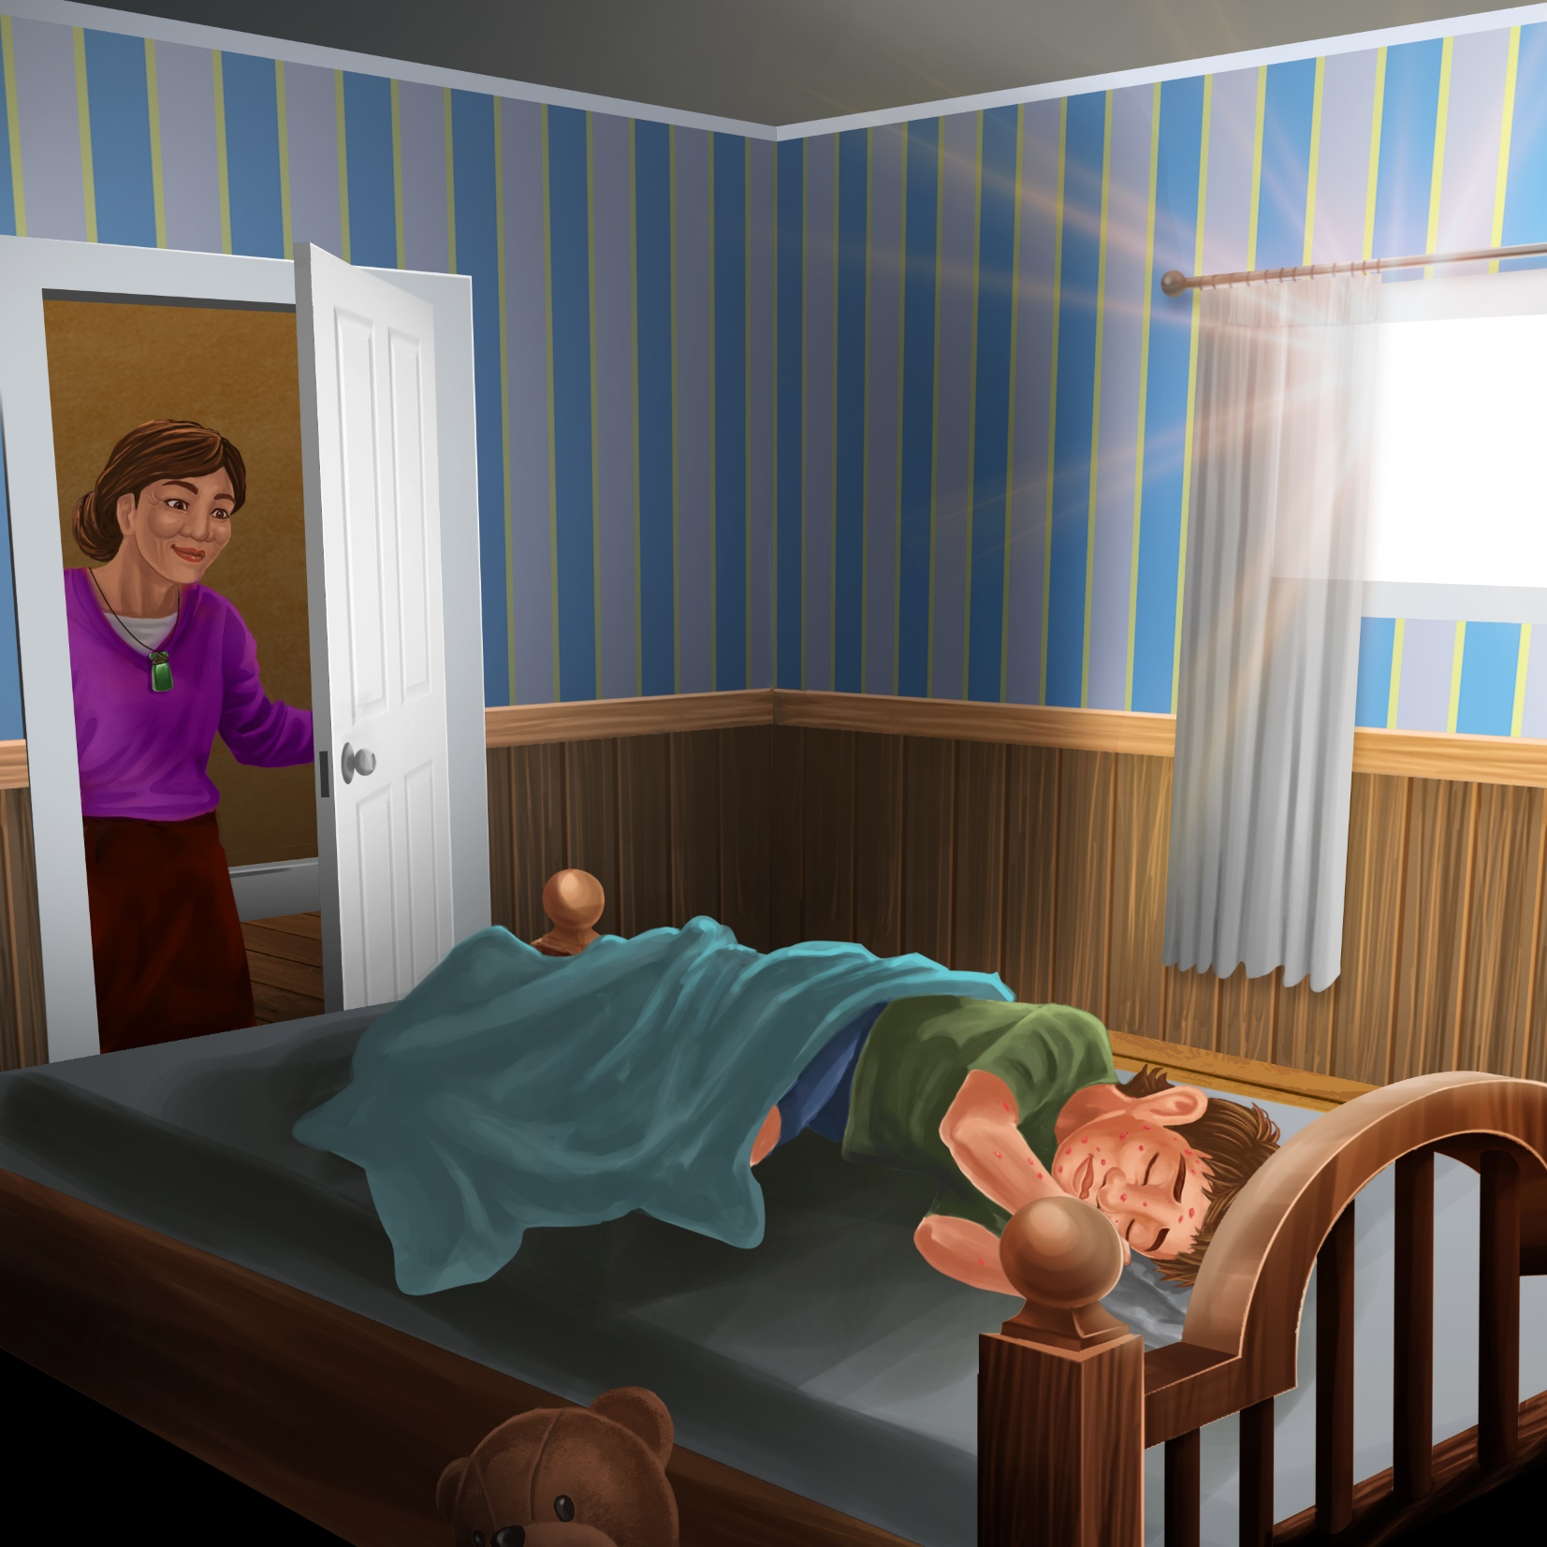

Tama is sleeping in bed.
Tama’s nan comes in.

“Wake up Tama!” calls Nan.
“The sun is up.
It is time to wake up.”
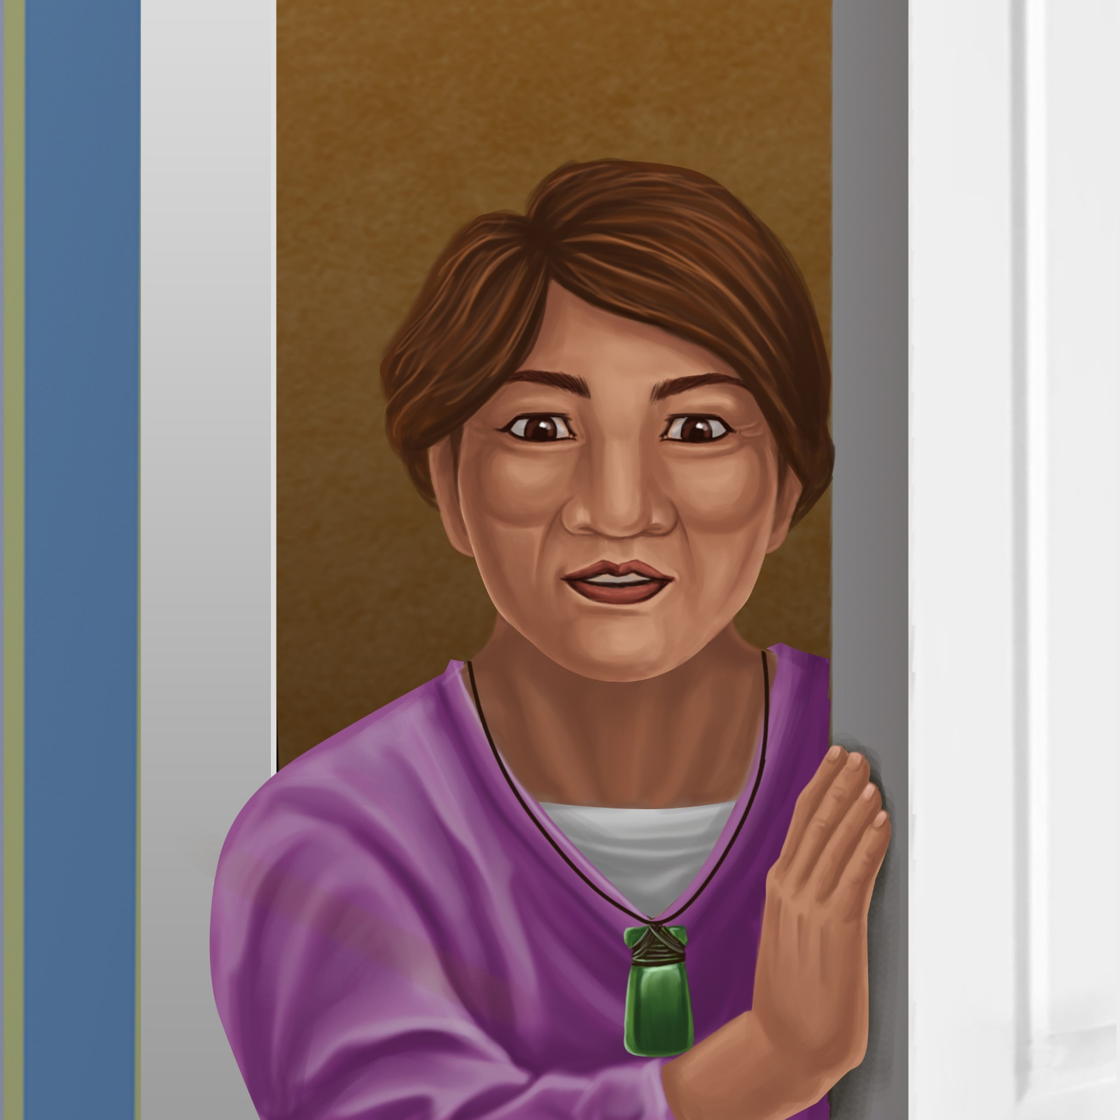

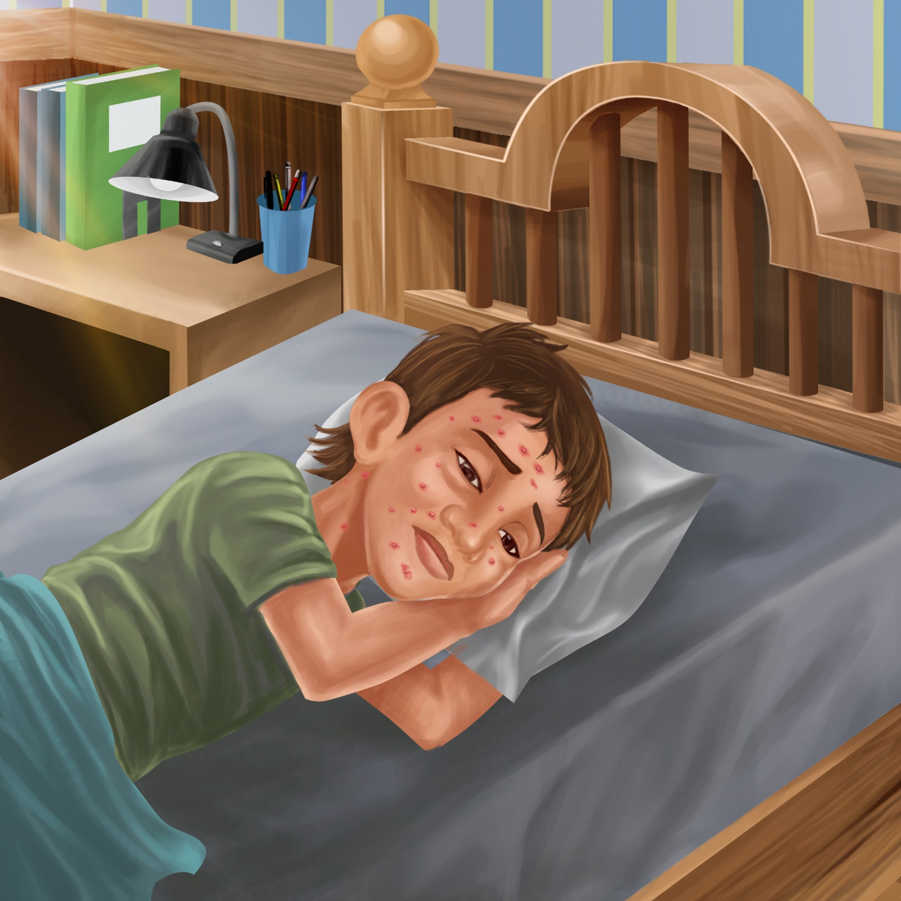

Tama wakes up,
but he feels sick.
Oh no! Tama has spots!

He has a spot on his chin.
He has a spot on his cheek.
He has spots on his chest.

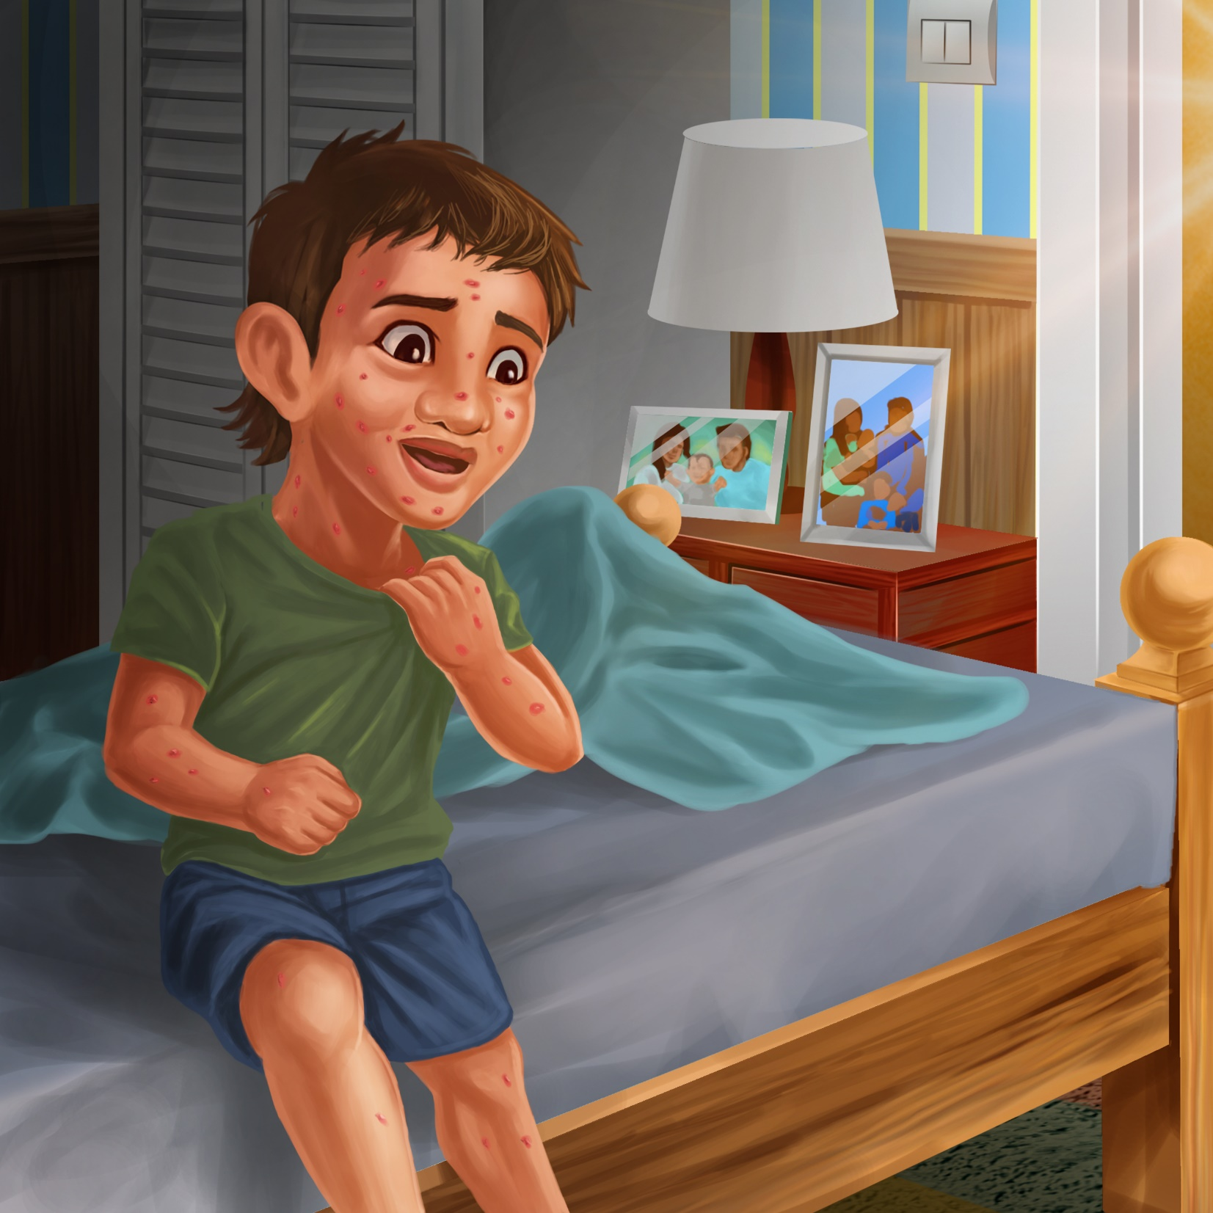
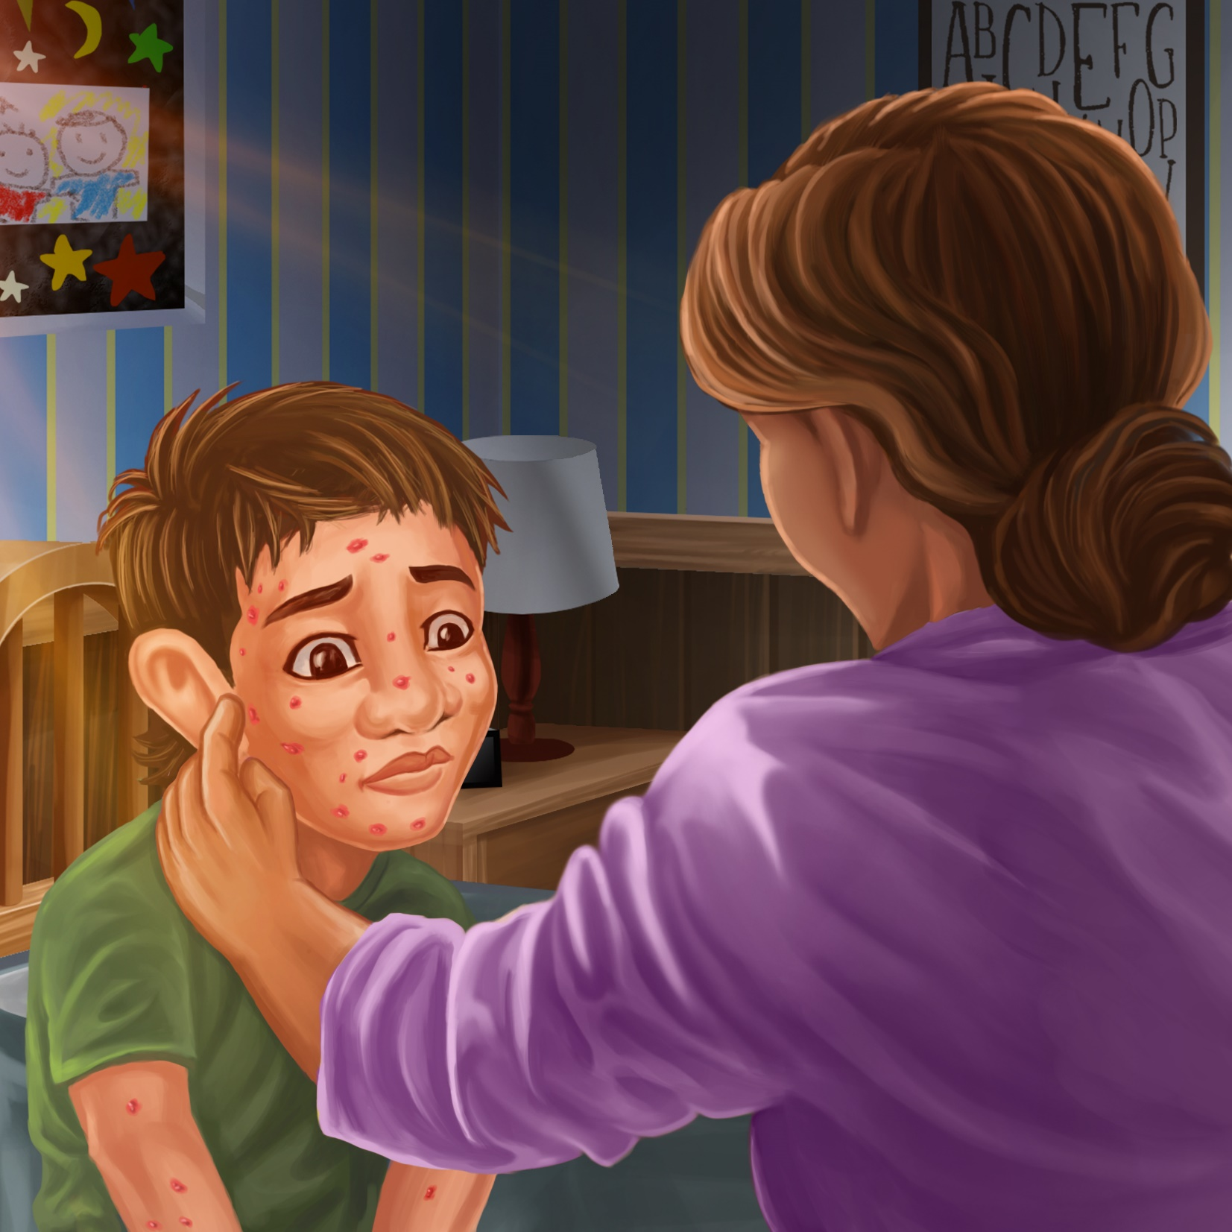

Nan looks at Tama’s cheek.
She looks at his chin and his chest.

“Oh no!” says Nan.
“You have chicken pox!
You must stay in bed. Try not to scratch the spots.”

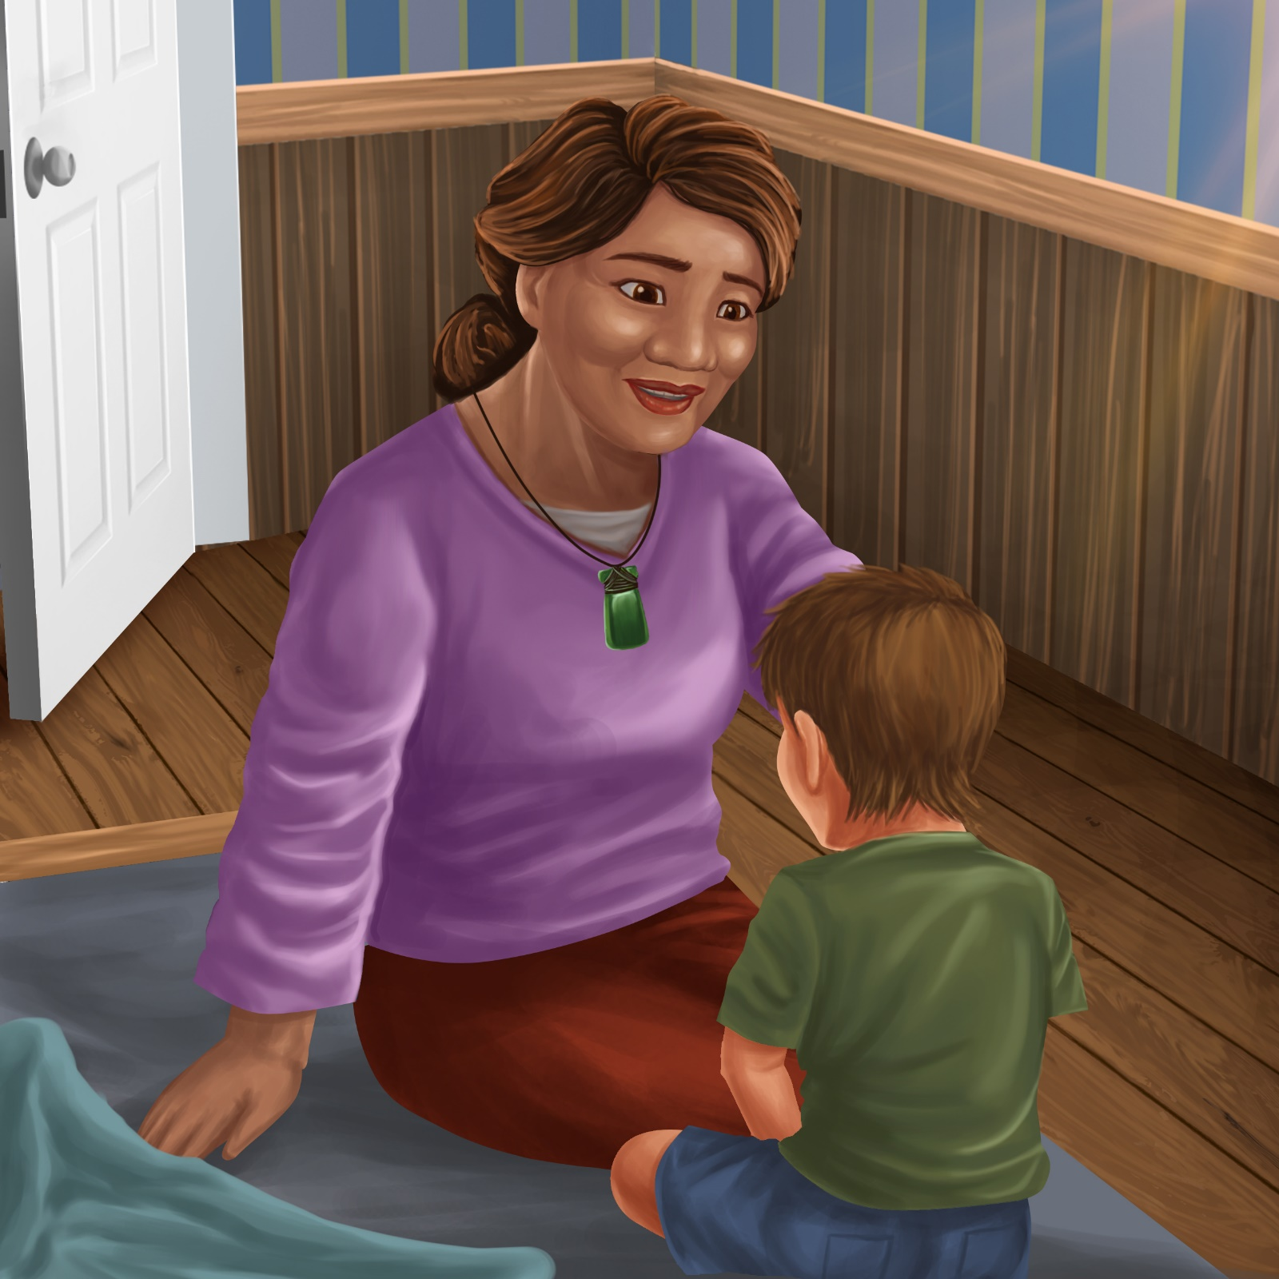
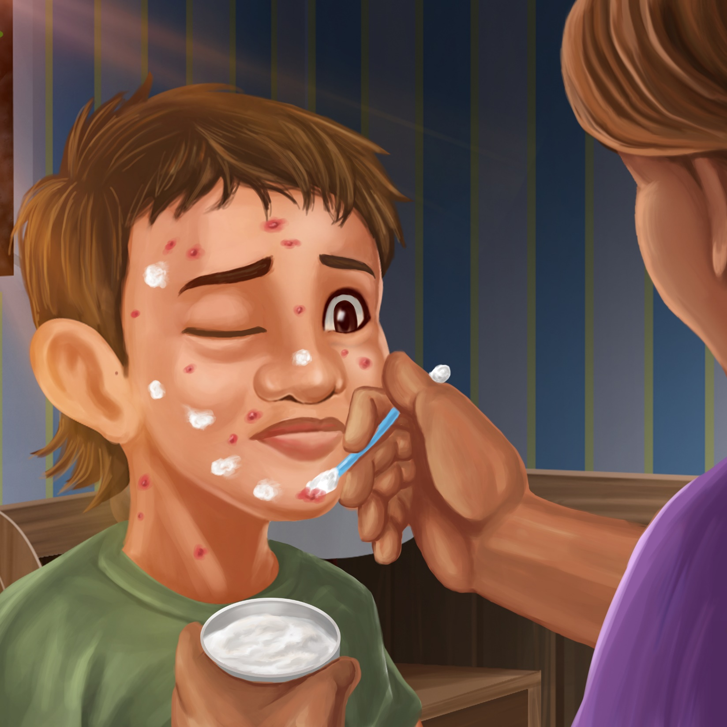

Nan dabs cream on Tama’s chin, on his cheek and on his chest.

She gives Tama a big hug.
“Stay in bed Tama and go back to sleep.
Soon the spots will go away.”

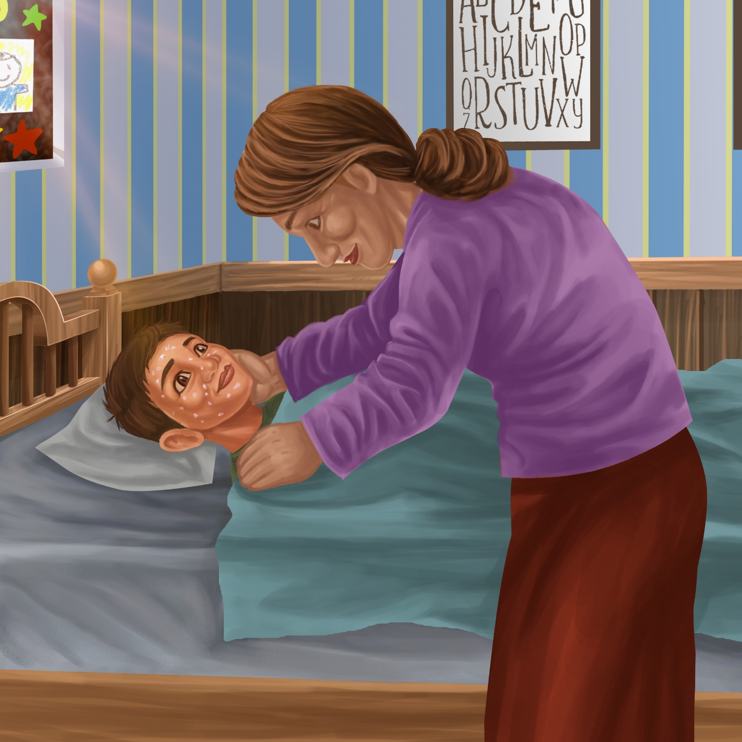
Teaching Notes: Book 17 Tama Has Spots
Reading Practice: This story provides children with practice in decoding short words with a focus on words that start with consonants ch and reviews words that start with s blends.

Introduce the text and read the story aloud together, pointing to each word as you read the story. Encourage children to help you “sound out” the regular words in the story. Help children sound out the word and then blend the sounds together, for example, s-p-o-t = spot. When reading unknown high frequency words (e.g., he, calls, has), tell children the words as you read together. Give plenty of praise for children’s reading attempts and encourage re-reading to build fluency and accuracy.

Phonological Awareness
Practice segmenting and blending words. Ask children to clap out each phoneme (sound) in the word: h-u-g (3 sounds), s-l-ee-p (4 sounds), ch-ee-k (3 sounds), s-p-o-t-s (5 sounds), d-a-b-s (4 sounds).
Help children to find each word you segment on the page.
Think of all the words you can that start with a ch sound. Find objects in the room that start with a ch sound.

Spelling
Listen and identify where the sound change occurs in words. Use the phrasing: “If this word spells hug, can you make it say hut. If this word says hut can you change it to hat”.
Change sun to fun to fan to man
Change sleep to steep to step to stop

Vocabulary
Discuss the word scratch. Say the word scratch drawn out like you are scratching something. Think of words that are also sounds e.g., bang, buzz, zip, zoom, pop. See https://thinkwritten.com/onomatopoeia/ for examples.

Story Discussion
Ask children to discuss with a friend a time they remember being sick. What happened? Did they need to stay in bed, visit the doctors, have some medicine etc? Talk about how important it is to stay home when you are sick, so your friends don’t get sick.

Story Retell
Ask children to re-tell the story to a friend. Prompt as necessary using picture cues. Give plenty of praise and encouragement.
Print Concepts
Bring children’s attention to the apostrophe, e.g., Tama’s spots. This means the spots belong to Tama. Write some short phrases together using an apostrophe to indicate possession, e.g., Hemi’s pot, Pam’s top, Nan’s dinner.


