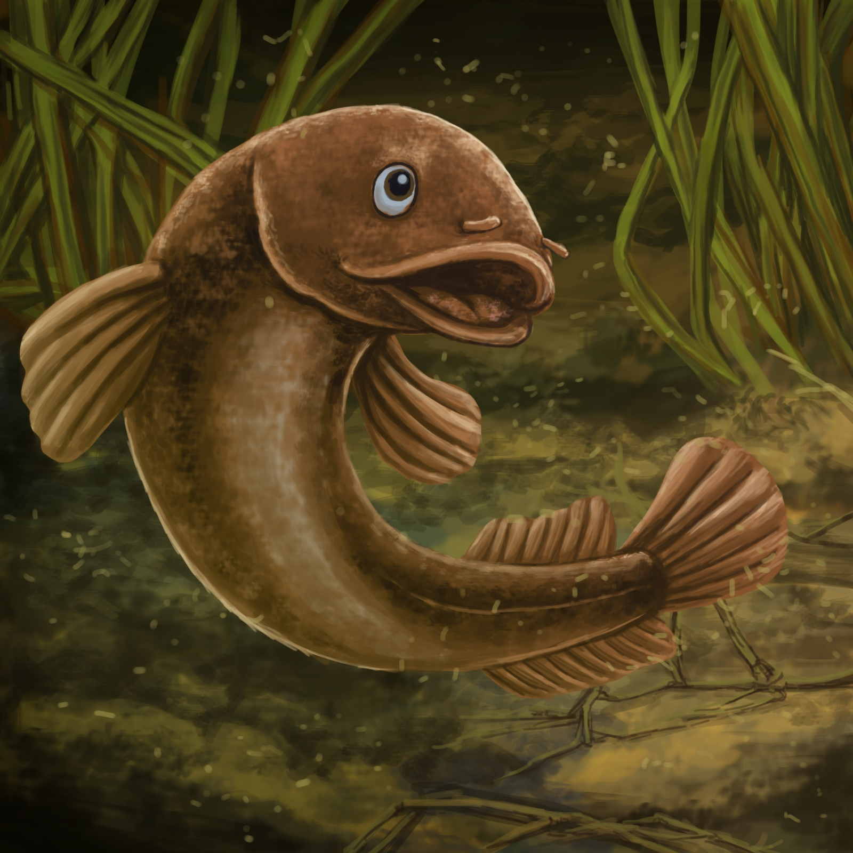

Ika the
Mud fish
By Maggie Boston
Illustrations by Susan Trisna

Ika the Mudfish
Book 11

This reader for young children is part of a reading series for the Better Start Literacy Approach. Each book provides reading practice for children to decode short words with a focus on target consonants and vowels. The reader has been designed to support class teaching activities that are part of the Better Start Literacy Approach.

The Better Start Literacy Approach has been developed through the University of Canterbury Child Well-being Research Institute. The lead research team includes:
Professor Gail Gillon, Associate Professors Brigid McNeill and Alison Arrow, Drs Amy Scott and Amanda Denston and Professor Angus Macfarlane.

To access these readers online in narrated and book form, please visit https://sites.google.com/view/betterstart-whānau/home and click on the ‘Children’s Readers’ tab.
Published February, 2020, UC Child Well-being Research Institute.

The Better Start Literacy Approach is supported by the
A Better Start National Science Challenge, a 10-year programme of research investigating practical, evidence-based solutions that make a measurable difference for our tamariki. https://www.abetterstart.nz/




Ika is a Mud fish.
He hides in the
wet land.
“I have fun in the mud,” says Ika.
“I can slip. I can slide. I can swim.”

A big red truck is in the wet land.
The men step out of the truck.
They begin to dig in the mud.
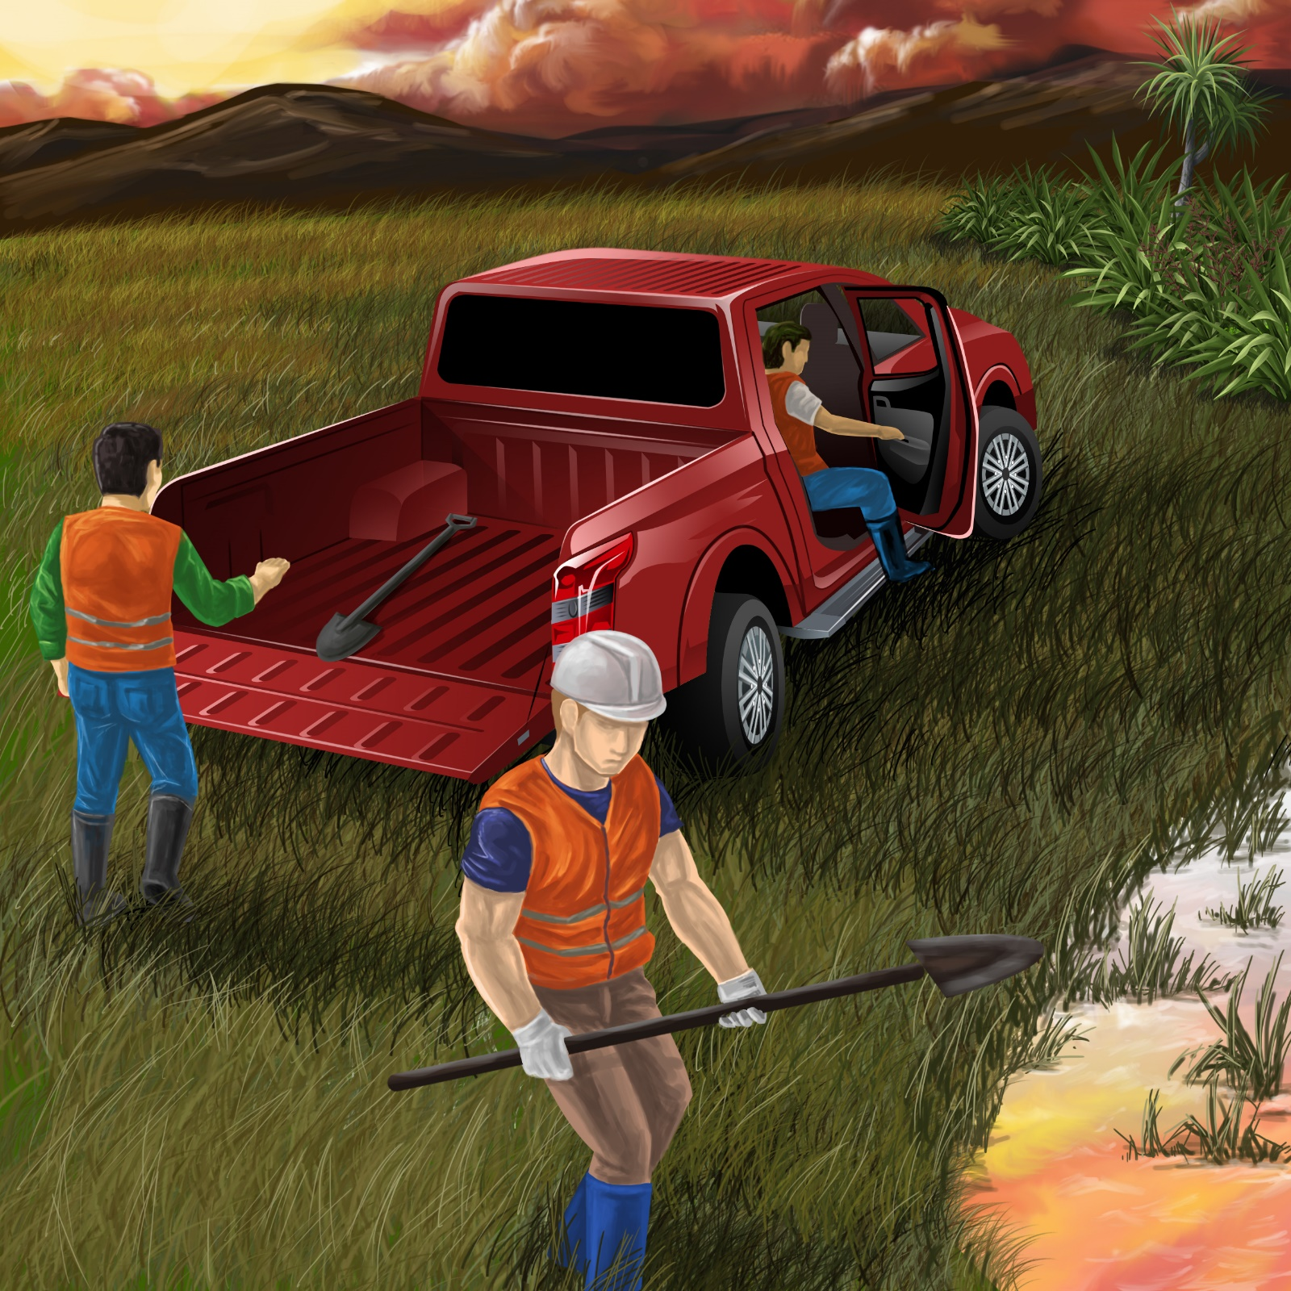

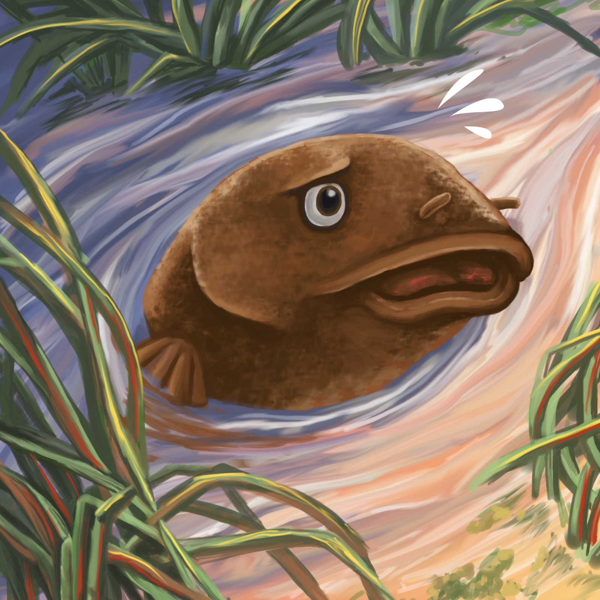

Oh no! Little mud fish!
You must hide!
You must hide from the men who dig in the mud.

Ika is smart.
He can slip and slide.
He swims by a log.

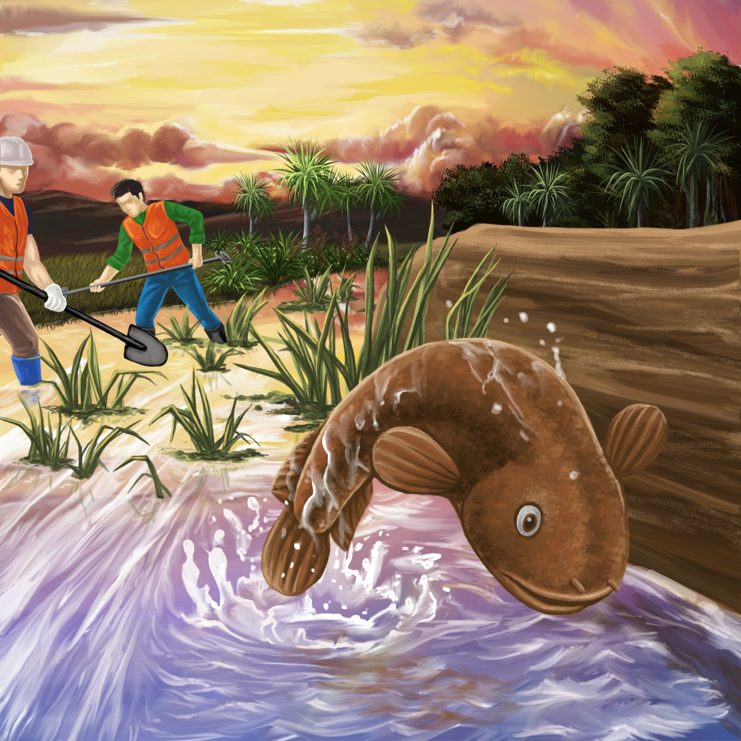
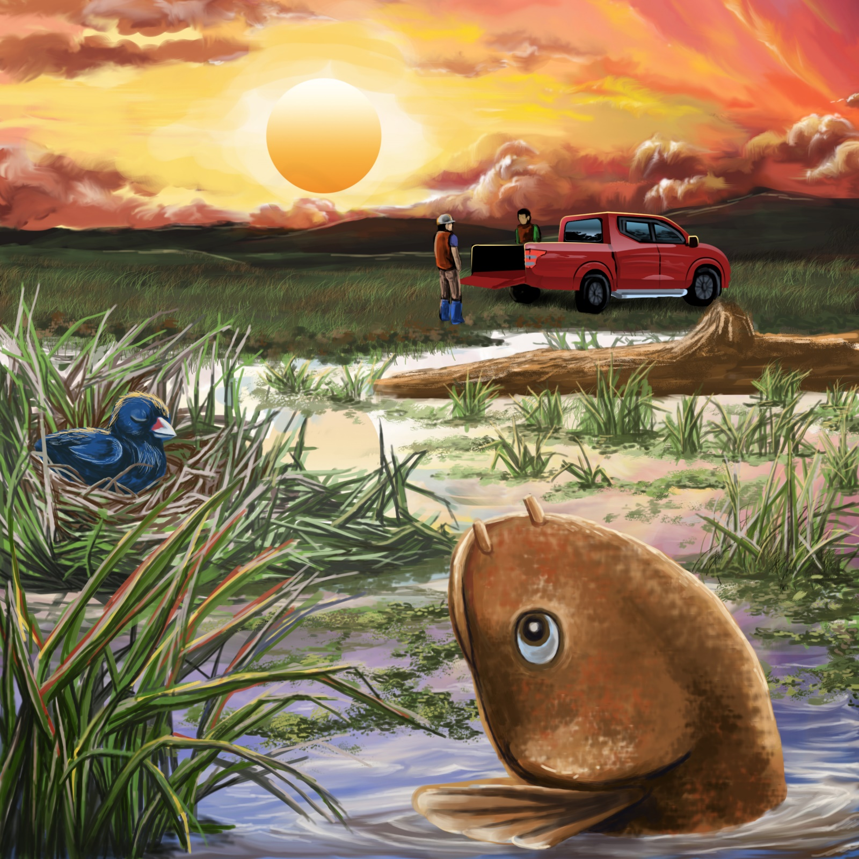

The men stop digging.
Little mud fish is safe.
Ika is safe to swim and slide in the
wet land.

Teaching Notes: Book 11 Ika the Mudfish
Reading Practice: This story provides children with practice in decoding short words with a focus on words that start with s and s-blend consonants and include a o and i vowels.

Introduce the text and read the story aloud together, pointing to each word as you read the story. Encourage children to help you “sound out” the regular words in the story. Help children sound out the word and then blend the sounds together, for example, s-l-i-p = slip. When reading unknown high frequency words (e.g., is, by, the), tell children the words as you read together. Give plenty of praise for children’s reading attempts and encourage re-reading to build fluency and accuracy.

Phonological Awareness
Practice segmenting and blending words. Ask children to clap out each phoneme (sound) in the word: m-u-d (3 sounds), s-t-e-p (4 sounds), f-a-s-t (4 sounds), s-w-i-m (4 sounds), s-t-r-ea-m (5 sounds). Help children to find each word you segment on the page.
Think of all the words you can that start with an s sound. Find objects in the room that start with an s sound.

Spelling
Listen and identify where the sound change occurs in words. Use the phrasing: “If this word spells slip, can you make it say slap. If this word says slap can you change it to slop”.
Change slop to lop to lip to flip
Change fast to past to last to lost

Vocabulary
Ika is the Māori word for fish. Look up the Māori dictionary on-line, listen to the pronunciation of ika and read about the wider use of the word: https://maoridictionary.co.nz/.

Story Discussion
Discuss why it is important to take care of special places in nature, like wetlands. Learn more about New Zealand mudfish and their habitat in our regional wetlands.
https://www.doc.govt.nz/nature/native-animals/freshwater-fish/mudfish/.

Story Retell
Ask children to re-tell the story to a friend. Prompt as necessary using picture cues. Give plenty of praise and encouragement.
Print Concepts
Discuss the use of the exclamation mark. We use an exclamation mark to show we are excited or using a loud voice.


