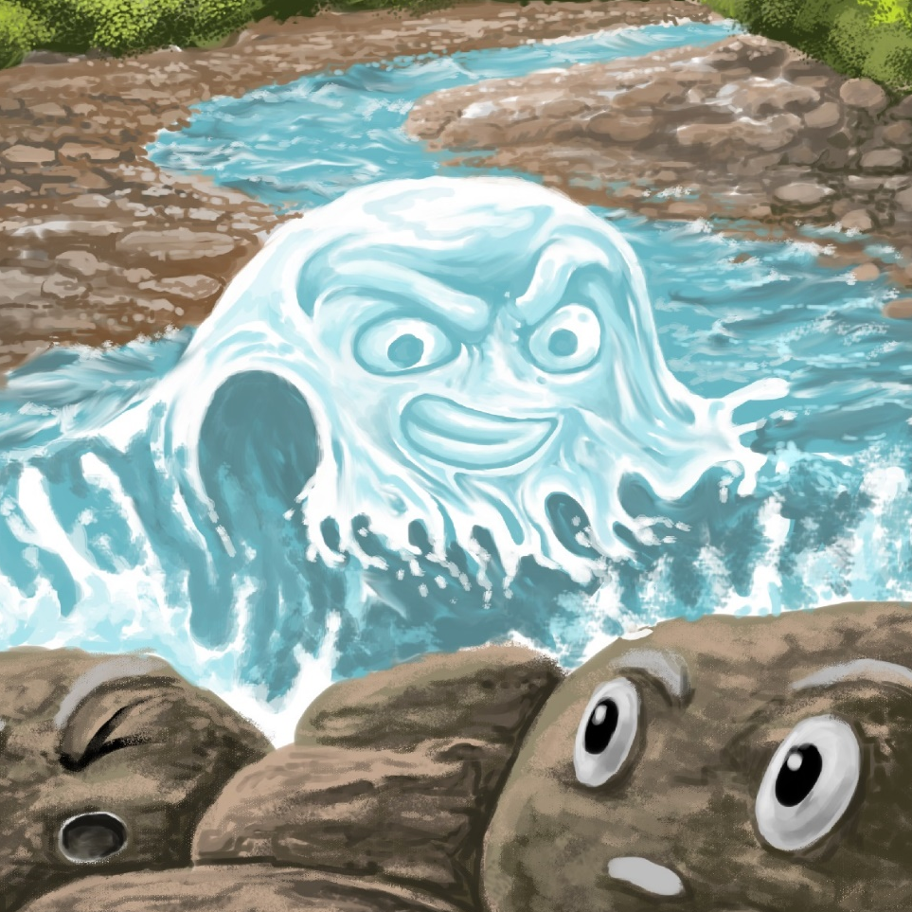
Awa is Mad
By Maggie Boston
Illustrations by Susan Trisna

Awa is Mad
Book 15

This reader for young children is part of a reading series for the Better Start Literacy Approach. Each book provides reading practice for children to decode short words with a focus on target consonants and vowels. The reader has been designed to support class teaching activities that are part of the Better Start Literacy Approach.

The Better Start Literacy Approach has been developed through the University of Canterbury Child Well-being Research Institute. The lead research team includes:
Professor Gail Gillon, Associate Professors Brigid McNeill and Alison Arrow, Drs Amy Scott and Amanda Denston and Professor Angus Macfarlane.

To access these readers online in narrated and book form, please visit https://sites.google.com/view/betterstart-whānau/home and click on the ‘Children’s Readers’ tab.
Published February, 2020, UC Child Well-being Research Institute.



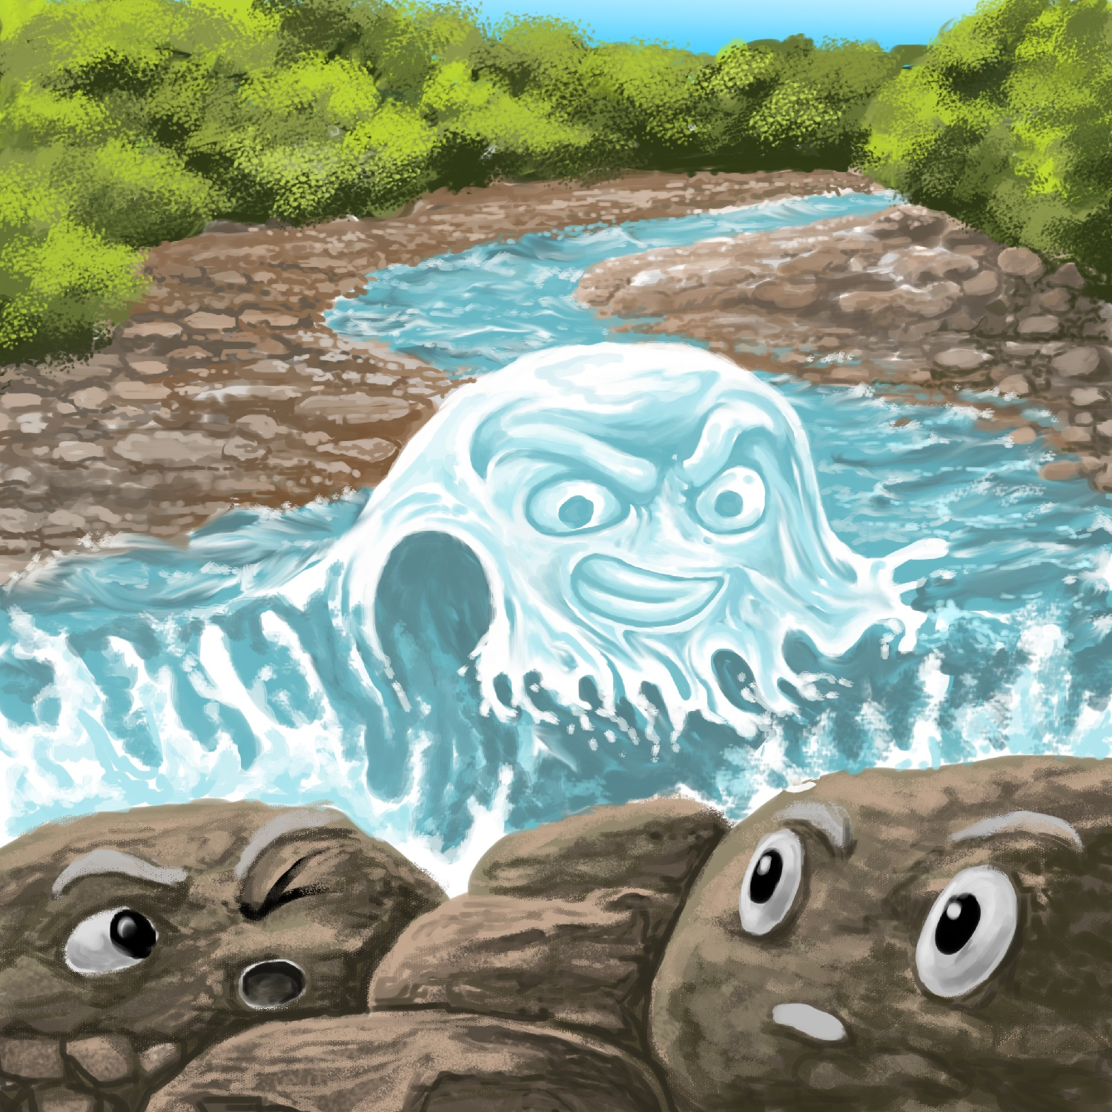
The Better Start Literacy Approach is supported by the
A Better Start National Science Challenge, a 10-year programme of research investigating practical, evidence-based solutions that make a measurable difference for our tamariki. https://www.abetterstart.nz/

Awa is mad.
Awa cannot flow.

The dam says stop.
You must not go.
Stop! Stop!
You can not flow.
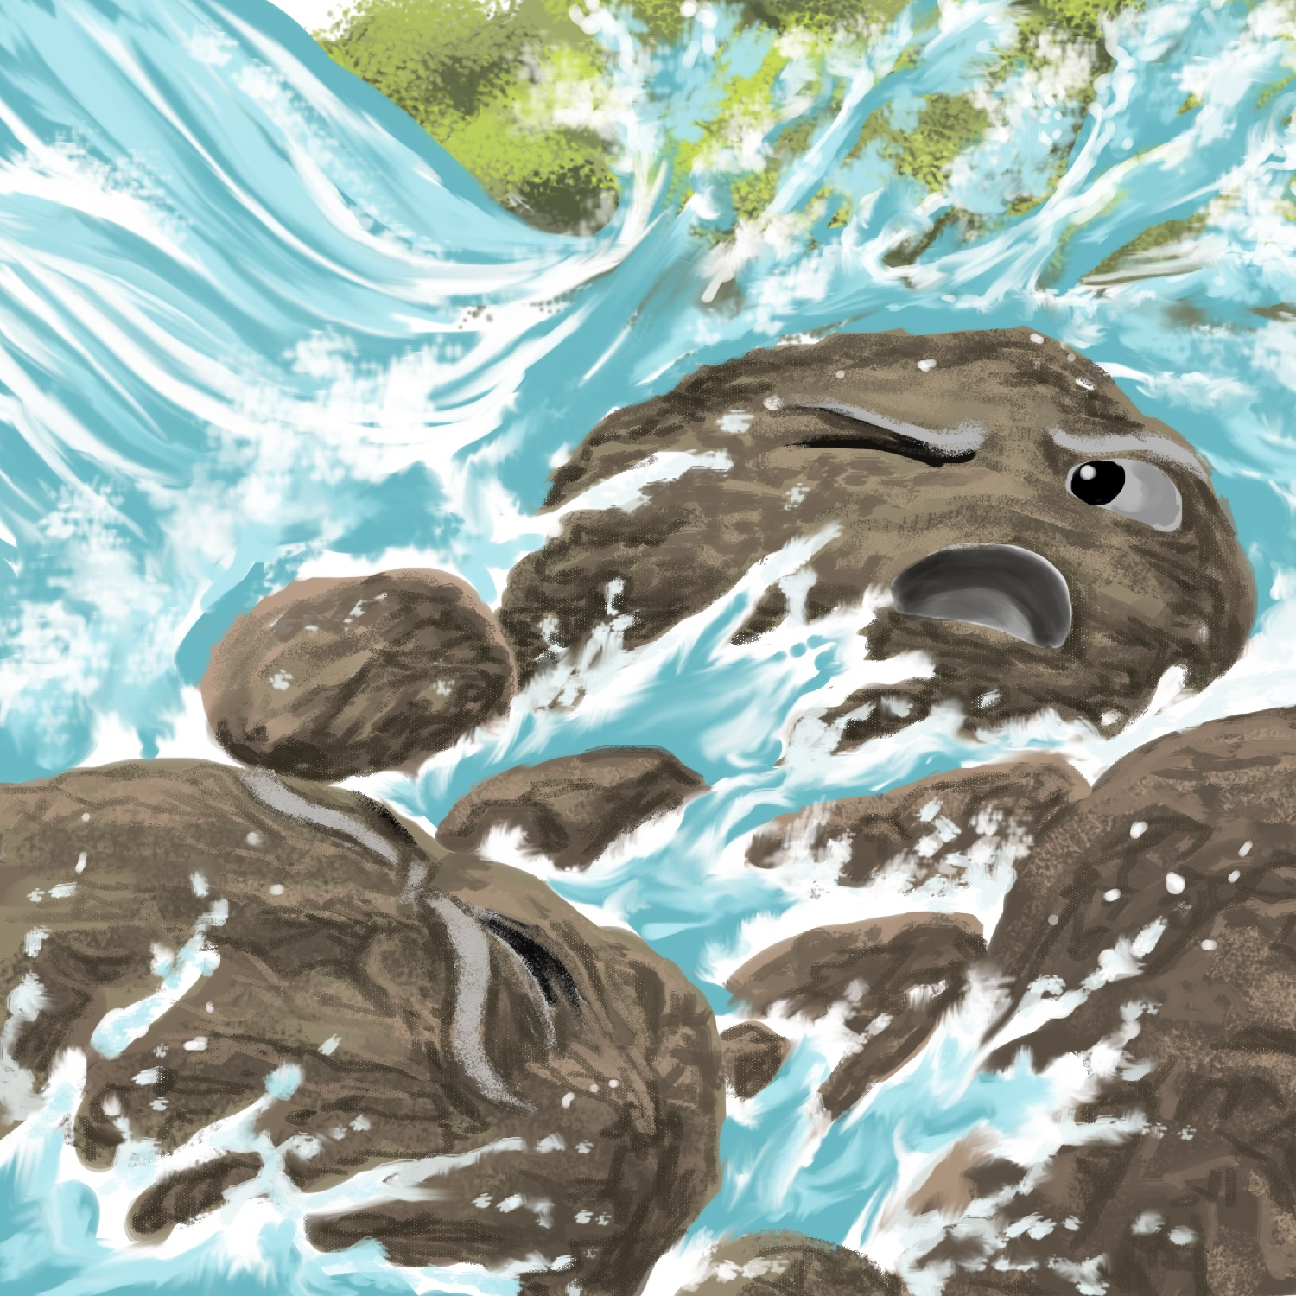

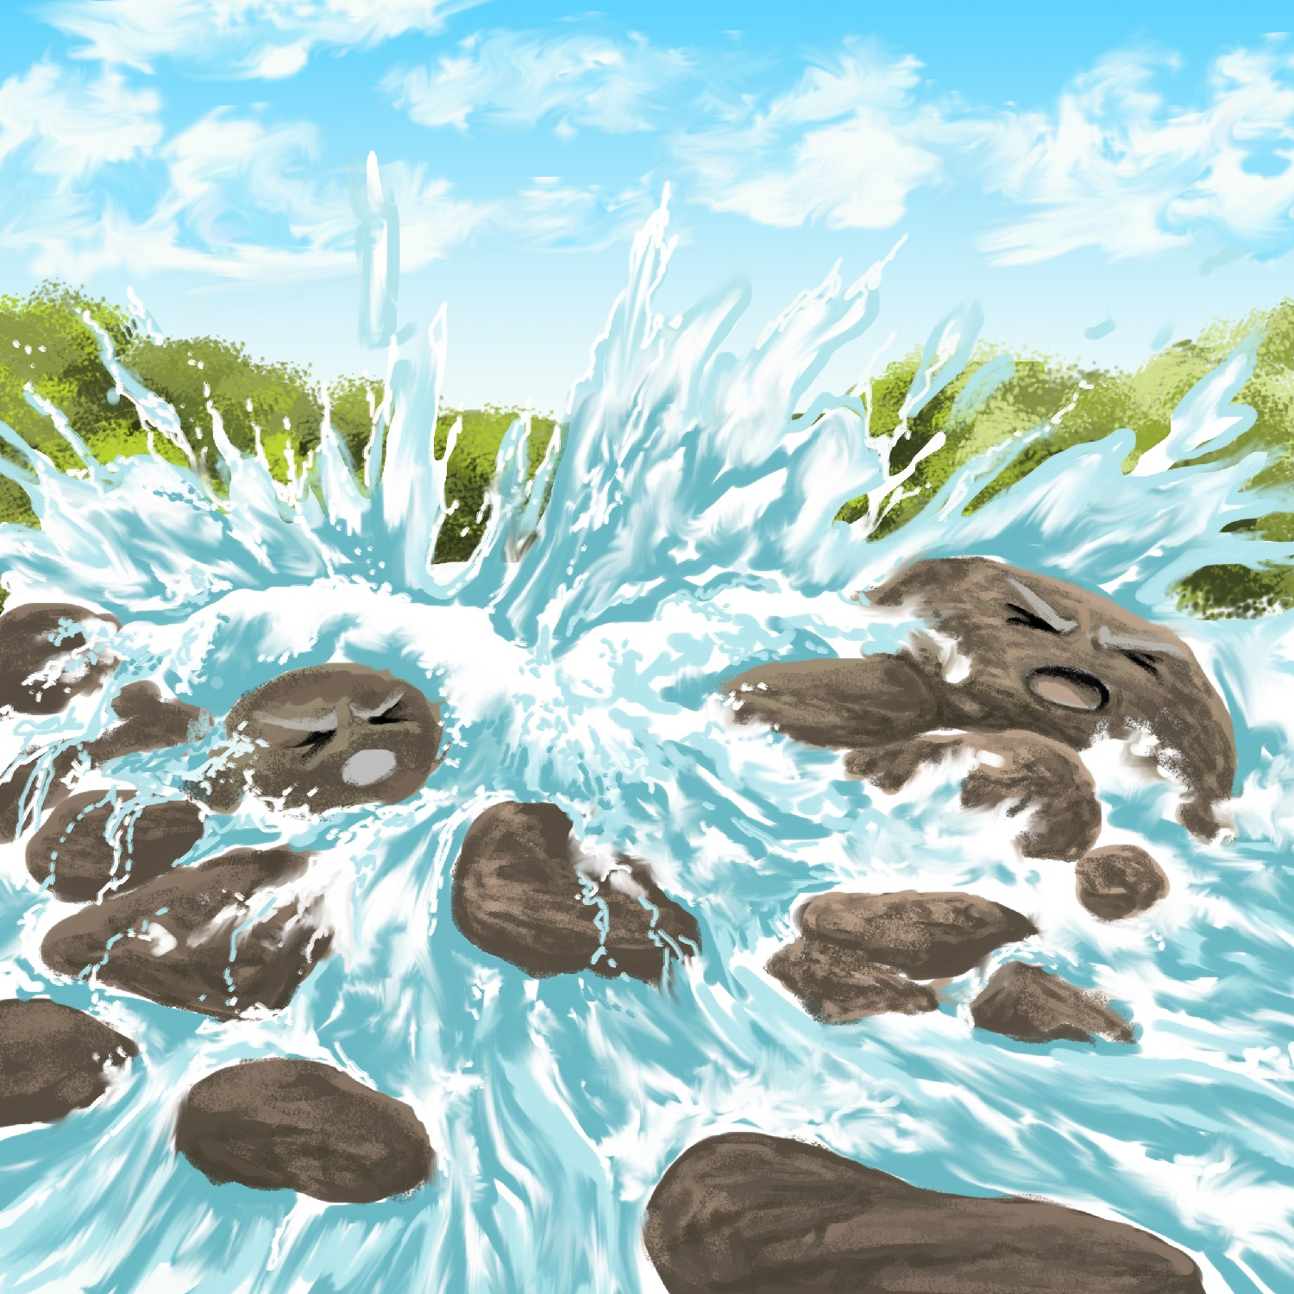

But…
Drip, drop, drip, drop.
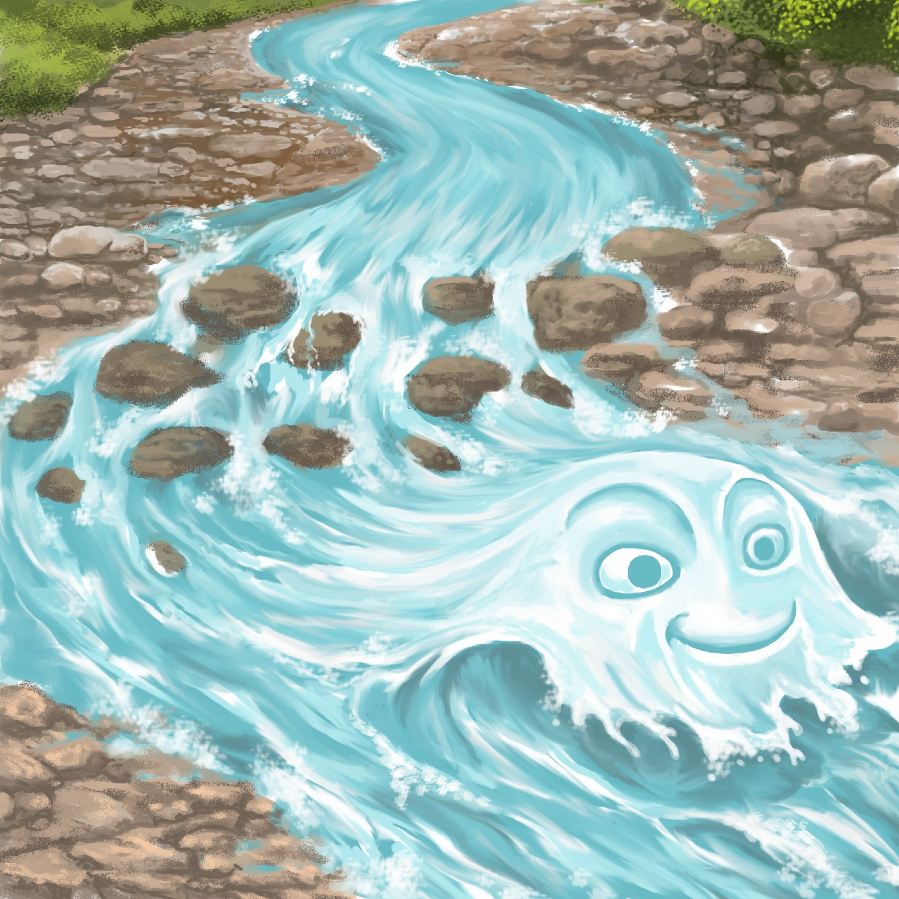
Pop! Boom! The dam burst!

Awa sped past.
Awa sped past fast!

Teaching Notes: Book 15 Awa is Mad
Reading Practice: This story provides children with revision practice of decoding short words with sounds they have learnt so far, including consonants m, d, p, t, s, f, g and b and vowels a, e, o, i and u.

Introduce the text and read the story aloud together, pointing to each word as you read the story. Encourage children to help you “sound out” the regular words in the story. Help children sound out the word and then blend the sounds together, for example, s-p-e-d = sped. When reading unknown high frequency words (e.g., is, says), tell children the words as you read together. Give plenty of praise for children’s reading attempts and encourage re-reading to build fluency and accuracy.

Phonological Awareness
Practice segmenting and blending words. Ask children to clap out each phoneme (sound) in the word: d-a-m (3 sounds), m-u-s-t (4 sounds), d-r-i-p (4 sounds), s-p-e-d (4 sounds), f-a-s-t (4 sounds).
Help children to find each word you segment on the page.
Think of all the words you can that start with their choice of target sound from the book. Find objects in the room that start with this sound, too.

Spelling
Listen and identify where the sound change occurs in words. Use the phrasing: “If this word spells drop, can you make it say drip. If this word says drip can you change it to rip”.
Change drop to drip to rip to dip
Change top to stop to step to stem

Vocabulary
Discuss the meaning of the word burst – this is when something breaks open suddenly. Talk about how the dam burst in the story and what happened after this. What other things can you think of that burst?

Story Discussion
Discuss how a dam stops water from flowing. Talk about different uses of a dam - from a small dam to stop flooding to large dams that can help make electricity, help with water supply or irrigation.

Story Retell
Ask children to re-tell the story to a friend. Prompt as necessary using picture cues. Give plenty of praise and encouragement.
Print Concepts
Discuss use of the exclamation mark. We use an exclamation mark to show we are excited or using a loud voice.

